Name: \_\_\_\_\_\_\_\_\_\_\_\_\_\_\_\_\_\_\_\_\_\_\_\_\_\_\_\_\_ (please print)

Signature: \_\_\_\_\_\_\_\_\_\_\_\_\_\_\_\_\_\_\_\_\_\_\_\_\_\_

ECE 2300 – Final Exam

December 14, 2013

Keep this exam closed until you are told to begin.

1. This exam is closed book, closed notes. You may use one 8.5” x 11” crib sheet, or its equivalent.

2. Show all work on these pages. Show all work necessary to complete the problem. A solution without the appropriate work shown will receive no credit. A solution that is not given in a reasonable order will lose credit. Clearly indicate your answer (for example by enclosing it in a box).

3. It is assumed that your work will begin on the same page as the problem statement. If you choose to begin your work on another page, you must indicate this on the page with the problem statement, with a clear indication of where the work can be found. **If your work continues on to another page, indicate clearly where your work can be found. Failure to indicate this clearly will result in a loss of credit.**

4. Show all units in solutions, intermediate results, and figures. Units in the exam will be included between square brackets.

5. Do not use red ink. Do not use red pencil.

6. You will have 170 minutes to work on this exam.

1. \_\_\_\_\_\_\_\_\_\_\_\_\_\_\_\_/20

2. \_\_\_\_\_\_\_\_\_\_\_\_\_\_\_\_/30

3. \_\_\_\_\_\_\_\_\_\_\_\_\_\_\_\_/30

4. \_\_\_\_\_\_\_\_\_\_\_\_\_\_\_\_/30

5. \_\_\_\_\_\_\_\_\_\_\_\_\_\_\_\_/20

6. \_\_\_\_\_\_\_\_\_\_\_\_\_\_\_\_/35

7. \_\_\_\_\_\_\_\_\_\_\_\_\_\_\_\_/35

Total = 200

Room for extra work

1. {20 Points} Find the equivalent resistance seen by terminals A and B. Show your work with reasonable steps.

C:\Users\GULIN\Desktop\UH ECE 2300\Gulin Lecture Notes\Exams\final\q1.emfRoom for extra work

2. {30 Points} Two voltmeters are put in series, and used to measure an unknown voltage. The unknown voltage is determined by adding the readings of the two voltmeters. Voltmeter #1 can read a maximum voltage of 50[V], and has a meter resistance of 2.35[MΩ]. Voltmeter #2 can read a maximum voltage of 20[V], and has a meter resistance of 14.5[MΩ].

a) What is the largest voltage that can be measured in this way, by adding the readings of the two voltmeters?

b) Assume that a resistor of 4.75[MΩ] is now placed in parallel with Voltmeter #2, and that parallel combination is placed in series with Voltmeter #1. What is the largest voltage that can be measured in this way, by adding the readings of the two voltmeters?

c) Assume now that the resistor of 4.75[MΩ] is removed, and the two voltmeters are placed in series again. Assume that the voltmeters are such that they cannot be damaged, even if a voltage larger than their full-scale reading is placed across them. What is the largest voltage that can be measured, knowing the meter resistance of each meter, and using the reading on one of the meters?

Room for extra work

3. {30 Points}Use either the node-voltage method, or the mesh-current method, to write a complete set of equations that could be used to solve this circuit. Do not simplify the circuit. Do not attempt to simplify or solve your equations. Define all variables clearly.

C:\Users\GULIN\Desktop\UH ECE 2300\Gulin Lecture Notes\Exams\final\q3.emf

# Room for extra work

4. {30 Points} Find the Norton equivalent of the circuit shown below, as seen by the *iS1* current source.

a) Draw your Norton equivalent, labeling all components with numerical values.

b) Find the power delivered by the *iS1* current source, if *iS1* = 23[mA], using the Norton equivalent found in part a).

C:\Users\GULIN\Desktop\UH ECE 2300\Gulin Lecture Notes\Exams\final\q4.emf

Room for extra work

5. {20 Points} In the circuit given below, the switch periodically opens and closes. In every period, the switch is open for *tO* seconds and then closed for *tC* seconds. *vC*(t) is shown below. Find *tO* and *tC*.

C:\Users\GULIN\Desktop\UH ECE 2300\Gulin Lecture Notes\Exams\final\q5.emf

C:\Users\GULIN\Desktop\UH ECE 2300\Gulin Lecture Notes\Exams\final\fall2013_final_question.emfRoom for extra work

6. {35 Points} The switch was closed for a long time before *t* = 0. Find *iX* (30[ms]).

C:\Users\GULIN\Desktop\UH ECE 2300\Gulin Lecture Notes\Exams\final\q6.emf

Room for extra work

7. {35 Points} The circuit shown in Figure 7a is in steady state.

Load 1 absorbs (975-625j) [VA].

Load 2 delivers 505[VAR], and absorbs 300[W].

Load 3 absorbs 1530[VA], with a lagging power factor of 0.68.

The resistor RX absorbs 180[W].

a) Find *iX*(t).

b) Find the impedance of Load 3, ZL3.

c) To make the power factor of Load 3 equal to 1, an unknown device is connected in series with Load 3, as shown in Figure 7b. Find a circuit model in the time domain for the unknown device.

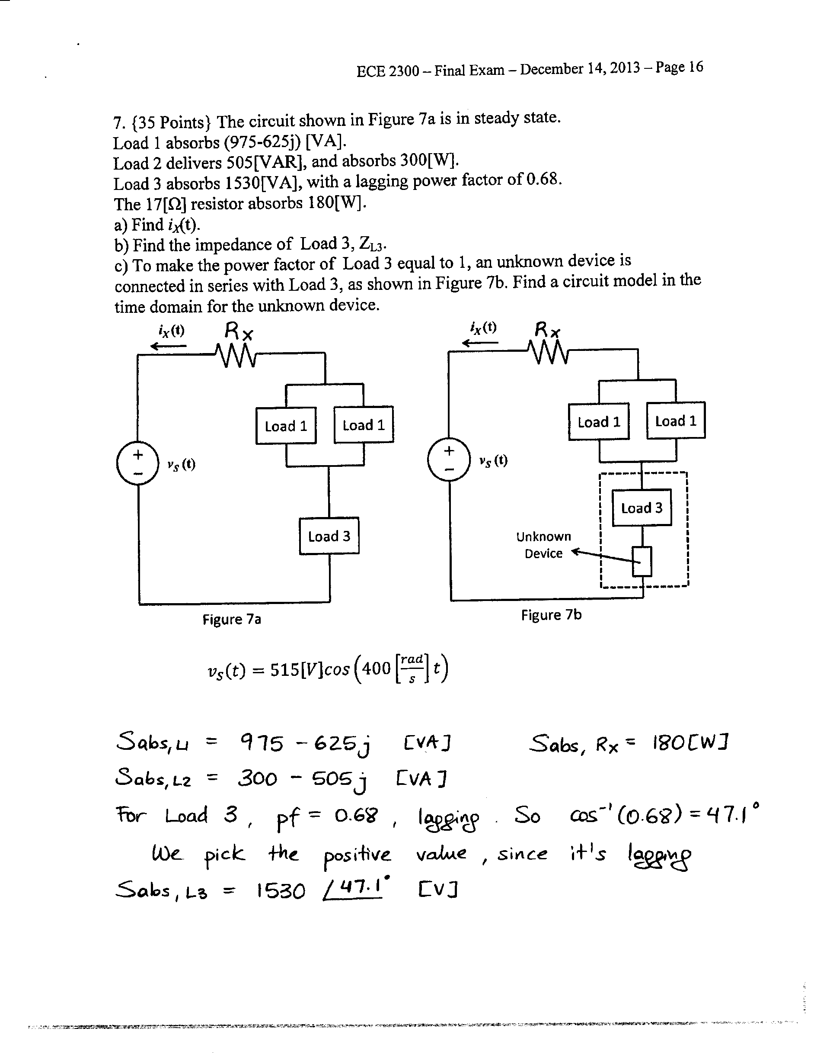

$v_{S}\left(t\right)=515\left[V\right]cos\left(400\left[\frac{rad}{s}\right]t\right)$

Solutions

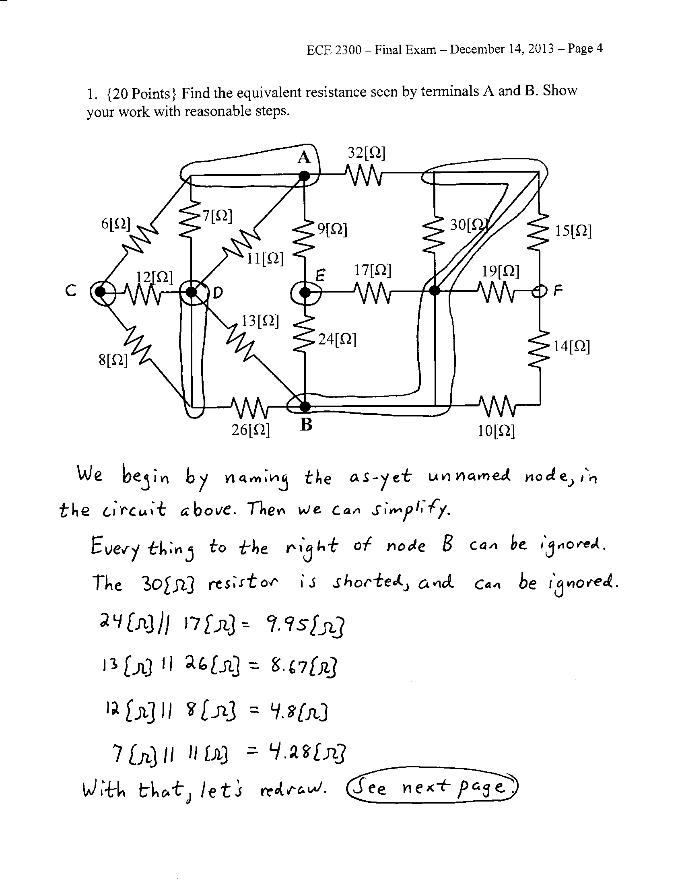

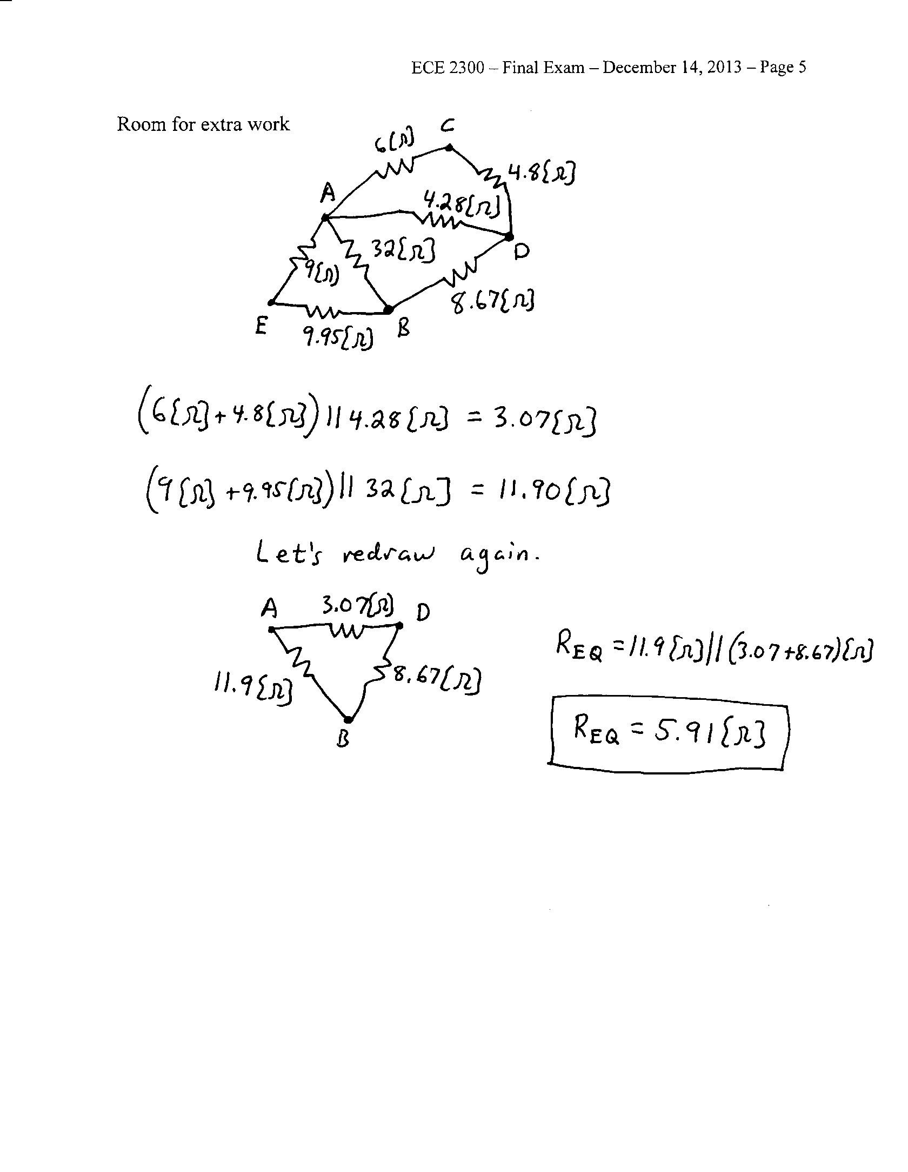

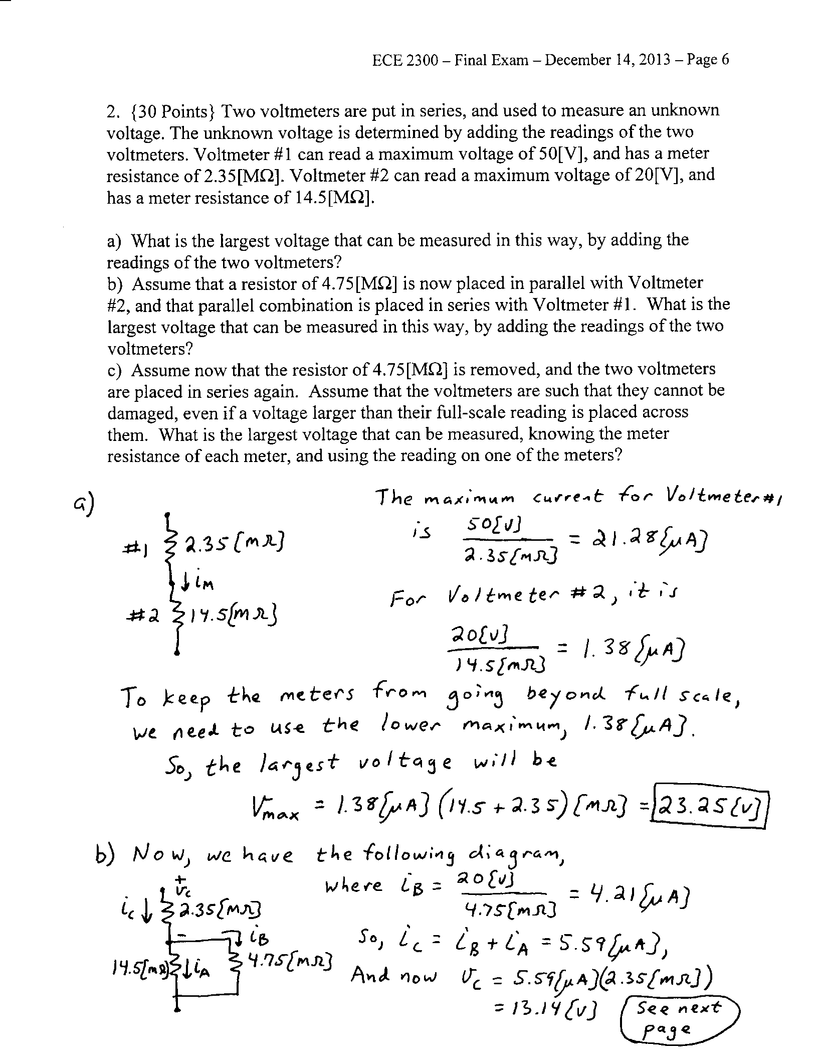

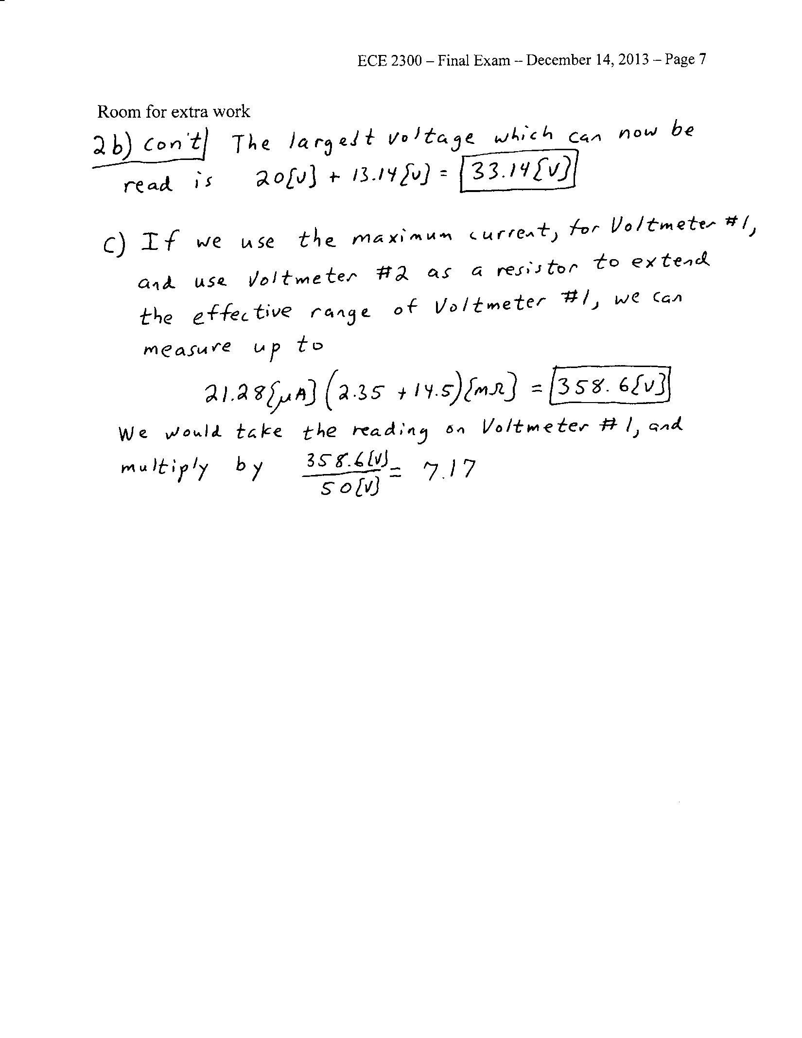

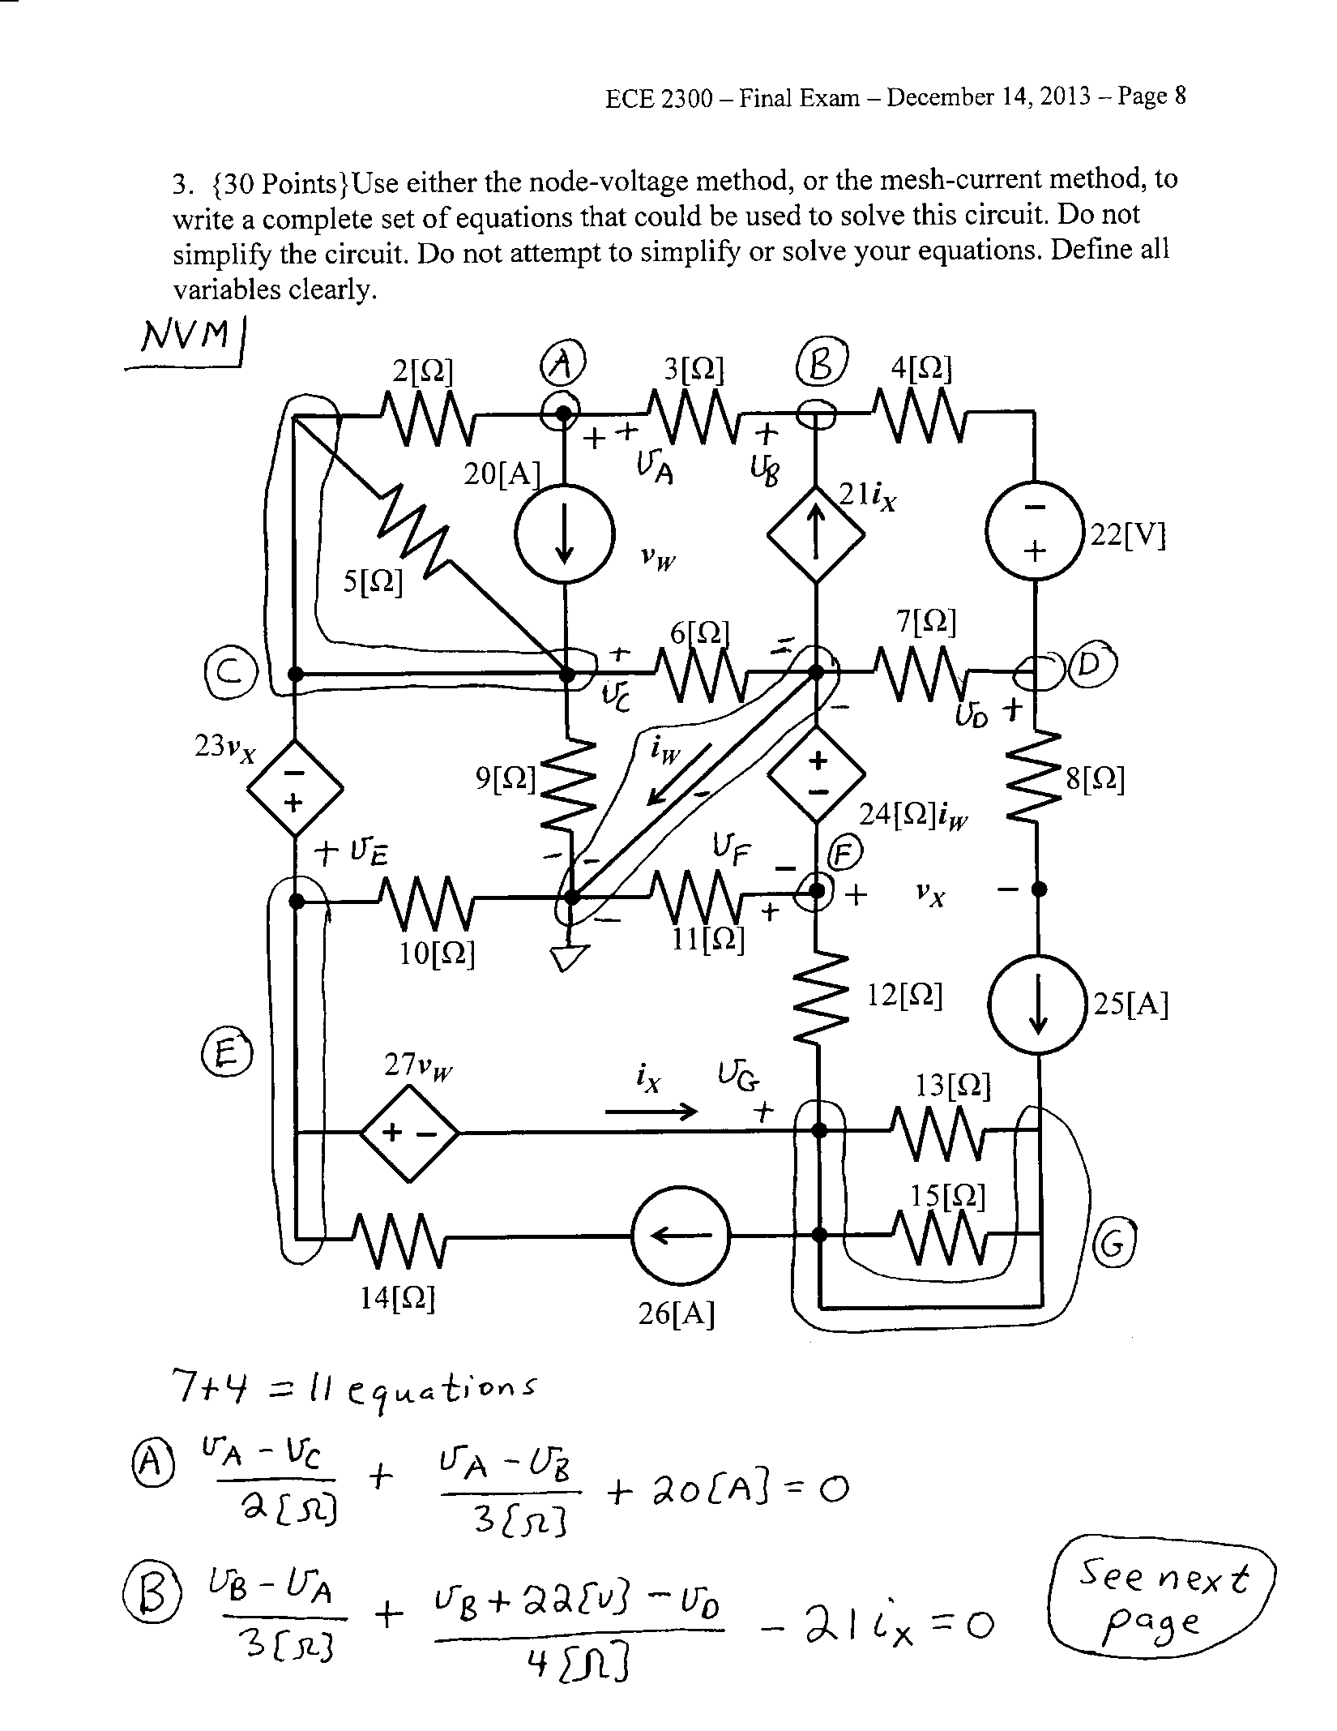

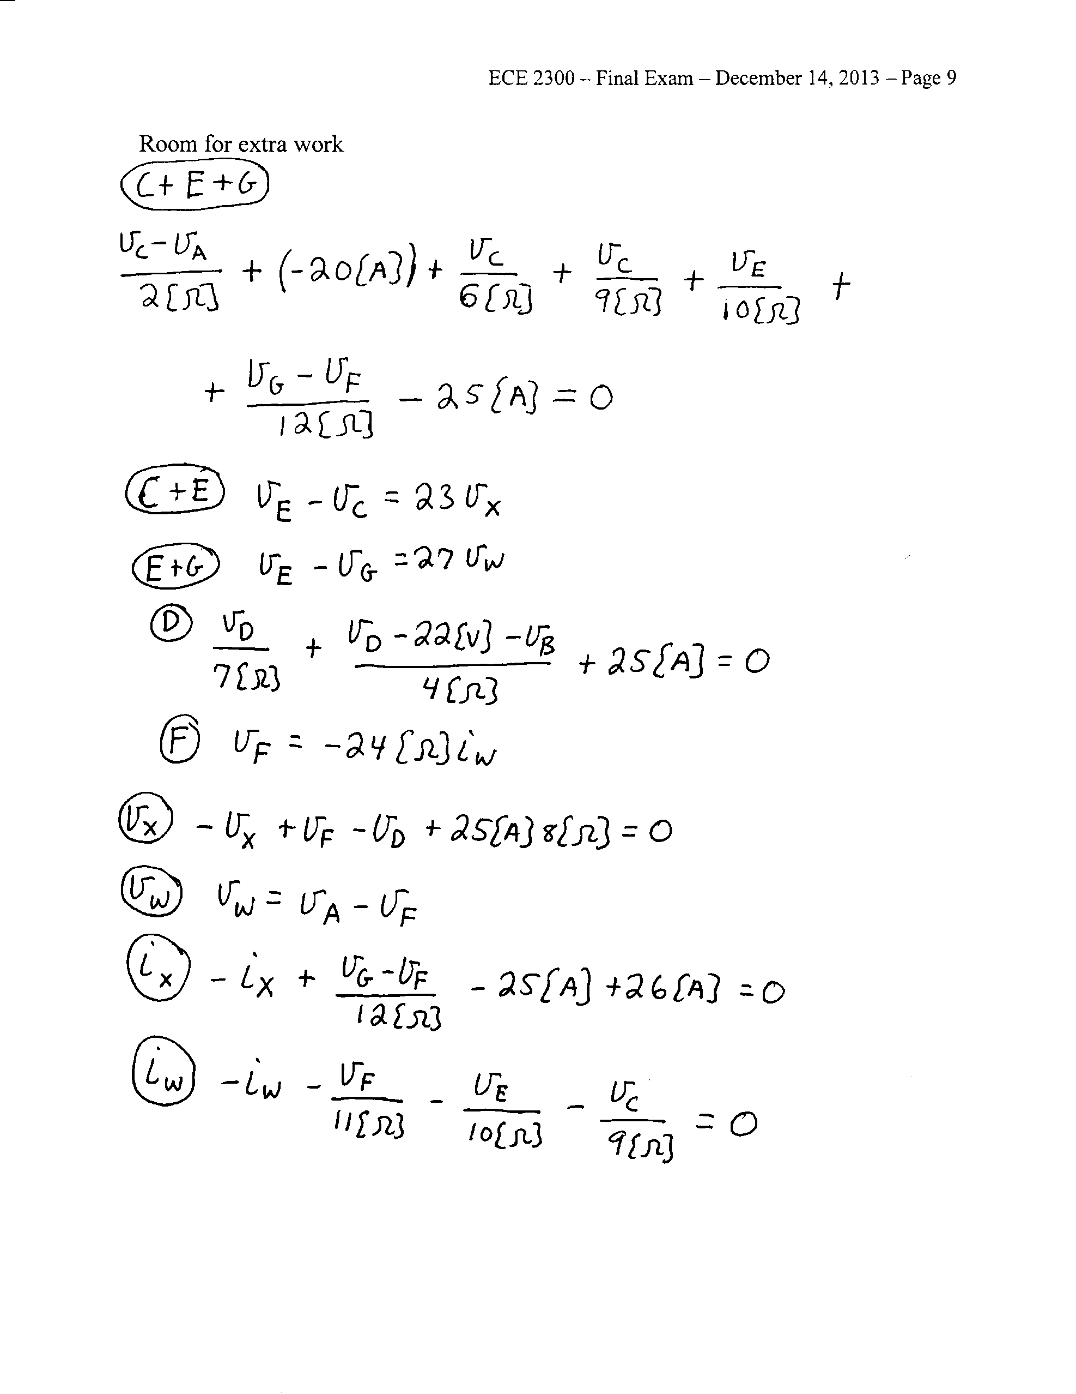

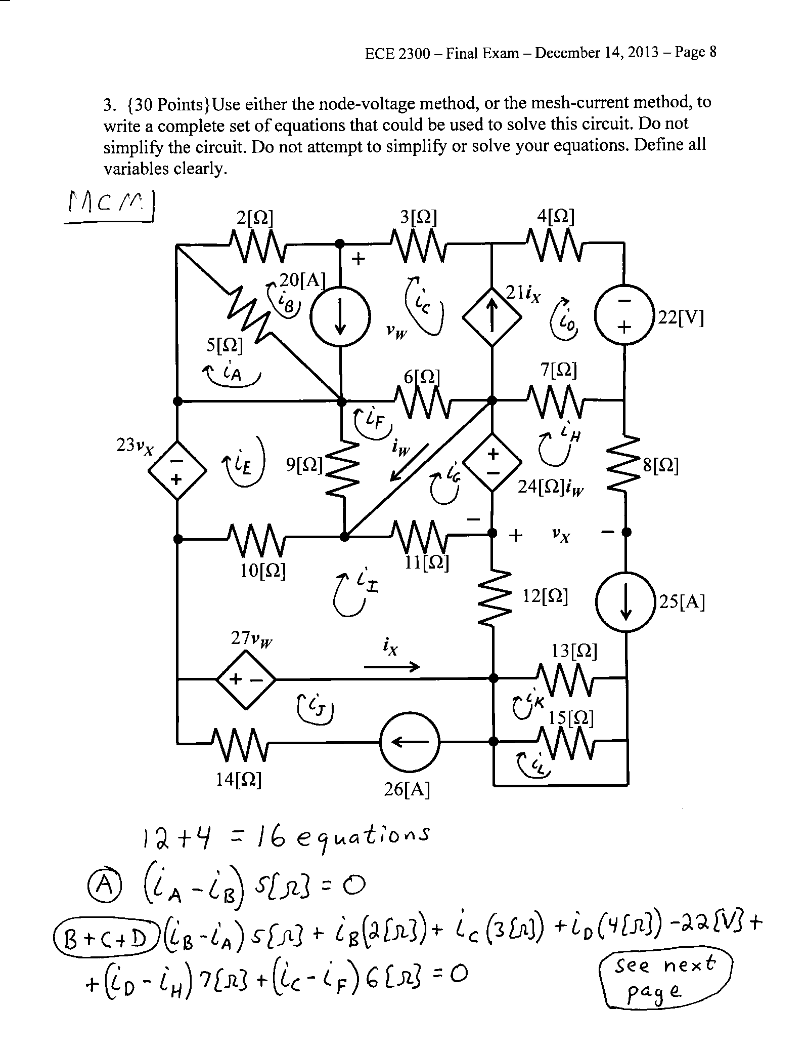

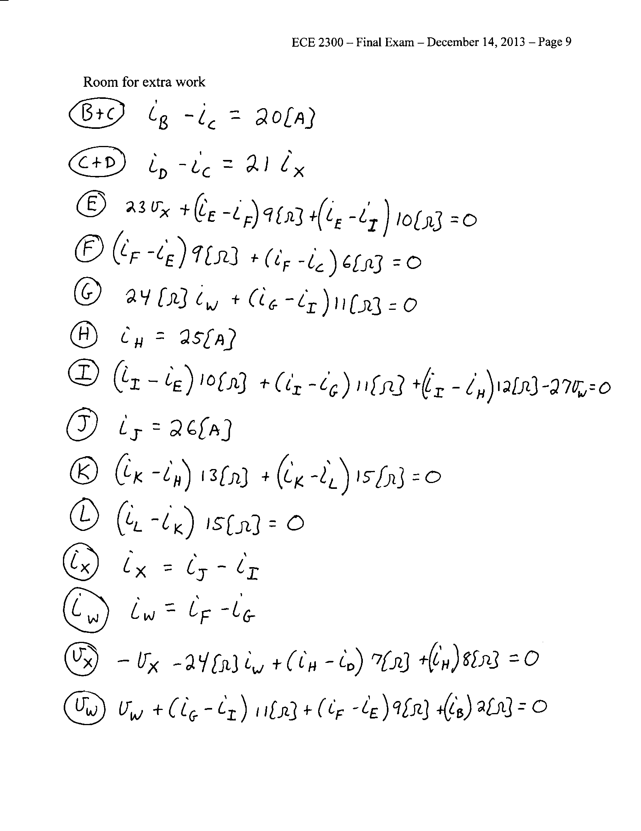

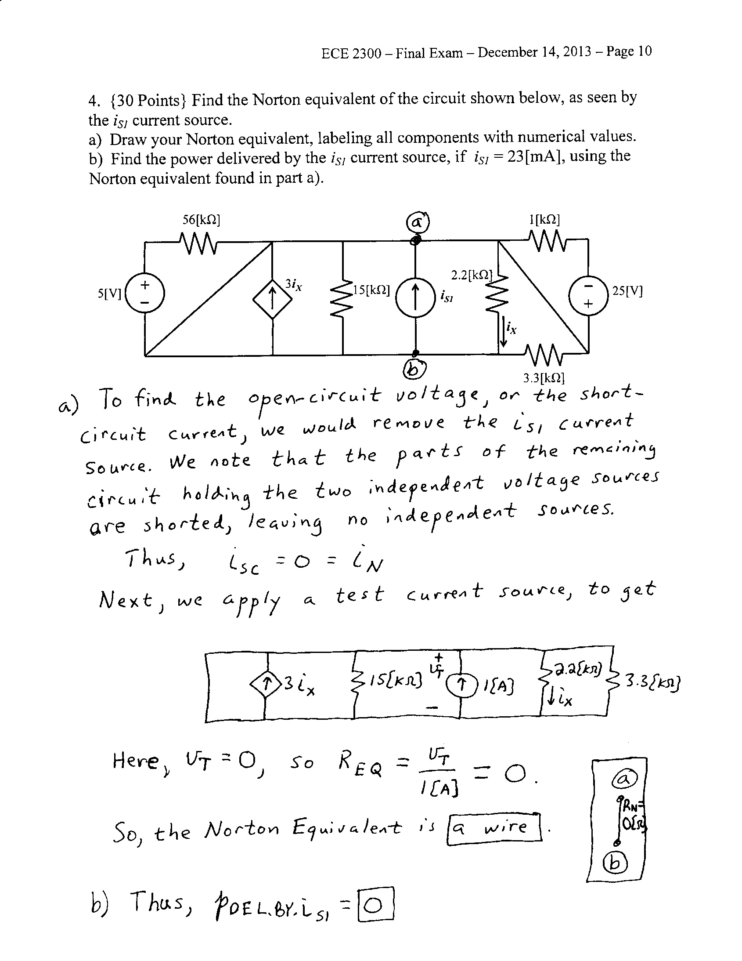

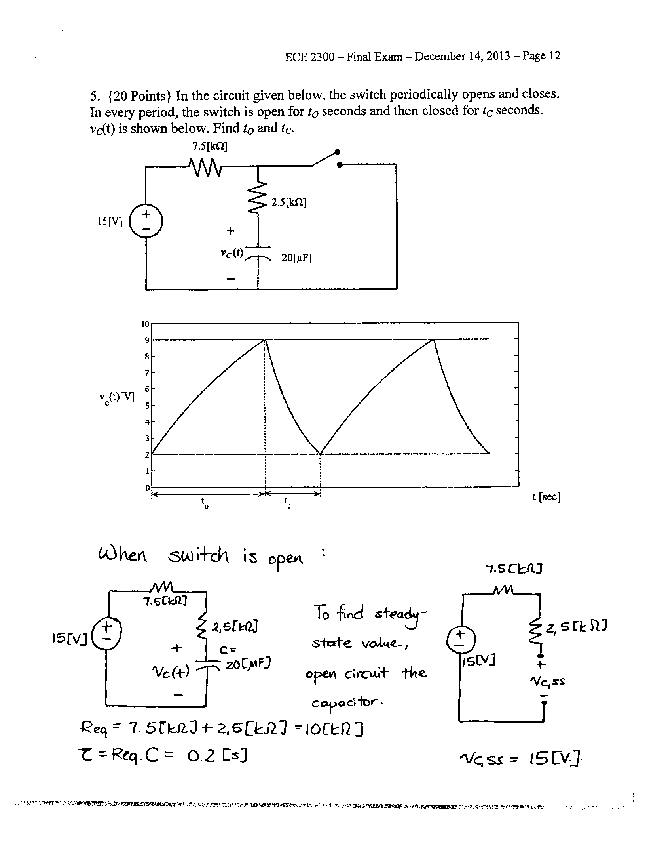

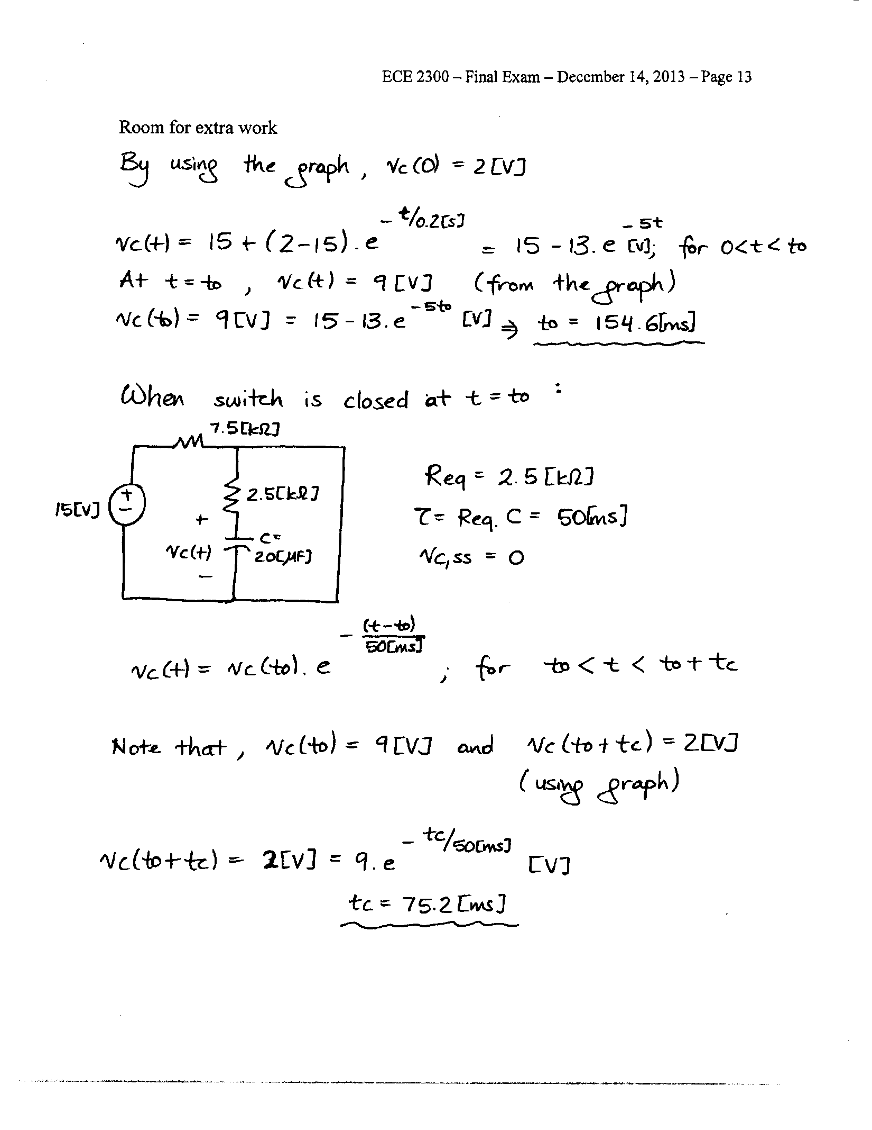

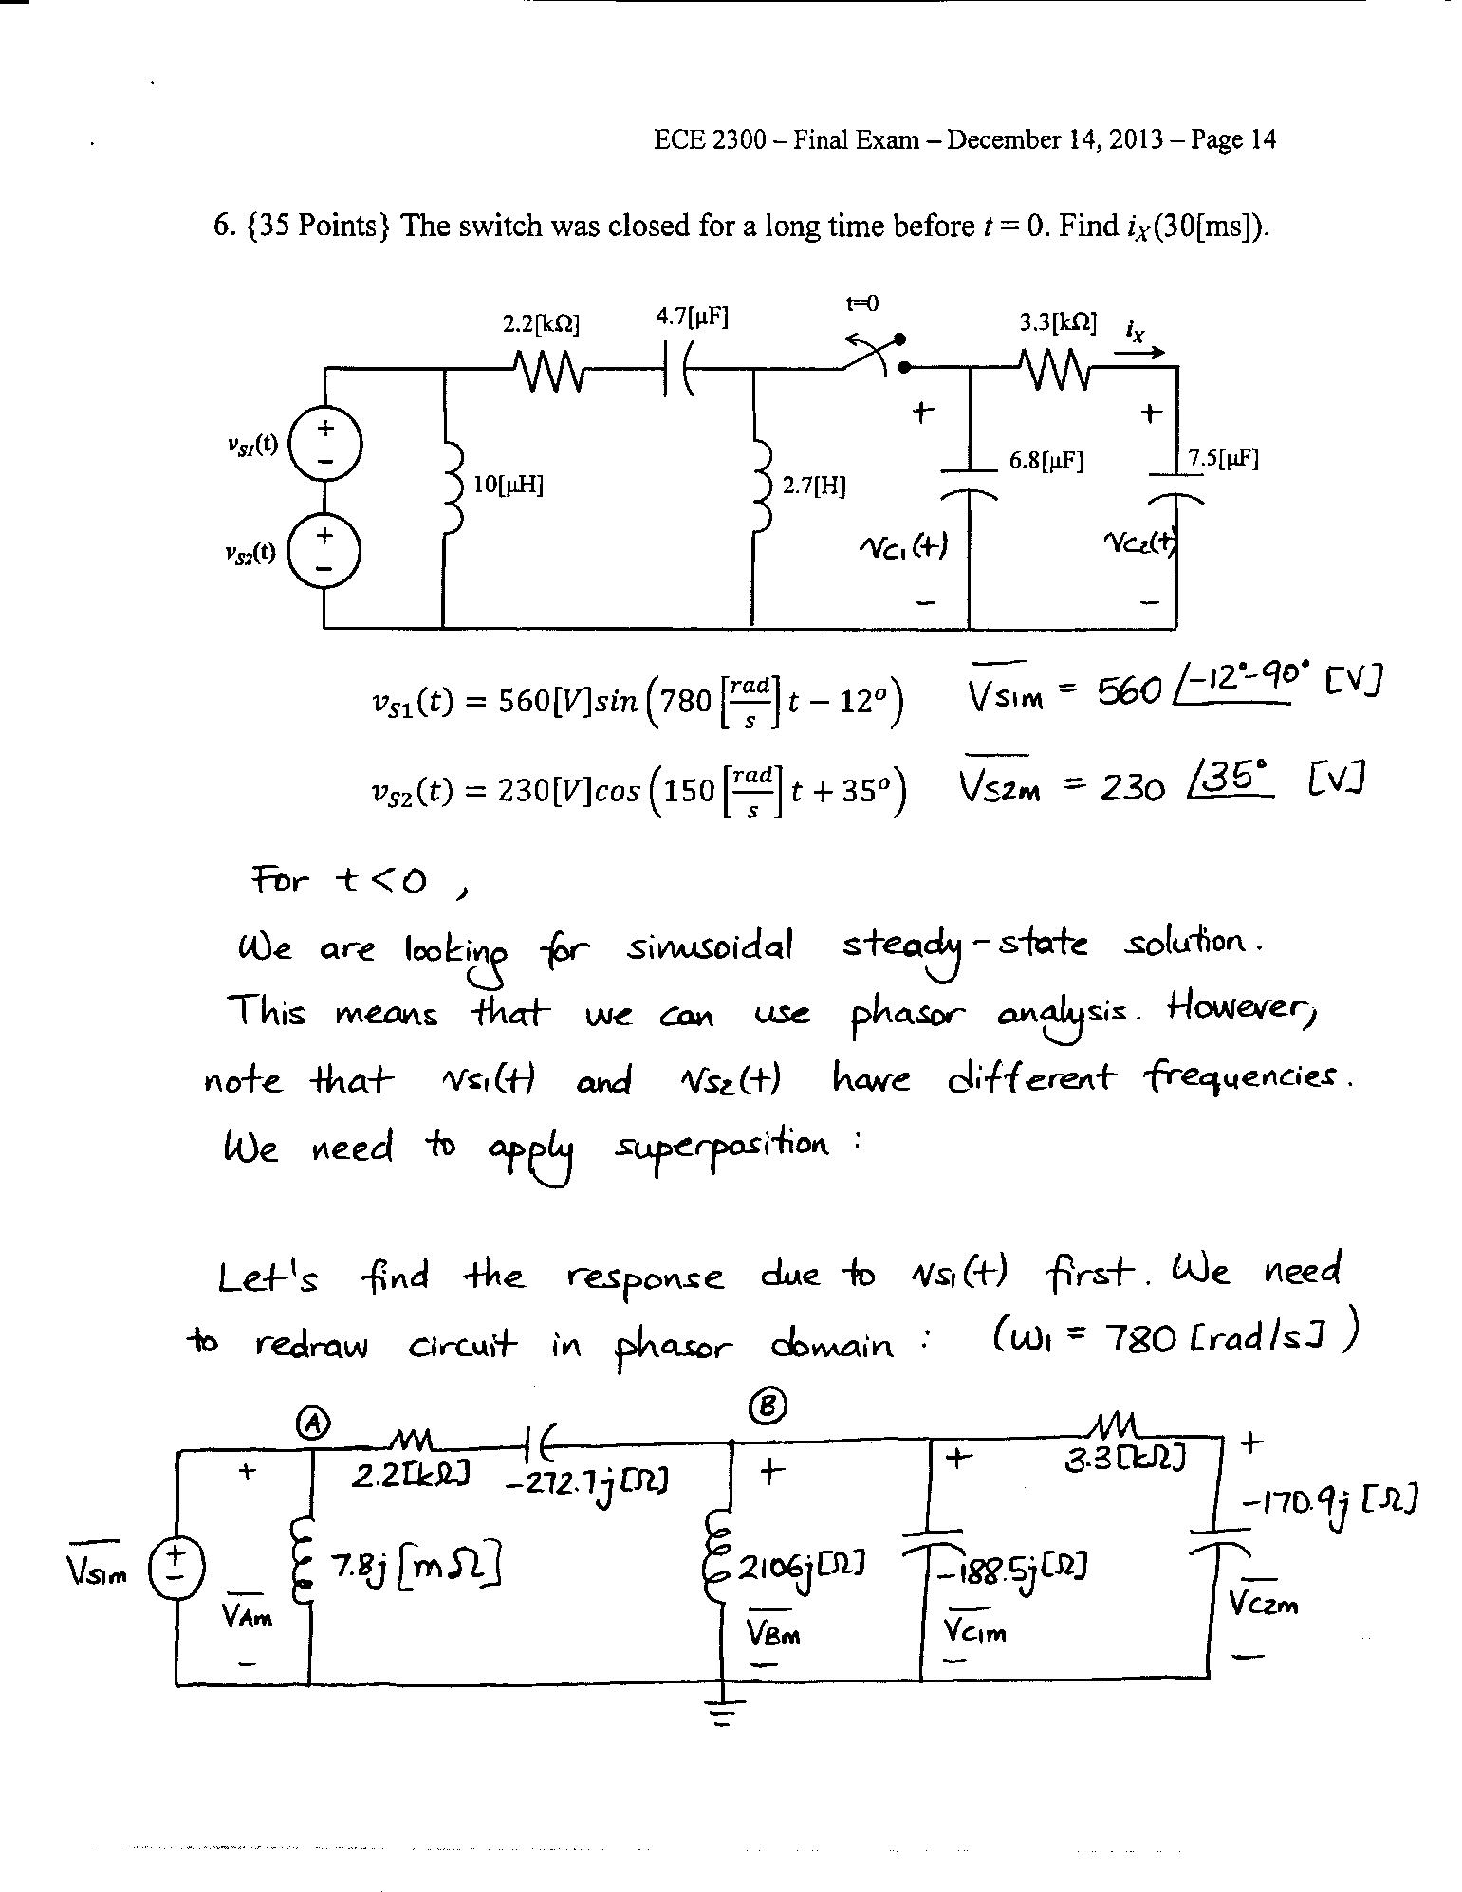

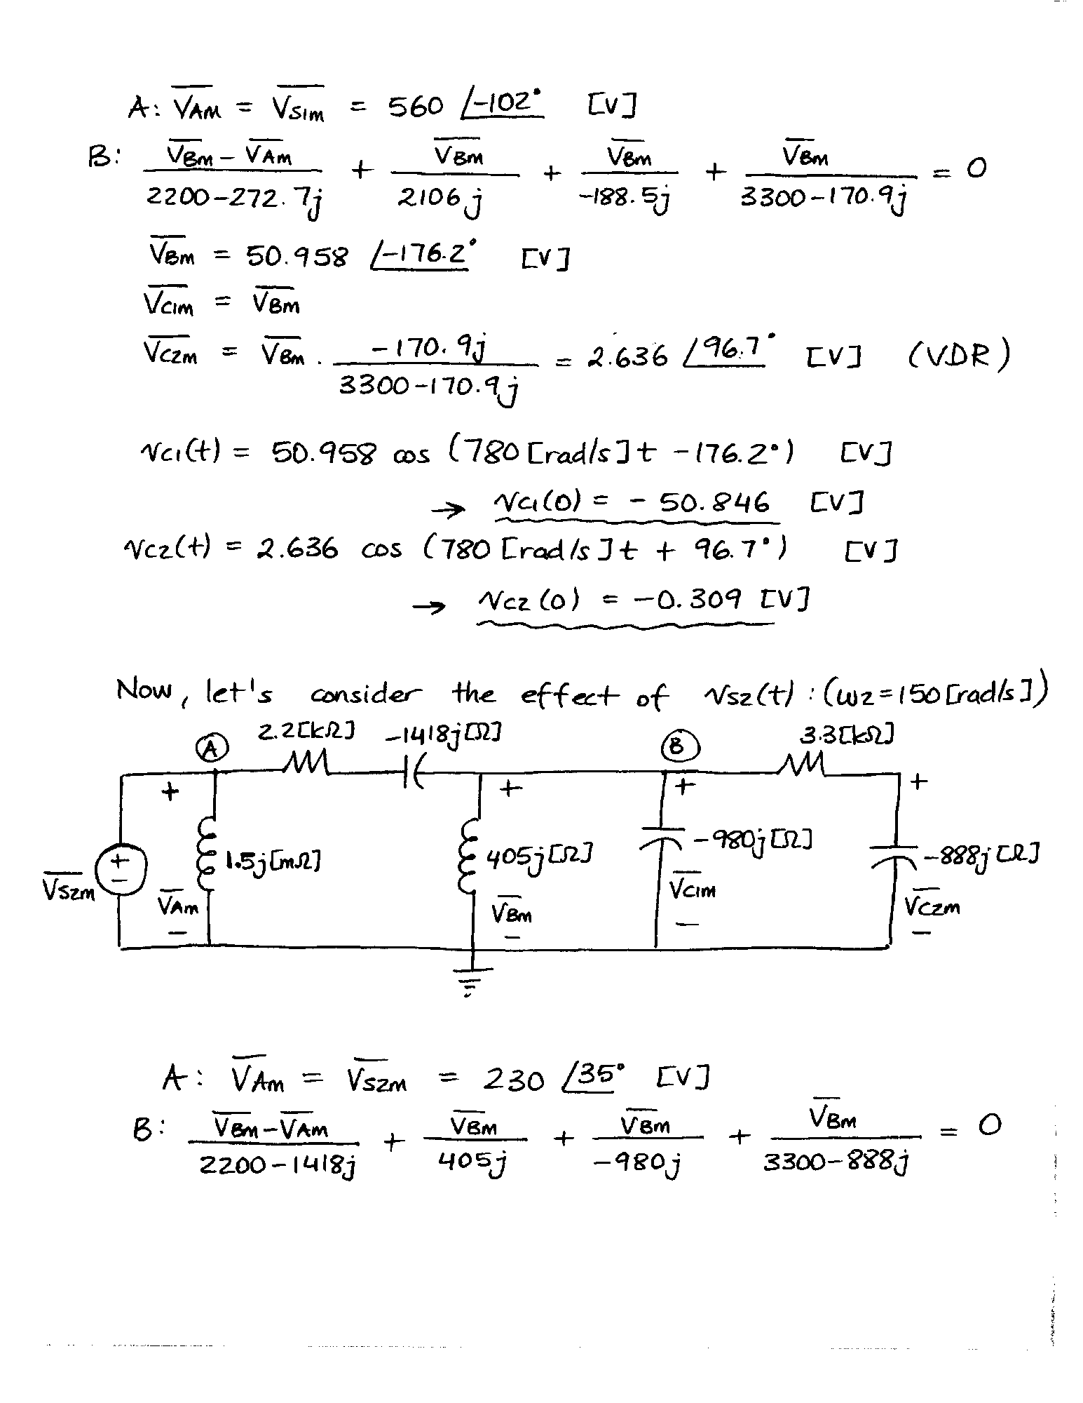

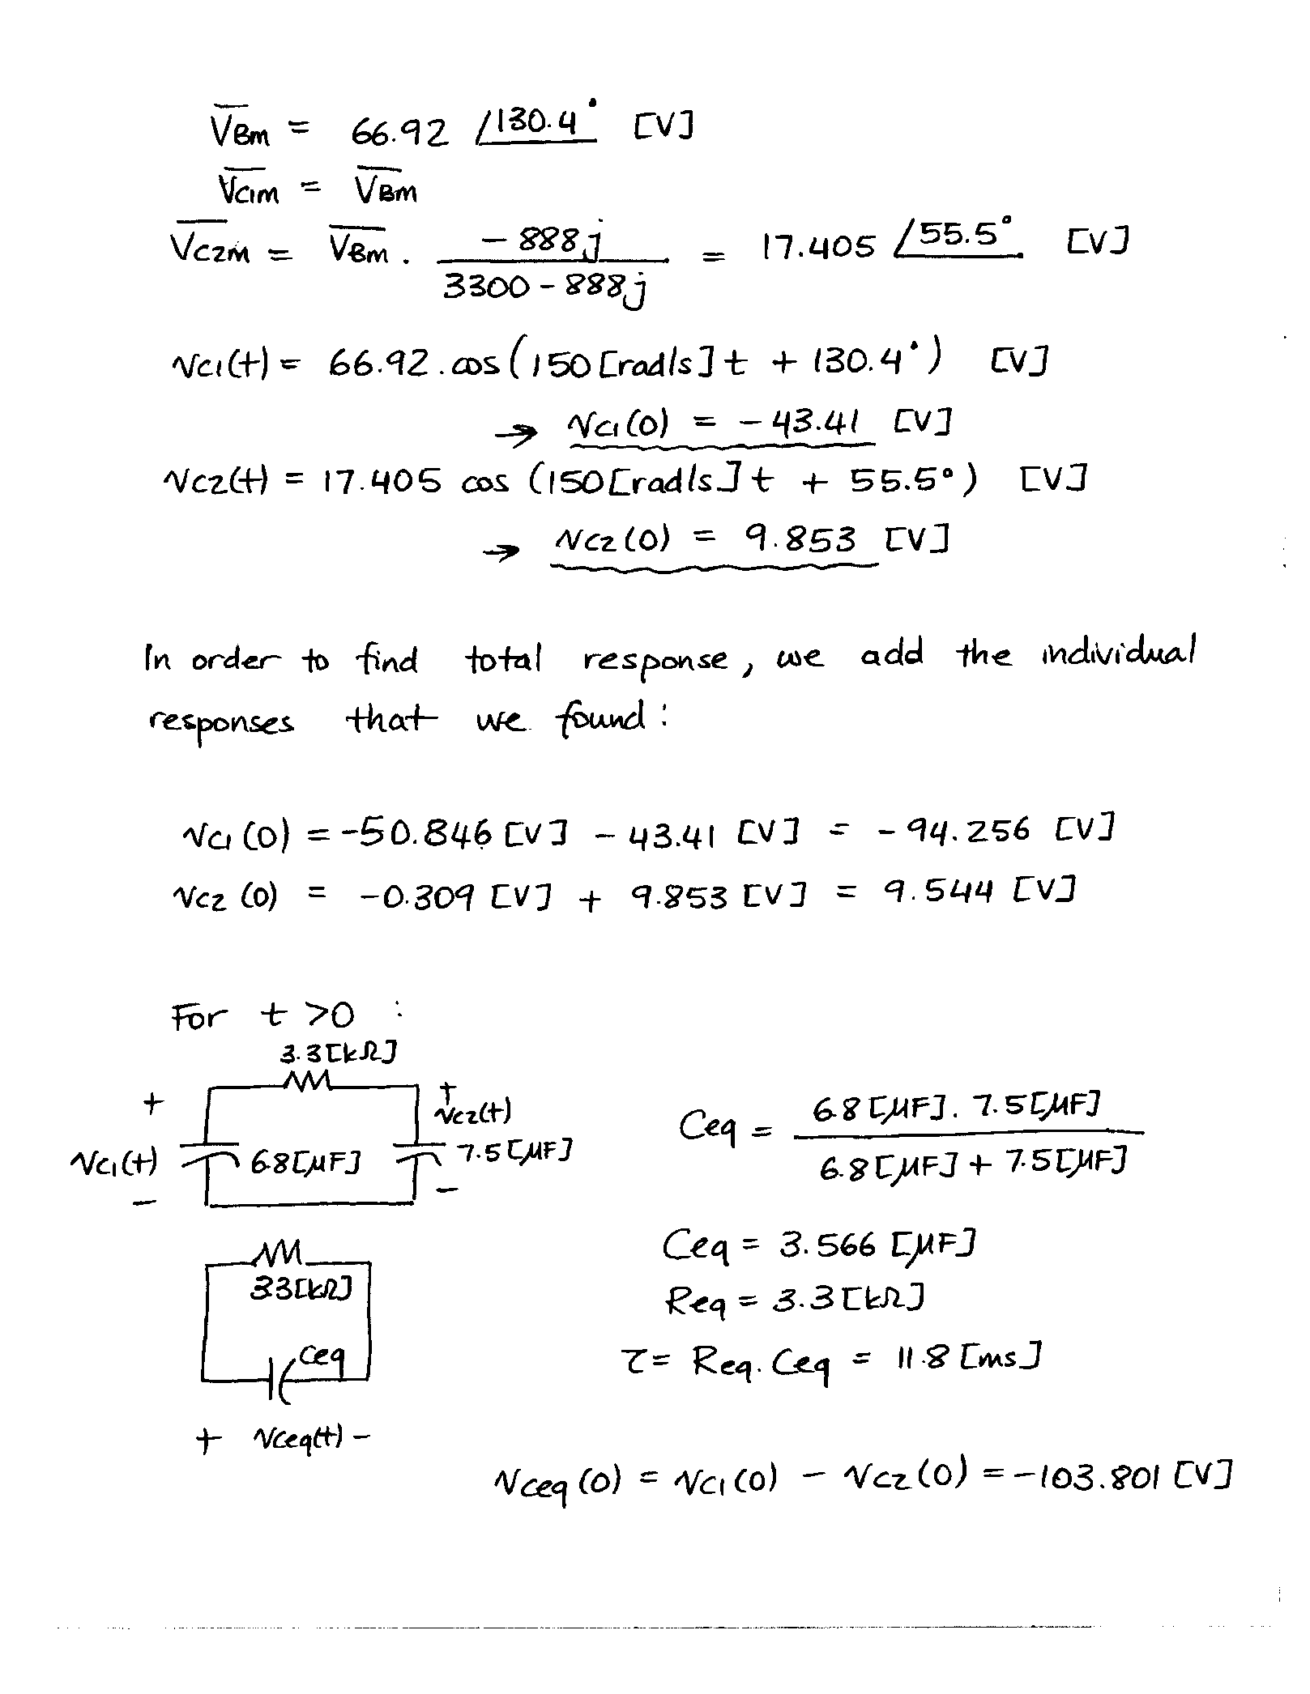

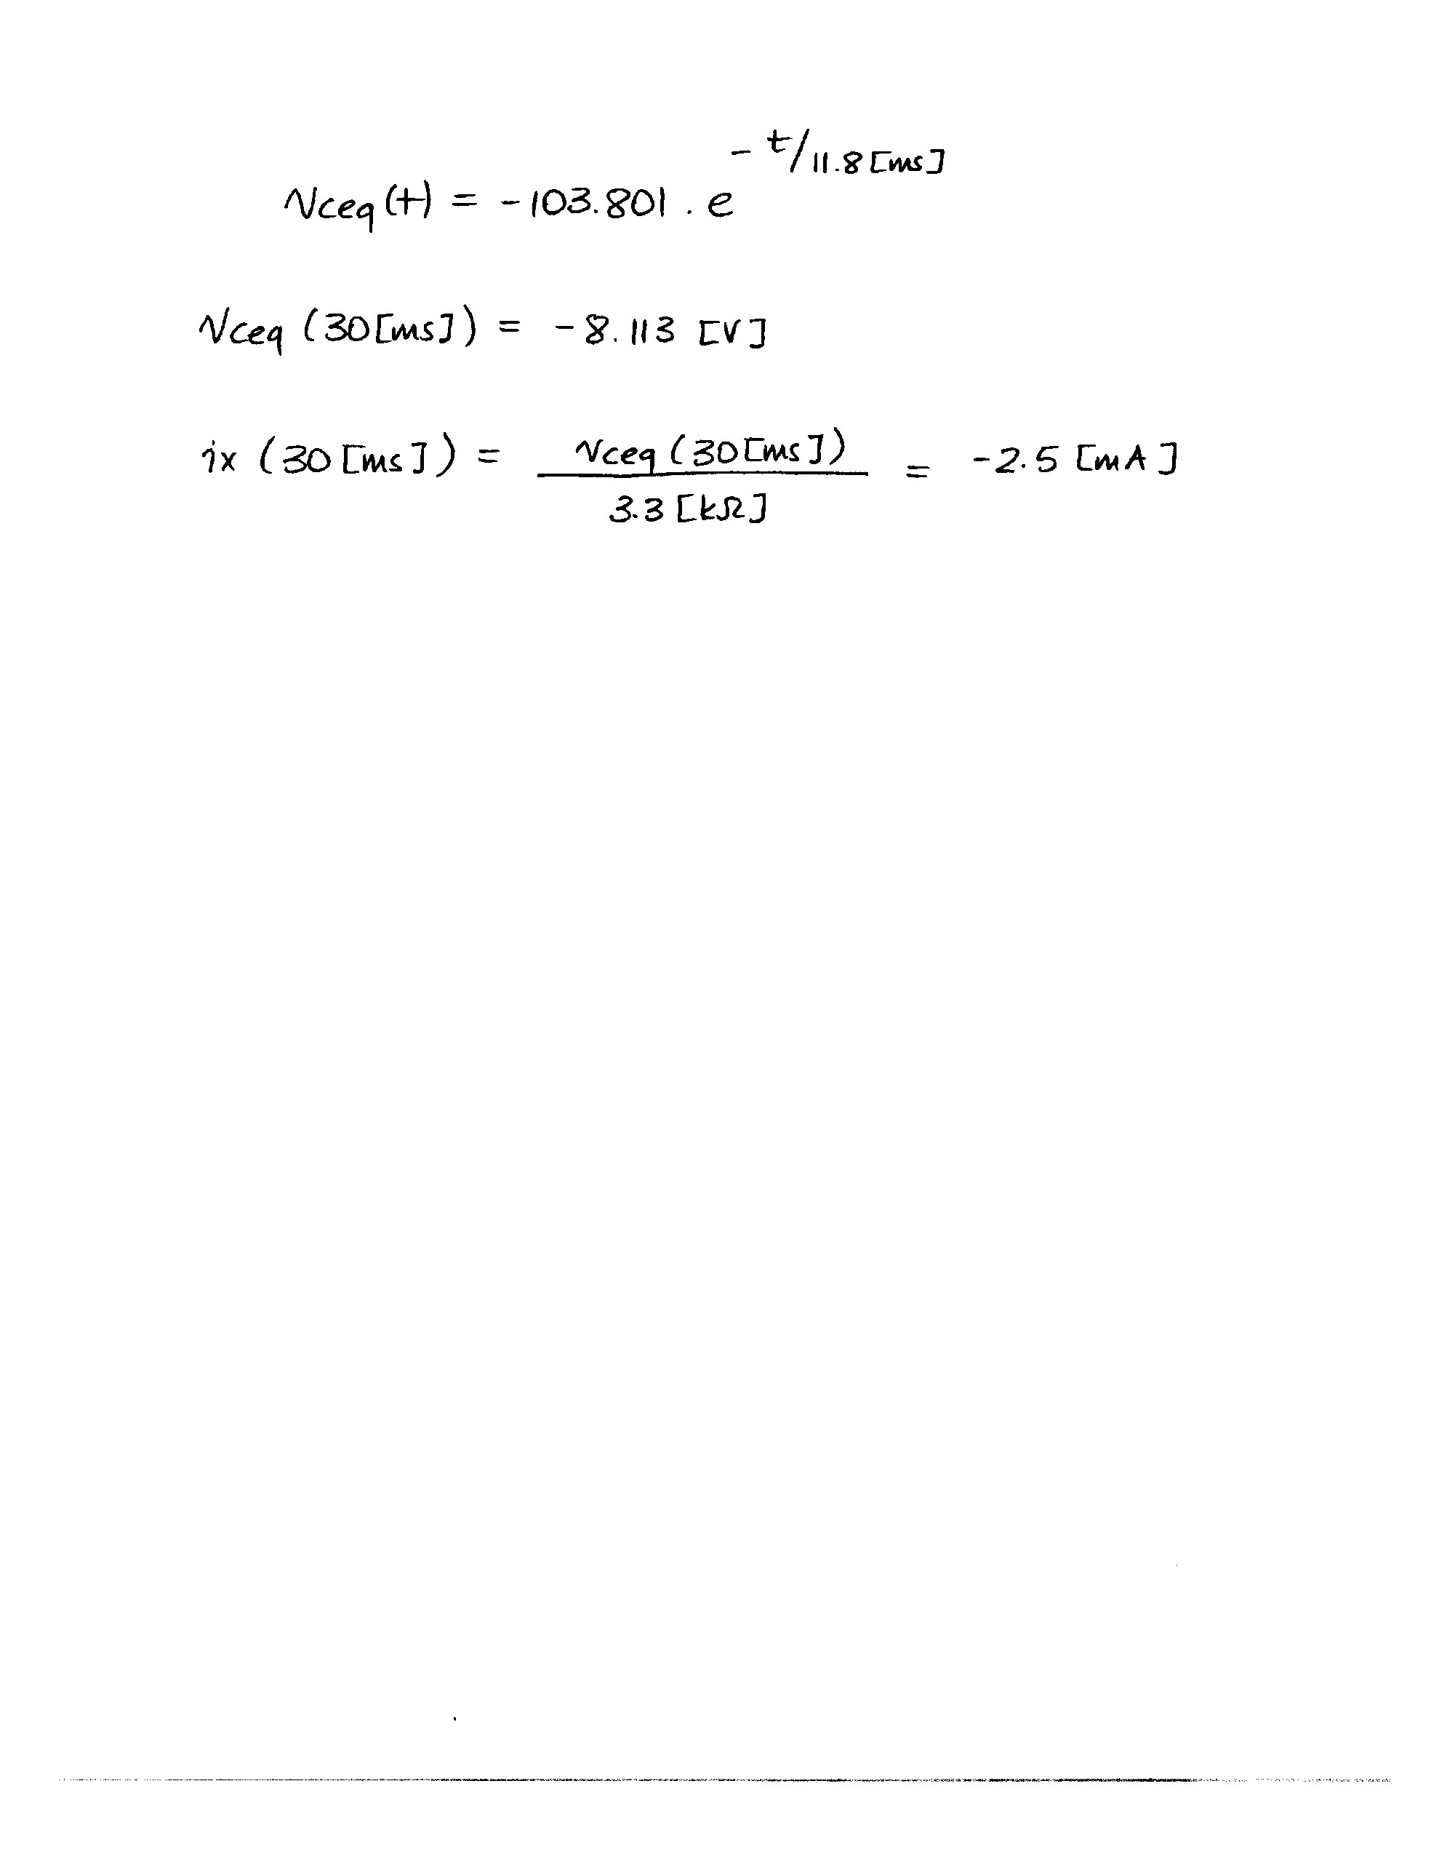

7. {35 Points} The circuit shown in Figure 7a is in steady state.

Load 1 absorbs (975-625j) [VA].

Load 2 delivers 505[VAR], and absorbs 300[W].

Load 3 absorbs 1530[VA], with a lagging power factor of 0.68.

The resistor RX absorbs 180[W].

a) Find *iX*(t).

b) Find the impedance of Load 3, ZL3.

c) To make the power factor of Load 3 equal to 1, an unknown device is connected in series with Load 3, as shown in Figure 7b. Find a circuit model in the time domain for the unknown device.

