Name: _____________________________ (please print)

Signature: __________________________

ECE 2202 – Quiz #6

November 29, 2018

Keep this quiz closed and face up until you are told to begin.

1. This quiz is closed book, closed notes. You may use one 8.5” x 11” crib sheet, or its equivalent.

2. Show all work on these pages. Show all work necessary to complete the problem. A solution without the appropriate work shown will receive no credit. A solution which is not given in a reasonable order will lose credit.

3. It is assumed that your work will begin on the same page as the problem statement. If you choose to begin your work on another page, you must indicate this on the page with the problem statement, with a clear indication of where the work can be found. **If your work continues on to another page, indicate clearly where your work can be found. Failure to indicate this clearly will result in a loss of credit.**

4. Show all units in solutions, intermediate results, and figures. Units in the quiz will be included between square brackets.

5. Do not use red ink. Do not use red pencil.

6. You will have 30 minutes to work on this quiz.

________________/20

Room for extra work

The circuit given below operates in steady-state.

Load 1 absorbs 47[kW] and delivers 56[kVAR].

Load 2 absorbs (36-16°)[kVA].

Load 3 absorbs 57[kW] at a lagging power factor of 0.48.

Load 4 absorbs 61[kVA] at a leading power factor of 0.73.

1. Find the steady-state value for *vA(t).*
2. Find the power factor for the entire equivalent load, as seen by the current source.





The circuit given below operates in steady-state.

Load 1 absorbs 47[kW] and delivers 56[kVAR].

Load 2 absorbs (3616°)[kVA].

Load 3 absorbs 57[kW] at a leading power factor of 0.48.

Load 4 absorbs 161[kVA] at a lagging power factor of 0.73.

1. Find the steady-state value for *vA(t).*
2. Find the power factor for the entire equivalent load, as seen by the current source.





Room for extra work

ECE 2202 Quiz 6 – November 29, 2018 – Solution:

The circuit given below operates in steady-state.

Load 1 absorbs 47[kW] and delivers 56[kVAR].

Load 2 absorbs (36-16°)[kVA].

Load 3 absorbs 57[kW] at a lagging power factor of 0.48.

Load 4 absorbs 61[kVA] at a leading power factor of 0.73.

1. Find the steady-state value for *vA(t).*
2. Find the power factor for the entire equivalent load, as seen by the current source.





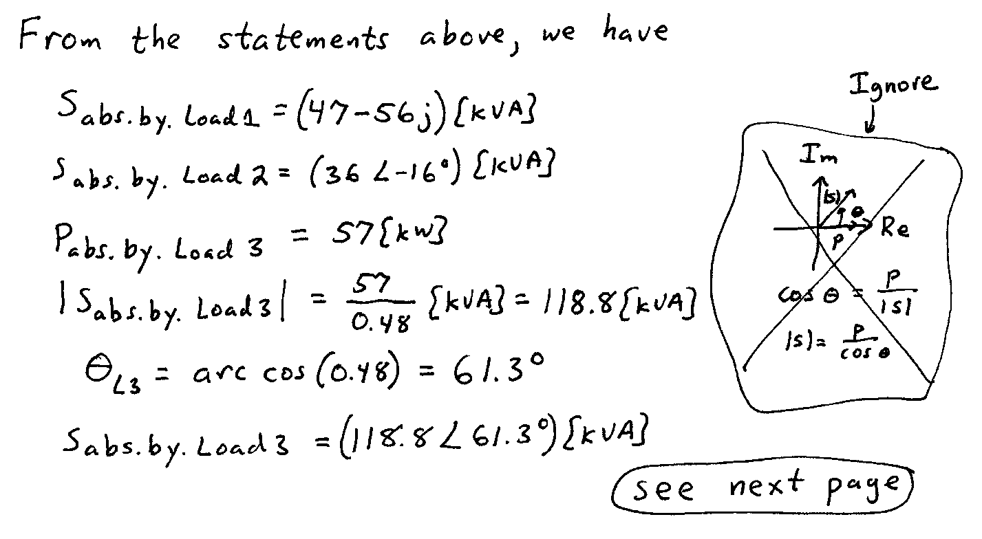

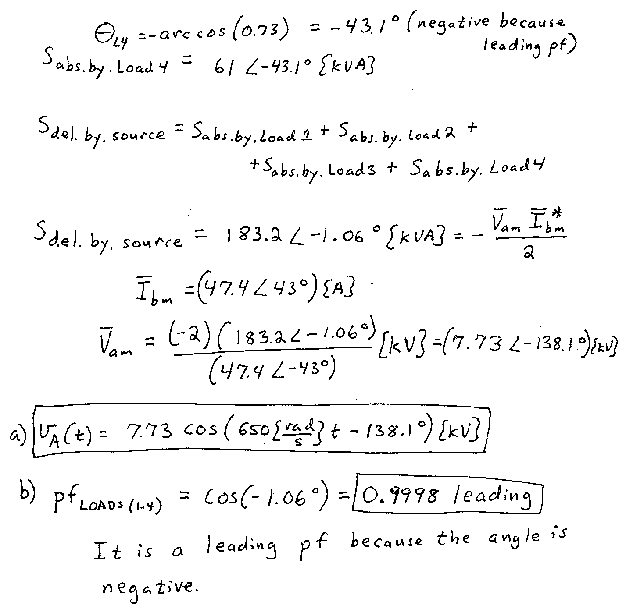

The circuit given below operates in steady-state.

Load 1 absorbs 47[kW] and delivers 56[kVAR].

Load 2 absorbs (3616°)[kVA].

Load 3 absorbs 57[kW] at a leading power factor of 0.48.

Load 4 absorbs 161[kVA] at a lagging power factor of 0.73.

1. Find the steady-state value for *vA(t).*
2. Find the power factor for the entire equivalent load, as seen by the current source.





