Name: _____________________________ (please print)
Signature: __________________________

ECE 2202 – Exam 1
October 5, 2019
Keep this exam closed until you are told to begin.

1. This exam is closed book, closed notes. You may use one 8.5” x 11” crib sheet, or its equivalent.
2. Show all work on these pages. Show all work necessary to complete the problem. A solution without the appropriate work shown will receive no credit. A solution that is not given in a reasonable order will lose credit. Clearly indicate your answer (for example by enclosing it in a box).
3. It is assumed that your work will begin on the same page as the problem statement. If you choose to begin your work on another page, you must indicate this on the page with the problem statement, with a clear indication of where the work can be found. If your work continues on to another page, indicate clearly where your work can be found. Failure to indicate this clearly will result in a loss of credit.
4. Show all units in solutions, intermediate results, and figures. Units in the exam will be included between square brackets.
5. Do not use red ink. Do not use red pencil.
6. You will have 90 minutes to work on this exam.

1. ________________/30
2. ________________/30
3. ________________/40
Total = 100
Room for extra work
1. {30 Points} Use the circuit shown below to solve.
The power absorbed by R_{L} is the largest possible, when R_{L} is 4.35[kΩ]. Find the value of X that makes this statement valid.

Room for extra work

Room for extra work

2. {30 Points} A device, shown in Figure 1, can be modeled as a Thevenin equivalent. This device acts as shown in the plot in Figure 2. The device is connected in the circuit shown in Figure 3. Note the location of terminals A and B. Find the power delivered by the 1.3[mA] current source in Figure 3.

Room for extra work

3. {40 Points} The circuit shown had switch SWA closed and switch SWB open for a long time before t = 0. Then, at t = 0, switch SWA opened and switch SWB closed.
- Find i_{A}(0⁻).
- Find i_{A}(0⁺).
- Find v_{Q}(0⁺).
- Find the energy stored in the inductor L_{A} at t = 6.5[μs].

Room for extra work

1. {30 Points} Use the circuit shown below to solve.
The power absorbed by R_{L} is the largest possible, when R_{L} is 4.35[kΩ]. Find the value of X that makes this statement valid.
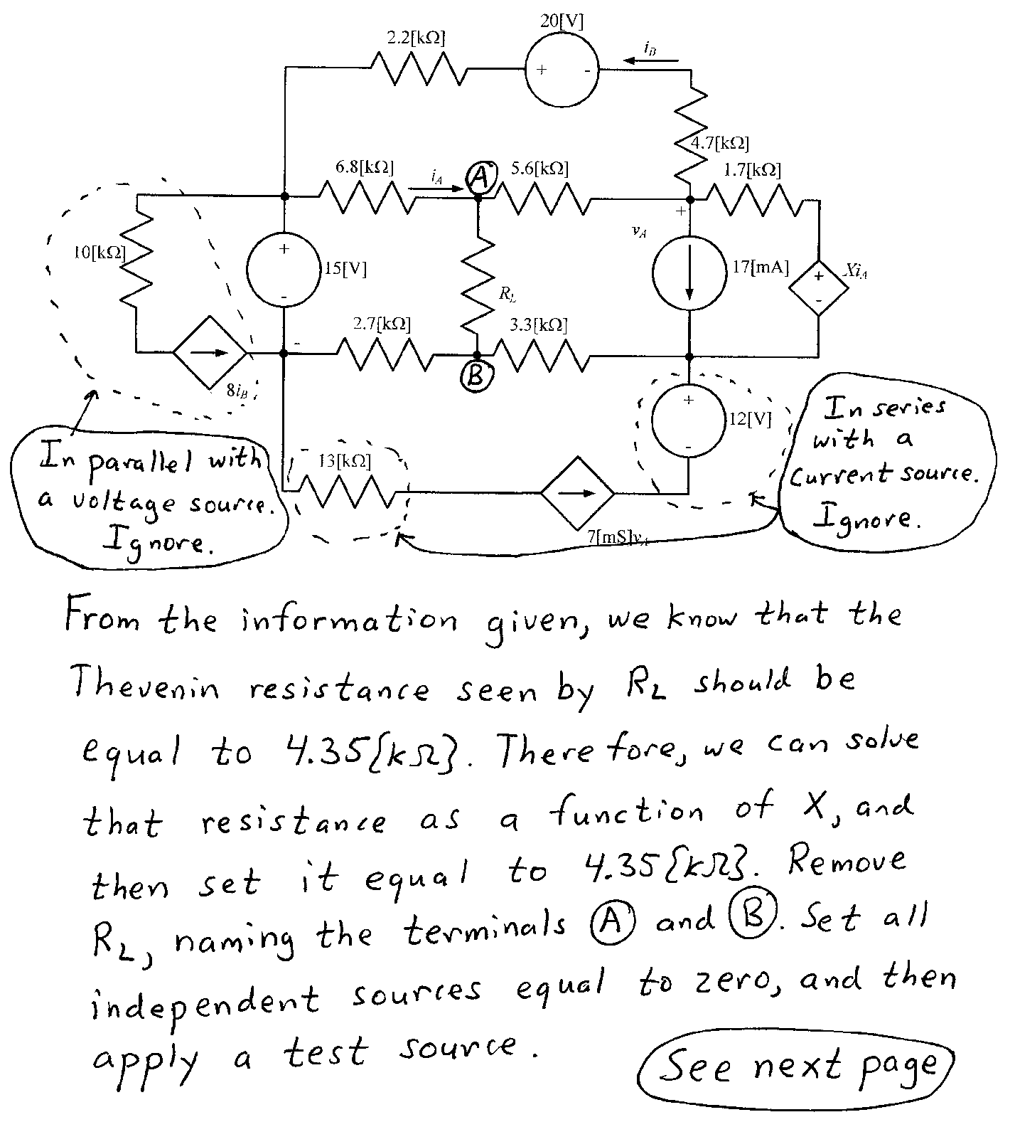
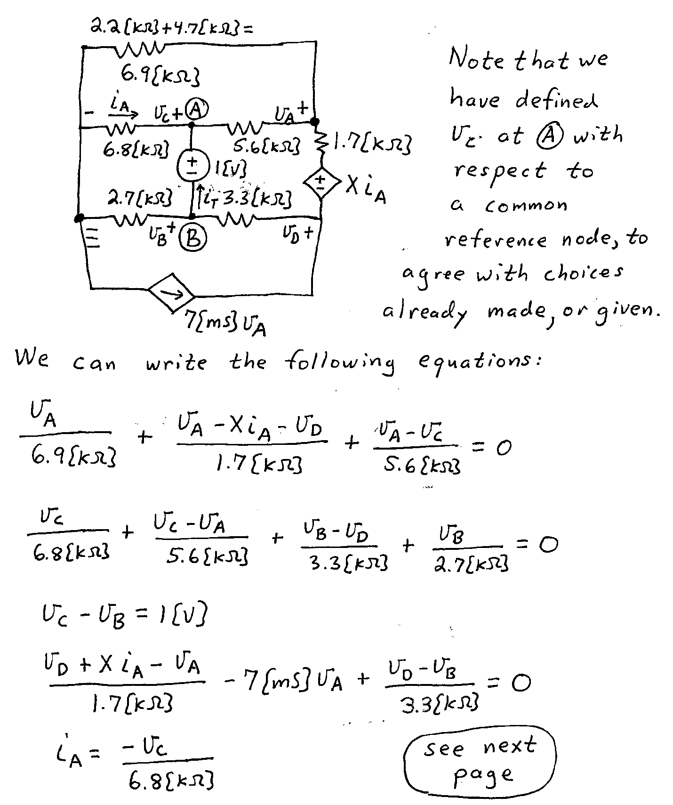
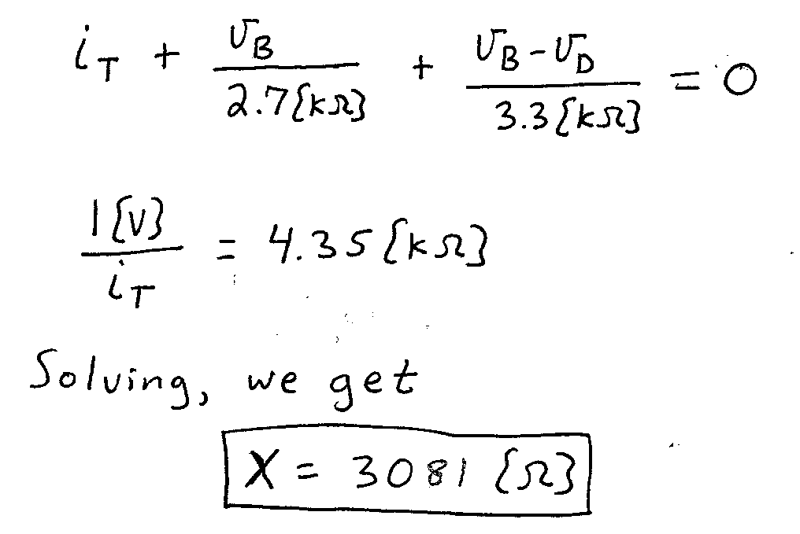

2. {30 Points} A device, shown in Figure 1, can be modeled as a Thevenin equivalent. This device acts as shown in the plot in Figure 2. The device is connected in the circuit shown in Figure 3. Note the location of terminals A and B. Find the power delivered by the 1.3[mA] current source in Figure 3.

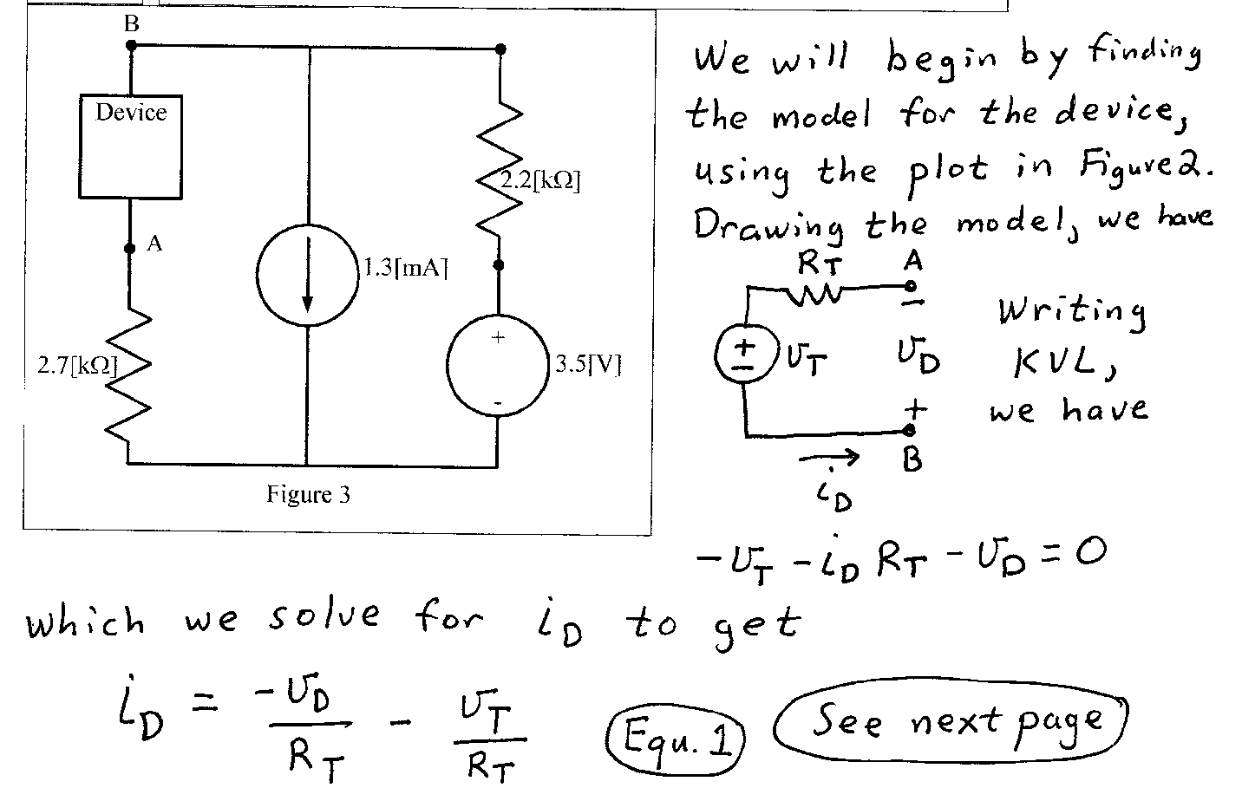
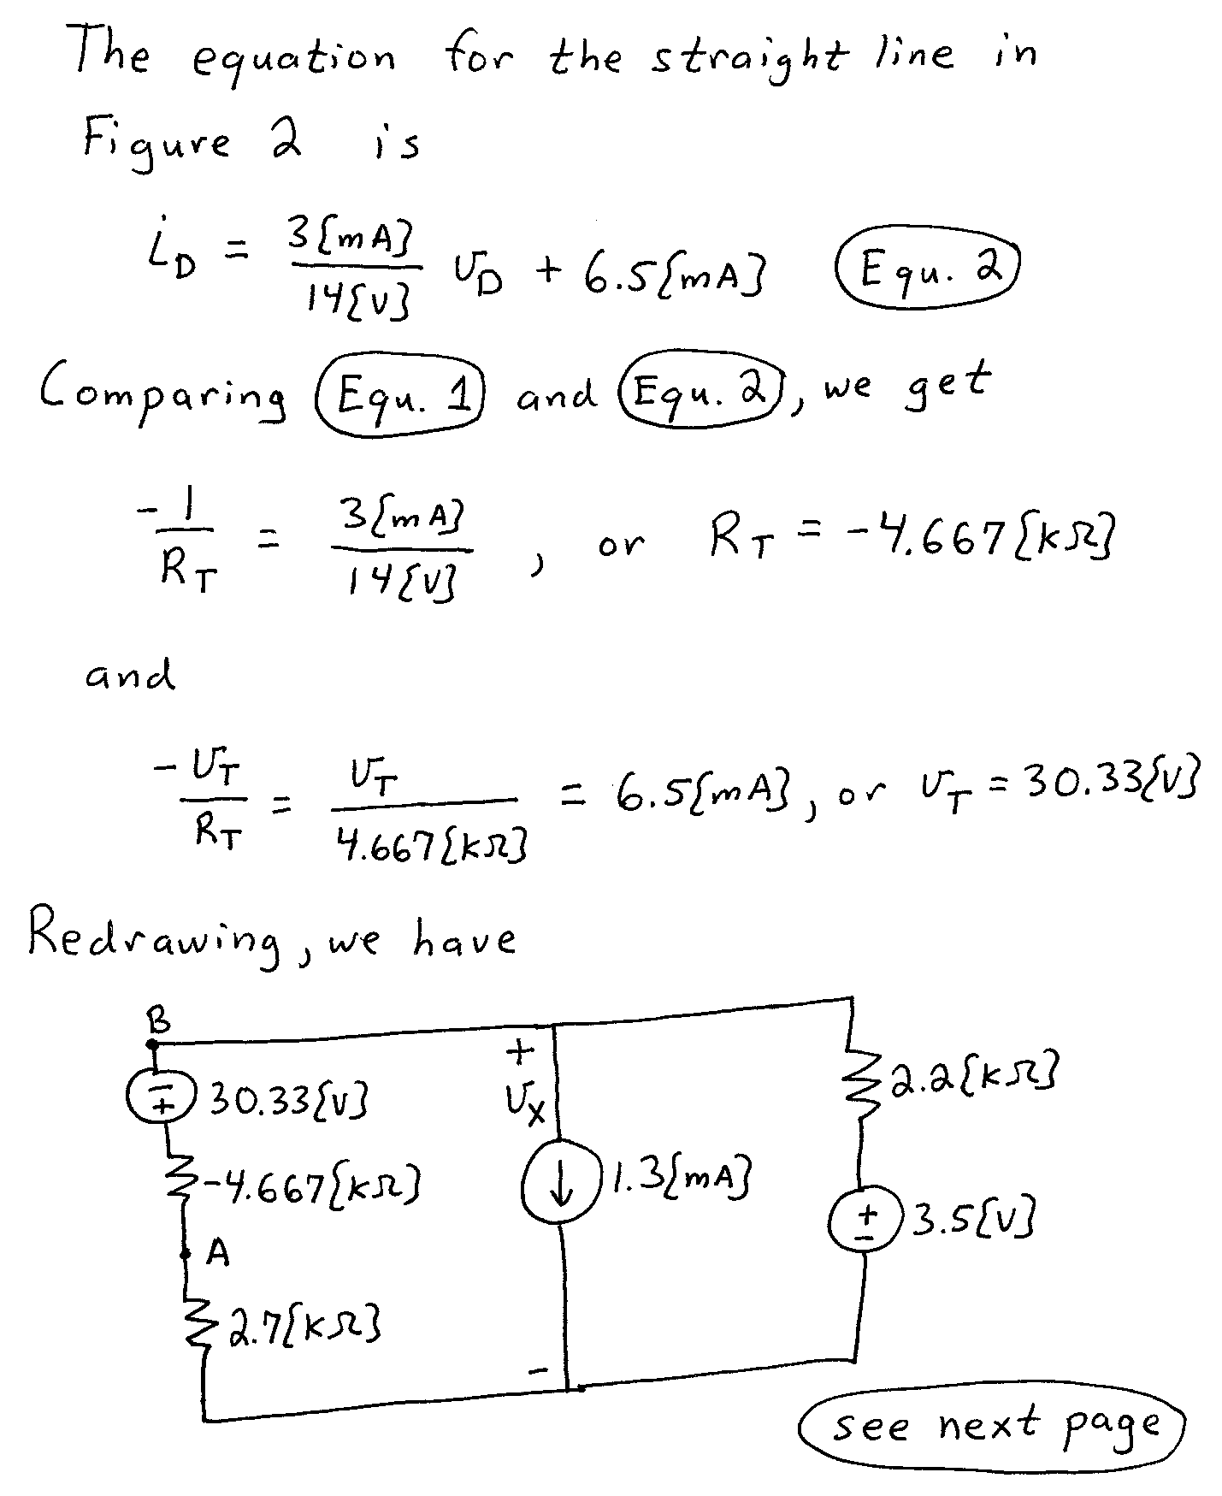
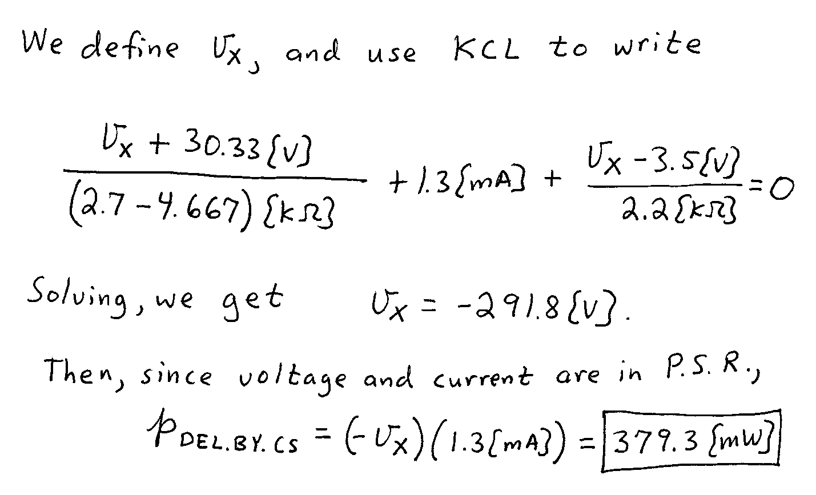

3. {40 Points} The circuit shown had switch SWA closed and switch SWB open for a long time before t = 0. Then, at t = 0, switch SWA opened and switch SWB closed.
- Find i_{A}(0⁻).
- Find i_{A}(0⁺).
- Find v_{Q}(0⁺).
- Find the energy stored in the inductor L_{A} at t = 6.5[μs].
