Name: _____________________________ (please print)
Signature: __________________________

ECE 2202 – Exam 2
November 2, 2019
Keep this exam closed until you are told to begin.

1. This exam is closed book, closed notes. You may use one 8.5” x 11” crib sheet, or its equivalent.
2. Show all work on these pages. Show all work necessary to complete the problem. A solution without the appropriate work shown will receive no credit. A solution that is not given in a reasonable order will lose credit. Clearly indicate your answer (for example by enclosing it in a box).
3. It is assumed that your work will begin on the same page as the problem statement. If you choose to begin your work on another page, you must indicate this on the page with the problem statement, with a clear indication of where the work can be found. If your work continues on to another page, indicate clearly where your work can be found. Failure to indicate this clearly will result in a loss of credit.
4. Show all units in solutions, intermediate results, and figures. Units in the exam will be included between square brackets.
5. Do not use red ink. Do not use red pencil.
6. You will have 90 minutes to work on this exam.

1. ________________/30
2. ________________/35
3. ________________/35
Total = 100
Room for extra work
1. {30 Points} Use the circuit shown below to solve. The switch SWA was closed for a long time, and switch SWB was open for a long time, before t = 0. At t = 0, switch SWA opened. Then, at t = 2[ms], switch SWB closed. Find the energy stored in inductor L_{X} at t = 4[ms].

Room for extra work

2. {35 Points} The switch was in position a for a long time, before it moved to position b at t = 0. Find the value of C_{X} that will give a current i_{X} equal
to -3.75[mA] at t = 100[ms].

Room for extra work

3. {35 Points} The circuit shown below is in steady state. The sources are given as
- Redraw this circuit in the phasor domain. Do not simplify the circuit in this step.
- Find the numerical expression for v_{E}(t), expressed as a function of time, t.

Room for extra work

1. {30 Points} Use the circuit shown below to solve. The switch SWA was closed for a long time, and switch SWB was open for a long time, before t = 0. At t = 0, switch SWA opened. Then, at t = 2[ms], switch SWB closed. Find the energy stored in inductor L_{X} at t = 4[ms].
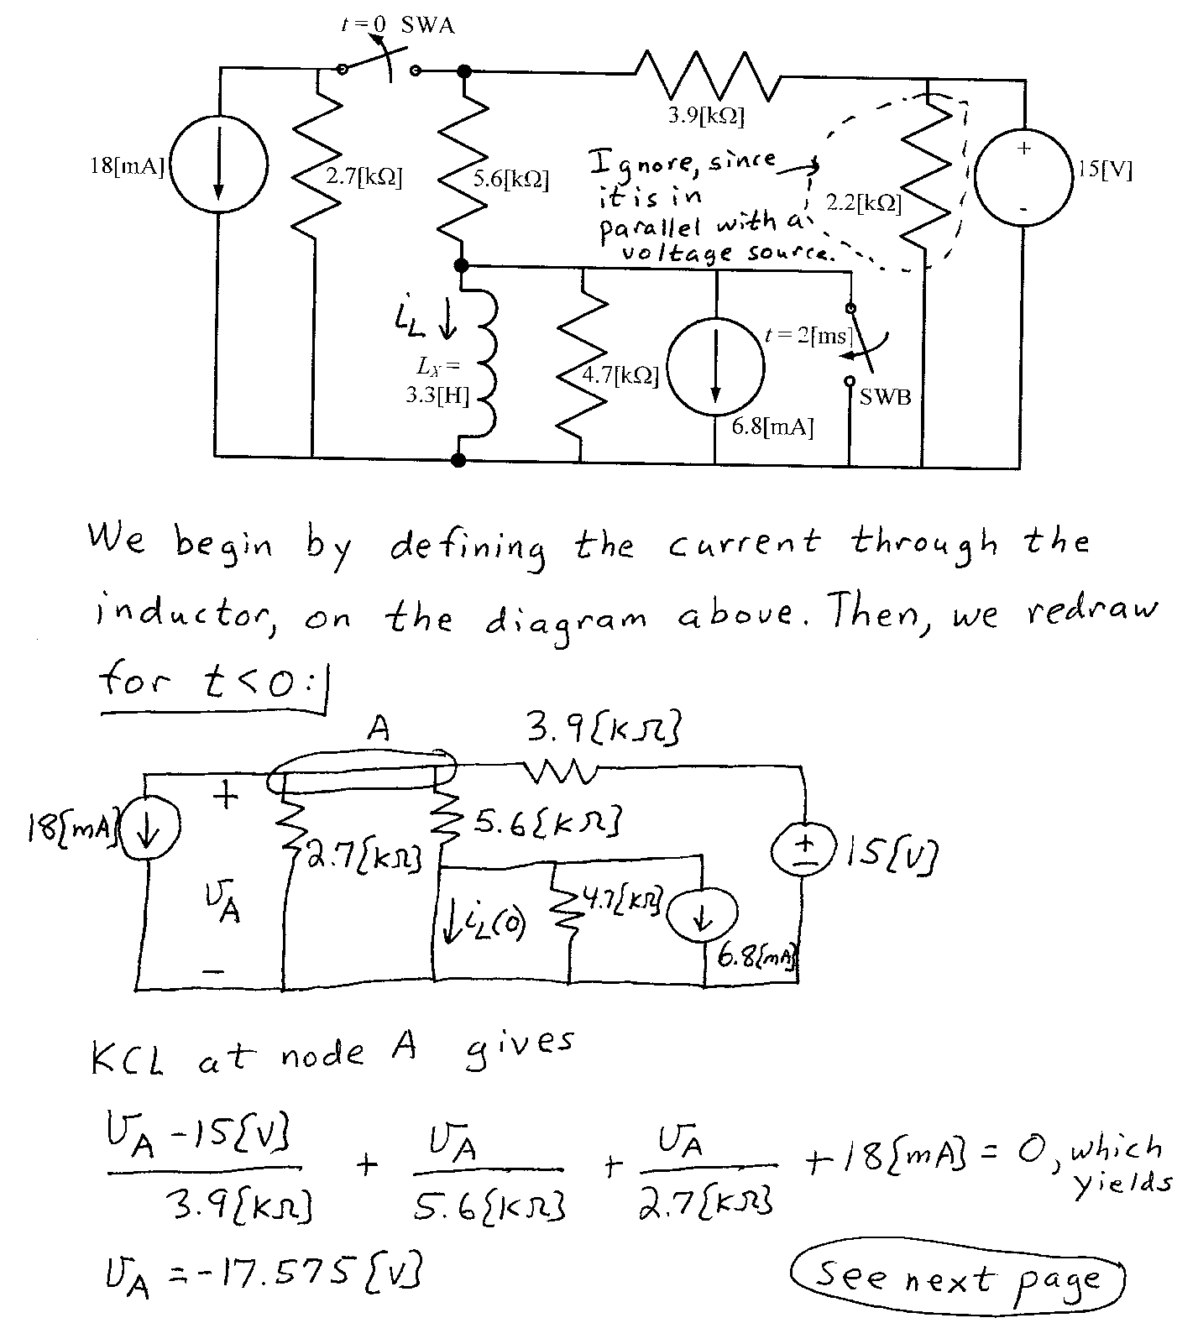
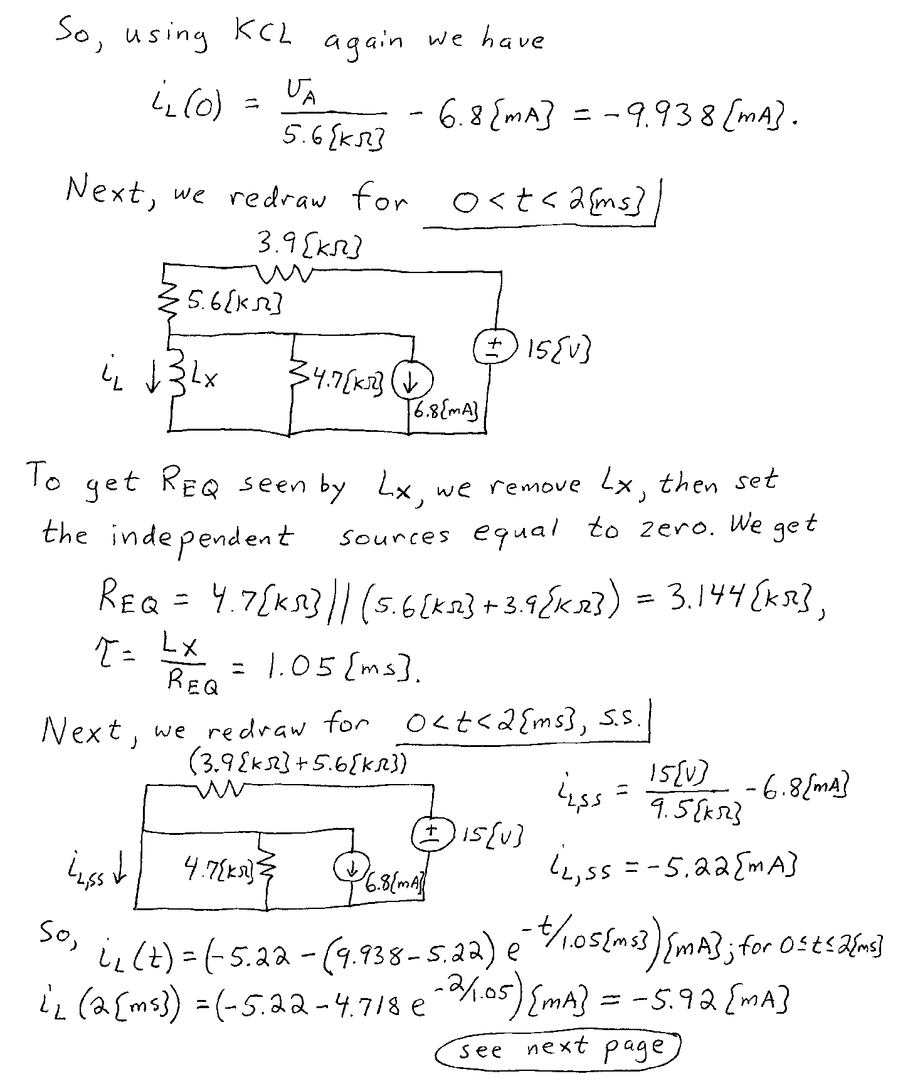
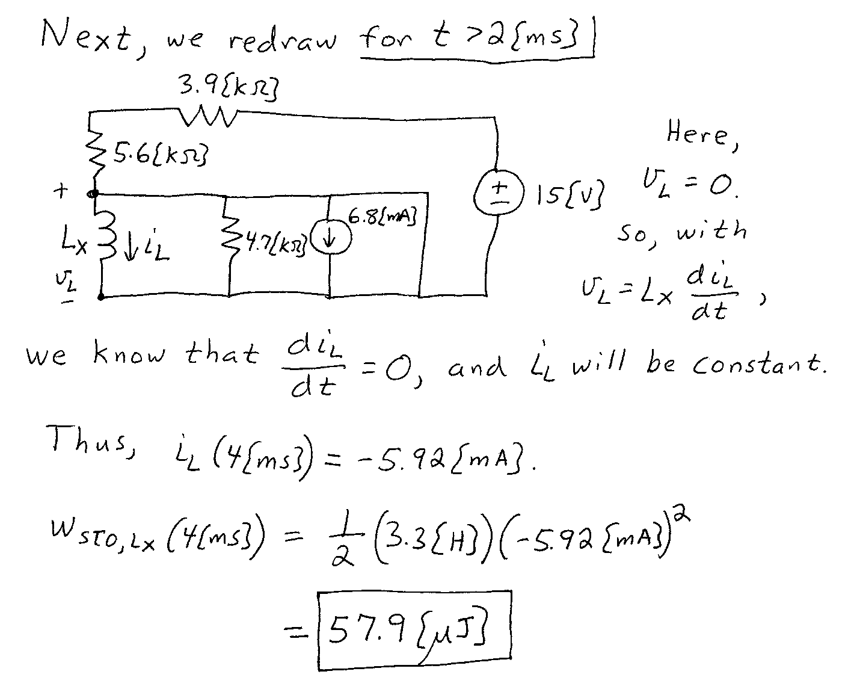
2. {35 Points} The switch was in position a for a long time, before it moved to position b at t = 0. Find the value of C_{X} that will give a current i_{X} equal
to -3.75[mA] at t = 100[ms].
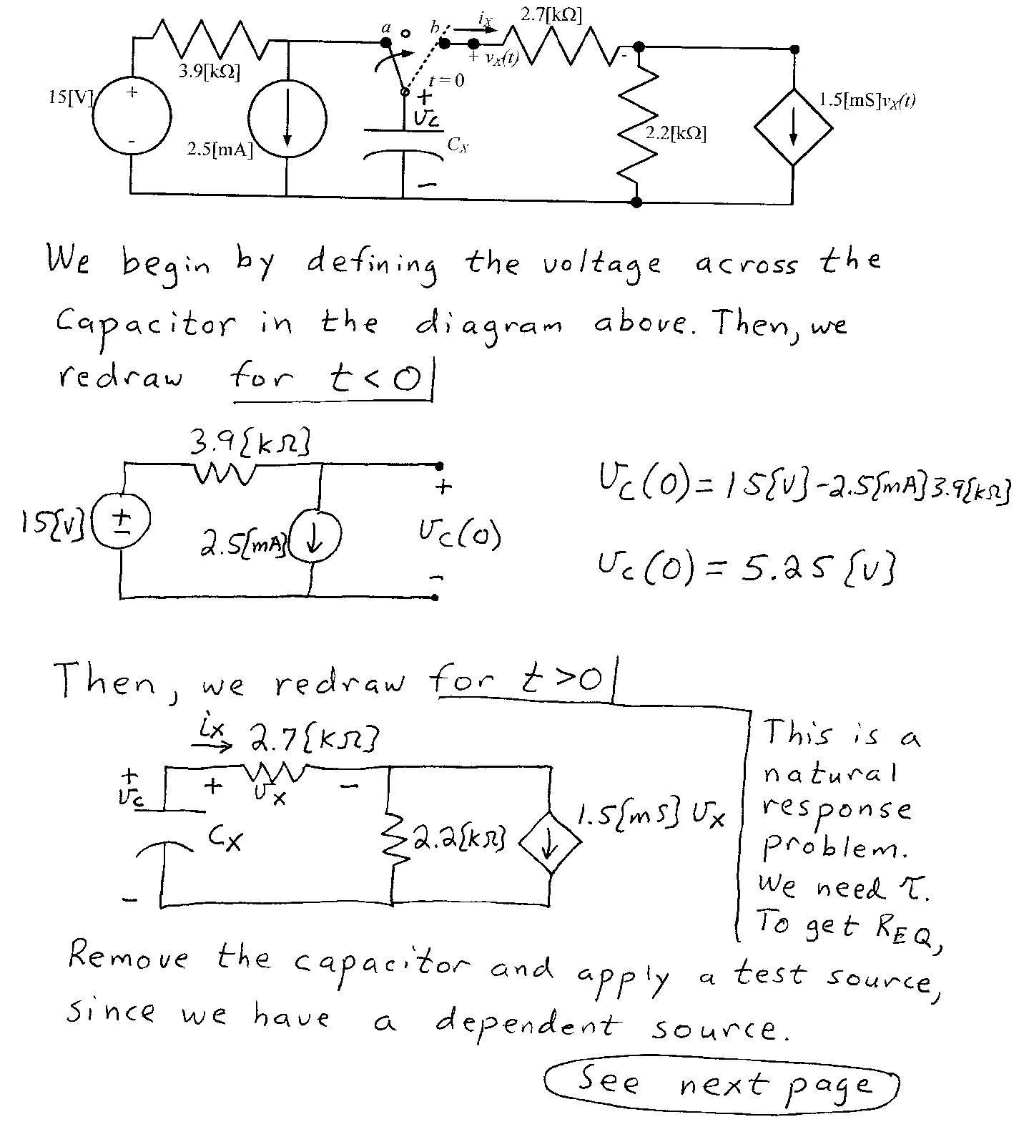
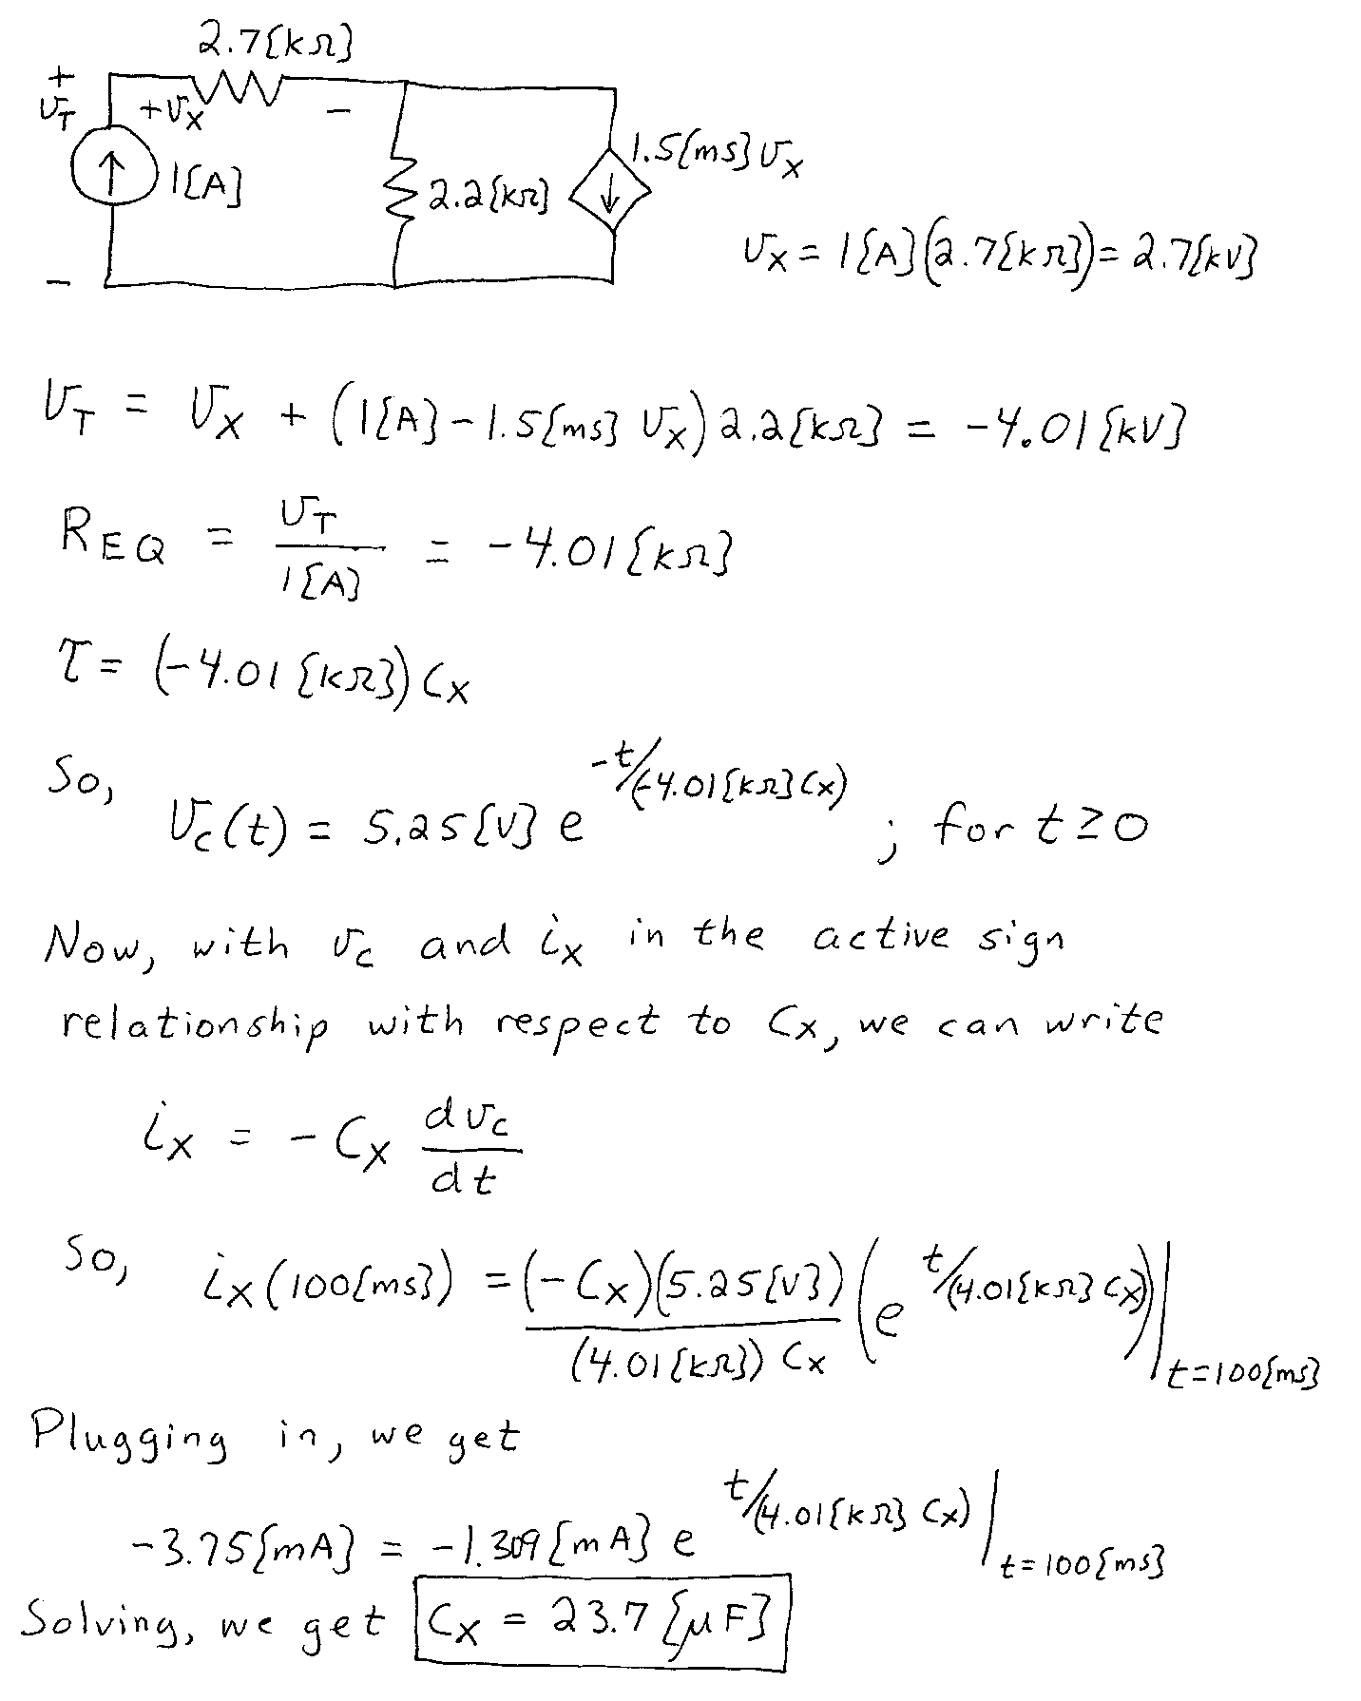
3. {35 Points} The circuit shown below is in steady state. The sources are given as
- Redraw this circuit in the phasor domain. Do not simplify the circuit in this step.
- Find the numerical expression for v_{E}(t), expressed as a function of time, t.

