Name: _____________________________ (please print)

Signature: __________________________

ECE 2202 – Final Exam

December 4, 2019

**Keep this exam closed until you are told to begin.**

1. This exam is closed book, closed notes. You may use one 8.5” x 11” crib sheet, or its equivalent.

2. Show all work on these pages. Show all work necessary to complete the problem. A solution without the appropriate work shown will receive no credit. A solution that is not given in a reasonable order will lose credit. Clearly indicate your answer (for example by enclosing it in a box).

3. It is assumed that your work will begin on the same page as the problem statement. If you choose to begin your work on another page, you must indicate this on the page with the problem statement, with a clear indication of where the work can be found. **If your work continues on to another page, indicate clearly where your work can be found. Failure to indicate this clearly will result in a loss of credit.**

4. Show all units in solutions, intermediate results, and figures. Units in the exam will be included between square brackets.

5. Do not use red ink. Do not use red pencil.

6. You will have 160 minutes to work on this exam.

1. ________________/30

2. ________________/30

3. ________________/30

4. ________________/30

5. ________________/40

6. ________________/40

Total = 200

Room for extra work

1. {30 Points} For the circuit below, find the Norton equivalent resistance as seen from terminals D and E.



# Room for extra work

2. {30 Points} The Device in the circuit shown in Figure 1 can be modeled with a Thevenin equivalent. The behavior of that Device is represented by the line in the plot in Figure 2, and should be considered to be valid for values of current and voltage outside the range that is plotted. The switch in Figure 1 was closed for a long time before it opened at *t* = 0.   
Find the energy stored in the inductor at *t* = 10[s].





# Room for extra work

3. {30 Points} The switch had been closed for a long time before *t* = 0, and then opened at *t* = 0. At *t* = 0-, *vX*(0-) = 13[V]. The current source is given by



Find the energy stored in capacitor *CA* at *t* =1.34[s].



Room for extra work

4. {30 Points} In the circuit shown below, the switch SWA was closed and switch SWB was open for a long time before *t* = 0. At *t* = 0, switch SWB closed. Then, 1[ms] later switch SWA opened. Finally, at *t* = 2[ms], switch SWB opened.   
Find *vX*(3[ms]).



Room for extra work

5. {40 Points} The circuit shown below operates in steady-state.

Find a numerical expression for *iE(t)*.





Room for extra work

Room for extra work

6. {40 Points} The circuit shown below operates in steady-state. We are given that



Load 1 absorbs 65[kVA] at a leading power factor of 0.92.

Load 2 absorbs (57 33[kVA].

Load 3 absorbs 33[kW] and delivers 27[kVAR].

Load 4 absorbs 92[kW] at a lagging power factor of 0.64.

1. Find *iB(t).*
2. Find *vE(t).*
3. Find the reactance of Load 1.
4. Find the susceptance of Load 1.



Solution:

1. {30 Points} For the circuit below, find the Norton equivalent resistance as seen from terminals D and E.

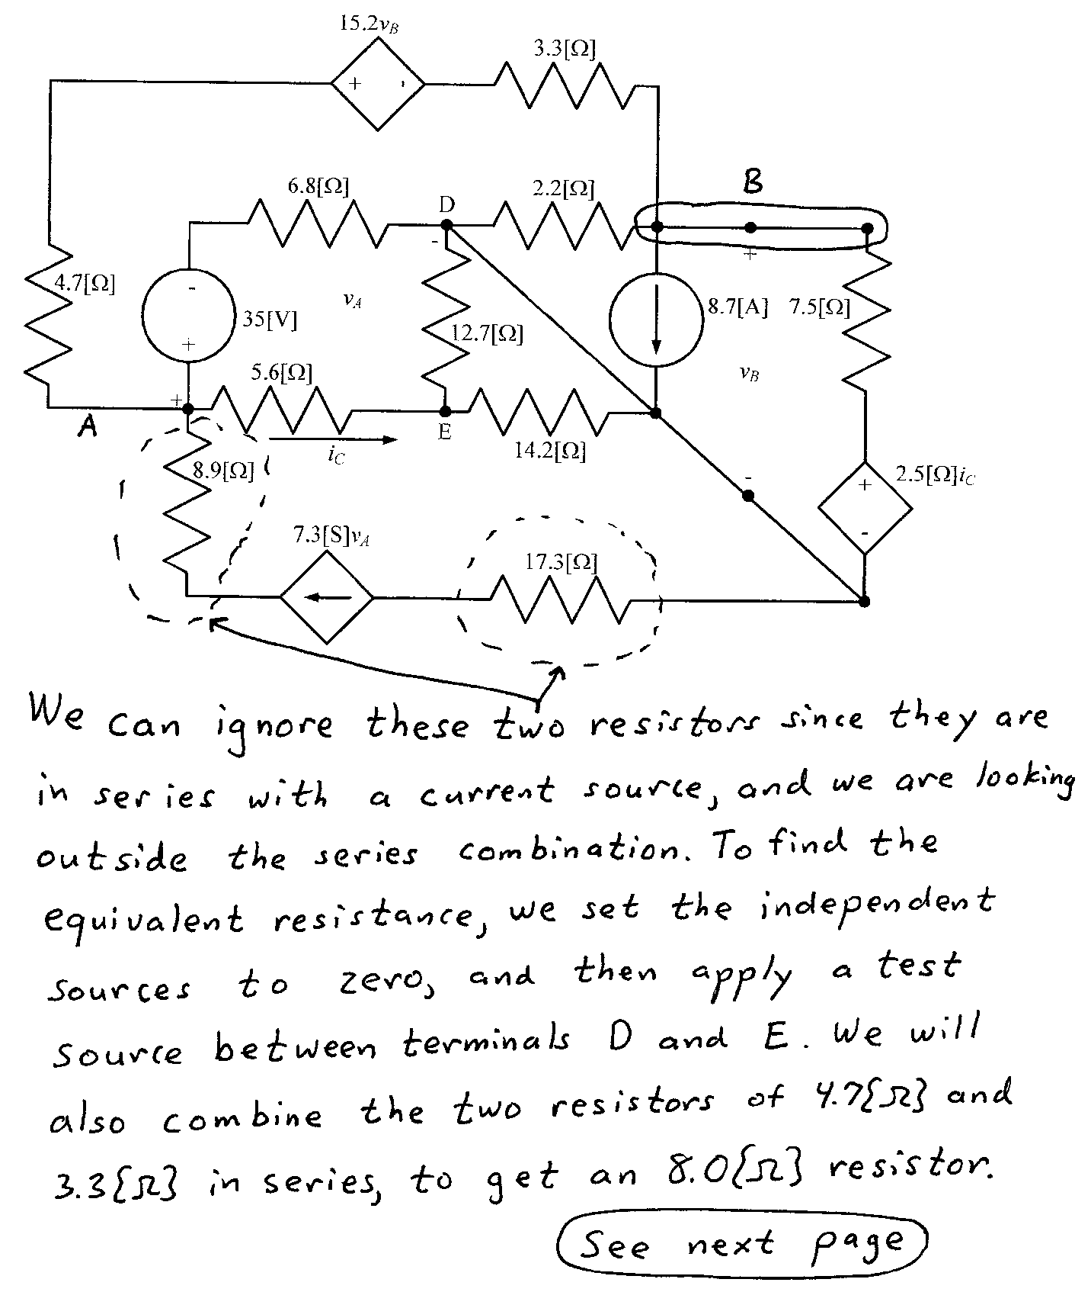

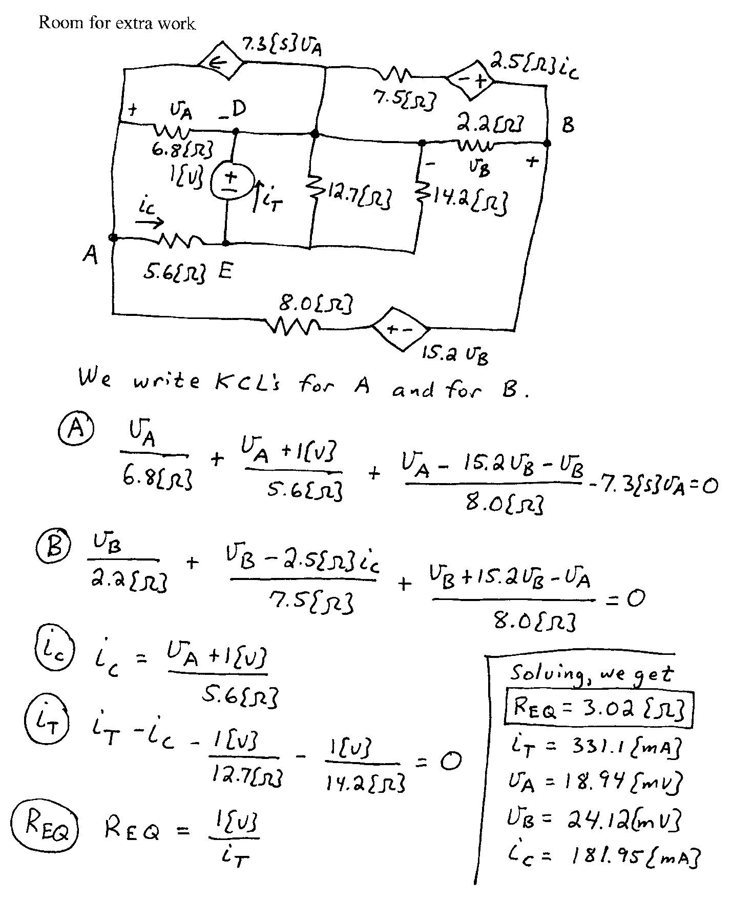

2. {30 Points} The Device in the circuit shown in Figure 1 can be modeled with a Thevenin equivalent. The behavior of that Device is represented by the line in the plot in Figure 2, and should be considered to be valid for values of current and voltage outside the range that is plotted. The switch in Figure 1 was closed for a long time before it opened at *t* = 0.   
Find the energy stored in the inductor at *t* = 10[s].

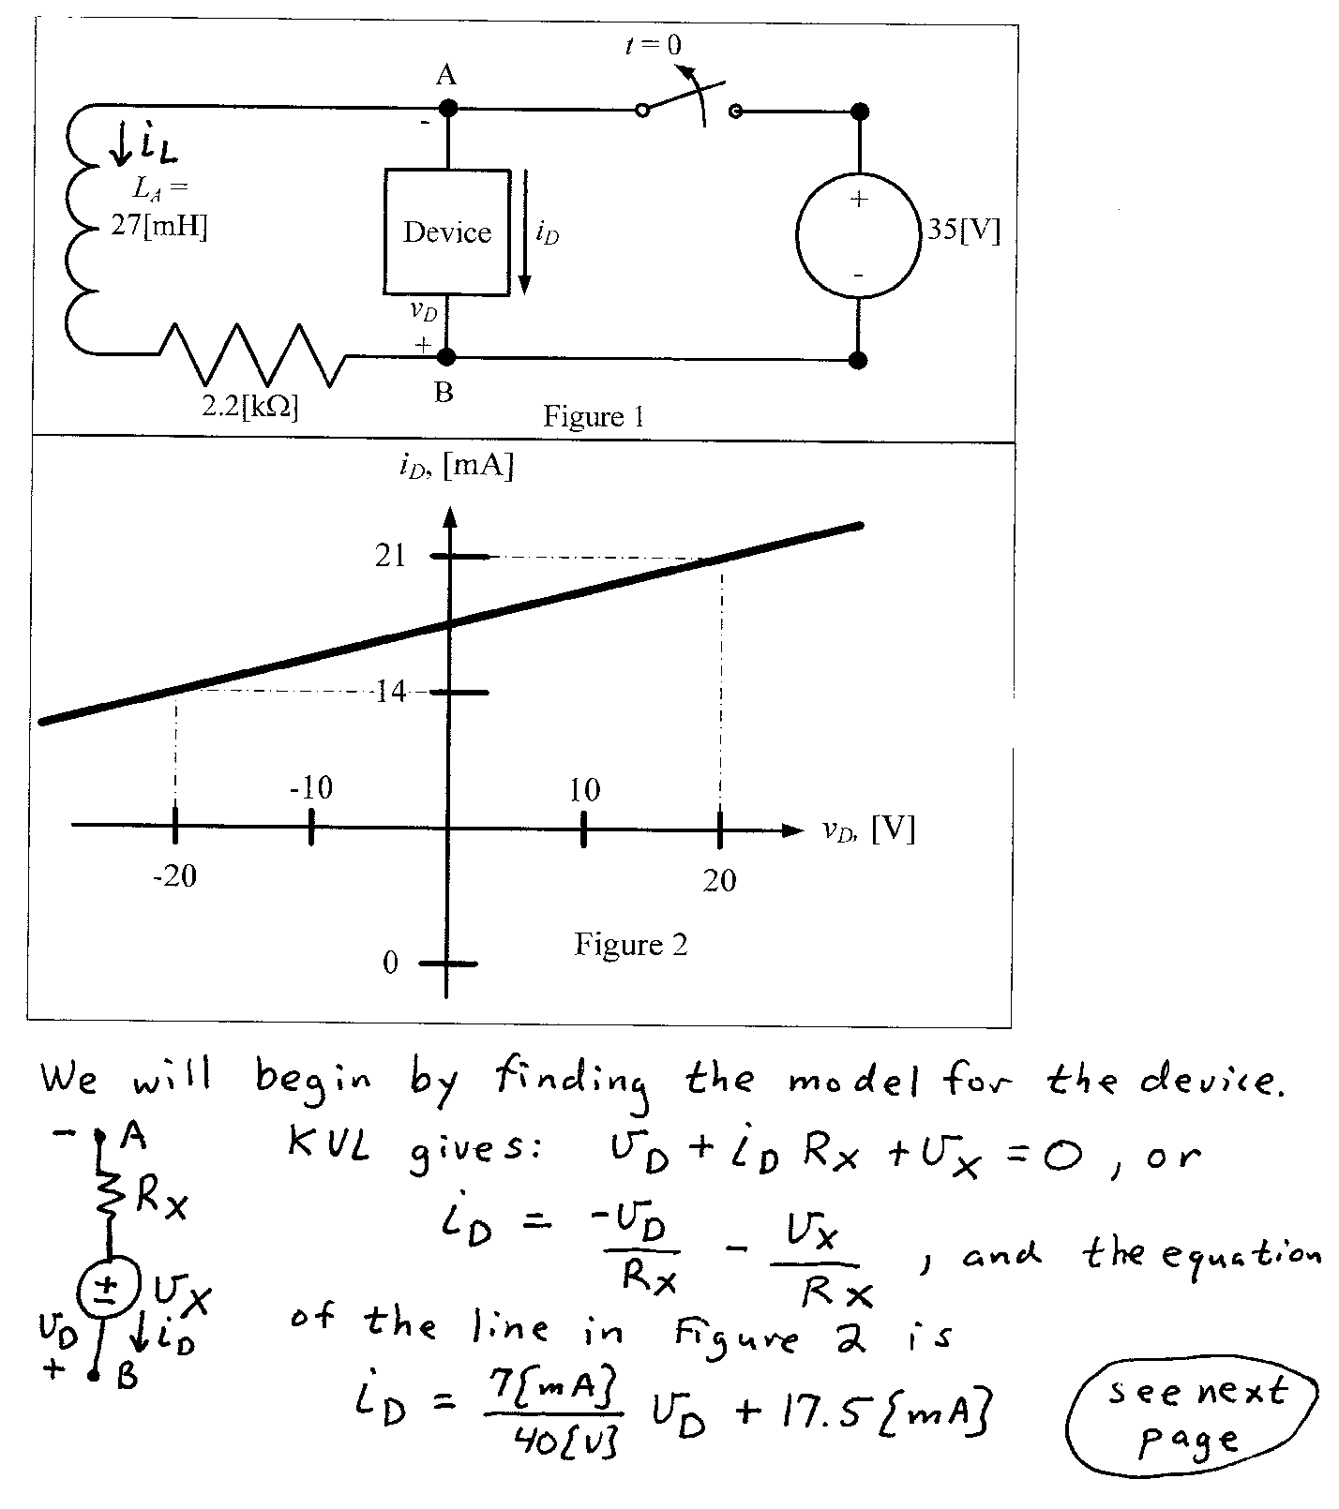

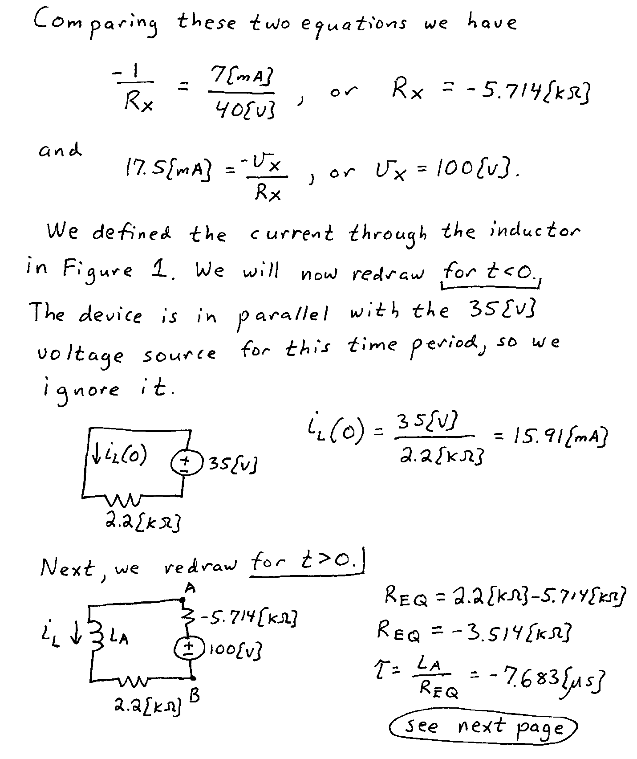

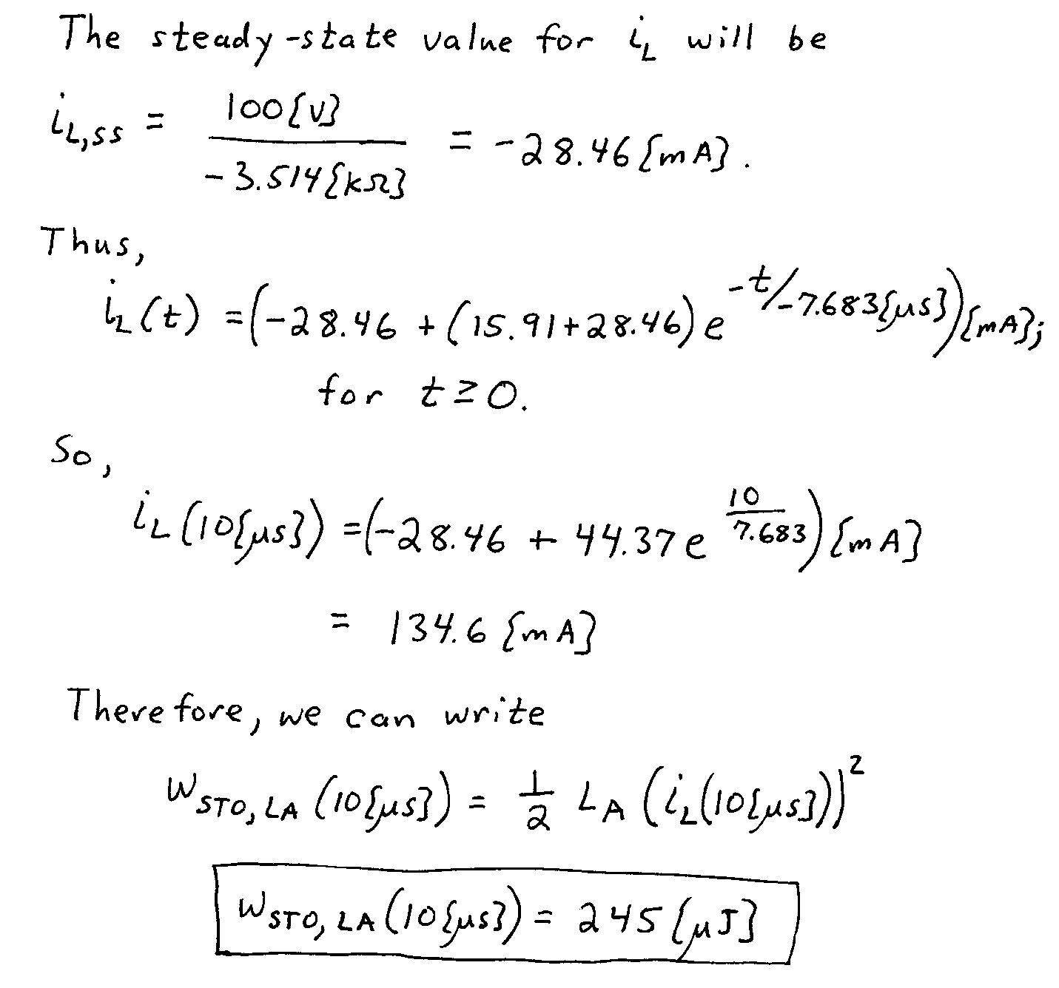

3. {30 Points} The switch had been closed for a long time before *t* = 0, and then opened at *t* = 0. At *t* = 0-, *vX*(0-) = 13[V]. The current source is given by



Find the energy stored in capacitor *CA* at *t* =1.34[s].

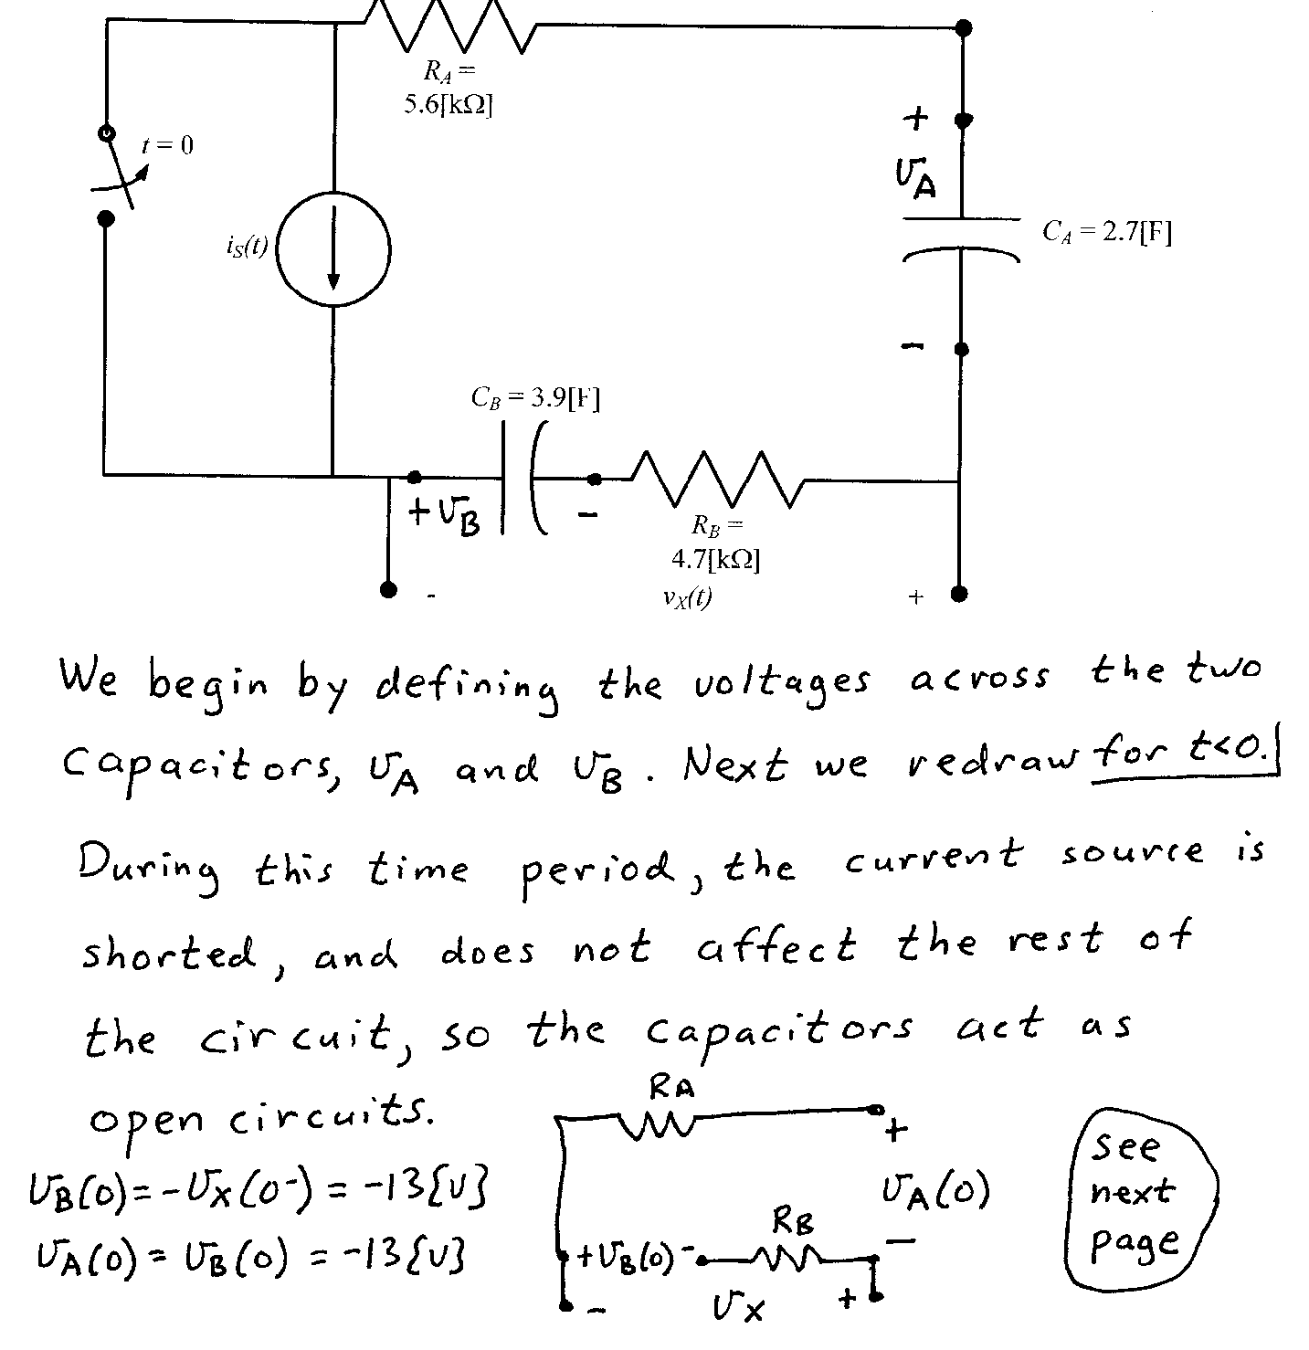

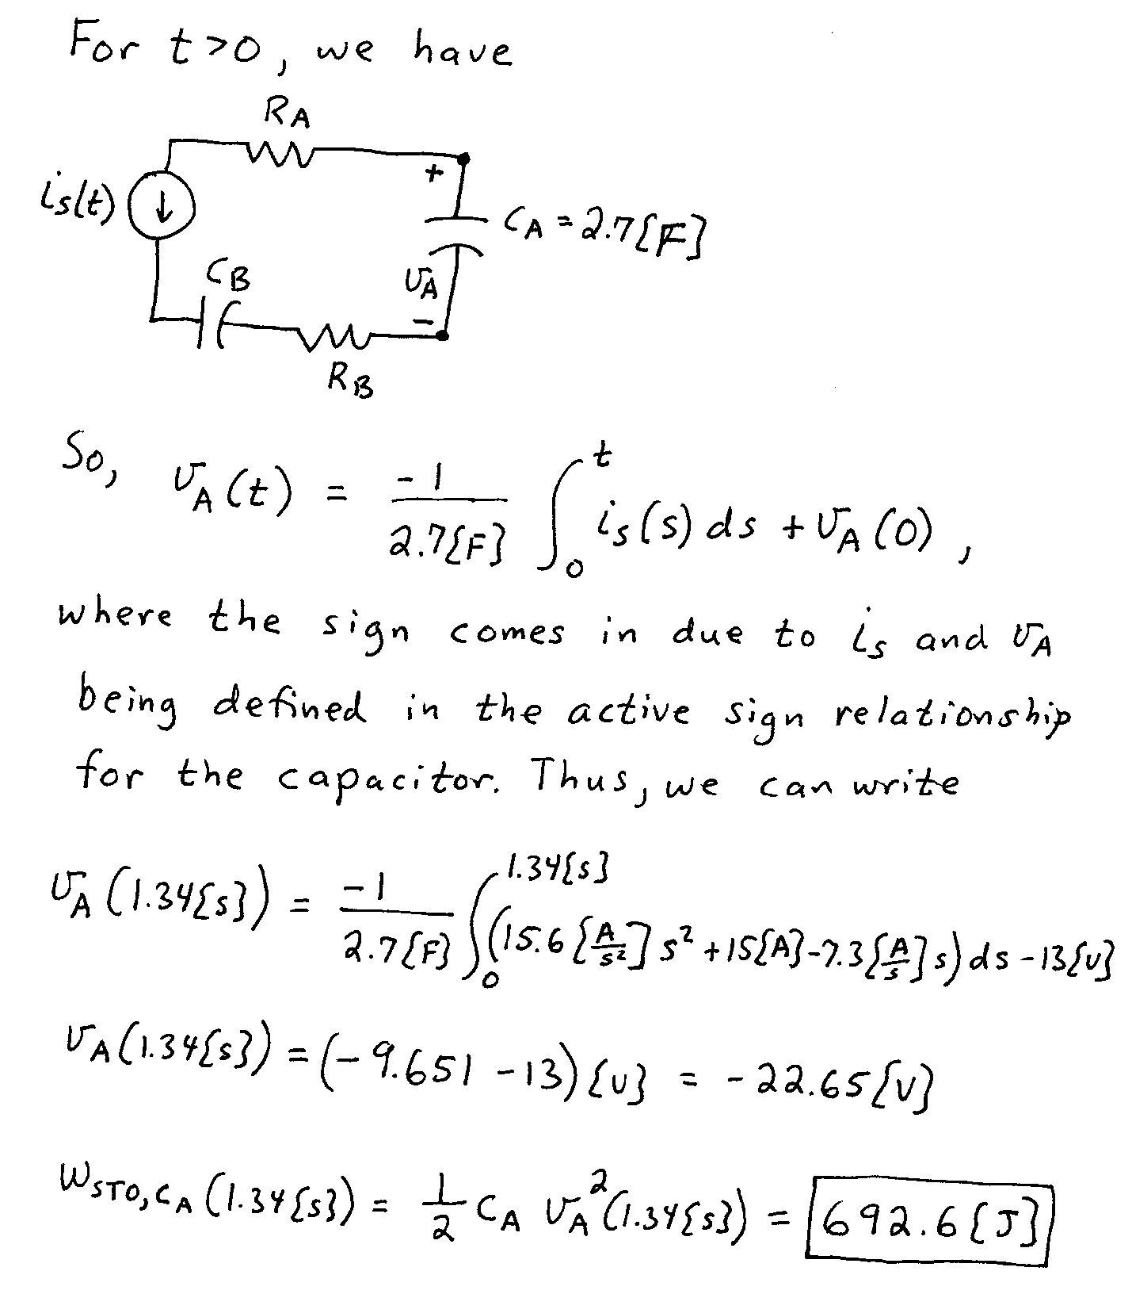

4. {30 Points} In the circuit shown below, the switch SWA was closed and switch SWB was open for a long time before *t* = 0. At *t* = 0, switch SWB closed. Then, 1[ms] later switch SWA opened. Finally, at *t* = 2[ms], switch SWB opened.   
Find *vX*(3[ms]).

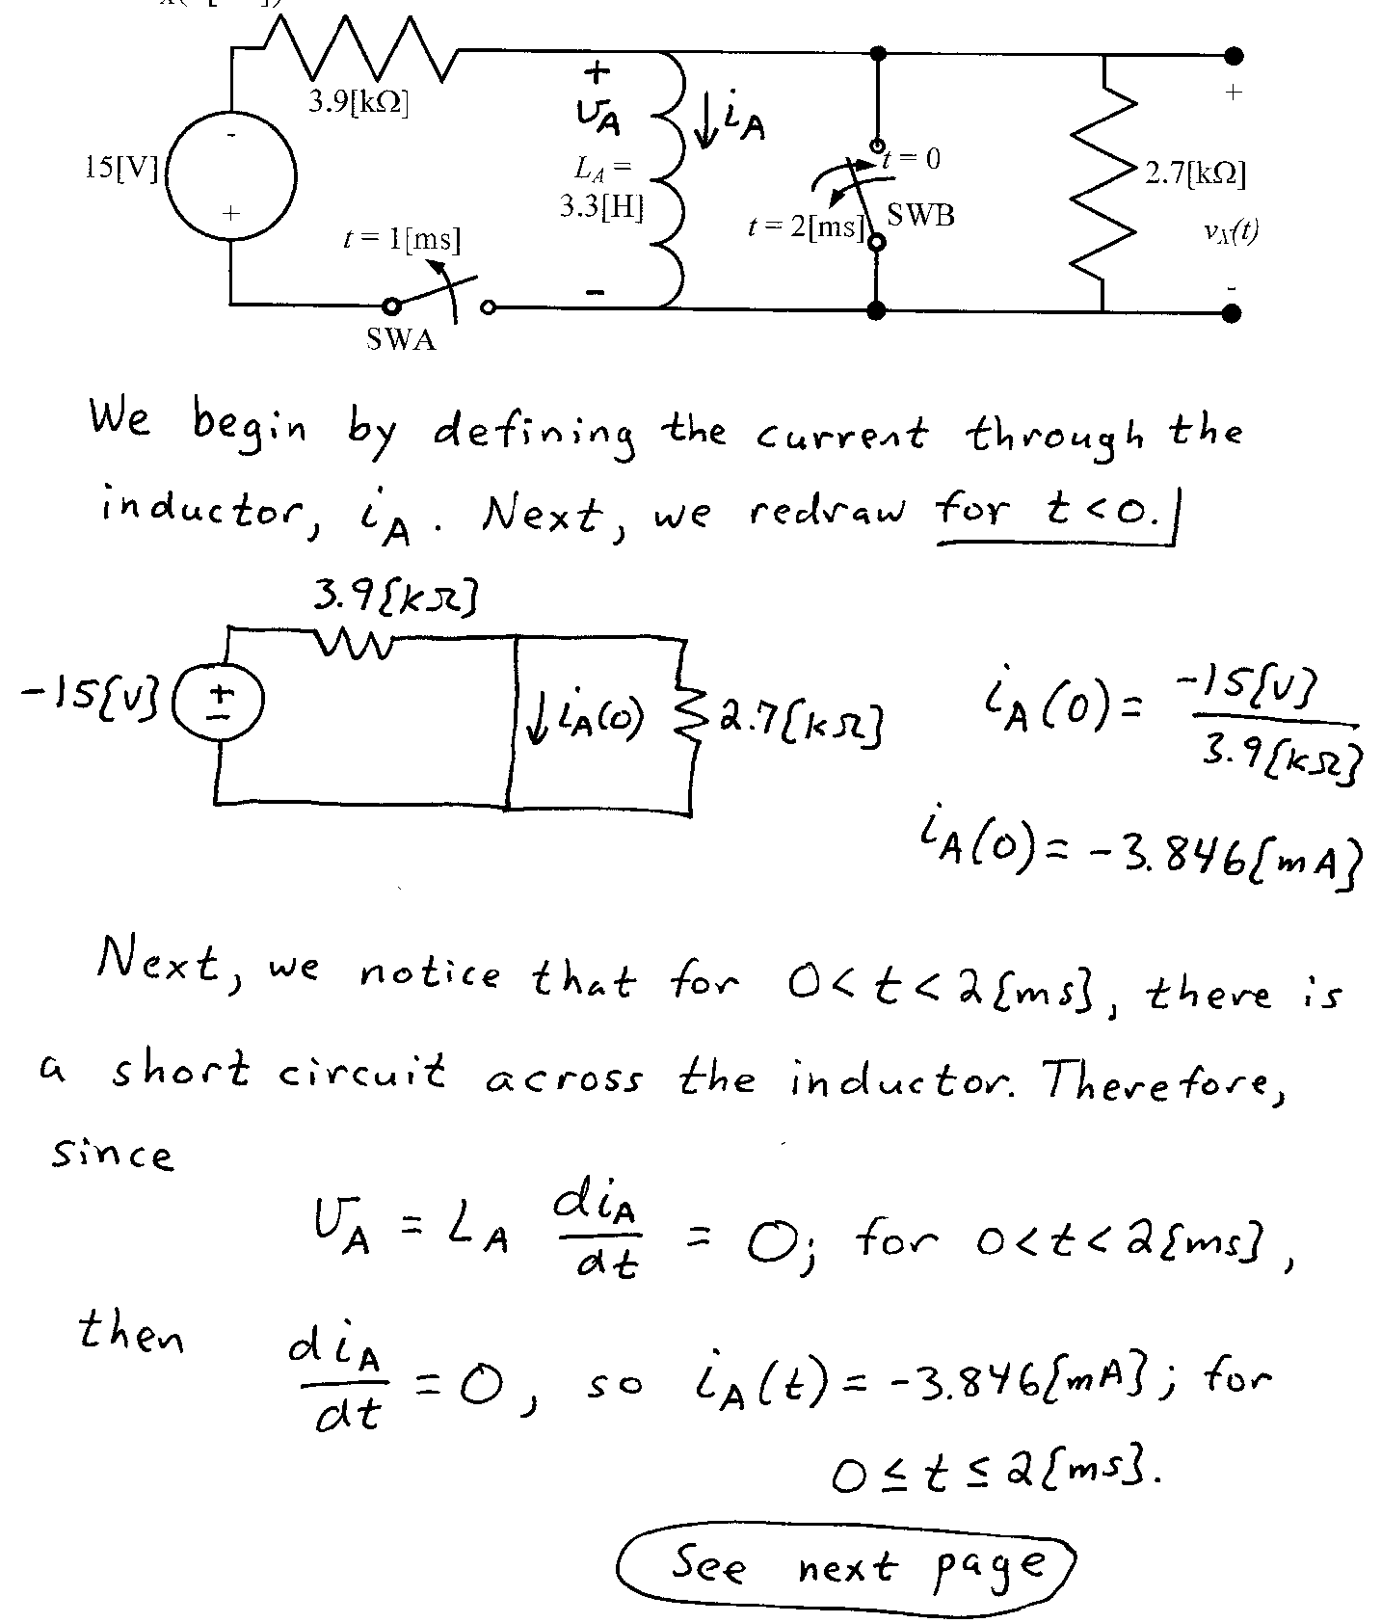

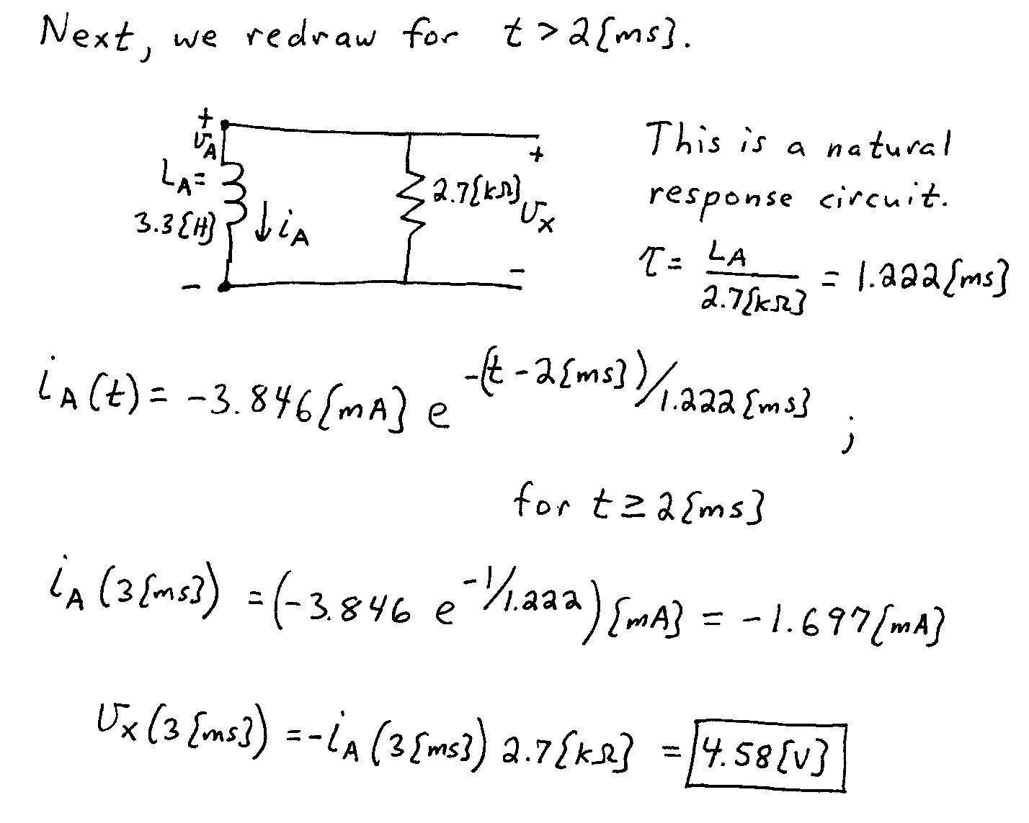

5. {40 Points} The circuit shown below operates in steady-state.

Find a numerical expression for *iE(t)*.



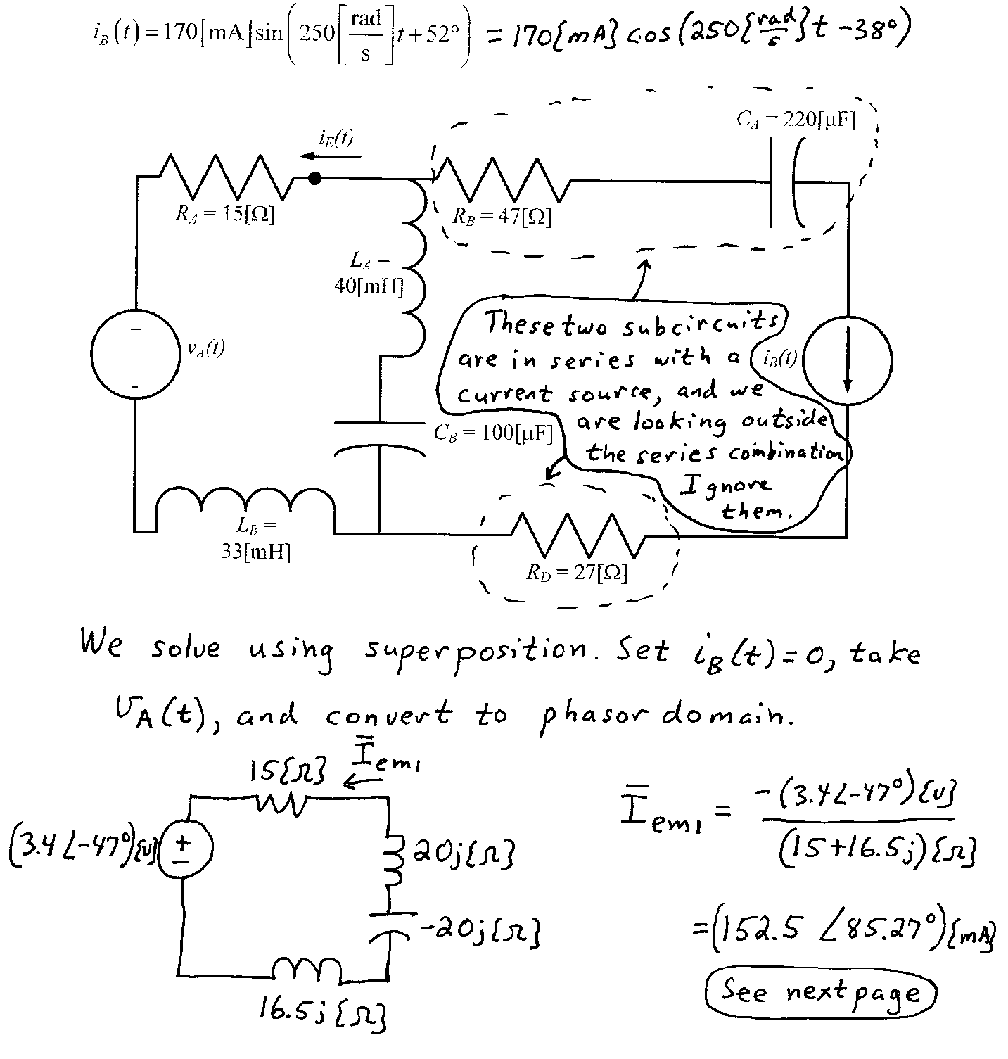

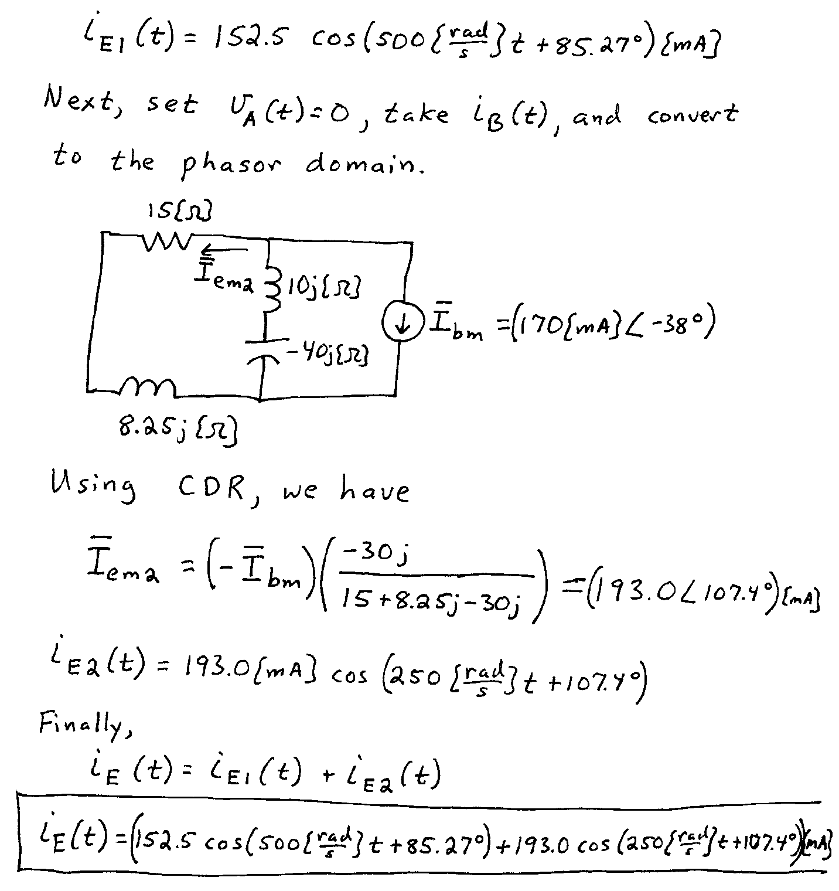

6. {40 Points} The circuit shown below operates in steady-state. We are given that



Load 1 absorbs 65[kVA] at a leading power factor of 0.92.

Load 2 absorbs (57 33[kVA].

Load 3 absorbs 33[kW] and delivers 27[kVAR].

Load 4 absorbs 92[kW] at a lagging power factor of 0.64.

1. Find *iB(t).*
2. Find *vE(t).*
3. Find the reactance of Load 1.
4. Find the susceptance of Load 1.



