Name: _____________________________ (please print)
Signature: __________________________

ECE 2300 -- Quiz #4A
8:30AM section – March 26, 2002

Keep this quiz closed and face up until you are told to begin.

1. This quiz is closed book, closed notes. You may use one 8.5” x 11” crib sheet, or its equivalent.
2. Show all work on these pages. Show all work necessary to complete the problem. If you go on to another page, indicate clearly where your work can be found. A solution without the appropriate work shown will receive no credit.
3. Show all units in solutions, intermediate results, and figures. Units in the quiz will be included between square brackets.
4. Do not use red ink. Do not use red pencil.
5. You will have 30 minutes to work on this quiz.

________________/20
Room for extra work
- Find the Thévenin equivalent as seen by resistor R₅.
- Find the power absorbed by resistor R₅.
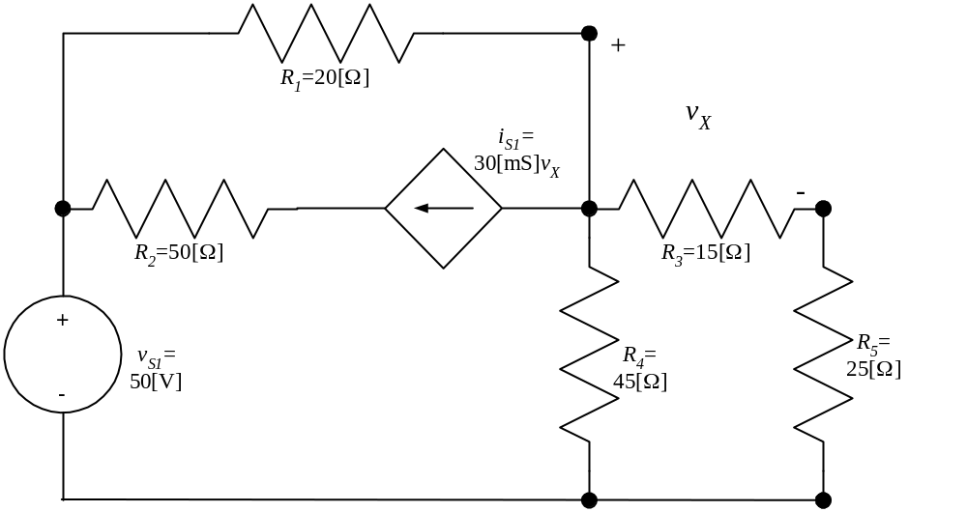

ECE 2300 -- Quiz #4 – 8:30AM section – March 26, 2002 – Solution
- Find the Thévenin equivalent as seen by resistor R₅.
- Find the power absorbed by resistor R₅.

a) The first step in this solution is to remove the R₅ resistor. We do that, and then we can solve for the open-circuit voltage, which we can define in the circuit that follows.
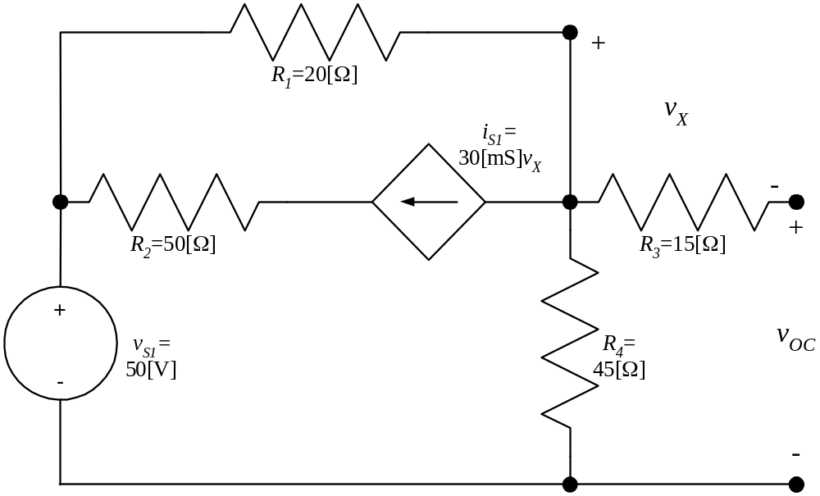
Now, note that in this circuit, the current through resistor R₃ is zero, and therefore the voltage across it, v_{X}, must also be zero. Thus, we can simplify the circuit as follows.
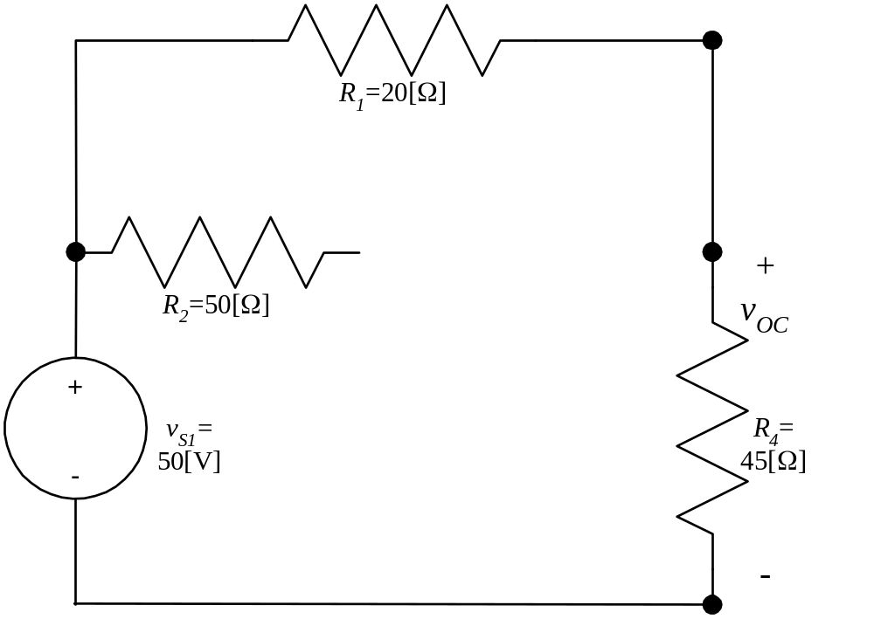
We can get the open-circuit voltage from the VDR, and obtain
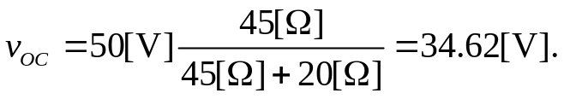
Next, we want to get the equivalent resistance. We go back to the original circuit, set the independent source equal to zero, and apply a test source. We choose a 1[A] current source, and get the circuit that follows.
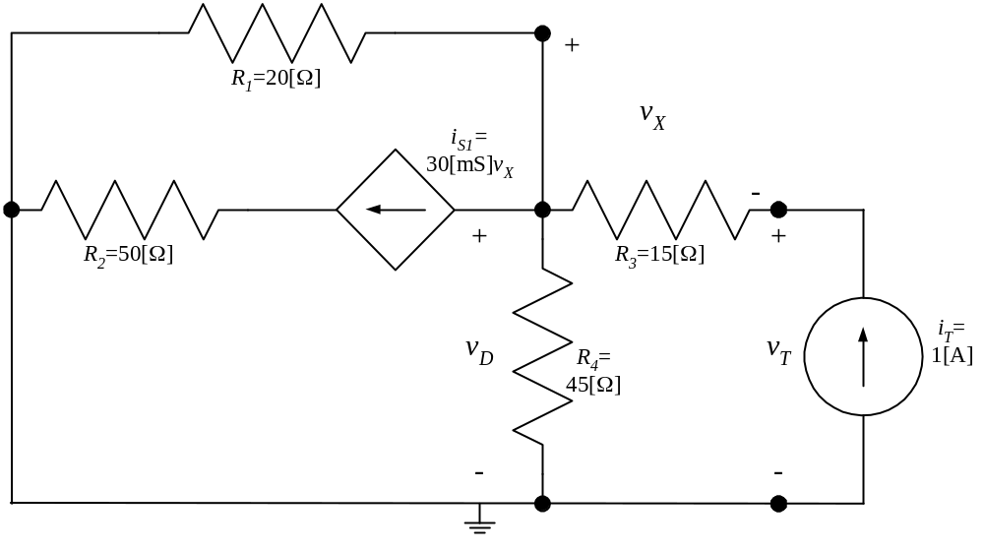
Here, we have v_{X} from Ohm’s Law as
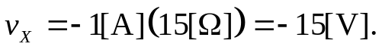
Using that, we can write the KCL using the voltage v_{D} as
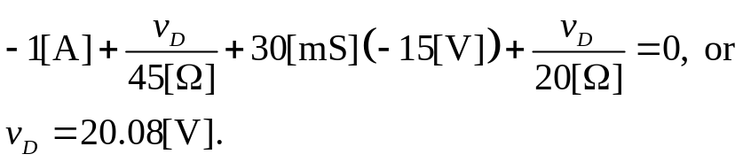
Then, writing KVL around the right hand loop, we get
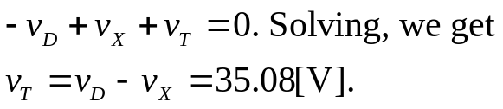
Thus, the equivalent resistance will be
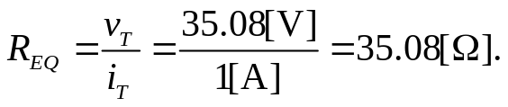
This gives us the equivalent circuit shown as follows.

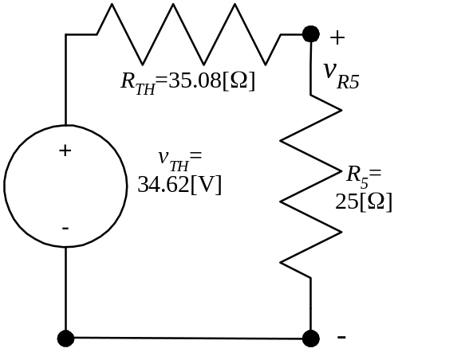

b) Using this solution, we can find the voltage across R₅ as
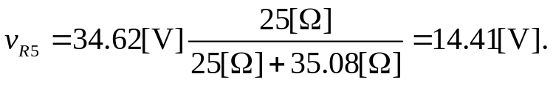
This allows us to find the power absorbed by R₅ as
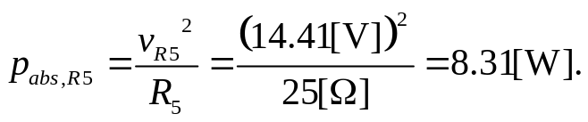
Name: _____________________________ (please print)
Signature: __________________________

ECE 2300 -- Quiz #4B
4:00PM section – March 26, 2002

Keep this quiz closed and face up until you are told to begin.

1. This quiz is closed book, closed notes. You may use one 8.5” x 11” crib sheet, or its equivalent.
2. Show all work on these pages. Show all work necessary to complete the problem. If you go on to another page, indicate clearly where your work can be found. A solution without the appropriate work shown will receive no credit.
3. Show all units in solutions, intermediate results, and figures. Units in the quiz will be included between square brackets.
4. Do not use red ink. Do not use red pencil.
5. You will have 30 minutes to work on this quiz.

________________/20
Room for extra work
Find the Norton equivalent as seen at terminals A and B.
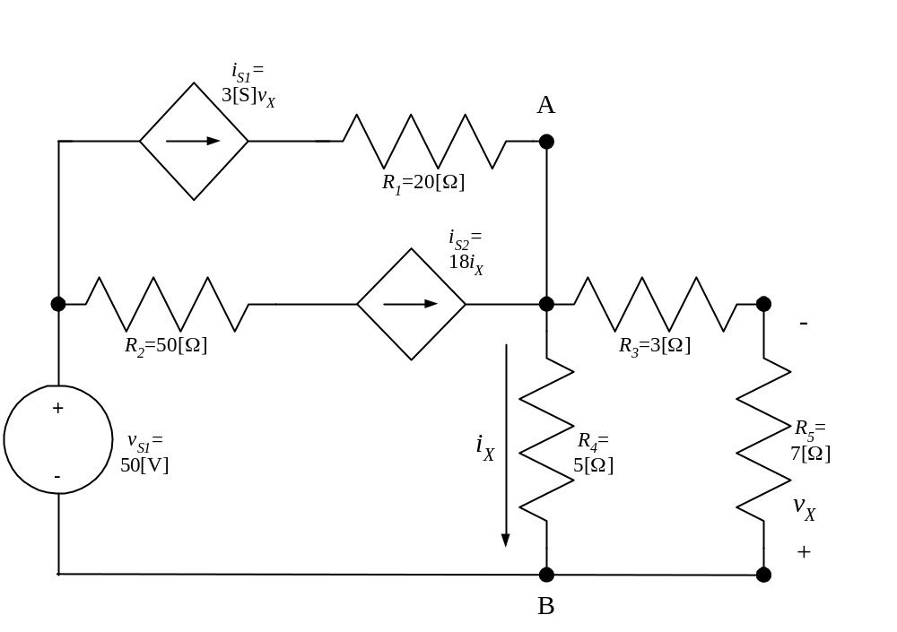

ECE 2300 -- Quiz #4B – 4:00PM section – March 26, 2002 – Solution
Find the Norton equivalent as seen at terminals A and B.
The solution begins by finding the open-circuit voltage. We need to define this voltage, which is done in the circuit that follows.
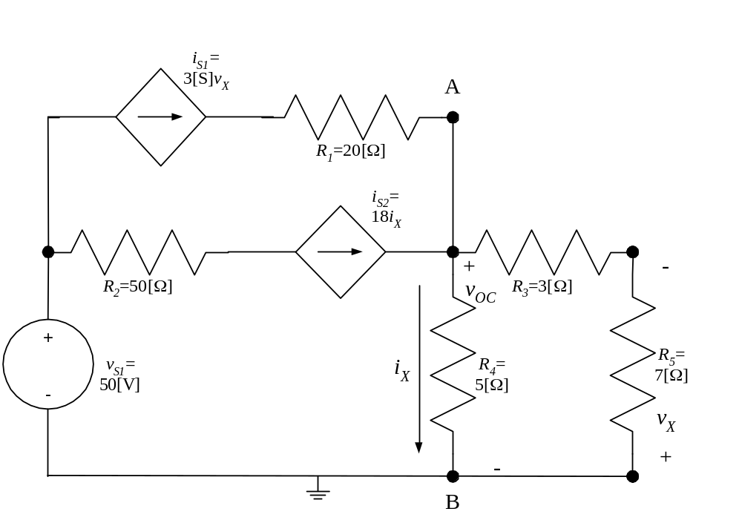
Now, let’s write KCL for the A node. We have
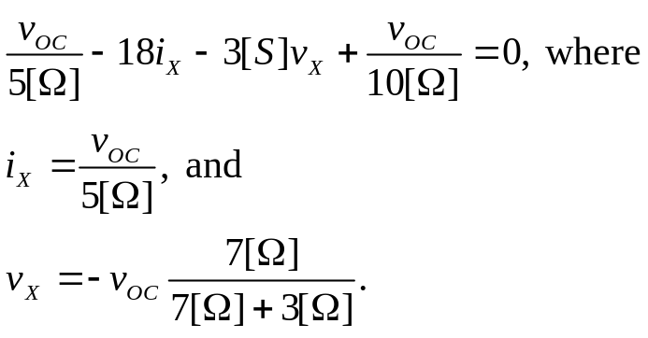
We plug the equations for i_{X} and v_{X} back into the KCL equation, and we get
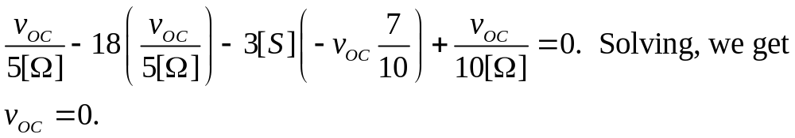
Thus, the open-circuit voltage is zero, which means in turn that the short-circuit current will be zero. We have no choice, then, but to find the equivalent resistance directly.
We start this process by setting all independent sources equal to zero. We have only one independent source, v_{S1}. We set it equal to zero, which makes it a short circuit. Then, we apply a test sources at the terminals of interest, and get the circuit that follows.
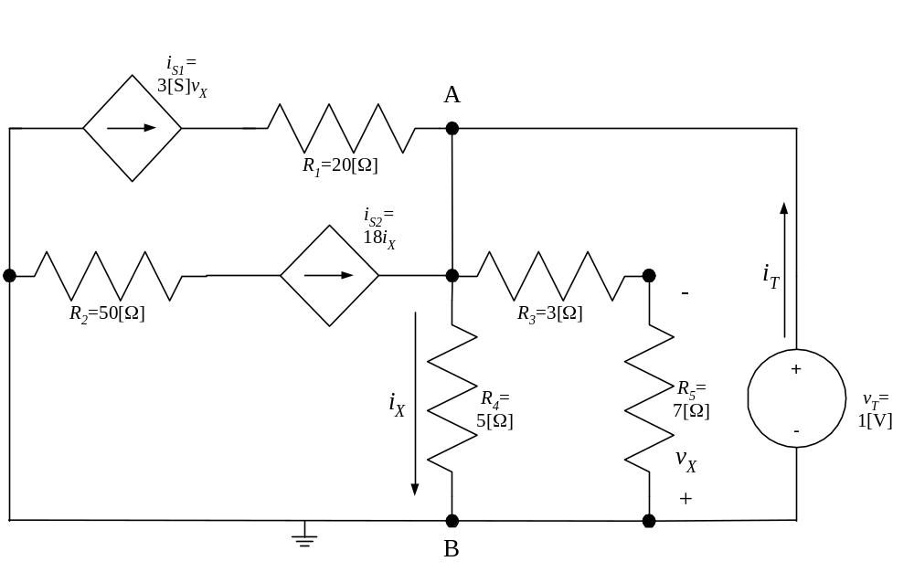
We can write KCL for the A node, and get
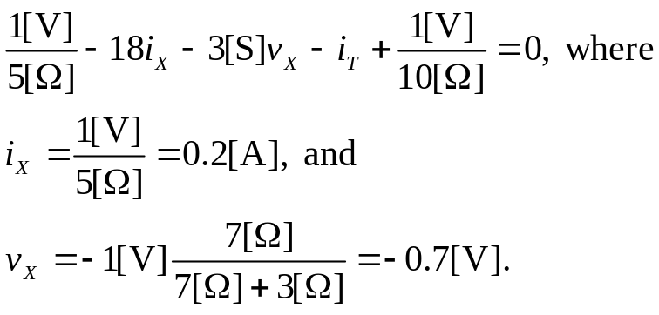
We plug the equations for i_{X} and v_{X} back into the KCL equation, and we get
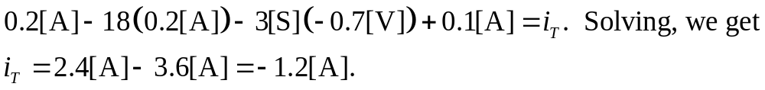
Next, we find the equivalent resistance, by taking the ratio of v_{T} to i_{T}, and we get
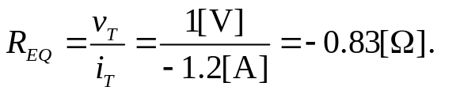

Thus, the Norton equivalent is just the equivalent resistance, which is


