Name: _____________________________ (please print)
Signature: __________________________

ECE 2300 -- Quiz #2
Shattuck Section – TuTh 8:30-10AM
February 13, 2003

Keep this quiz closed and face up until you are told to begin.

1. This quiz is closed book, closed notes. You may use one 8.5” x 11” crib sheet, or its equivalent.
2. Show all work on these pages. Show all work necessary to complete the problem. If you go on to another page, indicate clearly where your work can be found. A solution without the appropriate work shown will receive no credit.
3. Show all units in solutions, intermediate results, and figures. Units in the quiz will be included between square brackets.
4. Do not use red ink. Do not use red pencil.
5. You will have 30 minutes to work on this quiz.

________________/20
Room for extra work
- In the circuit shown, find the equivalent resistance R_{ab} as seen by the current source at terminals a and b.
- For this circuit, find the power absorbed by the current source.
Remember to use lower-case variables for voltage, current, and power.
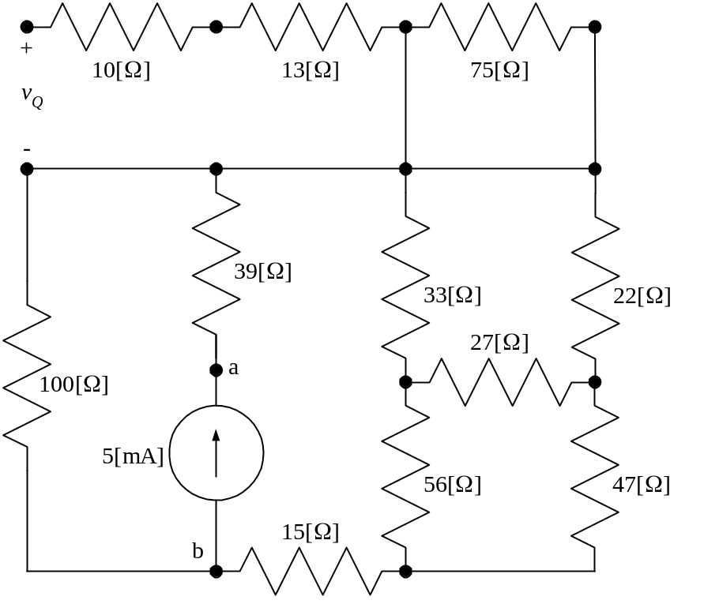
ECE 2300 -- Quiz #2 – February 13, 2003 – 8:30-10AM TuTh Shattuck Section Solution
- In the circuit shown, find the equivalent resistance R_{ab} as seen by the current source at terminals a and b.
- For this circuit, find the power absorbed by the current source.
Remember to use lower-case variables for voltage, current, and power.
The first step in the solution is to simplify the circuit. Note that the 10[Ω] and 13[Ω] resistors are effectively in series with an open circuit, thus no current flows through them. As a result, they have no voltage across them. They can be ignored. Also, the 75[Ω] resistor is in parallel with a short circuit, and so has no voltage across it. As a result, it has no current through it, and it can be ignored. We get the simplified circuit that follows.
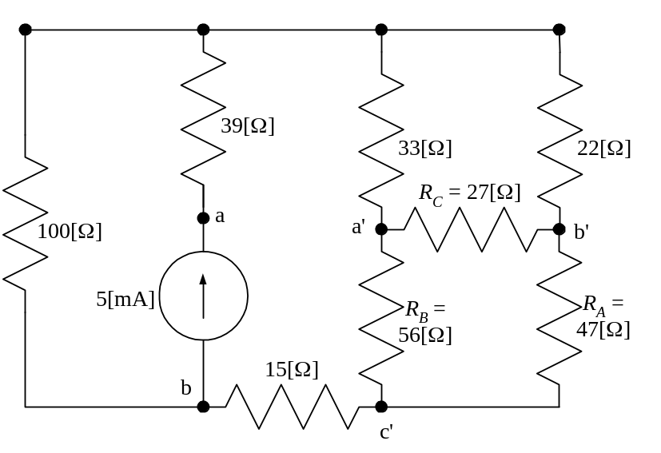
Next, we note that we have no resistors that are in parallel with each other, and no resistors that are in series with each other. Thus, we move to a delta-to-wye transformation to solve this circuit. We have already chosen the delta that we wish to transform, and have indicated this by naming the terminals a’, b’, and c’. We added the primes to distinguish between these nodes, and the ones that were already named a and b.
We are prepared to convert this delta to a wye. We have the circuit that follows.
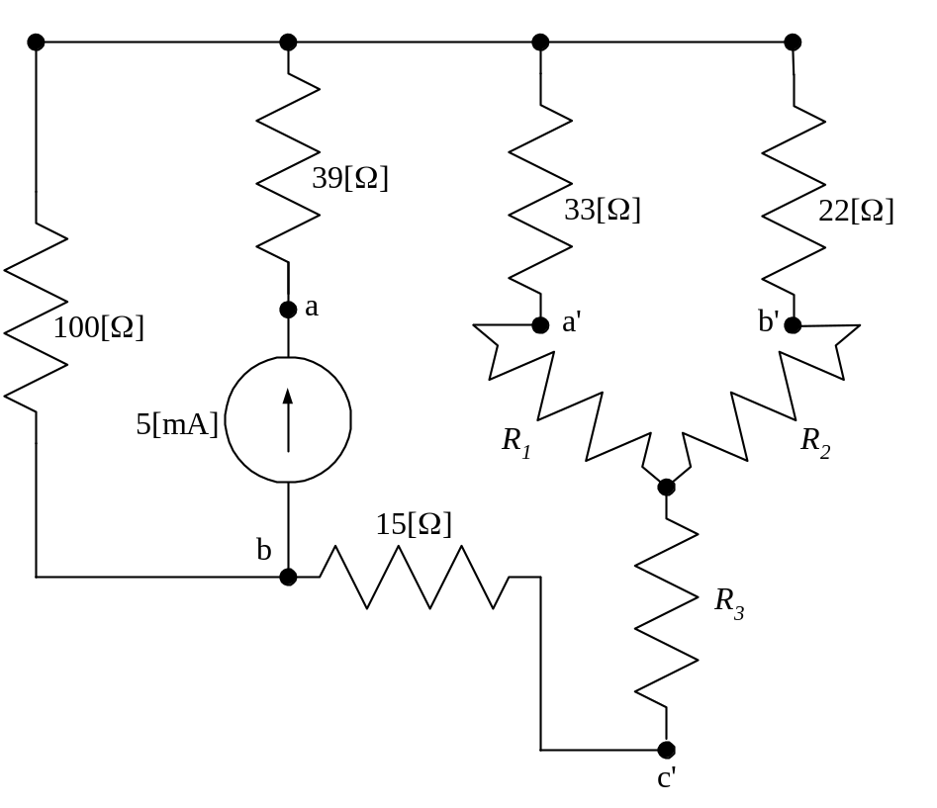
Now, we can use the formulas for the delta-to-wye conversion to find that
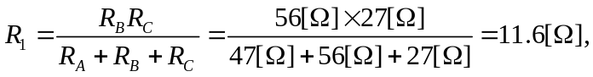
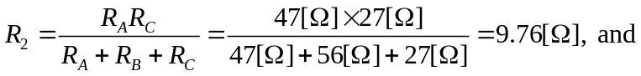
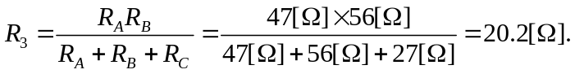
With this information, we can plug back into our diagram and get the circuit that follows.
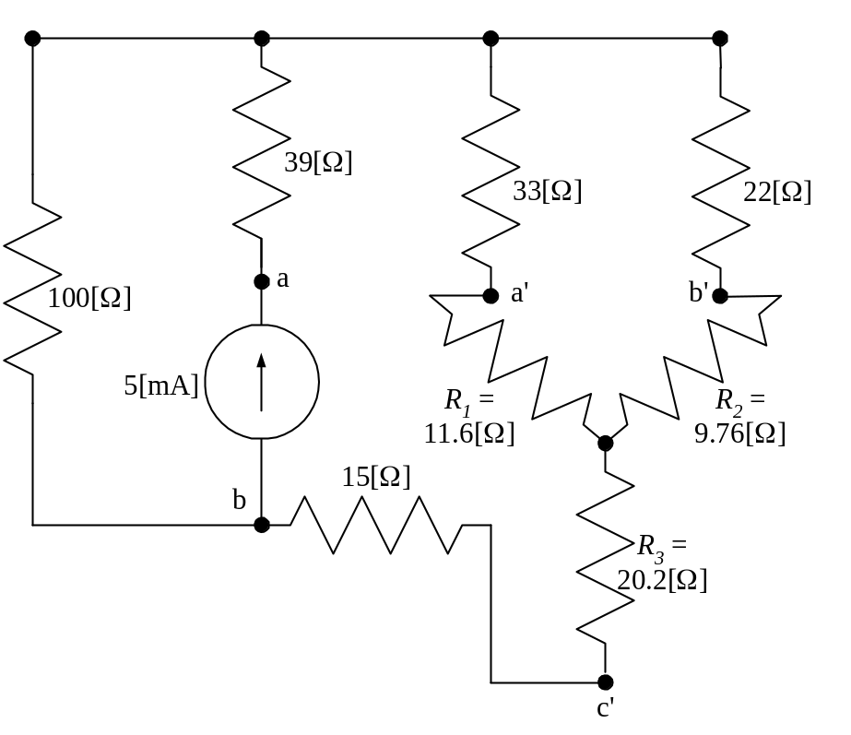
In this circuit, it is clear that R₁ and the 33[Ω] resistor are in series, and similarly R₂ and the 22[Ω] resistor are in series. These two series combinations are in parallel with each other, and can be replaced with an equivalent resistance R_{EQ} which is
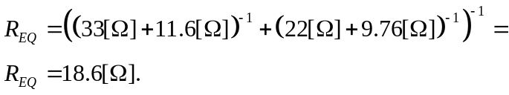
Now, we have a simpler circuit, which follows.
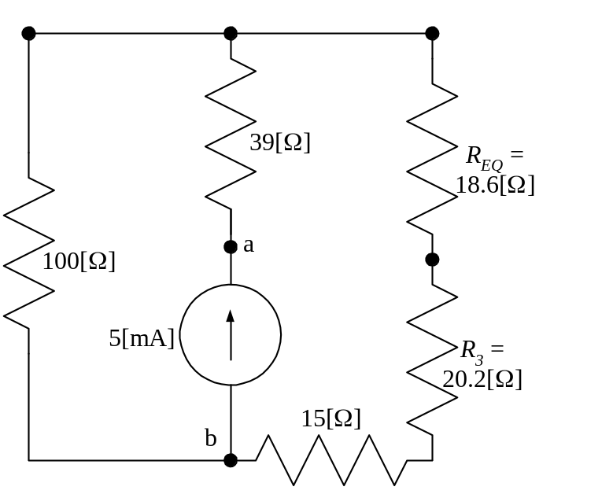
Now, we can see that R_{EQ}, R₃, and the 15[Ω] resistor, are in series, and we can replace them with their equivalent, a 53.8[Ω] resistor, and get the circuit that follows.
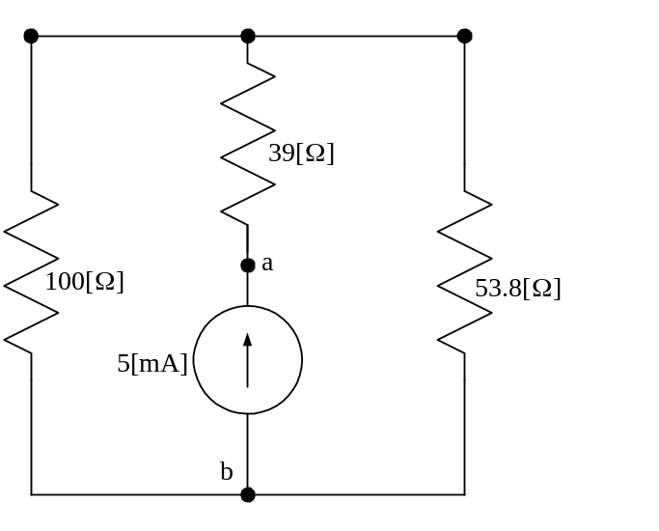
At this point, it should be clear that the 53.8[Ω] resistor and the 100[Ω] resistor are in parallel, and we can replace them with their equivalent, a 35.0[Ω] resistor. This is done in the diagram that follows.
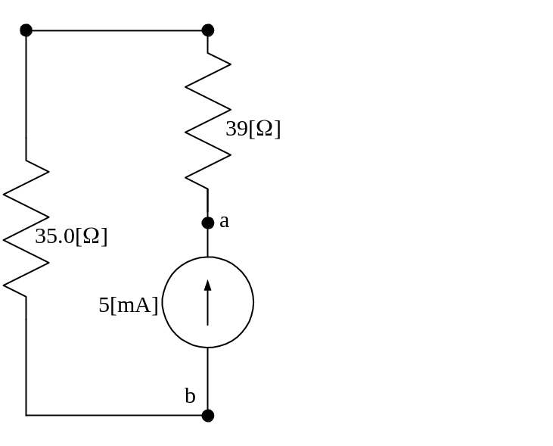
Finally, these two resistors are in series, and we can replace them with their equivalent, a 74[Ω] resistor. Thus,
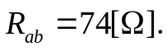
b) The power absorbed by the current source is the power delivered by the equivalent resistor, so we can say that
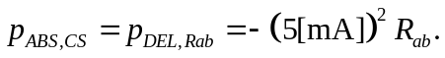
Thus, our answer is
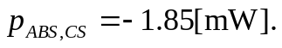

Note: More detail was shown in this solution than would be expected to be provided in the student’s solutions on the quiz. The intention here was to be as clear as possible. Students should generally work more quickly than would be implied by this solution.
Name: _____________________________ (please print)
Signature: __________________________

ECE 2300 -- Quiz #2
Shattuck Section – TuTh 4-5:30PM
February 18, 2003

Keep this quiz closed and face up until you are told to begin.

1. This quiz is closed book, closed notes. You may use one 8.5” x 11” crib sheet, or its equivalent.
2. Show all work on these pages. Show all work necessary to complete the problem. If you go on to another page, indicate clearly where your work can be found. A solution without the appropriate work shown will receive no credit.
3. Show all units in solutions, intermediate results, and figures. Units in the quiz will be included between square brackets.
4. Do not use red ink. Do not use red pencil.
5. You will have 30 minutes to work on this quiz.

________________/20
Room for extra work
The ammeter shown has a d’Arsonval meter movement with rated values of 400[mV] and 2[mA], as shown on the diagram.
- Find R_{X} so that the ammeter will read 100[mA] full-scale.
- Assume that the value for R_{X} that you found in part a) is used. A new resistor, R_{ab}, is added between terminals a and b, so that the ammeter will read 1[A] full-scale. Find the value for this new resistor, R_{ab}.
Remember to use lower-case variables for voltage, current, and power.
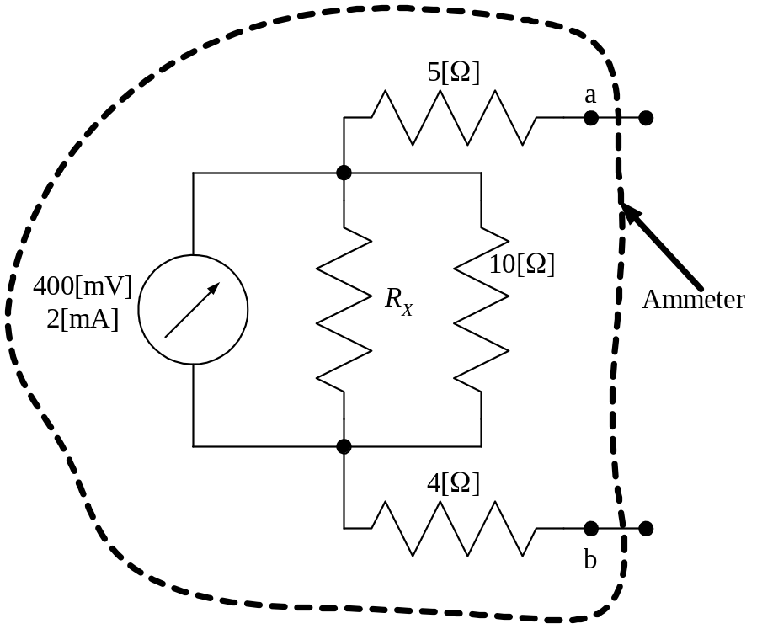
ECE 2300 -- Quiz #2 – February 18, 2003 – 4-5:30PM TuTh Shattuck Section Solution
The ammeter shown has a d’Arsonval meter movement with rated values of 400[mV] and 2[mA], as shown on the diagram.
- Find R_{X} so that the ammeter will read 100[mA] full-scale.
- Assume that the value for R_{X} that you found in part a) is used. A new resistor, R_{ab}, is added between terminals a and b, so that the ammeter will read 1[A] full-scale. Find the value for this new resistor, R_{ab}.
Remember to use lower-case variables for voltage, current, and power.
Solution: a) To solve this, we need to understand what the situation is with the d’Arsonval meter movement. Just as with any voltmeter or ammeter, the d’Arsonval can be modeled with a resistor. We get the value of this resistor by taking the ratio of the rated voltage to the rated current, since these are full-scale values, and occur at the same time.
Then, we solve, using these full-scale values. The diagram that follows has the d’Arsonval replaced by a 200[Ω] resistor, and has the full-scale voltages and currents labeled on the diagram. See the diagram.
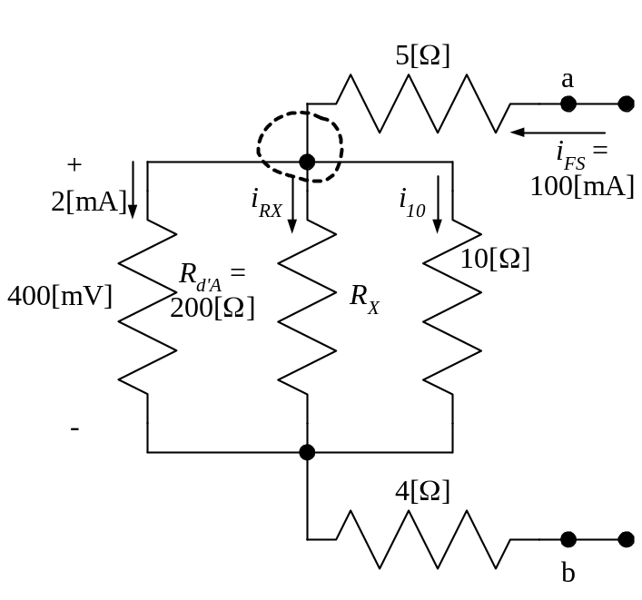
We can write KCL for the node shown with the dashed-line closed surface, and get
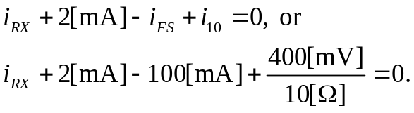
Note that we obtained the i₁₀ from the voltage across the resistance at full-scale. We can solve this equation for i_{RX} and get
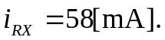
Thus, we have the current through, and the voltage across, the resistor R_{X}, in the passive sign convention. We can write
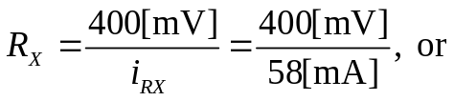
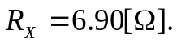

b) Now, we take the circuit, and add another resistor between terminals a and b. We get the circuit that follows.
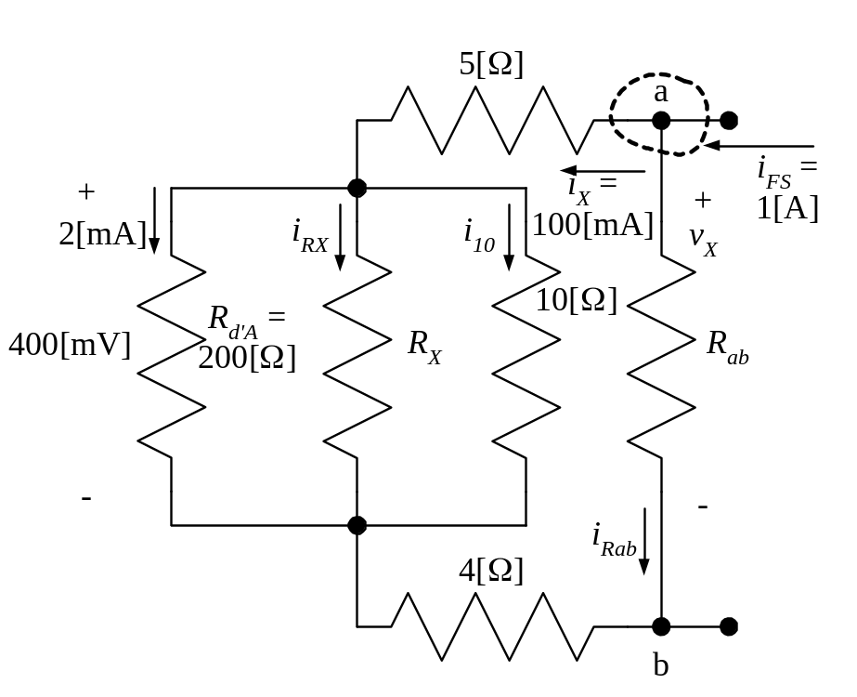
Next, we take advantage of the fact that we know that at full scale, the current i_{X} must be the same as it was before, since we picked R_{X} to make i_{X} be equal to 100[mA]. Thus, we can write KVL around the loop to get v_{X}, as
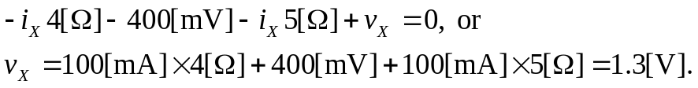
Writing KCL at the closed surface shown, we can write
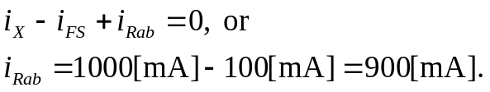
Thus, using Ohm’s law, we can write


