Name: _____________________________ (please print)
Signature: __________________________

ECE 2300 – Quiz #4 – Shattuck Section
March 31, 2008

Keep this quiz closed and face up until you are told to begin.

1. This quiz is closed book, closed notes. You may use one 8.5” x 11” crib sheet, or its equivalent.
2. Show all work on these pages. Show all work necessary to complete the problem. A solution without the appropriate work shown will receive no credit. A solution which is not given in a reasonable order will lose credit.
3. It is assumed that your work will begin on the same page as the problem statement. If you choose to begin your work on another page, you must indicate this on the page with the problem statement, with a clear indication of where the work can be found. If your work continues on to another page, indicate clearly where your work can be found. Failure to indicate this clearly will result in a loss of credit.
4. Show all units in solutions, intermediate results, and figures. Units in the quiz will be included between square brackets.
5. Do not use red ink. Do not use red pencil.
6. You will have 30 minutes to work on this quiz.

________________/20
Room for extra work
In the circuit given below, solve for the current i_{W}.
It is recommended that you use a series of source transformations, equivalent resistances, and one current-divider rule, to solve this problem.
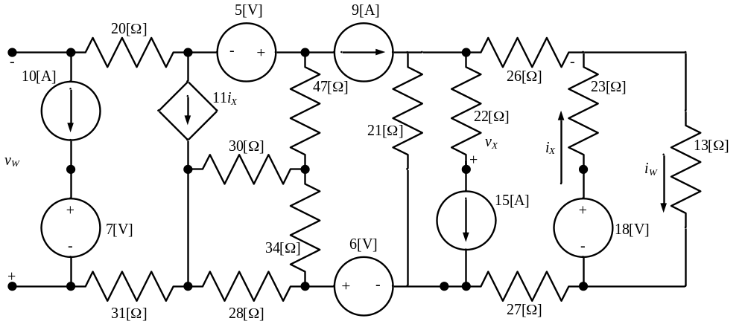

Room for extra work
ECE 2300 -- Quiz #4 – March 31, 2008 – Solution
In the circuit given below, solve for the current i_{W}.
It is recommended that you use a series of source transformations, equivalent resistances, and one current-divider rule, to solve this problem.
Solution: We begin by recognizing the items in series with current sources in this circuit. The 22[Ω] resistor is in series with the 15[A] current source, and can be neglected. Also, the 10[A] current source is in series with the 20[Ω] resistor, the 31[Ω] resistor, and the 7[V] voltage source, and thus those three components can also be ignored. However, we can also recognize that there are several more components that are in series with the 9[A] current source. We will redraw the circuit below, to show which components we are addressing here.
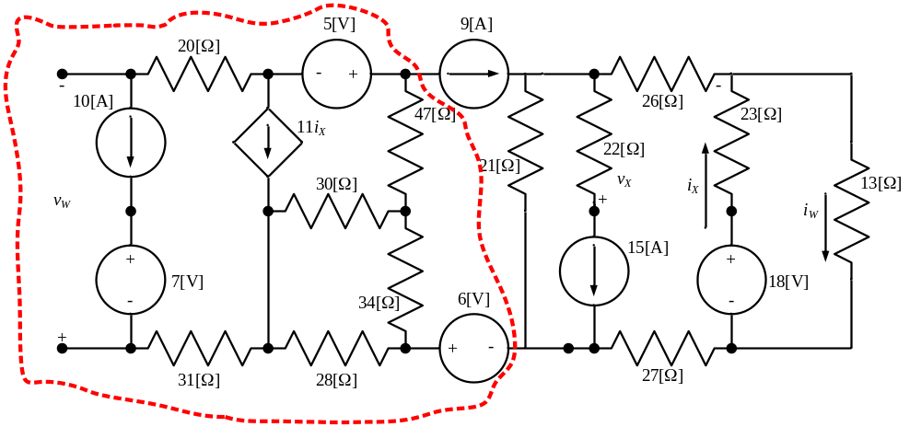
Everything in the diagram above, circled by the red dashed line, is in series with the 9[A] current source, and can be ignored with respect to things outside the series combination. Let's redraw now, replacing those things which can be ignored in this circuit.
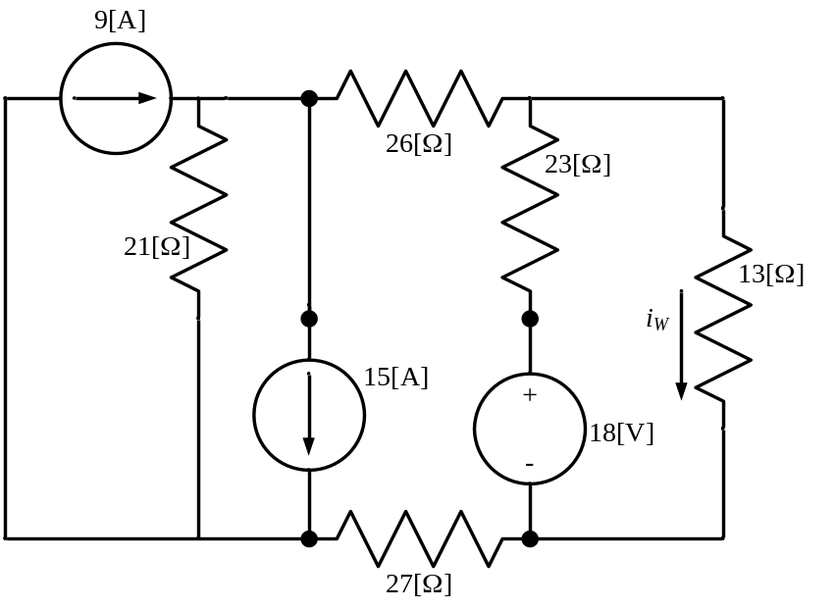
Here we have a 9[A] current source and a 15[A] current source, and they are in parallel. We can replace them with a 6[A] current source, pointing down, which is in parallel with the 21[Ω] resistor. Thus, we can replace this, using source transformations, with a voltage source of 126[V] in series with this 21[Ω] resistor. We redraw this circuit with these changes, as follows.
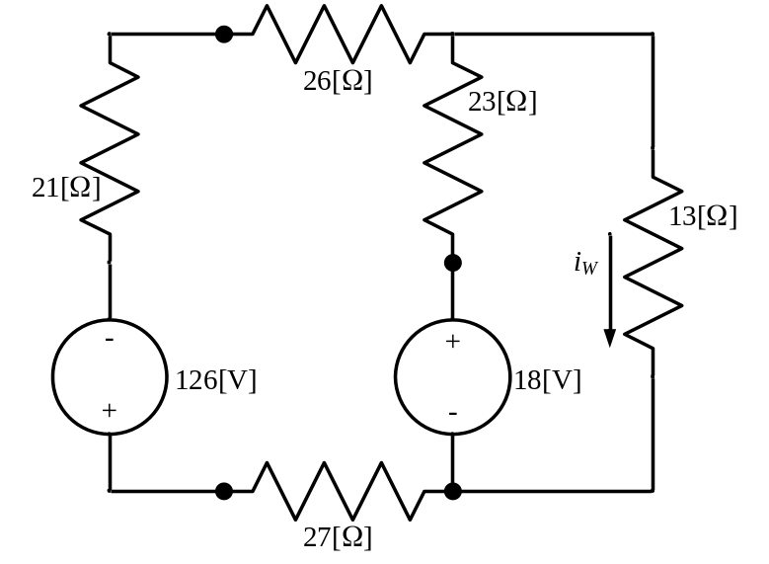
Note that the polarity of the 126[V] voltage source was determined by the polarity of the current source, from which it was converted. Since the arrow was pointing down, the plus sign in the voltage source was put closer to the bottom.
Now, we are going to convert the two sets of voltage sources in series with resistors, with current sources in parallel with resistors. First, we have a voltage source of 126[V] in series with a series combination of resistors, which combine to give a 74[Ω] resistor. This results in a parallel combination of a 74[Ω] resistor and a current source, with a value of
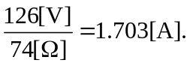
Second we have a voltage source of 18[V] in series with a 23[Ω] resistor. This results in a parallel combination of a 23[Ω] resistor and a current source, with a value of
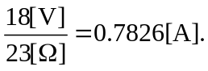
Thus, we have a new circuit, as follows.
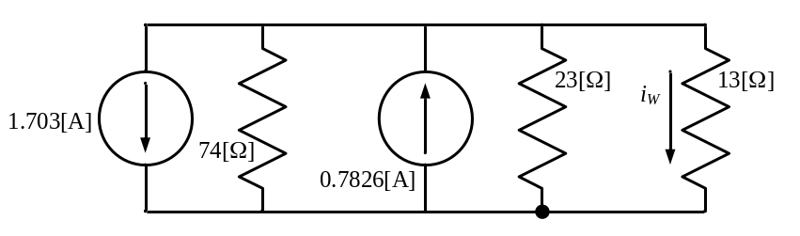
Now, with this circuit we have two current sources in parallel, which can be combined into a single equivalent current source, which is 920[mA]. This current source will be one pointing down. Also, we have two resistors, 74[Ω] and 23[Ω] in value, which are in parallel, and can be combined into a single equivalent resistor, with a value of 17.55[Ω]. This gives us the following equivalent circuit.
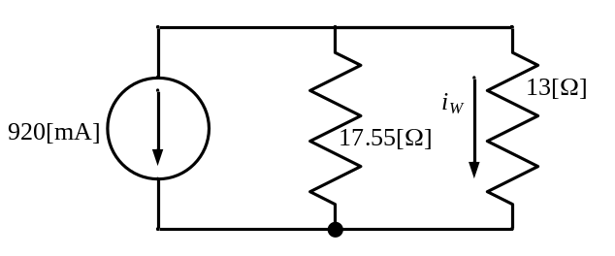
Finally, we can use the current-divider rule to solve for i_{W}. We have


