Name: _____________________________ (please print)
Signature: __________________________

ECE 2355 -- Exam #2
April 9, 2011

Keep this exam closed until you are told to begin.

1. This exam is closed book, closed notes. You may use one 8.5” x 11” crib sheet, or its equivalent.
2. Show all work on these pages. Show all work necessary to complete the problem. A solution without the appropriate work shown will receive no credit. A solution that is not given in a reasonable order will lose credit. Clearly indicate your answer (for example by enclosing it in a box).
3. It is assumed that your work will begin on the same page as the problem statement. If you choose to begin your work on another page, you must indicate this on the page with the problem statement, with a clear indication of where the work can be found. If your work continues on to another page, indicate clearly where your work can be found. Failure to indicate this clearly will result in a loss of credit.
4. Show all units in solutions, intermediate results, and figures. Units in the exam will be included between square brackets.
5. Do not use red ink. Do not use red pencil.
6. You will have 90 minutes to work on this exam.

1. ________________/30
2. ________________/30
3. ________________/40
Total = 100
Room for extra work
1. {30 Points} For the given circuit, use the Mesh-Current Method to write a complete set of independent equations that could be used to solve this circuit. Do not simplify the circuit. Do not attempt to solve or simplify your equations. Define all variables.

Room for extra work

2. {30 Points} A small motor, modeled as a resistance R_{L}, is connected in the circuit below. Find the resistance for this motor that will maximize the power delivered to the motor.

Room for extra work

3. {40 Points} For the circuit shown the switch had been open for a long time before it closed at t = 0.
a) Find i_{Z}(0⁺).
b) Find i_{Q}(0⁺).
c) Find i_{X}(0⁺).
d) Find v_{X}(2[ms]).
Room for extra work

1. {30 Points} For the given circuit, use the Mesh-Current Method to write a complete set of independent equations that could be used to solve this circuit. Do not simplify the circuit. Do not attempt to solve or simplify your equations. Define all variables.
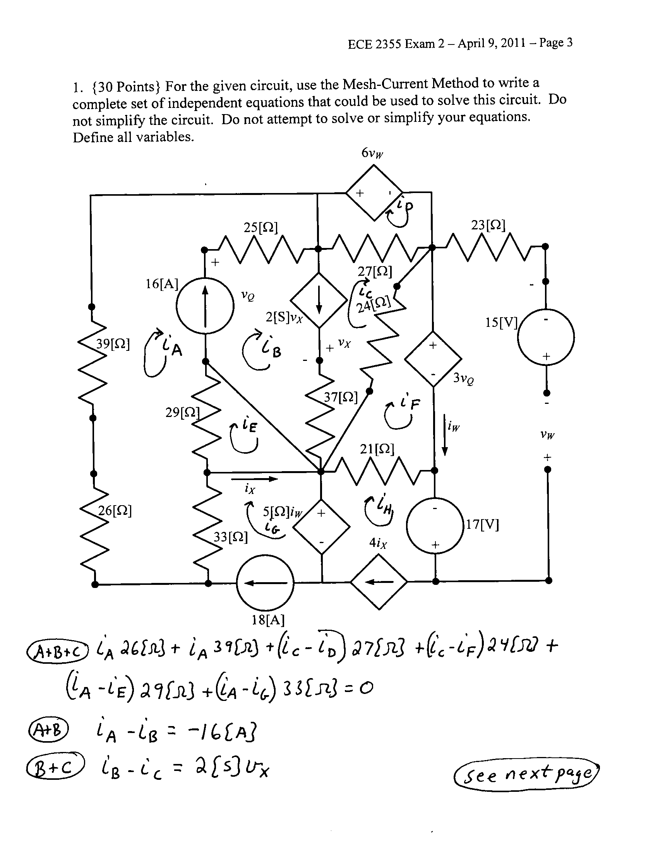
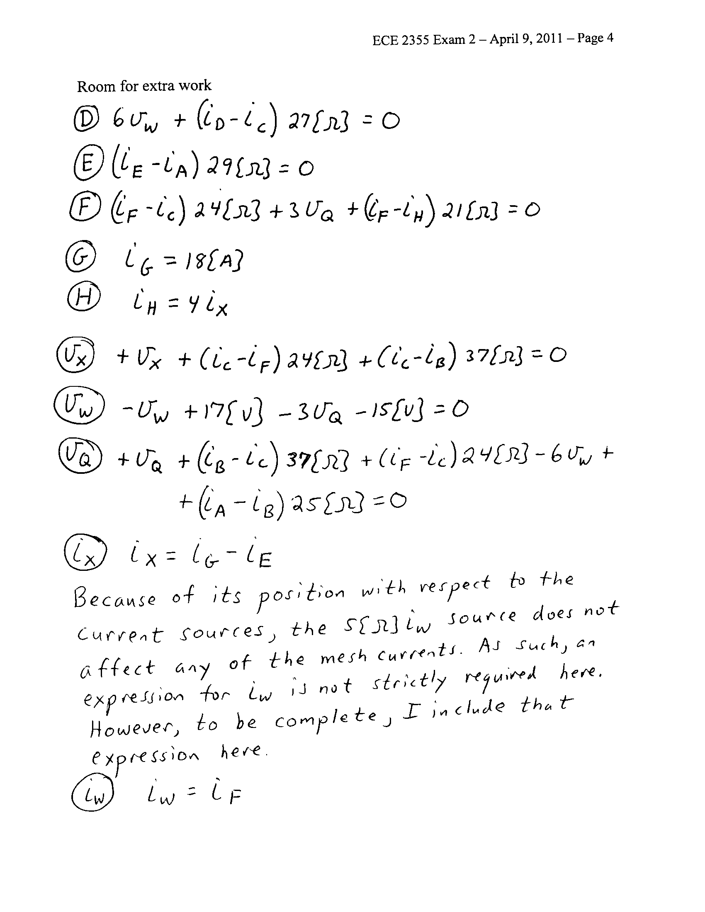

2. {30 Points} A small motor, modeled as a resistance R_{L}, is connected in the circuit below. Find the resistance for this motor that will maximize the power delivered to the motor.
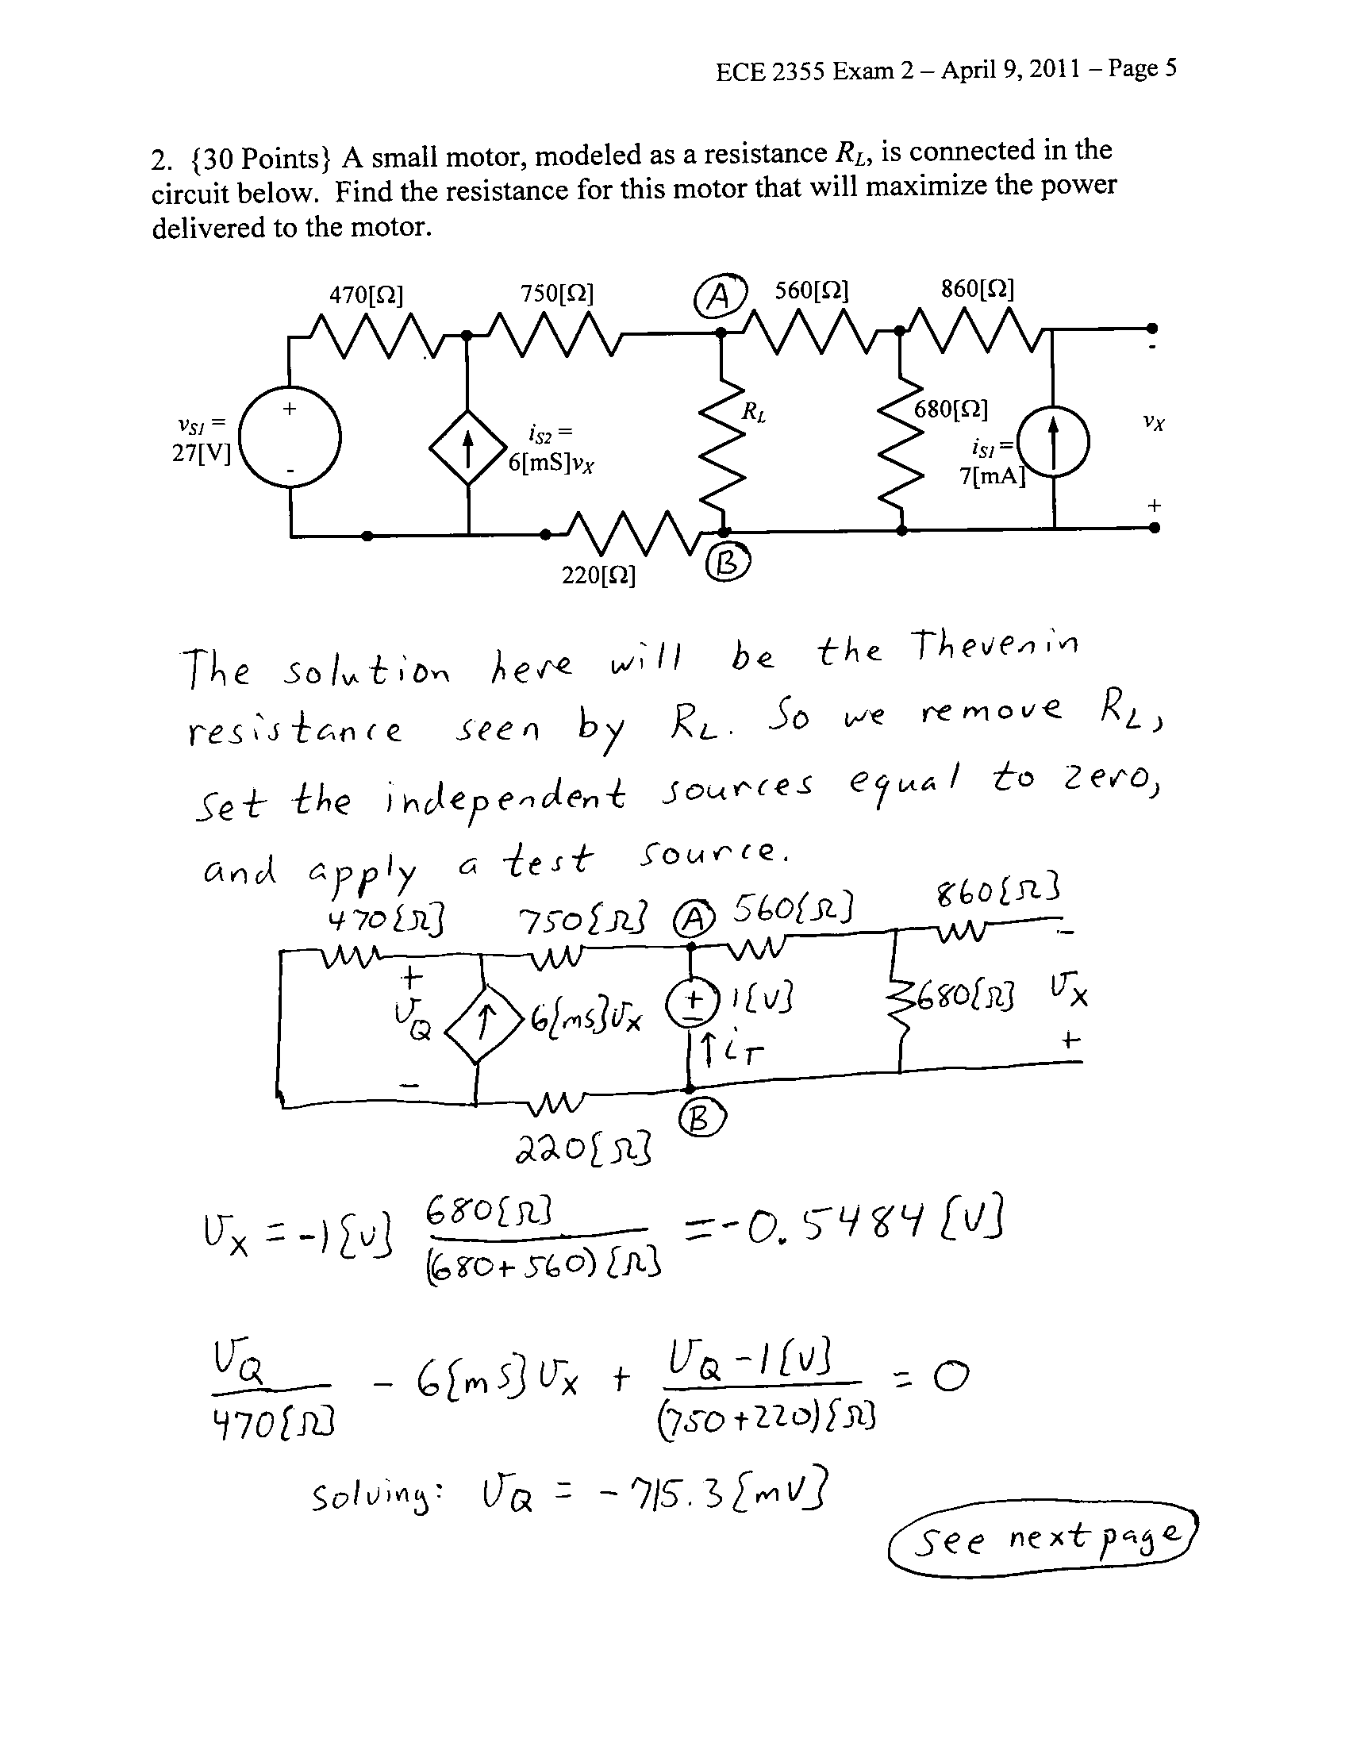

3. {40 Points} For the circuit shown the switch had been open for a long time before it closed at t = 0.
a) Find i_{Z}(0⁺).
b) Find i_{Q}(0⁺).
c) Find i_{X}(0⁺).
d) Find v_{X}(2[ms]).
