Name: _____________________________ (please print)
Signature: __________________________

ECE 2355 – Final Exam
May 7, 2011

Keep this exam closed until you are told to begin.

1. This exam is closed book, closed notes. You may use one 8.5” x 11” crib sheet, or its equivalent.
2. Show all work on these pages. Show all work necessary to complete the problem. A solution without the appropriate work shown will receive no credit. A solution that is not given in a reasonable order will lose credit. Clearly indicate your answer (for example by enclosing it in a box).
3. It is assumed that your work will begin on the same page as the problem statement. If you choose to begin your work on another page, you must indicate this on the page with the problem statement, with a clear indication of where the work can be found. If your work continues on to another page, indicate clearly where your work can be found. Failure to indicate this clearly will result in a loss of credit.
4. Show all units in solutions, intermediate results, and figures. Units in the exam will be included between square brackets.
5. Do not use red ink. Do not use red pencil.
6. You will have 170 minutes to work on this exam.

1. ________________/20
2. ________________/20
3. ________________/20
4. ________________/20
5. ________________/20
6. ________________/20
Total = 120
Room for extra work
1. {20 Points} For the given circuit, use the Node-Voltage Method to write a complete set of independent equations that could be used to solve this circuit. Do not simplify the circuit. Do not attempt to solve or simplify your equations. Define all variables.

Room for extra work

2. {20 Points} A multi-range voltmeter is shown in the diagram below. The meter has three ranges, one with a 10[V] full-scale reading, one with a 50[V] full-scale reading, and one with a 100[V] full-scale reading.
a) Find R₁, R₂, and R₃.
b) Assume that the goal is to measure a voltage with a value that could be up to 500[V], using the multi-range voltmeter shown in the diagram. Find the value of a resistor that could be placed between the 10[V] terminal and the Common terminal, to allow this measurement to be made.
c) Assume that the goal is to measure a voltage with a value that could be up to 500[V], using the multi-range voltmeter shown in the diagram. Find the value of a resistor that could be placed between the 50[V] terminal and the Common terminal, to allow this measurement to be made.
d) Assume that the goal is to measure a voltage with a value that could be up to 500[V], using the multi-range voltmeter shown in the diagram. Can you place a resistor between the 50[V] terminal and the 10[V] terminal to allow this measurement to be made? Explain your answer.
Room for extra work

3. {20 Points} For the circuit shown, the switch had been closed for a long time before it opened at t = 0.
a) Find v_{X}(0⁻).
b) Find v_{X}(0⁺).
c) Find v_{X}(10[μs]).
d) Find the energy stored in the inductor at t = 10[μs].
Room for extra work

4. {20 Points} The circuit shown was in steady state for t < 0. Then, at t = 0 the switch closed.
Find v_{X}(10[ms]).
Room for extra work

5. {20 Points} The circuit shown is in steady state. The transformer is ideal. a) Find the phase of the complex power absorbed by the load.
b) Determine whether the load has a leading or lagging power factor.

Room for extra work

6. {20 Points} Assume an ideal op amp. Find v_{O}/v_{X}.

Room for extra work

1. {20 Points} For the given circuit, use the Node-Voltage Method to write a complete set of independent equations that could be used to solve this circuit. Do not simplify the circuit. Do not attempt to solve or simplify your equations. Define all variables.
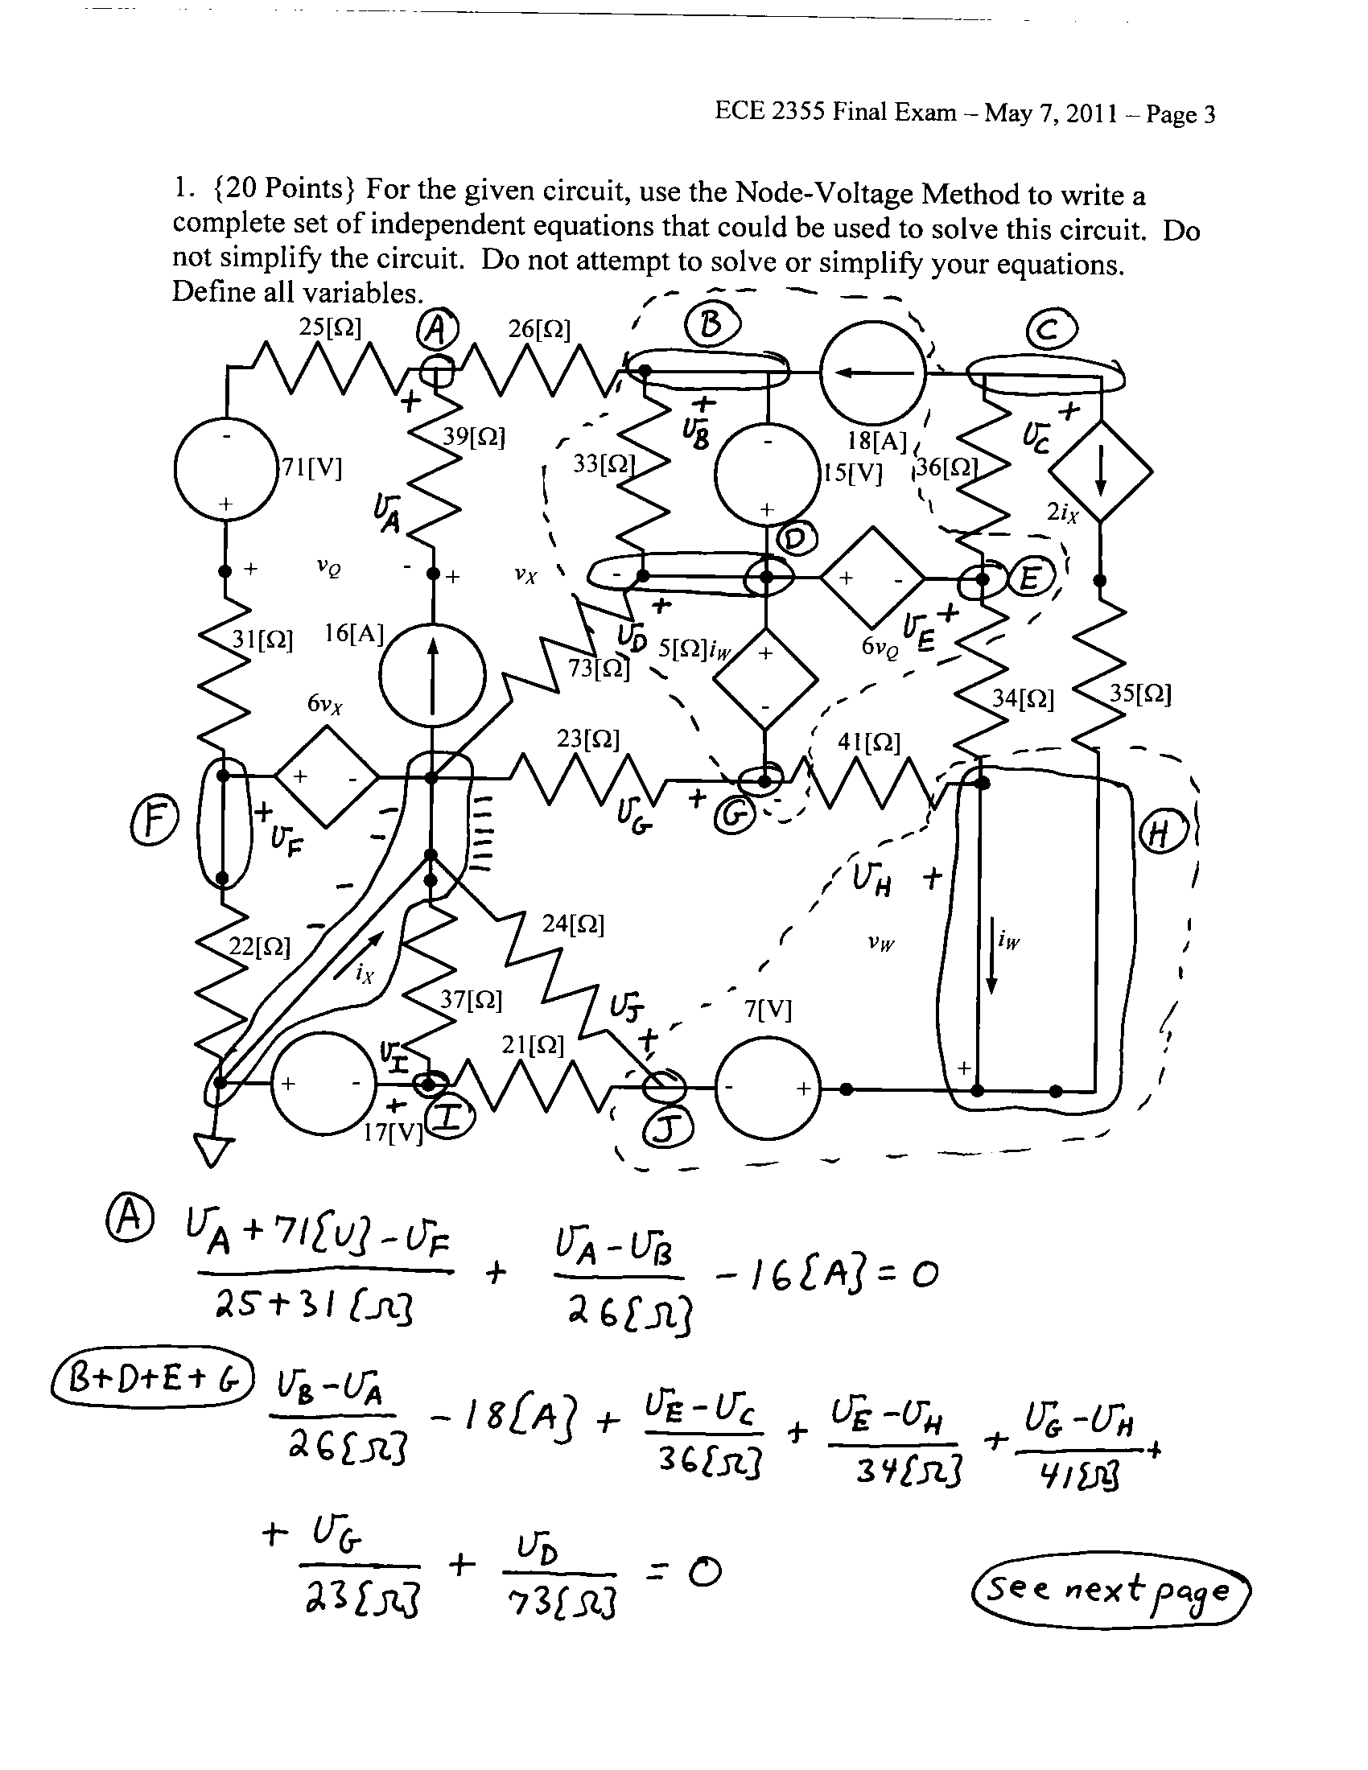
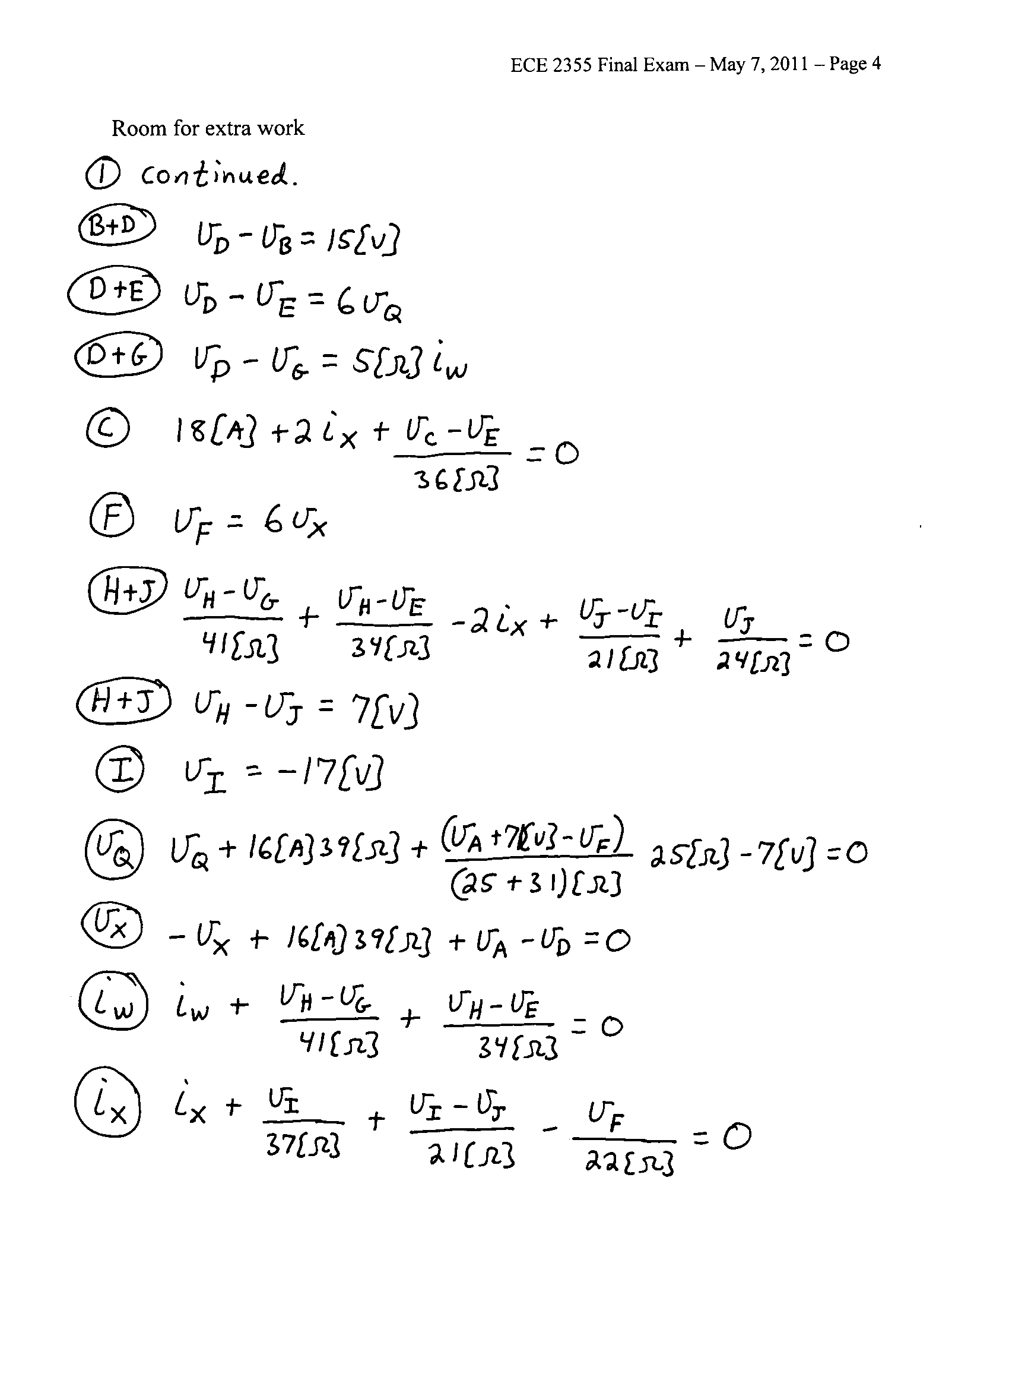

2. {20 Points} A multi-range voltmeter is shown in the diagram below. The meter has three ranges, one with a 10[V] full-scale reading, one with a 50[V] full-scale reading, and one with a 100[V] full-scale reading.
a) Find R₁, R₂, and R₃.
b) Assume that the goal is to measure a voltage with a value that could be up to 500[V], using the multi-range voltmeter shown in the diagram. Find the value of a resistor that could be placed between the 10[V] terminal and the Common terminal, to allow this measurement to be made.
c) Assume that the goal is to measure a voltage with a value that could be up to 500[V], using the multi-range voltmeter shown in the diagram. Find the value of a resistor that could be placed between the 50[V] terminal and the Common terminal, to allow this measurement to be made.
d) Assume that the goal is to measure a voltage with a value that could be up to 500[V], using the multi-range voltmeter shown in the diagram. Can you place a resistor between the 50[V] terminal and the 10[V] terminal to allow this measurement to be made? Explain your answer.
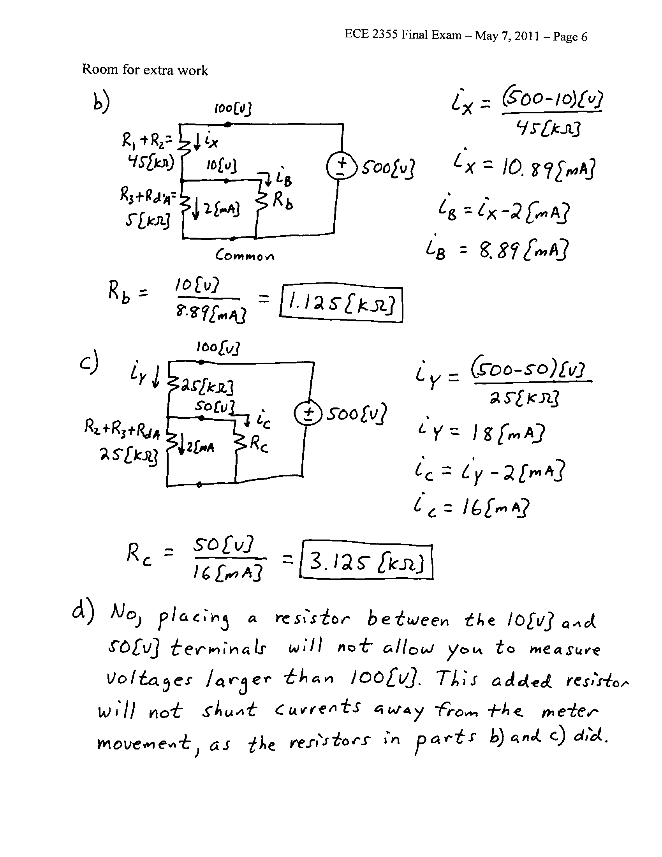
3. {20 Points} For the circuit shown, the switch had been closed for a long time before it opened at t = 0.
a) Find v_{X}(0⁻).
b) Find v_{X}(0⁺).
c) Find v_{X}(10[μs]).
d) Find the energy stored in the inductor at t = 10[μs].

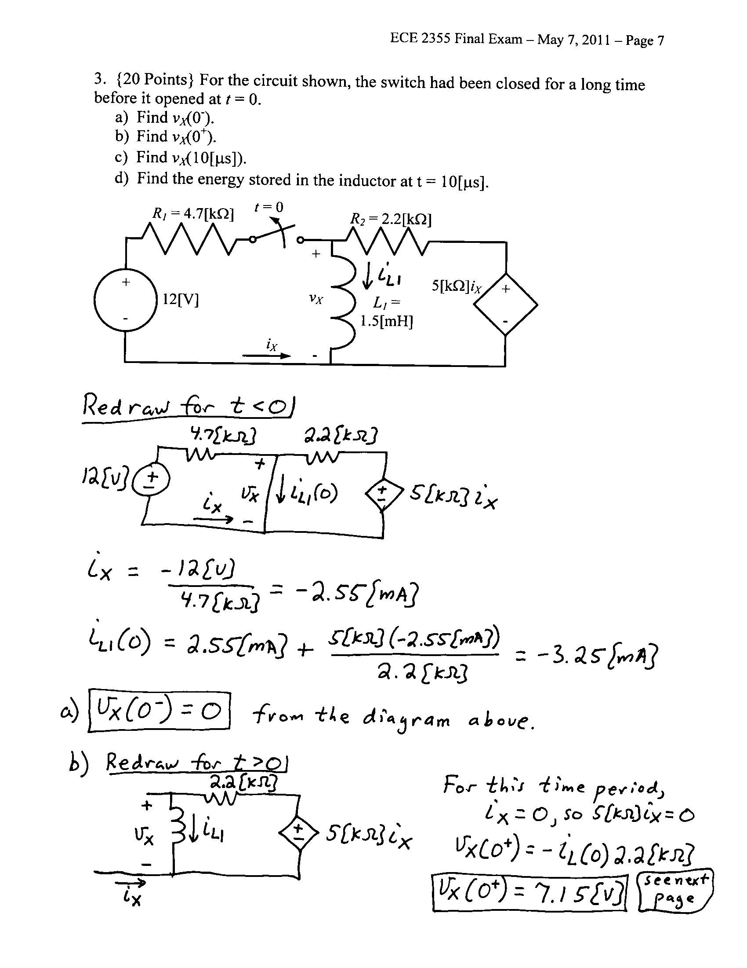
4. {20 Points} The circuit shown was in steady state for t < 0. Then, at t = 0 the switch closed.
Find v_{X}(10[ms]).

5. {20 Points} The circuit shown is in steady state. The transformer is ideal. a) Find the phase of the complex power absorbed by the load.
b) Determine whether the load has a leading or lagging power factor.
6. {20 Points} Assume an ideal op amp. Find v_{O}/v_{X}.
