Name: _____________________________ (please print)

Signature: __________________________

ECE 2202 – Exam 2

April 13, 2019

Keep this exam closed until you are told to begin.

1. This exam is closed book, closed notes. You may use one 8.5” x 11” crib sheet, or its equivalent.

2. Show all work on these pages. Show all work necessary to complete the problem. A solution without the appropriate work shown will receive no credit. A solution that is not given in a reasonable order will lose credit. Clearly indicate your answer (for example by enclosing it in a box).

3. It is assumed that your work will begin on the same page as the problem statement. If you choose to begin your work on another page, you must indicate this on the page with the problem statement, with a clear indication of where the work can be found. **If your work continues on to another page, indicate clearly where your work can be found. Failure to indicate this clearly will result in a loss of credit.**

4. Show all units in solutions, intermediate results, and figures. Units in the exam will be included between square brackets.

5. Do not use red ink. Do not use red pencil.

6. You will have 90 minutes to work on this exam.

1. ________________/40

2. ________________/30

3. ________________/30

Total = 100

Room for extra work

1. {40 Points} For the circuit shown below, the switch has been in position **a** for a long time before $t=0$. At $t=0$, the switch moved to position **b**. Then, 1 [s] later, the switch moved to position **c**.

Please find for .



# Room for extra work

1. {30 Points} The circuit shown below is operating in the steady-state. The values of the voltage source and the current source are given as

, and

.

Please find the current .



Room for extra work

Room for extra work

1. {30 Points} The circuit shown below operates in steady-state. Find *RX* so that the voltage *vX* is given by



where *VA* is an unknown constant. It is given that





1. {40 Points} For the circuit shown below, the switch has been in position **a** for a long time before $t=0$. At $t=0$, the switch moved to position **b**. Then, 1 [s] later, the switch moved to position **c**.

Please find for .

 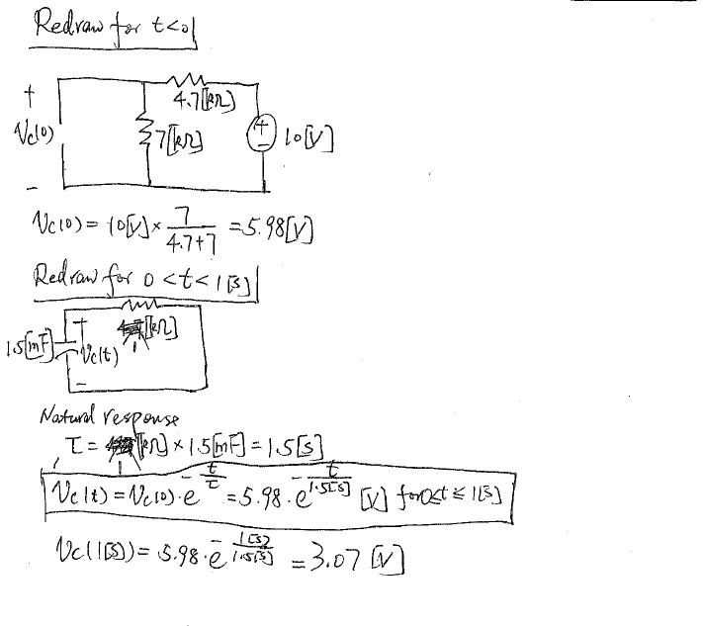

# Room for extra work

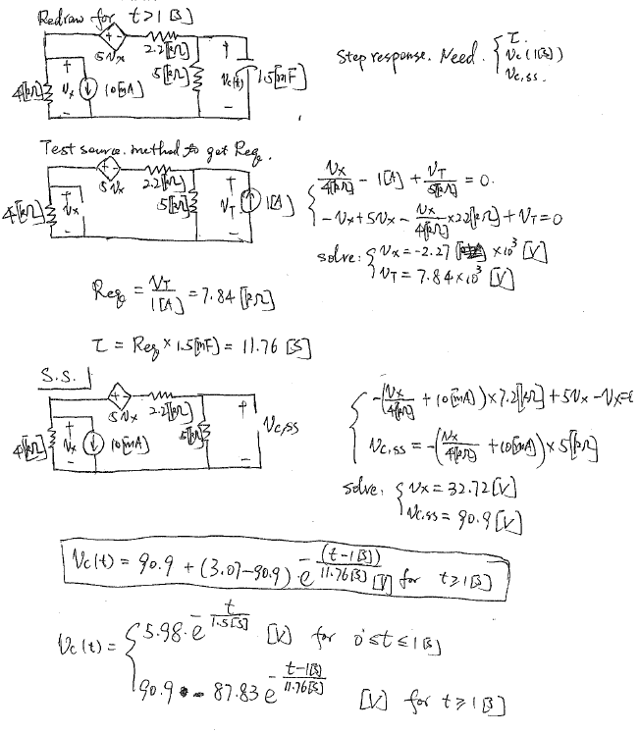

1. {30 Points} The circuit shown below is operating in the steady-state. The values of the voltage source and the current source are given as

, and

.

Please find the current .



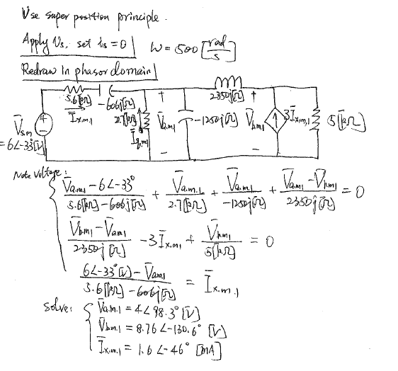

Room for extra work

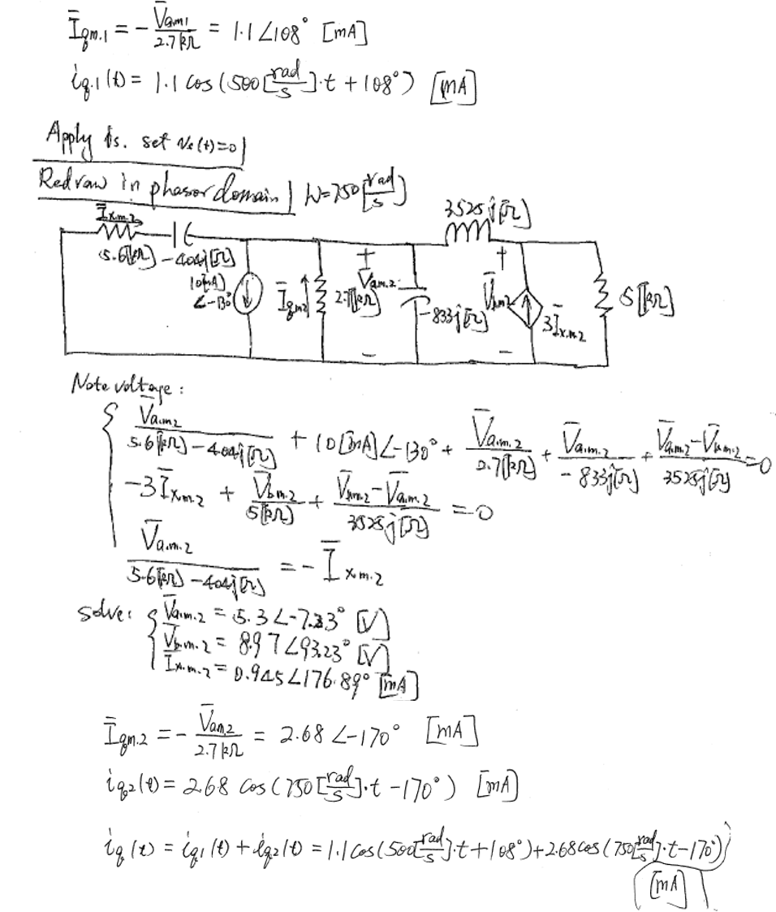

Room for extra work

1. {30 Points} The circuit shown below operates in steady-state. Find *RX* so that the voltage *vX* is given by



where *VA* is an unknown constant. It is given that





