Name: _____________________________ (please print)
Signature: __________________________

ECE 2202 – Mid-semester Exam
July 23, 2019

Keep this exam closed until you are told to begin.

1. This exam is closed book, closed notes. You may use one 8.5” x 11” crib sheet, or its equivalent.
2. Show all work on these pages. Show all work necessary to complete the problem. A solution without the appropriate work shown will receive no credit. A solution that is not given in a reasonable order will lose credit. Clearly indicate your answer (for example by enclosing it in a box).
3. It is assumed that your work will begin on the same page as the problem statement. If you choose to begin your work on another page, you must indicate this on the page with the problem statement, with a clear indication of where the work can be found. If your work continues on to another page, indicate clearly where your work can be found. Failure to indicate this clearly will result in a loss of credit.
4. Show all units in solutions, intermediate results, and figures. Units in the exam will be included between square brackets.
5. Do not use red ink. Do not use red pencil.
6. You will have 100 minutes to work on this exam.

1. ________________/30
2. ________________/30
3. ________________/40
Total = 100
Room for extra work
- {30 Points} A device, as shown in Figure 1, can be modeled as a Norton Equivalent. For this device, when v_{D} = 15[V], then i_{D} = 470[μA]. Also, when v_{D} = 20[V], then i_{D} = 1.254[mA].
Two identical versions of this device are connected in the circuit in Figure 2, with terminal a for each device connected to a₁ and a₂, and terminal b connected to b₁ and b₂.
Find the power delivered by the 3.3[V] voltage source in Figure 2.

Room for extra work

- {30 Points} There was no energy stored in the capacitor and no energy stored in the inductor when the switch moved from position b to position a at t = 1[s].
- Find the energy stored in the capacitor at t = 3[s].
- Find the energy stored in the inductor at t = 4[s].
- Find the power delivered by the current source at t = 2.5[s].

Room for extra work

Room for extra work

- {40 Points} Switch SWA had been closed, and switch SWB had been open for a long time before t = 0. Then at t = 0 switch SWA opened and switch SWB closed. After that, switch SWB opened at t = 5[ms]. Find v_{X}(10[ms]).

- {30 Points} A device, as shown in Figure 1, can be modeled as a Norton Equivalent. For this device, when v_{D} = 15[V], then i_{D} = 470[μA]. Also, when v_{D} = 20[V], then i_{D} = 1.254[mA].
Two identical versions of this device are connected in the circuit in Figure 2, with terminal a for each device connected to a₁ and a₂, and terminal b connected to b₁ and b₂.
Find the power delivered by the 3.3[V] voltage source in Figure 2.
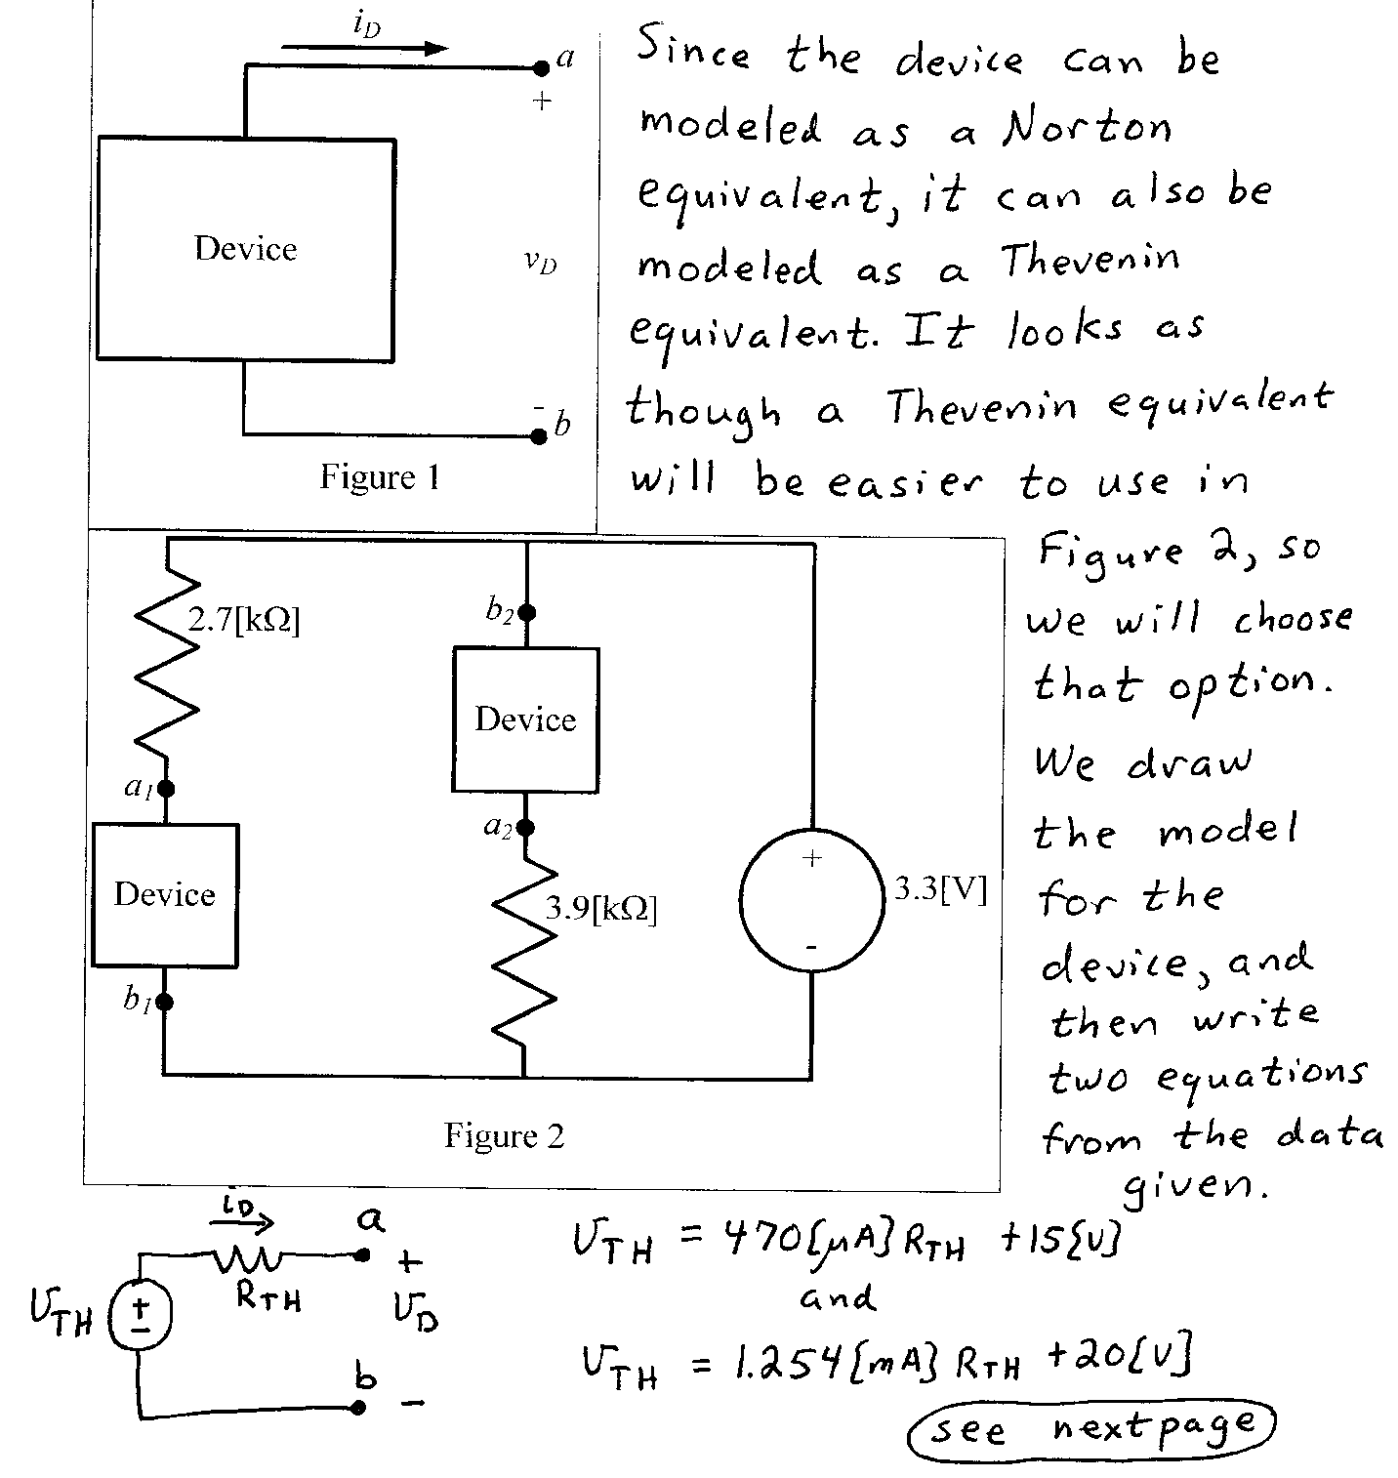
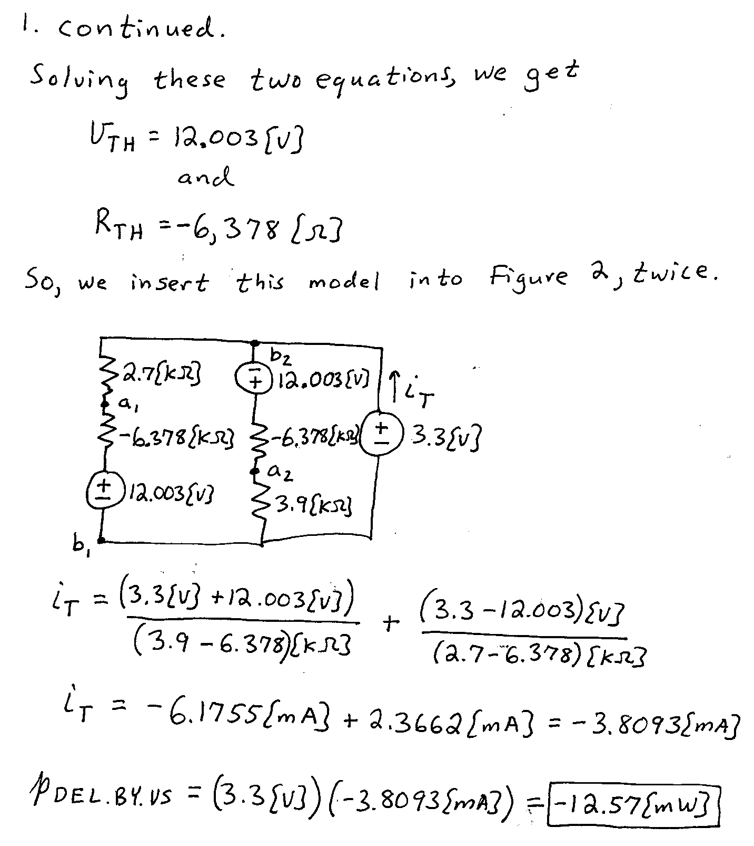

- {30 Points} There was no energy stored in the capacitor and no energy stored in the inductor when the switch moved from position b to position a at t = 1[s].
- Find the energy stored in the capacitor at t = 3[s].
- Find the energy stored in the inductor at t = 4[s].
- Find the power delivered by the current source at t = 2.5[s].
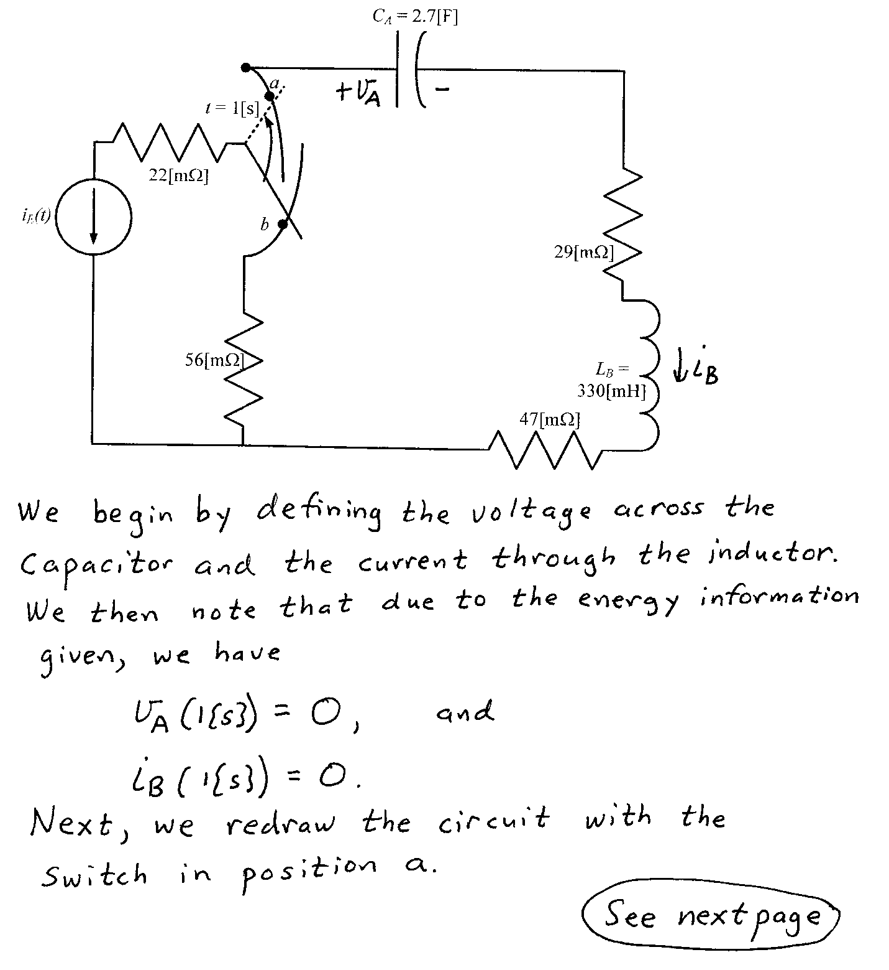
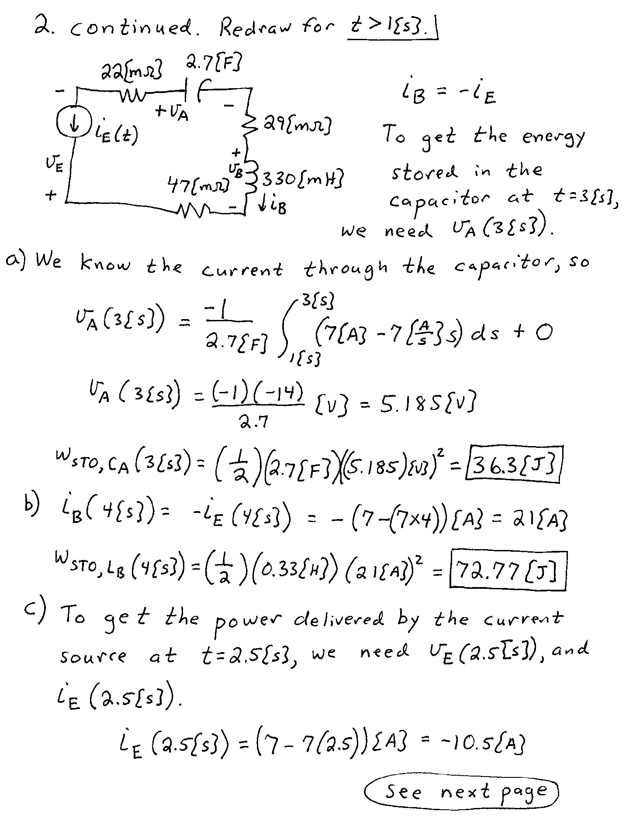
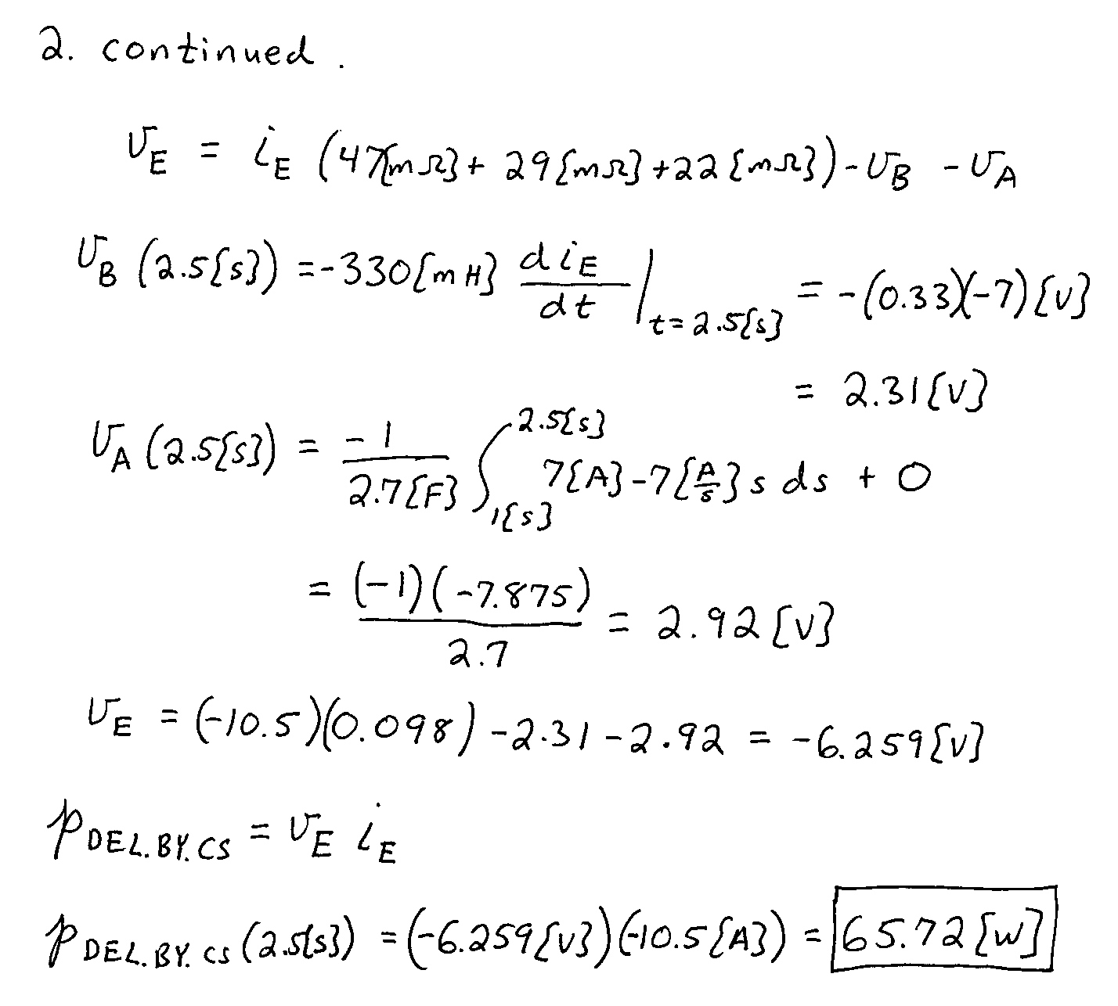

- {40 Points} Switch SWA had been closed, and switch SWB had been open for a long time before t = 0. Then at t = 0 switch SWA opened and switch SWB closed. After that, switch SWB opened at t = 5[ms]. Find v_{X}(10[ms]).
