#### ECE 3317

#### Applied Electromagnetic Waves

#### Exam 2

#### Nov. 26, 2024

**Name: _______________________________________**

**General Information:**

The exam is open-book and open-notes. You are not allowed to use any device that has communication functionality (laptop, cell phone, ipad, etc.). 

**Remember, you are bound by the UH Academic Honesty Policy during the exam!**

**Instructions:**

* Show all of your work. No credit will be given if the work required to obtain the solutions is not shown.
* Write neatly. You will not be given credit for work that is not easily legible.
* Leave answers in terms of the parameters given in the problem.
* Show units in all of your final answers.
* Circle your final answers.
* Double-check your answers. For simpler problems, partial credit may not be given.
* If you have any questions, ask the instructor. You will not be given credit for work that is based on a wrong assumption.
* Make sure you sign the academic honesty statement below.

**Academic Honesty Statement**

By taking this exam, you agree to abide by the UH Academic Honesty Policy during this exam. You understand and agree that the punishment for violating this policy will be most severe, including getting an F in the class and getting expelled from the University.

Signature: _____________________________________

Problem 1 (30 pts)

A coaxial cable has the following parameters:



Find the length of the cable at 10 GHz for which the attenuation will be 10 dB.



**ROOM FOR WORK**

**ROOM FOR WORK**

Problem 2 (35 pts)

A microstrip line on a printed circuit board (PCB) having [Ω] is connected to a quarter-wave transformer, which is then connected to a load impedance [Ω]. The frequency is 3.0 GHz and the effective relative permittivity of the 50 [Ω] line is . An open-circuited microstrip stub line of length  is connected in parallel to the load. This stub line also has [Ω]. The open-circuit stub line and the quarter-wave transformer together ensure that the feed line to the left of the transformer sees a 50 [Ω] load.

1. Find the length of the stub line  (in cm)using the Smith chart. (Use the smallest length possible.)
2. Find the value of .

**ROOM FOR WORK**

**ROOM FOR WORK**

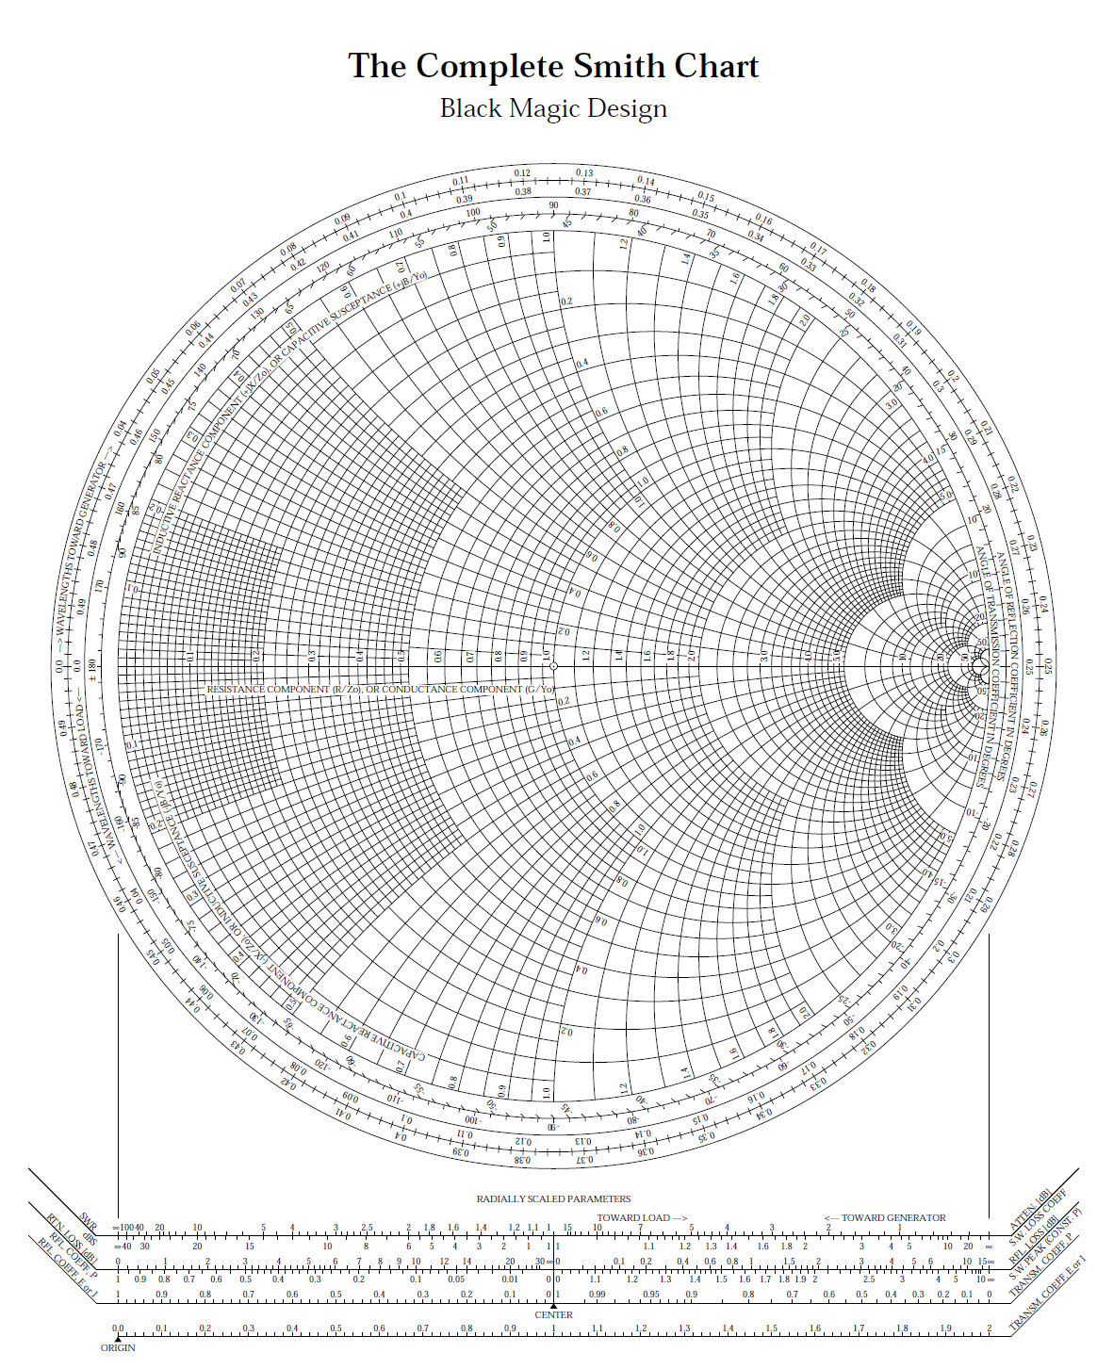



Problem 3 (35 pts)

A plane wave is traveling in the *z* direction downward in the ocean, as shown below, at 1.0 GHz. The electric field is given by

.

The ocean water has a relative permittivity of  and a conductivity of .

(a) Classify the polarization of this wave (linear, LHCP, RHCP, LHEP, RHEP).

(b) Find the axial ratio of this wave.

(c) Find how many dB of attenuation there is when the wave travels 1.0 [cm] into the ocean.



**ROOM FOR WORK**

**ROOM FOR WORK**