#### ECE 3318

#### Applied Electricity and Magnetism

**Final Exam**

#### May 7, 2024

Name: ________________**SOLUTION**__________________________________________________

**General Instructions**

1. This exam is open-book and open-notes.
2. Cell phones, laptops, ipads, and any other devices that have communication functionality are not allowed during the exam.
3. Show all of your work. No credit will be given if the work required to obtain the solutions is not shown.
4. Write neatly. You will not be given credit for work that is not easilylegible.
5. Leave answers in terms of the parameters given in the problem.
6. Show units in all of your final answers.
7. Circle your final answers.
8. Double-check your answers. For simpler problems, partial credit may not be given.
9. If you have any questions, ask the instructor. You will not be given credit for work that is based on a wrong assumption.
10. Remember the UH Academic Honesty Policy. You must not receive or give assistance to anyone else during the exam or communicate with anyone other than the instructor during the exam.

**TABLE OF INTEGRALS**

















**Problem 1 (25 pts.)**

A coaxial cable has an inner radius of *a* (the radius of the inner conductive wire) and an outer radius of *c* (the radius of the outer conductive shield). There is a dielectric “sleeve” surrounding the inner conductor, in the region . Outside the sleeve (between the sleeve and the outer conductor) is air. The sleeve has a relative permittivity  and a breakdown field strength of  while the air has a breakdown field strength of , where . A cross-sectional view is shown below.

a) Find the capacitance per unit length of the coaxial cable.

b) Find the maximum voltage that can be put on the coaxial cable before breakdown occurs in the air region.



**SOLUTION**

**Part (a)**

Let’s assume a line charge density of  [C/m] on the inner conductor. The voltage drop  (where *A* is on the inner conductor and *B* is the outer conductor) is then

.

We have

.

We then have

.

**Part (b)**

We set

.

This gives us

.

We then have

.

**Problem 2 (25 pts.)**

A transmission line consists of two thick metal slabs (with different thicknesses) as shown below. The structure is infinite in the *z* direction. The top slab carries a DC current *I* Amps in the *z* direction. The bottom slab carries a DC current *I* Amps in the -*z* direction. Assume that *w* is large enough so that so that you may neglect fringing.

a) Find the magnetic field vector *H* inside the bottom slab, for .

b) Find the magnetic field vector *H* in the middle air region, for .

c) Find the magnetic field vector *H* inside the top slab, for .





**SOLUTION**

We apply Ampere’s law with a path *C* as shown below.



Ampere’s law gives us

 (where  is the current in the positive *z* direction).

Hence,

.

We have



We then have



with



**Problem 3 (25 pts.)**

Find the magnetic field at the origin (the observation point) from the infinite wire shown below. The wire carries a DC current of *I* Amps, and it extends to infinity in the positive *x* direction and to infinity in the positive *z* direction. Note that the vertical part starts on the *x* axis at . Do this by calculating the magnetic field from the two parts of the wire (horizontal and vertical) as indicated in the parts below.

a) Find the magnetic field vector *H* from the horizontal bottom part of the wire.

b) Find the magnetic field vector *H* from the vertical part of the wire.



**SOLUTION**

We use the Biot-Savart law:

.

**Part (a)**





Note that .

Hence,

.

**Part (b)**







so

.

Evaluating the integral, we have

.

Hence, we have

.

**Bonus Problem (25 pts.)**

A transformer consists of two coils (coil 1 and coil 2) that are wound on a rectangular core as shown below (note how the coils are wound and the current reference directions). Note that  is the horizontal dimension of the core and  is the vertical dimension of the core. Also note that all segments of the core have a cross-sectional area of *A*. Assume that the relative permeability of the core  is high enough so that we can neglect flux leakage.

a) Draw the magnetic circuit for this structure. (Make sure that you show the polarity of the voltage sources in your circuit.)

b) Find formulas for the self inductances  and  (for coil 1 and coil 2, respectively).

c) Find a formula for the mutual inductance  (make sure that you get the sign right!).

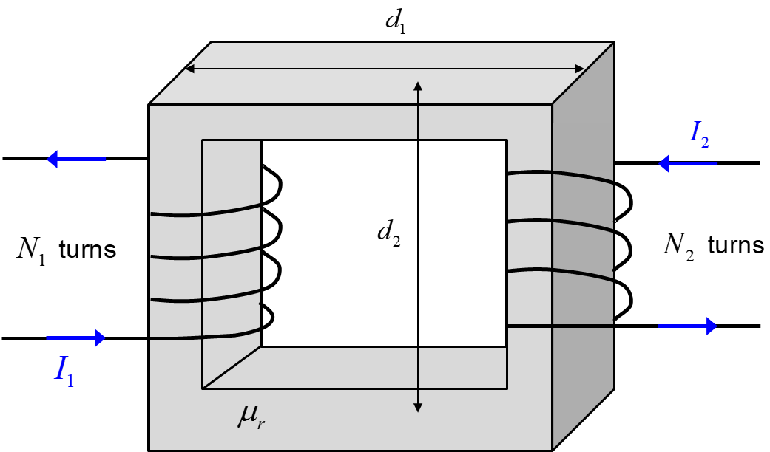

**SOLUTION**

**Part (a)**

The magnetic circuit is shown below.

We have

.

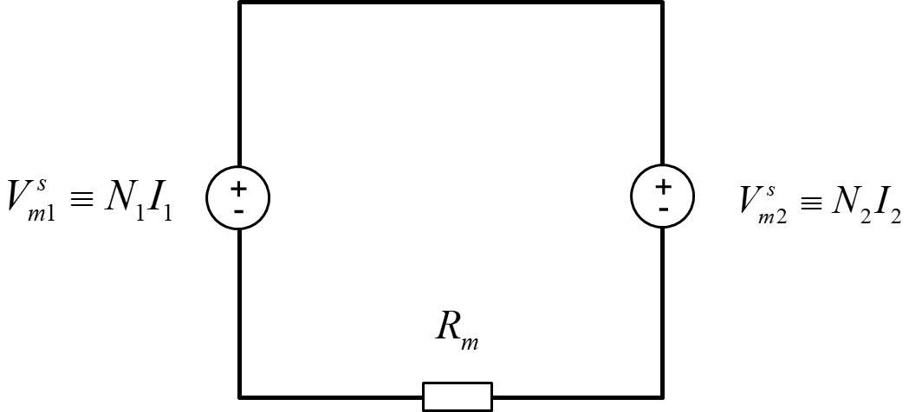

**Part (b)**

When coil 1 is energized we have a clockwise current  that models a clockwise flux  in the transformer core. We have

.

Hence, we have

.

Similarly, if coil 2 is energized and we let  model the counterclockwise flux  in the transformer core, we have

.

Hence, we have

.

**Part (c)**

For  we energize coil 2 and look at the flux  that goes through coil 1. Notes that this flux will be negative (assuming that  is positive) since the unit normal direction for coil 1 is pointing up (due to the winding sense of the coil and the right-hand rule for inductor flux).

We have

.

Hence, we have

.