May 9, 2024

**CLASS PROJECT**

ECE 3318

**APPLIED ELECTRICITY AND MAGNETISM**

**Spring 2024**

*Solution of Laplace’s Equation by the Finite Difference Method*

**Due date:** Monday, May 13, 12:00 noon.

Please submit the project by emailing a pdf version of the project to the instructor by the deadline. Any corrections to the project will be posted on the class Canvas site. The date at the top right of this first page shows the last time the project was updated. Please check this date regularly to make sure that your version of the project is the latest one.

**Introduction**

In this project you will use the finite difference method to solve Laplace’s equation (in two dimensions) and obtain the capacitance per unit length for the practical microstrip line shown below in Fig. 1 (the structure is infinite in the *z* direction).This will allow you to calculate the characteristic impedance of the microstrip line.

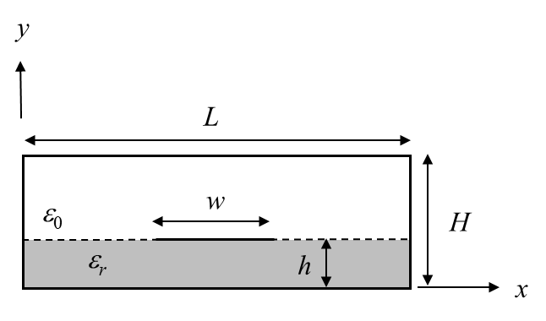

# Fig. 1. Cross section of the microstrip line.

The structure in Fig. 1 is analyzed by the finite difference method, which starts by introducing a finite difference mesh in the cross section, as shown in Fig. 2 below. The square mesh has a cell width and length of Δ. (Figure 2 does not show the actual dimensions of the project; this figure is only a sketch of the geometry, showing a sample mesh.)

Note that there are three types of nodes (points where the horizontal and vertical mesh lines intersect). There are *interior* nodes (located inside the air or dielectric regions, but not on the air/dielectric boundary), *boundary* nodes (located on the air/dielectric boundary), and *conducto*r nodes (located on one of the conductors, either the strip or the outer box).

The strip conductor is assigned a voltage of 1 volt and the outer conducting box is assigned a voltage of zero volts.



# Fig. 2. The structure in Fig. 1 shown with the finite difference mesh.

**Background**

Many problems in electrostatics, such as the one in Fig. 1, involve boundaries that do not coincide with the coordinate surfaces of rectangular, cylindrical, or spherical coordinate systems. Analytical methods may not be useful in these cases, and numerical methods must be employed. A powerful method for solving Laplace’s equation subject to boundary conditions corresponding to conductors of arbitrary shapes is the finite difference (FD) method, which makes use of finite-difference approximations. The method may be used to solve Laplace’s equation, summarized as follows:

* Laplace’s equation (a partial differential equation) is .

This equation is approximated by its finite-difference approximation on a regularly-spaced grid of points covering the region of interest. This approximation expresses the potential at grid points interior to the region in terms of the potentials at neighboring points of the grid. Potentials at grid points on the region’s conducting boundaries are fixed by the boundary conditions.

* The system of finite difference equations constitutes a linear system that may be solved either by standard methods, such as Gaussian elimination, or by iterative methods.

In this project, we will apply the finite difference method to the problem of determining the potential, electric field, capacitance per unit length, and characteristic impedance of the microstrip line. An iterative method will be used to solve the linear system of equations, and this will be done using an Excel spreadsheet.

### Finite Difference Approximation of Laplace’s Equation

Consider finding a solution for the potential in a two-dimensional, charge-free () region bounded by conductors on which the potential is specified. The potential obeys the Laplace equation,



with  given on the conductive boundaries*.* To illustrate, consider Fig. 3, showing an interior node (which could be inside the air region or inside the dielectric region, but not on the air/dielectric boundary). The interior node is at  and its surrounding neighbors are highlighted (in green color) in Fig. 3, and this so-called “computational molecule” is expanded below for clarity.

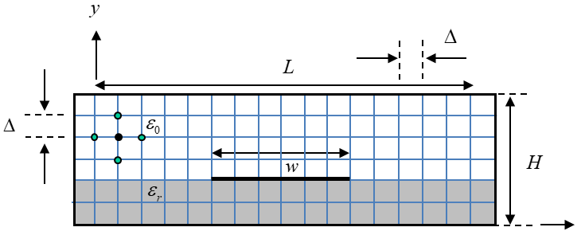



**Fig. 3.** An interior node, surrounded by its neighboring nodes, is shown in the mesh for the structure. Below this is shown an expanded view of a “computational molecule” that is used to derive the finite-difference formula for the potential at an interior node (at point (*x*,*y*)).

We approximate Eq. (1) by using finite difference approximations to the derivatives that appear there. The second order derivatives in Laplace’s equation are approximated by using a central difference approximation assuming that we know the first-order derivatives. The basic central-difference approximation to a derivative is

.

The error in using this formula to estimate the derivative at the point *x* is proportional to . Note that the central difference formula is more accurate than using the “one-sided” difference formula, which is

.

The error in using this (less accurate) formula to estimate the derivative at point *x* is proportional to Δ. This is why we prefer to use the central-difference formula.

If we wanted to calculate the second-order derivative at a point *x* using the central-difference formula, we could use

.

Using the central-difference formula again for the first derivative terms in the numerator, we have

.

or

.

Applying this to our computational molecule shown in Fig. 3, we have

.

Similarly, we have

.

Hence, the finite difference approximation to Laplace’s equation becomes



Solving for  in the above equation, we obtain the result that *at any node is simply the average of the potential at its four nearest neighbors*:

.

Note that Eq. holds at every interior node of the grid used to model the geometry, as long as the node is not on a boundary between two different materials.

If any of the neighboring potential values on the right hand side of Eq. are on a conducting boundary, then their known values appear in Eq. .

The solution is a little more complicated when the node is on the boundary between air and dielectric. This situation is shown in Fig. 4. The solution for the node on the air/dielectric boundary is given in Appendix A. If we assume that we have a node on the air/dielectric boundary at , then the equation for that node (derived in appendix A) is



This is a “modified average” formula. Note that Eq. reduces to Eq. when .

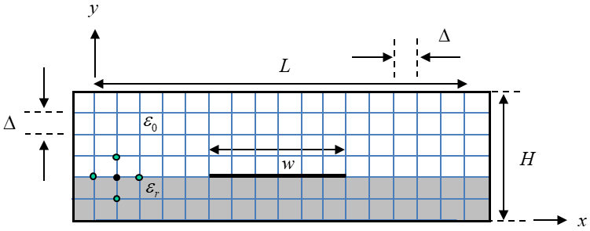

**Fig. 4.** A boundary node is shown, residing on the air/dielectric boundary (at point (*xn*, *yb*)). The four neighboring nodes are also shown.

For all nodes that are on a conductor, the potential is either 1 volt or zero volts, so that value is directly assigned to the node.

We will use an iterative procedure to solve the resulting system of linear equations.

### Iterative Solution Procedure

The system of linear equations generated by applying Eq. at every interior node (and Eq. at a boundary node) (may be solved iteratively by assigning arbitrary initial values (0 [V], for example, is a possible choice) to all interior and boundary nodes, and then applying the averaging condition of Eqs. and to update each interior value successively. After all the interior nodes are updated once, the process is repeated until the nodal potentials converge. Mathematically, this is called “Gauss-Seidel iteration” for solving the linear system of equations. (You are invited to read more about it by searching on the Internet. For example: http://en.wikipedia.org/wiki/Gauss%E2%80%93Seidel_method.)

The iterative procedure may be conveniently handled by using an **Excel spreadsheet**. The necessary steps may be summarized as follows:

* The given conductor potentials are entered as known cell values for all cells representing nodes on the conductors (the strip and the outer box) of the geometry. When there are many boundary nodes to be assigned, the “Cut” and “Paste” features of the spreadsheet program can be used to speed up this process.
* A spreadsheet formula is assigned to each interior node (spreadsheet cell) that expresses its value as the average of its neighboring values. The “Cut” and “Paste” features of the spreadsheet can be used to aid in assigning this formula to each interior node.
* For the nodes at a dielectric boundary, the “modified average” formula is used. Again, the “Cut” and “Paste” features of the spreadsheet can be used to aid in assigning this formula to each boundary node.
* The automatic iterative evaluation of nodal values and the number of iterations can be controlled by setting the spreadsheet parameters. Make sure that your spreadsheet is set to do “Automatic” calculations (make sure that the “Automatic” button is selected under “Workbook Calculation”) and that the check box called “Enable iterative calculation” is checked. (Click on the “office button” and then click on “Excel Options”. Then click on “Formulas” and make sure that “Workbook Calculation” is set to “Automatic”.)

**Note:** *There is a maximum number of iterations that Excel allows when in “automatic” mode. (Click on “Formulas” and then “Calculation Options”.) In Office 365, the default is 32,767 (which you can see by clicking on “File”, then “Options”, then “Formulas”). If the results have not converged after the maximum number of iterations, you may need to have the spreadsheet run through the iteration process multiple times. On a Windows computer, this can be done by clicking the “Formulas” tab, and then the “Calculate Now” button.*

**Important note:** Note that each node (dot) in the finite difference (geometry) mesh corresponds to a cell of the spreadsheet.

### Calculation of Charge Density

After the iteration process is finished, the electric field or other quantities, such as charge density, may be determined from the data. For example, the surface charge density on each side of the strip surface may first be found by using finite differences of the potentials to estimate the normal field components –– and hence the charge density –– along the surface of the strip. Consider, for example, the surface charge density on the top surface of the strip in Fig. 5.

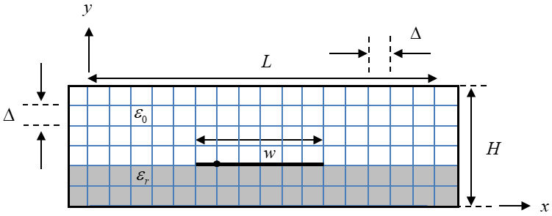

**Fig. 5.** A node is shown on the conducting strip, where the surface charge densities are to be calculated.

The charge may be estimated from the boundary condition on a perfect conductor, which says that



where *D* is the flux density vector at the surface of the conductor, and is the outward-pointing unit normal to the surface of the conductor. Hence, on the top surface of the strip we have

,

where  are points on the strip. Hence, we have

.

Note that we are calculating the derivative at a point that is displaced from the strip by, which is not desirable, but we have no choice since we must use the nodal potential values. (This means that the calculation of surface charge density is probably less accurate than the calculation of the potential function itself.)

Similarly, the charge at points along the bottom surface of the strip are given by

,

so that

.

Thus, by taking finite differences between potentials above/below and on the strip, we may estimate the normal component of the electric field, and hence the normal flux density, which is equal to the surface charge density there.

#### Calculation of Capacitance

#### To calculate capacitance per unit length (in the *z* direction), we use , where is the charge on a one-meter (in *z*) length of the strip conductor. Note that the charge is the sum of the charge on both sides (top and bottom) of the strip. The total charge may be found approximately by appropriately summing the charge densities that are found on the top and bottom surfaces, but a more accurate way is to use Gauss’s law. Using Gauss’s law allows us to maintain a higher accuracy by using a central-difference approximation. The formula is

,

where *C* is the contour shown in Fig. 6 for the structure of Fig. 1. (Note that the contour *C* is equivalent to a closed surface *S* if it is extruded in the *z* direction by one meter.) The nodes are numbered so that *n* = 1 corresponds to the node that is at the left edge of the strip, with node *N* (*N* = 7 in Fig. 6) being the node at the right edge of the strip. The value *ys* is the *y* coordinate of the strip. The Gaussian surface is illustrated below. Applying Gauss’s law, and approximating the gradient on the contour with a finite difference, we have



The first term on the right-hand side of Eq. is the flux coming out (up) of the top of the contour *C*, while the second term on the right-hand side is the flux coming out (down) of the bottom of the contour *C*. The last two terms in the above equation correspond to the flux coming out through the left and right sides of the contour, where the factor of 1/2 comes from the lengths  above and below the air/dielectric boundary on the left and right edges of the contour *C*.

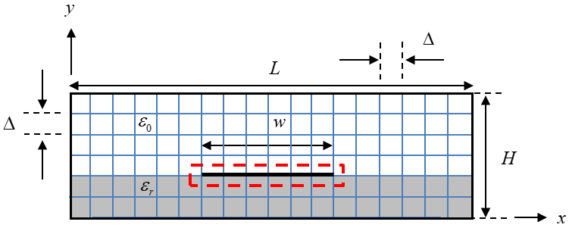

**Fig. 6**. The Gaussian surface (contour) *C* shown for the capacitance calculation. Note that in thie sample figure *N* = 7 (there are 7 nodes on the strip).

Therefore, we have (since ) that



Note that the value of Δ has cancelled out in the final result (Eq. ), so that capacitance does not depend on absolute dimensions. In only depends on the *ratio* of dimensions.

#### Calculation of Characteristic Impedance

Using the capacitance per unit length , we can calculate the characteristic impedance  of the microstrip transmission line. Note that the characteristic impedance involves both the capacitance per unit length  and the inductance per unit length  as

.

We can find the inductance per unit length from the capacitance per unit length, since the phase velocity  of a wave on the transmission line is known, and therefore

 ,

where the effective relative permittivity of the microstrip line can be calculated by using

,

where  is the capacitance per unit length of the microstrip line after we have set . (In this case there are no boundary nodes. Hence, we use the simple averaging formula for all nodes that are not on a conductor.) Equation gives us

.

We therefore have, from Eq. , that



or

.

#### Geometry for Project

The specific geometry (microstrip line) to be analyzed in this project is shown in Fig. 1. Assume that

.

Assume the following dimensions:



where the integers are chosen as



This gives us



Also, assume that

,

where *m* is an adjustable integer (which is used to control the mesh density). Note that the number of nodes *N* on the strip (which is one more than the number of segments on the strip) is given by

.

Hence,

.

As an illustration, in Fig. 2 this sample figure has *m* = 2, , , , and . (These are not the values for the actual project; these values are only for the structure shown in the figure.) Examine Fig. 2 carefully and make sure that you understand the meaning of these integers.

There is a potential difference between the strip and box walls of 1.0 [V]. Hence, the potential of the strip may be taken to be 1.0 [V] while the walls are at 0 [V]. The value of *N* will vary in the tasks below.

Note that the actual value of Δ in meters does not come into play in any of the computations below, except when calculating the charge density on the strip. For the charge density calculation, you may assume  [m] and hence  [m].

**Warning:** In performing these tasks, you should ensure that a sufficient number of iterations have been taken so that the solution for the potentials, and hence all of the results that come from the potentials, converges to at least four significant figures. Please see the note on p. 6 about controlling the number of iterations.

# TASKS

Please read each task below carefully to make sure that you are doing everything that is indicated.

# Task 1

For the case  (for which the number of nodes on the strip is equal to ), make a plot of the equipotential contours using the spreadsheet’s plotting capabilities. Excel, for example, allows one to plot a “contour” plot, in which regions between equipotential levels are shown in colors, corresponding to ranges of potentials. (As a suggestion, using a gray scale for the colors (using different shades of gray for the different regions would look nice.) The potential should change by the same amount over each region. That is, there should be the same voltage difference from one color region to the next.

Starting with this contour plot, draw in (by hand) flux lines, in order to make a flux plot. You can draw the lines by hand using a colored pen, or you can draw them by hand using a drawing tool, e.g., in Word or PowerPoint. As you do so, remember the following rules:

1. Flux lines go from positive to negative charges (and also from higher to lower potential).
2. Flux lines must remain perpendicular to the equipotential lines.
3. Flux lines should be perpendicular to a conductor boundary (because the tangential electric field is zero there). This includes both the strip and the outer box.
4. The ratio of length to width for each “curvilinear square” should be a constant. Take the constant to be unity in your plot.

# Note that the spacing between the flux lines will change as you go from below the strip to above the strip, since the electric field and the flux density vector will be stronger in the region below the strip.

# Task 2

For the case  (), calculate the surface charge density in [pC/m2] both on the strip’s top and bottom surfaces at each node on the conductor using Eqs. and . For this calculation, some dimension must be given; assume  [m] and hence  [m]. Add the surface charge densities on the top and bottom surfaces to get the total surface charge density. Make a table of charge densities showing the three surface charge densities (top, bottom, and total) versus node point *n* on the strip, with *n* going from 1 (at the left edge of the strip) to 17 (the right edge of the strip). Then make a plot that shows these three charge densities. In the plot, normalize the bottom axis scale so that the bottom axis goes from -0.5 [m] (left edge of the strip) to 0.5 [m] (right edge of the strip).

# Task 3

Calculate the capacitance per unit length  of the microstrip transmission line (in [pF/m]), using  (). Then let  and repeat the calculation to obtain the capacitance per unit length (in [pF/m]) (you will need this for Task 5).

# Task 4

Calculate the capacitance per unit length  of the structure using the simple *parallel-plate capacitor formula*. Note that the plate area “*A*” in the usual formula  for the total capacitance of a capacitor should be replaced here with *w*, since we are talking about capacitance per unit length. Hence, we have

.

Compare with the value  obtained from Task 3 (using units of [pF/m] for both values). Note that we do not expect this simple parallel-plate capacitor formula  to be a very accurate approximation for , since the formula for  assumes that the plates are very large compared to the separation (i.e., ), which is not the case here. That is okay; the purpose here is to see how much error there is in using Eq. , because of the fringing of the fields at the edges of the capacitor and the charge build up near the edges of the capacitor. We expect a lot of error.

# Task 5

* Using your values of capacitance per unit length  and  from task 4, calculate the characteristic impedance  of the microstrip transmission line using Eq. . Compare with the approximate CAD formula given in Appendix B.

**Points of discussion**

Here are some points to consider when discussing your results in the Task sections and the conclusions. Feel free to discuss more than this, but these points should be considered.

* How does the flux plot deviate from what would be expected for an ideal parallel-plate capacitor?
* How does the surface charge density on the top surface of the strip compare with that on the bottom surface? Is this what you would expect?
* How does the charge density behave as you approach the sharp edges of the strip (a knife edge)? Theoretically, how should the electric field and the charge density behave as we approach a knife edge?
* How does your characteristic impedance result compare with that obtained by using the CAD formula in Appendix B?

##### Grading

The project will be graded on the accuracy of the results, the quality of data presentation in the report, neatness, and the quality of discussion and interpretation of results. The report must be done using a word processor. This includes the equations. It is suggested that you use MathType to make your equations. The only part that is allowed to be done by hand is the step of drawing the flux lines on the flux plot.

The report should contain the following sections:

* A cover page containing the project title, name of class (ECE 3318), your instructor’s name, your name, and any other information that you want to include.
* An Abstract. This should be no more than about one paragraph long, in which a very concise summary of the entire report is given.
* An Introduction. This should be limited to no more than about one-half page in length. Explain what the purpose of the project is, and what the main objectives are. Give some background and motivation (but do not copy directly from what is already written here in the project description!).
* A Results section, subdivided by tasks. For each task, *include a discussion (at least one paragraph) interpreting the data.*  Note that your grade depends in part on your making good observations concerning the results.
* A Conclusion section. This should be limited to about one-half page in length. Summarize the main conclusions that you reached while doing this project.
* A References section. Put here any references that you cited in your report.

The project should use a 1.5 line spacing and a Time Roman 12-point font (the same format as this project description is written in).

The project will be graded mainly on the accuracy of the results and the quality of the discussion –– not on length. Do not try to add more length than is necessary. However, your grade will depend on the quality of your discussion as you interpret the results. Make sure that you have enough discussion to adequately make meaningful interpretations and conclusions, both in the Tasks and Conclusions sections.

It is expected that your report will be written using adequate grammar and writing style, and this will also be a significant part of the grading. This should be the type of report that you would feel comfortable turning into your supervisor if you were an engineer doing this as a job assignment. Write accordingly.

**Academic Honesty Statement**

You are expected to work individually on the project, and to not give or receive any material to/from anyone else except the instructor. All of the results that you generate must be completely your own, and all of the writing that you do for the report must be completely your own. Do not accept anything related to the project from anyone else (including students who have taken the course previously). To do otherwise will be considered a violation of the UH Academic Honesty Policy.

When you submit your project, you must include a separate page at the end of the report, with the following sentence: “This project represents completely my own work, and I have abided by the University of Houston Academic Honesty Policy in doing this work and writing this report.” After this sentence, you must sign your name.

**Appendix A**

**Modification of the Finite Difference Equation to Account for the Dielectric Boundary**

For boundary nodes that are on the horizontal boundary between air and the dielectric, we can apply Gauss’s law as we did in Fig. 6 and Eq. , except that this time we apply it to a Gaussian surface that surrounds a single node at the boundary (at a node on the boundary at a point where there is no strip), so there is no charge enclosed.

This gives us



The value  denotes the *y* coordinate of a node on the boundary. The factor of 1/2 in the above equation is due to the fact that for the left and right sides of the Gaussian surface, half of each side is in the air region and half is in the dielectric region. Collecting terms, this equation then gives us the result



Finally, from this we then have



Note that this result is a generalization of the result given in Eq. , and the above result reduces to the result in Eq. when .

**Appendix B**

**CAD Formula for a Microstrip Line**

This approximate CAD formula for  assumes that :

 ,

where

 .