**Signature _________________________________________________________**

**Name (print, please)_______________________________________________**

**Lab partner’s name_________________________________________________**

**Date(s) and time(s) lab was performed____________________________________**

**ECE 3155**

**Experiment VI**

**BJT Transistor Amplifiers**

Rev. dps mar2025

The transistor is the basic building block for most of electronics. Transistors of one sort or another are used to build up operational amplifiers and most other integrated circuits. One of the favorite types of transistors is the Bipolar Junction Transistor, or BJT. In this exercise you will use the BJT to amplify ac signals. The intention here is to allow you to become familiar with the working principles of basic transistor amplifiers.

BJTs are available as discrete components as well as integrated circuits. While designs with discrete components are not common, an understanding of the behavior of the discrete components allows one to use integrated circuits that incorporate BJTs wisely. If you understand how the BJT works, you better understand its limitations and strengths. In addition, while you may not actually perform the designs yourself, you may be called upon to trouble-shoot or modify existing designs using discrete BJTs. Finally, although unlikely, you may find yourself in a situation where the integrated circuits needed are not available or affordable.

Most of these experiments in this exercise do not address design principles per se; their purpose is to illustrate the behavior of transistor amplifiers. It is hoped that this will give you some of the insight needed in design. Try to discern the pattern, or underlying theme of the measurements. Many considerations come into play in transistor amplifier design and many of the aspects interact with each other. In these experiments, we will try to isolate many of these considerations.

BJTs exhibit four modes of operation. For linear (or “active” mode) operation, the emitter-base junction is forward biased and the collector-base junction is reverse biased. Transistors operating in the linear region are generally used for amplification, since the collector behaves like a dependent current source.

The emitter-base junction and the collector-base junction are forward biased during operation of the transistor in the “saturation” mode. Typically, we like to think that large base currents will saturate most transistors. In fact, the exact value that saturates a transistor depends on the value of the external components to which the transistor is connected. The situation is analogous, but not identical, to saturation in operational amplifiers. The voltage between the collector and the emitter in saturation, *VCE*, is almost independent of the collector current, *IC*, when the transistor is in saturation. The value of the voltage *VCE* in the saturation region is a relatively small value, typically in the range 0.1[V] to 0.3[V]. Thus it is often thought of as a switch in the “on” position.

For operation in the “cutoff” mode, both the emitter-base junction and the collector-base junction are reverse biased. In this case, all the currents in the transistor are zero. This is like a switch in the “off” position. So, transistor switches operate by simply flipping back and forth between the “on” and “off” states.

BJTs also operate in the reverse active mode, in which the base-collector is forward biased and the base-emitter reverse biased. This mode is rarely used and will not be discussed further here.

A transistor biased in the linear region can be modeled with a small signal equivalent circuit, assuming only small signals are applied. A first order small signal model is given in Figure 5.51(b) in Sedra and Smith, 5th Ed., p. 448. (### Need reference to 8th Edition.###) This model will be sufficient for the work in this laboratory. When the terms input resistance or input impedance are used, they refer to the ac resistance or impedance seen at the input with the load in place. These terms concern signal quantities only. They specifically do not include dc components of voltages or currents; they are the ac component of the voltage divided by the ac component of the current at the input. The output resistance or impedance is defined in a similar way but with respect to the output and with the source in place.

Each of these resistances or impedances is found in the same way that Thevenin equivalent resistances or impedances are found. However, sometimes an amplifier will not behave normally under short-circuit conditions. In such cases it is much more accurate, and indeed easier, to use a resistance substitution box to find the series resistance at the input which gives a factor-of-two drop in voltage at the amplifier input; this value will equal the input resistance of the amplifier. To find output resistance, one can apply the resistance substitution box in place of the load resistance and find the value at which the output is half the open-circuit voltage. This value will equal the output resistance.

There are three configurations in which the transistor is used as a single stage amplifier. In the first, the input is applied at the base, and the output is taken at the collector. In this case, the emitter leg is common to the input loop and the output loop, and this amplifier configuration is called the common-emitter amplifier. In the second, the input is at the base, and the output at the emitter; this is referred to as the common-collector configuration, or emitter-follower. In the third configuration the input is applied at the emitter and the output taken at the collector, which is called the common-base configuration.

***Components Required***

(2) npn transistors, with relatively large  (>50)

***Resistors: Capacitors:***

(2) 1 [k] (1) 1 [F]

(2) 2.2 [k] (2) 10 [F]

(1) 5.6 [k] (1) 47 [F]

(1) 8.2 [k] (1) 100 [F]

(3) 10 [k]

(1) 22 [k]

Resistance substitution box

***Procedure***

**Part A. The Common-Emitter Configuration**

1. Calculate all the dc node voltages and branch currents for the transistor amplifier shown in Figure 1. Make sure the amplifier is biased in the linear region. For your calculations you can assume that ** for the transistor is 100 and that the *VBE* is 0.7[V]. Record your answers below.

2. Calculate the ac voltage gain *vl/vs*, the input resistance *rin*, and the output resistance *rout*. Use the equivalent circuit from the textbook mentioned in the introduction. Use the value of the dc currents that you calculated in step 1 to obtain the value of *r*. Record your answers below.

3. Build the circuit of Figure 1 on your prototyping board and connect it to the dc power supply. For the time being, do not connect the signal source. Measure the dc voltages at the transistor terminals and record them below. Do they agree with your calculations? This is a good first test of any transistor amplifier. From just three measurements you can determine whether the transistor is actually biased in the linear region.



**Figure 1.** Common Emitter Amplifier. The 1[F] capacitor, enclosed in a dashed line, will be added in step #7.

4. Apply a sinusoidal signal source at a frequency of 1[kHz]. Start with as low an amplitude as you can apply. Then, turn up the amplitude until it is easy to measure but not so much that the output distorts. By “distortion” we mean that the shape of the output and the input are not the same.

5. Measure the voltage gain, input resistance, and output resistance. Compare these values with your calculated values and find the percent error in your calculations. (Remember that your calculations are approximations. Your measurements are your best possible estimates of the “real world,” and are therefore the goal against which your calculations should be compared.)

|  |  |  |
| --- | --- | --- |
| *Av, calc*= | *Av, meas*= | % error= |
| *rin, calc*= | *rin, meas*= | % error= |
| *rout, calc*= | *rout, meas*= | % error= |

6. The 3[dB] bandwidth of an amplifier is the frequency range over which the amplifier gain is within 3[dB] of the gain in the passband. The passband is a somewhat arbitrarily defined range in frequency over which the gain is usually largest, and fairly constant. Find the 3[dB]-bandwidth for your amplifier.

7. Return your frequency generator to 1[kHz]. Connect a 1[F] capacitor between the emitter and ground. This is called a bypass capacitor; it will significantly increase your gain. You may have to reduce your amplitude to obtain an undistorted output. Measure your gain and bandwidth. You should note some advantages and disadvantages to the bypass capacitor. Summarize your findings in a few short sentences.

8. Remove the bypass capacitor and turn down the input sinusoid to a value well below the maximum possible. Replace the 2.2[k] collector resistor, *RC*, with a resistance substitution box set to the same value. Increase the collector resistance slightly, and monitor the gain. Compare the gain to the ratio of *RC* and *RE*. Now, increase *RC* even further and note the relationship to the gain at very high values. What happens at very high values of *RC*?

**Part B The Common-Collector Amplifier**

9. Calculate the dc node voltages and branch currents for the transistor amplifier shown in Figure 2. Make sure the amplifier is biased in the linear region. Assume that ** for the transistor is 100 and that the *VBE* is 0.7[V]. Record your answers below.

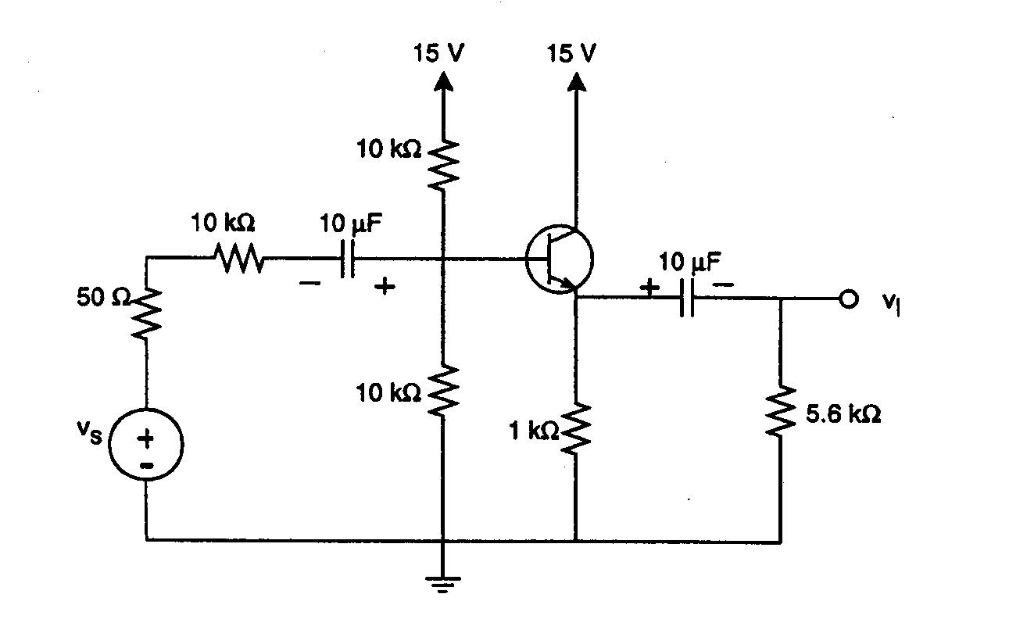

**Figure 2.** Common Collector Amplifier.

1. Calculate the voltage gain *vl/vs*. Calculate the input resistance *rin* and the output resistance *rout*. Use the value of the dc currents that you calculated in step 9 to obtain the value of *r*. Record your answers below.
2. Build the circuit in Figure 2 on your prototyping board, and connect it to the dc power supply. For the time being, do not connect the signal source. Measure the dc voltages at the transistor, and record them below. Do they agree with your calculations?

12. Now apply the signal source at a frequency of 1[kHz]. Start with as low a signal as you can apply. Then, turn up the amplitude until it is easy to measure but does not distort.

13. Measure the voltage gain, input resistance, and output resistance. Compare these values with your calculated values, and find the percent error in your calculations. It may be difficult to measure the output resistance accurately since it is so low the output often distorts when such a small load resistance is attached. Find a value for the load that allows a reasonably accurate estimate of the output resistance. This means that you will have to use a larger value of resistance than the actual output resistance and apply the voltage divider rule.

|  |  |  |
| --- | --- | --- |
| *Av, calc*= | *Av, meas*= | % error= |
| *rin, calc*= | *rin, meas*= | % error= |
| *rout, calc*= | *rout, meas*= | % error= |

**Questions**

The amplifier configuration not tested here was the common-base amplifier. What sort of voltage gain and current gain are possible with a common-base transistor amplifier? What input and output resistances are likely? Compare the usefulness of this configuration to the ones used in this lab. This question may require some research into the text or other sources. Try to give a complete yet concise answer.

**To the Student: We are no longer using Pre-laboratory exercises as a tool for guiding student work. This page is left here, in case a return to pre-laboratory exercises is considered. You may ignore this page.**

***Pre-Lab***

Part A, Steps 1 and 2: Calculate the dc bias point and ac parameters for the BJT amplifier in Figure 1, as described in these steps. Note that for this step there is no bypass capacitor.

Part A, Step 7: Calculate the gain of the BJT amplifier of Figure 1, but with the bypass capacitor in place.

Part B, Steps 9 and 10: Calculate the dc bias point and ac parameters for the BJT amplifier in Figure 2, as described in these steps.