Name: _____________________________ (please print)
Signature: __________________________

ECE 3455 Electronics
Exam #2 -- November 14, 1998

DO NOT OPEN THIS QUIZ BOOKLET UNTIL YOU ARE TOLD TO BEGIN

1. This examination is open book and open notes. Any calculator may be used.
2. You will have 90 minutes to complete this exam.
3. Show all work on these pages. Show all work necessary to complete the problem. If your work goes on to another page, indicate this with a note. A solution without the work shown will receive no credit.
4. Use appropriate notation.
5. Show units in all answers and in all major intermediate results. Units in the examination questions will be enclosed in square brackets.
6. Do not use red ink. Do not use red pencil.

1) ______________/40
2) ______________/30
3) ______________/30

Room for extra work
1) (40 Points) Assume that all 3 diodes can be modeled with a piecewise linear model with rd = 0, Vf = 1.0[V], and Is = 0. State your assumptions, and test them, showing your tests. Find VX if
a) VIN = 2[V]
b) VIN = -2[V]
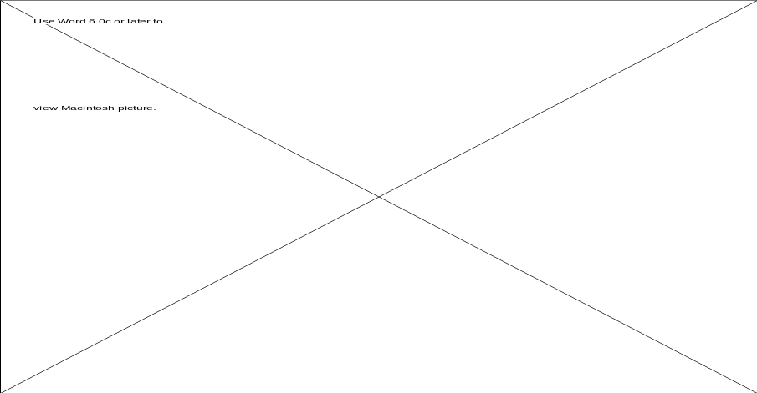
Room for extra work

2. (30 Points) Assume an ideal op-amp, and a transistor with VCESAT = 0.2[V] and ß = 100. Find VX. State your assumptions, and test them, showing your tests. (A hint: If the transistor is in the saturation or in the linear region, you will have negative feedback for the op-amp. If the transistor is in the cutoff region, you will not have negative feedback for the op-amp.)


Room for Extra Work
3) (30 Points) Design a circuit that will produce a square wave. Your circuit should require no inputs other than dc power supplies. You may use ideal op-amps, ideal diodes, and any resistors, capacitors, inductors, or power supply values that you like.
a) The repetition frequency of your output should be 4.7[kHz].
b) The highest voltage of your output should be +5[V], and the lowest voltage should be -15[V]. In other words, you should have a 20[Vpp] square wave, with a -5[V] dc component.
Show calculations to verify that your design meets these specifications.
Room for Extra Work

Solution:


