Name: _____________________________ (please print)
Signature: __________________________

ECE 3355 –Exam 2
November 19, 2011

Keep this exam closed until you are told to begin.

1. This exam is closed book, closed notes. You may use one 8.5” x 11” crib sheet, or its equivalent.
2. Show all work on these pages. Show all work necessary to complete the problem. A solution without the appropriate work shown will receive no credit. A solution that is not given in a reasonable order will lose credit. Clearly indicate your answer (for example by enclosing it in a box). If your answer is a plot, no box is needed.
3. It is assumed that your work will begin on the same page as the problem statement. If you choose to begin your work on another page, you must indicate this on the page with the problem statement, with a clear indication of where the work can be found. If your work continues on to another page, indicate clearly where your work can be found. Failure to indicate this clearly will result in a loss of credit.
4. Show all units in solutions, intermediate results, and figures. Units in the exam will be included between square brackets.
5. Do not use red ink. Do not use red pencil.
6. You will have 90 minutes to work on this exam.

1. ________________/30
2. ________________/30
3. ________________/40
Total = 100
Room for extra work
1. {30 Points} Assume that the diodes can be modeled using a piece-wise linear diode model with V_{f} = 1[V], r_{d} = 1[kΩ], and I_{s} = 1[mA]. Find V_{X}. Show your work, stating your tests explicitly. Define all variables appropriately. You are expected to be able to complete at least three guesses, if needed, in the time period allotted.

Room for extra work

2. {30 Points} Assume that for both transistors, β = 100. Show your work, stating your tests explicitly. You are expected to be able to complete at least two guesses in the time period allotted. Find V_{A} and V_{D}. Assume that the source v_{I}(t) is

Room for extra work

3. {40 Points} Use the circuit below to solve this problem. Assume an ideal op amp. Assume that for the transistor, β = 100. Find V_{O} for the following inputs.
a) V_{I} = 5[mV].
b) V_{I} = -5[mV].
c) V_{I} = -5[V].
d) V_{I} = 5[V].

Room for extra work

Solution:
1. {30 Points} Assume that the diodes can be modeled using a piece-wise linear diode model with V_{f} = 1[V], r_{d} = 1[kΩ], and I_{s} = 1[mA]. Find V_{X}. Show your work, stating your tests explicitly. Define all variables appropriately. You are expected to be able to complete at least three guesses, if needed, in the time period allotted.
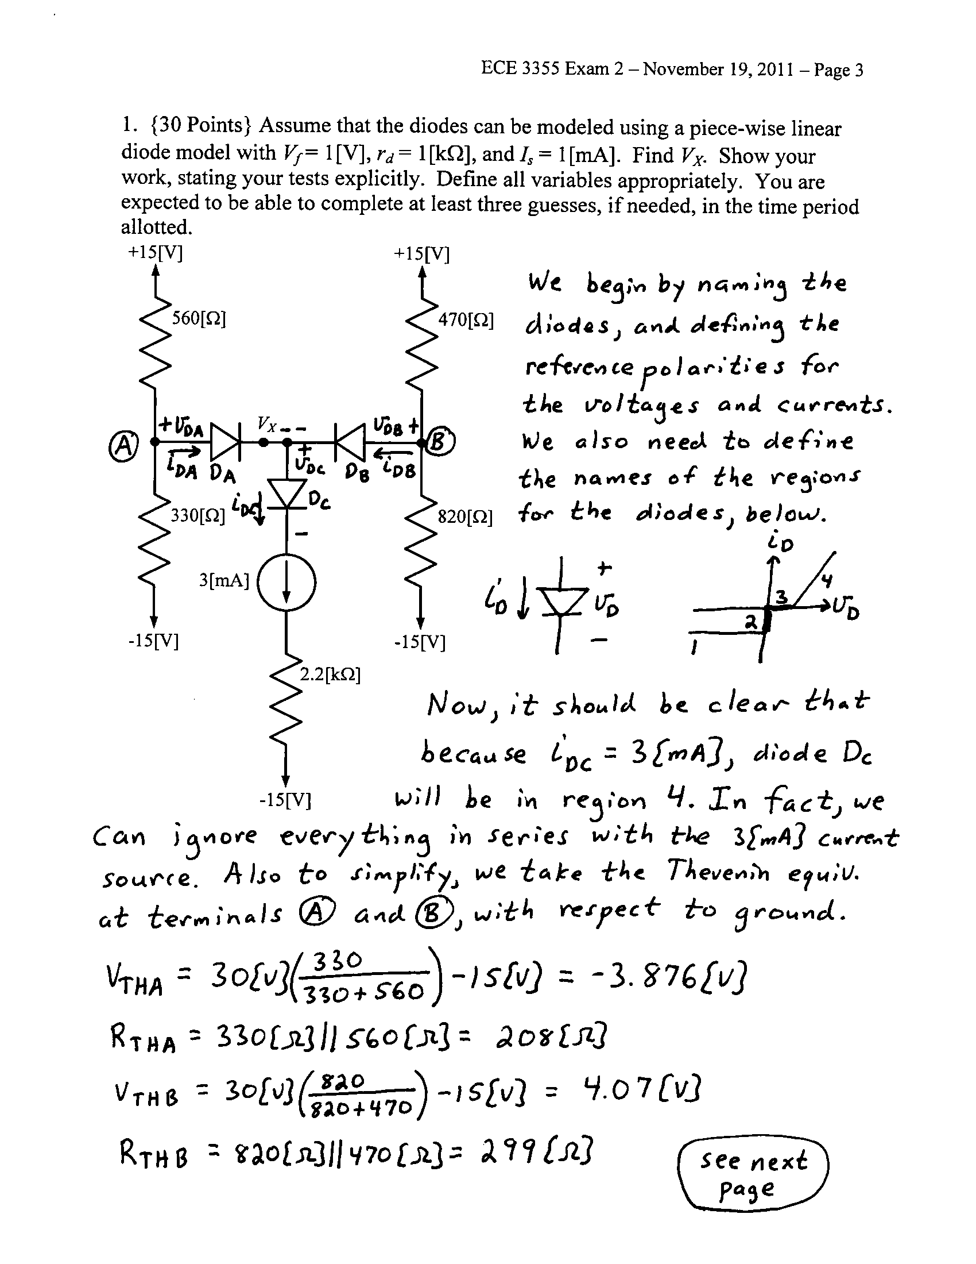

2. {30 Points} Assume that for both transistors, β = 100. Show your work, stating your tests explicitly. You are expected to be able to complete at least two guesses in the time period allotted. Find V_{A} and V_{D}. Assume that the source v_{I}(t) is
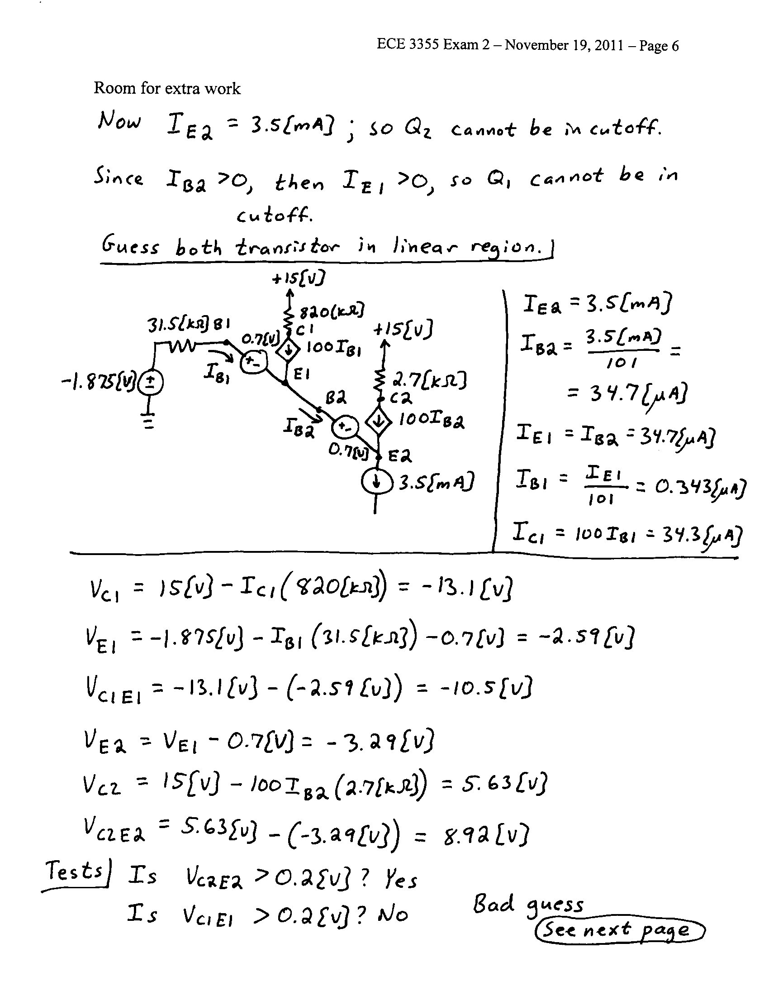
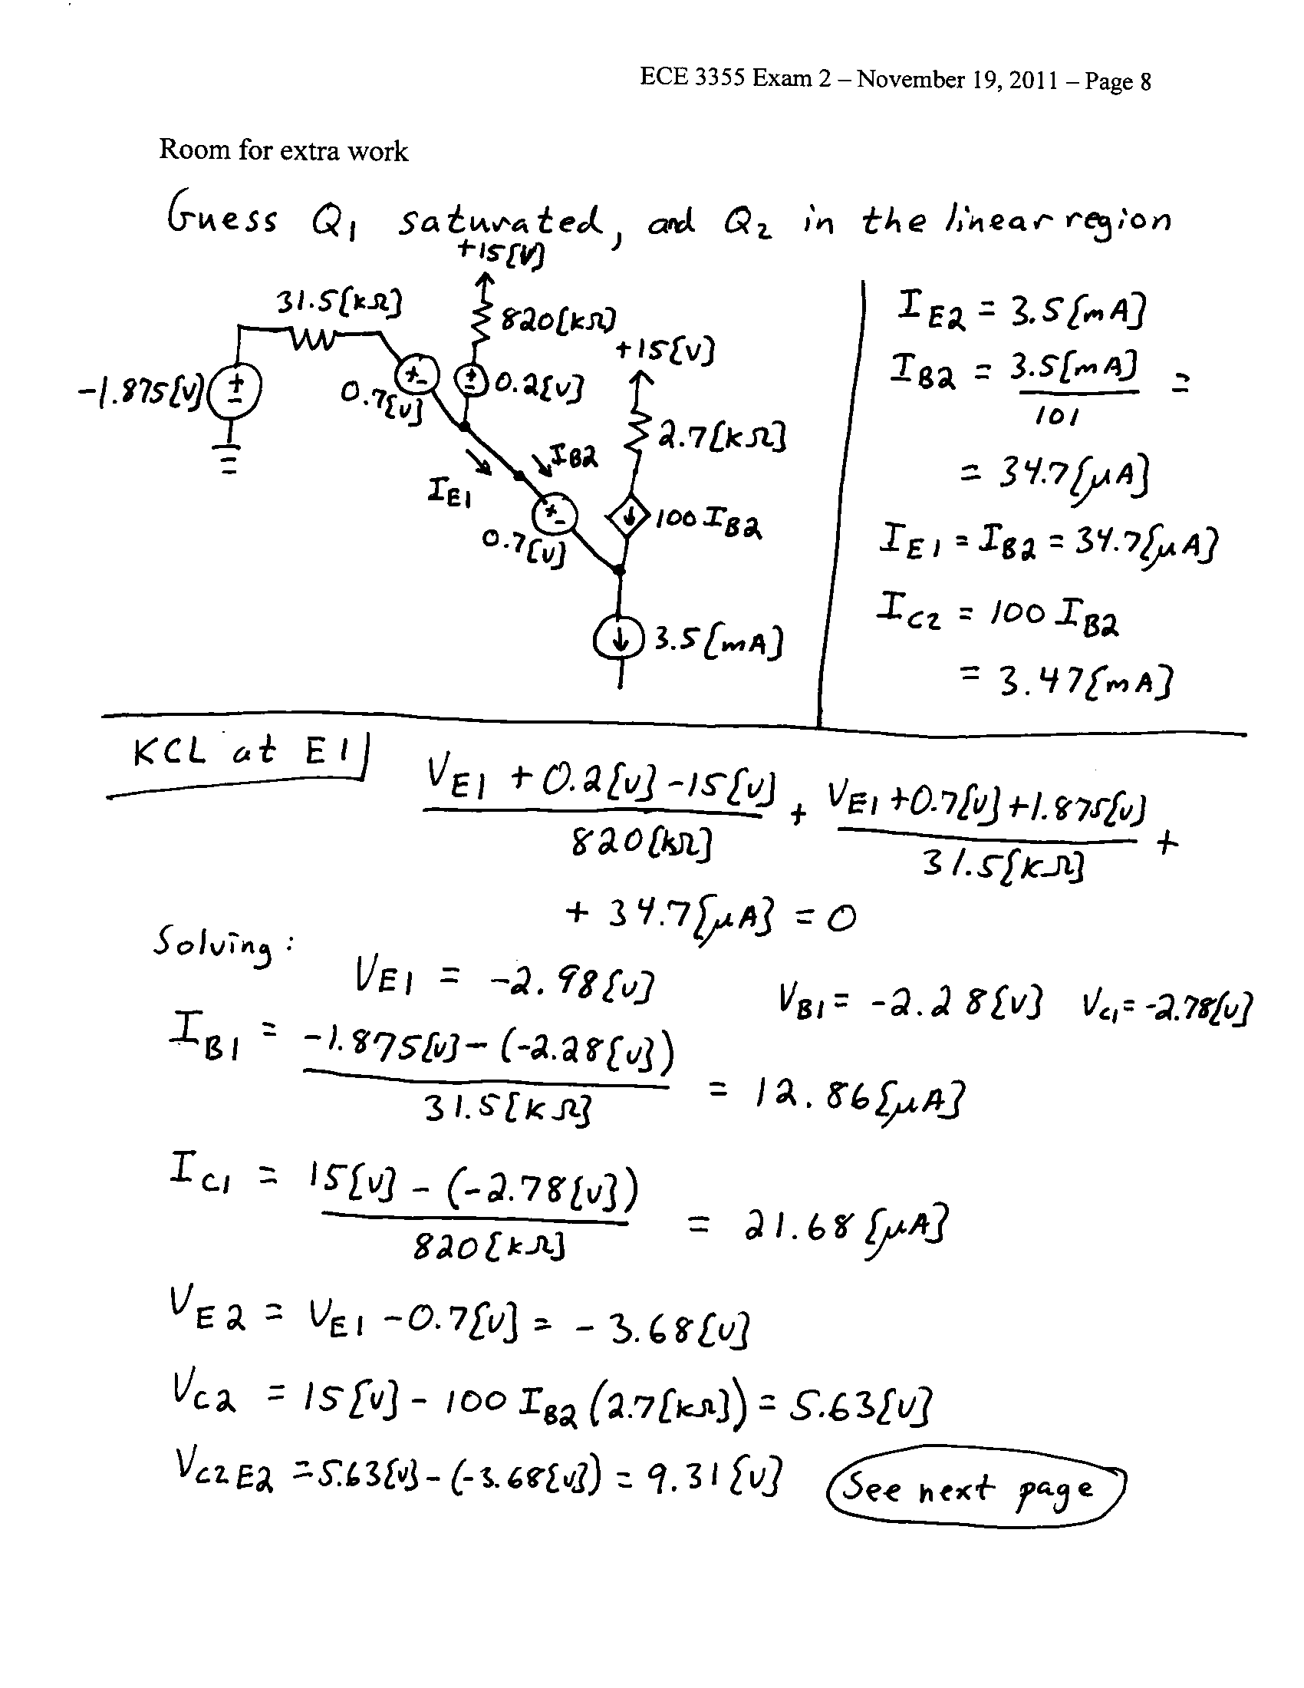

3. {40 Points} Use the circuit below to solve this problem. Assume an ideal op amp. Assume that for the transistor, β = 100. Find V_{O} for the following inputs.
a) V_{I} = 5[mV].
b) V_{I} = -5[mV].
c) V_{I} = -5[V].
d) V_{I} = 5[V].
