Op amp characterization and applications

Before you start, copy the SPICE model for LM741 provided on Blackboard into the sub folder in LTspice. The path must be something like C:\Program Files\LTC\LTspiceXVII\lib\sub
When you open a new schematic and would like to use this op amp model, first use spice directive to add the statement: .lib lm741.sub, then pick the opamp2 component, under [Opamps]. Once you place it on the schematic, right click on the opamp2 symbol and replace “opamp2” with LM741 for the Value. Now you are ready to use the op amp with LM741 SPICE model.

Op amp Non-idealities

In general, op amp’s behavior is very close to its ideal behavior in a wide range of useful circuits. However, real op amps have imperfections which can be a problem in certain circuits. In this project, you will need to characterize a commercial op amp, LM741.

1. Finite gain: Ideal op amp has infinite open-loop gain. However, all practical op amps have finite open-loop gains. Let’s first start by finding the open loop gain. Run a DC sweep on the following circuit. Sweep input voltage from -2mV to +2mV. Since there is no negative feedback, a very little input voltage will be enough to saturate the op amp. So we need to keep the range pretty small.

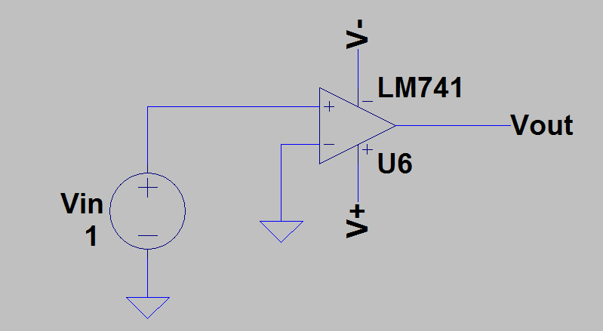
Figure 1

Find the open loop gain, Ao in [dB]. What is the output voltage when Vin = 0? Is it as you would expect? Explain why.

2. DC offset voltage: Inside an op amp, there is a symmetric structure. Theoretically, the symmetry is perfect with no mismatches. In reality, there are mismatches. As a result, an op amp’s output is not precisely zero when $v^{+}=v^{-}.$ The DC output voltage when $v^{+}=v^{-}$ is called the output offset voltage. When the output offset voltage is divided by the op amp gain, we get the input offset voltage, $V_{OS}$.

Set up the following circuit, then apply operating point analysis (.op) to find the DC output voltage. Divide that value by the non-inverting amplifier gain, and find $V_{OS}$.

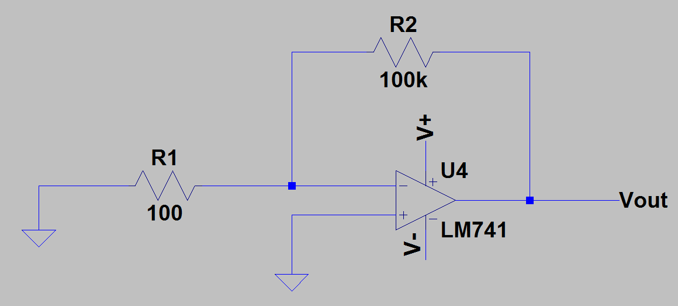
Figure 2

3. We can null the DC offset voltage by externally adding a DC voltage source with opposite polarity. (This works in simulation, but in practice, you place a potentiometer in between the offset null terminal pins of the op amp, and adjust it to make the output voltage equal to zero.)

Now connect a DC voltage source to the non-inverting terminal of the op amp in Figure 1 to cancel out the offset voltage. Be careful with the polarity of the voltage source that you connect. Apply DC sweep again. Note that, now you will have 2 voltage sources connected in series at the non-inverting input terminal. One to cancel out the DC offset, the other one is the input voltage source. Plot Vout vs. Vin. What do you observe?

4. The open-loop gain is not only finite, but it is also a function of frequency. As a matter of fact, the open-loop gain decreases with frequency. Let’s find the bandwidth of the LM741. In Figure 1, keeping the offset nulling voltage source, set the DC input voltage value to 0V and the AC source value to 1. Run an AC simulation from 1[Hz] to 10[MHz]. What is the low frequency gain? What is the bandwidth?

5. Now connect an input voltage source and the offset nulling voltage source to the non-inverting terminal of the op amp in Figure 2. Run an AC analysis and plot Vout. What is the gain? What is the bandwidth?

6. Do the same as you did in step 5, but change R2 to 10[kΩ]. Now plot the Vout from step 4, step 5 and step 6 all in one plot. Right click on y-axis and make the bottom range equal to 0[dB]. Right click on the right vertical axis, and chose the option “don’t plot phase”. With all 3 magnitude responses of 3 different circuits on the same plot, what do you observe? Compute the GBW (Gain $×$ Bandwidth) for those 3 circuits. Using the graph, find the value of the frequency where magnitude becomes 0[dB]. Comment on the results.

7. Slew rate: The response of an op amp to a change in the input is ideally instantly. In practice, there is a delay from the input to the output. Slew rate (SR) is the maximum rate at which an op amp can change its output. So if the input signal is a 5V peak-to-peak square wave, an op amp with an SR of 0.5V/μs will take 10μs to change its output voltage, from one level to another.

To measure the SR of LM741, set up a voltage buffer (unity-gain) circuit as shown below. Drive the buffer with a square wave input signal, Vin. Set Vin to have an amplitude of $±$10V, a 1μs delay, 10ns rise and fall times, a pulse width of 100μs and a period of 200μs. Run a transient analysis. Set the maximum timestep to be 100ns. Simulate for a period of the square wave. Plot Vout and Vin vs. time and determine the slew rate.

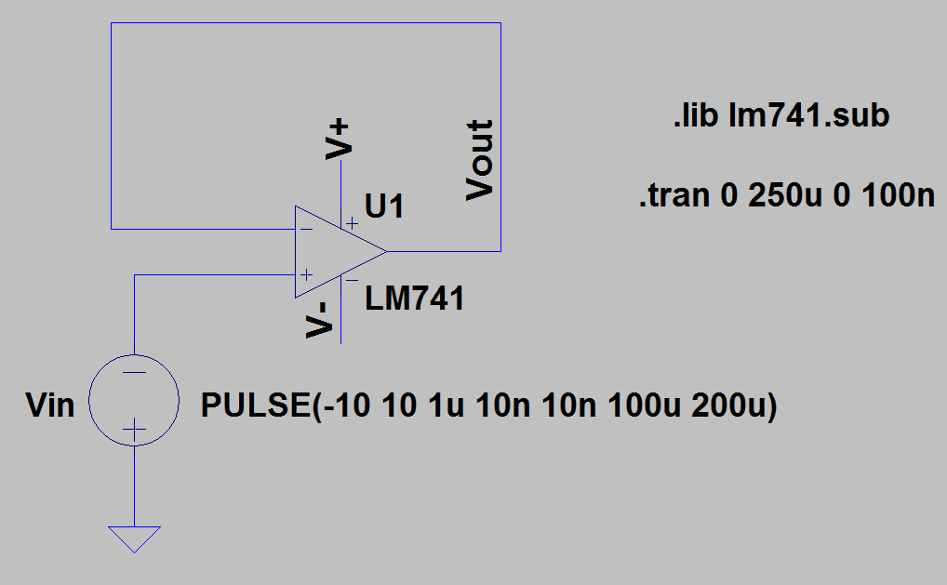
Figure 3

8. Input resistance: An ideal op amp has infinite input resistance, R_{i}. However, a real op amp has finite input resistance. In order to find the differential input resistance, apply a test current source in between the op amp terminals as shown in Figure 4, and then run AC analysis. Determine Ri at 100[Hz].

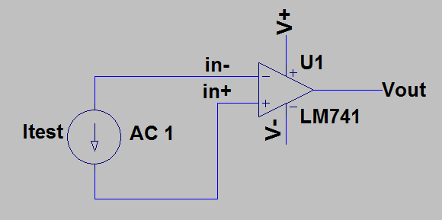
Figure 4

9. Create a table and compare the values that you found in steps 1 through 8, with the values provided in the data sheet. Are the values that you got as expected?

Design of an Instrumentation Amplifier

An instrumentation amplifier is typically used to amplify the signal produced by a transducer such as a thermocouple or a strain gauge. An instrumentation amplifier is a difference amplifier i.e., it amplifies the voltage difference between its two input terminals while suppressing common-mode signals. An instrumentation amplifier should have the following characteristics: high input impedance, high differential voltage gain, and low (ideally zero) common-mode voltage gain, i.e. high common-mode-rejection-ratio (CMRR).
Design an instrumentation amplifier using LM741 model for the op amps. Pick the resistor values such that a differential voltage gain of 50 will be obtained. Perform two different types of analyses.

1. First apply AC analysis to plot the differential voltage gain, $A_{d}$ and the common-mode voltage gain $A_{cm}$ versus frequency. To do that, you need to run AC analysis twice: First apply a differential signal to measure $A_{d}$. In order to apply a differential signal, you can connect a 0.5[V] AC voltage source to one of the input terminals of the instrumentation amplifier and a -0.5[V] AC voltage source to the other input terminal. Alternatively, you can connect a 1[V] AC source in between the two input terminals. Then plot $A_{d}$ versus frequency. To measure $A_{cm}$, apply AC voltage sources with a value of 1[V] from each input terminal to ground (which will serve as the common-mode signals) and plot $A_{cm}$ versus frequency. Only plot the magnitude responses. What are the values at 100Hz? Calculate CMRR at 100Hz. Measure the differential input resistance.

2. To see what an instrumentation amplifier does, apply transient analysis and plot input and output voltages vs time. Noise signals will be the common-mode signal and they will be superimposed on a differential signal which is a 100Hz sine wave with an amplitude of 1mV. $v_{1}$ and $v_{2}$ will be the input signals to the instrumentation amplifier. Provide plots of $v_{1}$ and $v_{out}$versus time. Comment on results.

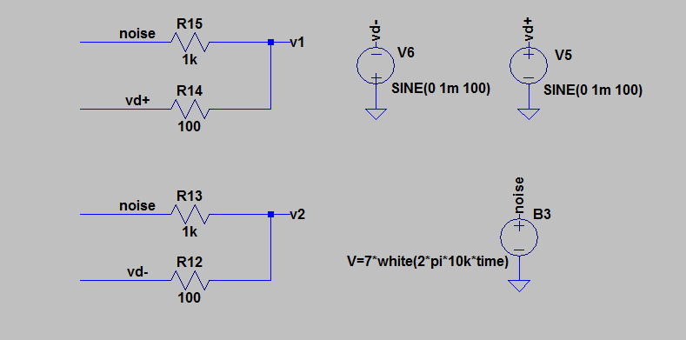
Figure 5

Design of a Digital-to-Analog Converter (DAC)

Digital-to-Analog Converters (DACs) and Analog-to-Digital Converters (ADC) are important building blocks in any electronic system. They serve as the interface between the analog signal and the digital systems such as microcontrollers or PCs. An ADC takes an analog signal – generally acquired from a sensor - and converts it into a binary code. A DAC on the other hand, takes a binary code as its input and converts it into an analog signal at the output. Sensor signals generally vary within a given range. The output of a microphone for instance, gives a voltage between 0 (no speech) to 100mV (for loud speech). The analog signal obtained from the microphone needs to be converted into a digital signal of n-bits in order to be processed by a digital signal processor (DSP). This is shown in Figure 6.

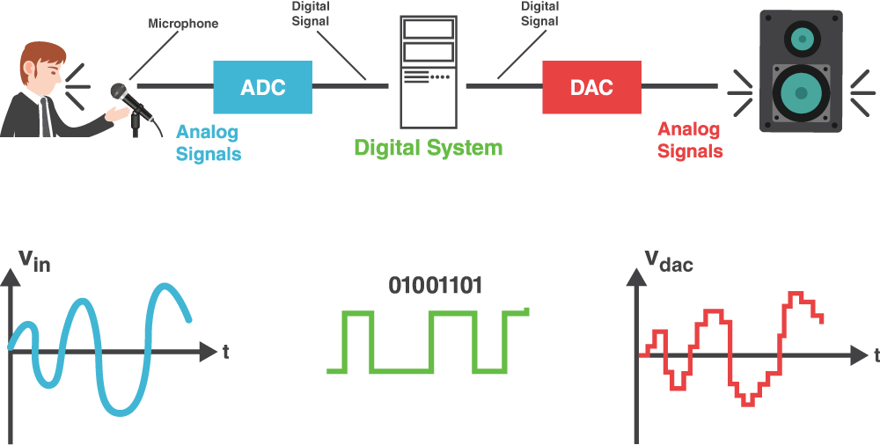
Figure 6

There are different circuit topologies to implement a DAC. The simplest way is by using a scaled resistor network. A 3-bit DAC using this topology is shown in Figure 7.

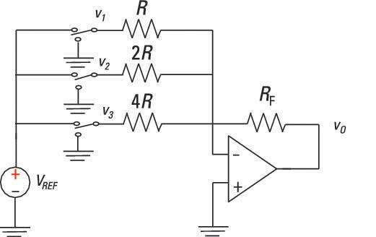

Figure 7

In this circuit, an inverting summer is used to realize the weighted-sum operation of a DAC. The necessary weights are adjusted by the ratios of $R_{F}$ to the individual resistance values. The digital signal is applied through use of switches. The voltage value, V_{REF} represents logic ‘1’ and the ground (0V) represents logic ‘0’.

1. First show that the circuit shown in Figure 7 is actually a DAC by writing an expression for Vout in terms of V₁, V₂, and V₃. Determine which voltage value represents the most significant bit (MSB), and which one represents the least significant bit (LSB).

2. Design a 4-bit DAC converter. Use LM741 op amp and connect its DC power supplies to $±$18V. Use the SW component from LTspice library to simulate the switches shown in Figure 7. This is a voltage-controlled switch. When using this switch, you need to include a spice directive to define a model for the switch. If you use the model shown in Figure 8, the threshold is set to 0.5[V] which means that the switch opens when a voltage below 0.5V is applied (like 0[V]), and closes when a voltage above 0.5V (like 1[V]) is applied. Note that, b0 through b3 represents the digital input signal. Connect them to a 1[V] DC voltage source to apply a logic’1’ or 0[V] to apply a logic ‘0’. Those will control the switch and in order to make a connection to either vref or gnd.

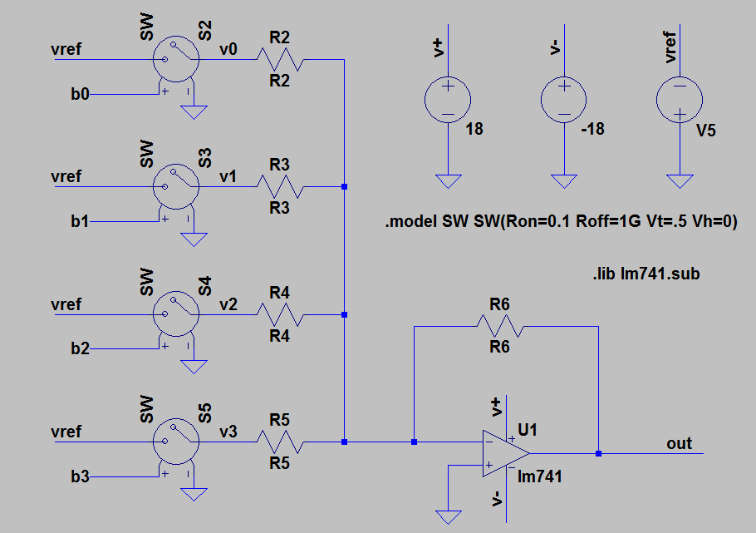
Figure 8

Determine the resistor values and the V_{REF} value so that 0000 at the input results in 0V at the output, and 1111 results in 15V at the output. Test your circuit by applying all possible inputs and measuring the output voltage for each case using .op analysis. Provide all your results in a table. No need to provide your .op results for each possible case.

