**Diodes and non-linear circuits**

1. Design and simulate the diode clamp circuit shown in Figure 1, to provide a voltage supply exclusively in the range of approximately +2.3V to +9.7V. Simulate the circuit to verify that the output stays within this range. Provide a hand analysis, using the constant-voltage drop model with $V_{f}=0.7[V]$ and plot the transfer characteristics, $V_{OUT}$ vs $V_{IN}$ for an input range of -5[V] to 15[V]. (Remember that diodes can be connected in series with voltage sources to limit the output voltage to any desired value. In order to design the limiter circuit, refer to the ppt for “Diode Applications”.) You can use the diode model 1N914 within LTspice, to design the circuit.



Figure 1. Diode Clamped Voltage Source

2. Simulate the half wave rectifier shown in Figure 2. First, plot the output vs. input characteristic, then apply a sinusoidal input and perform transient analysis. Choose a sinusoid with DC offset voltage equal to 0V, amplitude of 2V and a frequency of 1kHz. Plot the input and output voltages together on the same plot, as a function of time. Now apply a sinusoid with an amplitude of 20mV. What is the problem?

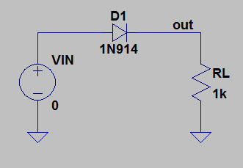

Figure 2. Half wave rectifier.

3. A super diode is shown in Figure 3. First, provide a hand analysis of that circuit assuming ideal op amps and using constant-voltage drop model with $V_{f}=0.7[V]$. Then simulate the circuit in LTspice using LM741 as your op amp model. Apply DC analysis and plot the transfer characteristics (input-output characteristic). Then apply transient analysis, using the same sinusoid that you used in step 2. What is the difference compared to the regular half-wave rectifier? Now, change the frequency of the input signal to 10kHz. What is the problem now? Plot V(X**)** and V(OUT) as a function of time, together on the same plot, in order to identify the problem. Comment on the results.

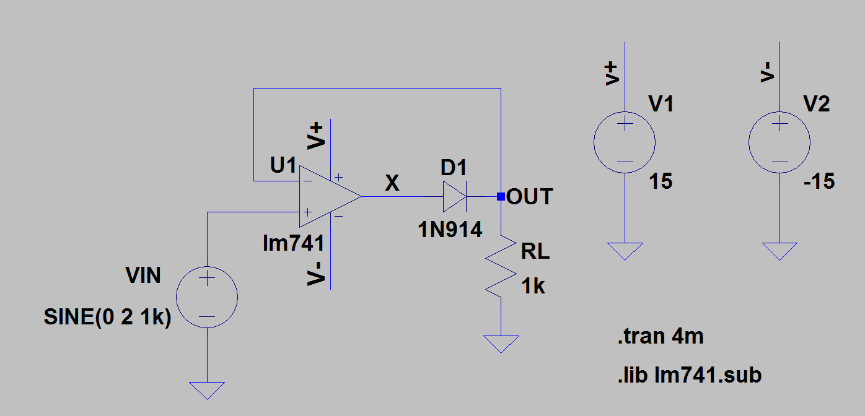

Figure 3. Super Diode

4. As a solution to the above problem, we will now take a look at the super duper diode – which is a fast half-wave rectifier. This circuit is shown in Figure 4. First provide a hand analysis of that circuit using constant-voltage drop model with $V_{f}=0.7[V]$. Then, build the circuit in LTspice and run transient analysis. Test it with sinusoids of different frequencies, such as 1kHz, 10kHz and 100kHz. Is the above problem solved? Explain by plotting the voltage at the output of the op amp, and $V_{OUT}$ together on the same graph as a function of time.

5. Op amps can be used for signal generation. Through the use of positive and negative feedback, an astable multivibrator can be designed to generate square-wave output. Then the output of that circuit will be connected to an integrator to get a triangle wave. This forms the basics of a function generator. Let’s start by building the square wave generator. Construct the circuit in Figure 5 in LTspice. Use the **Universal Opamp 2** model within LTspice library.

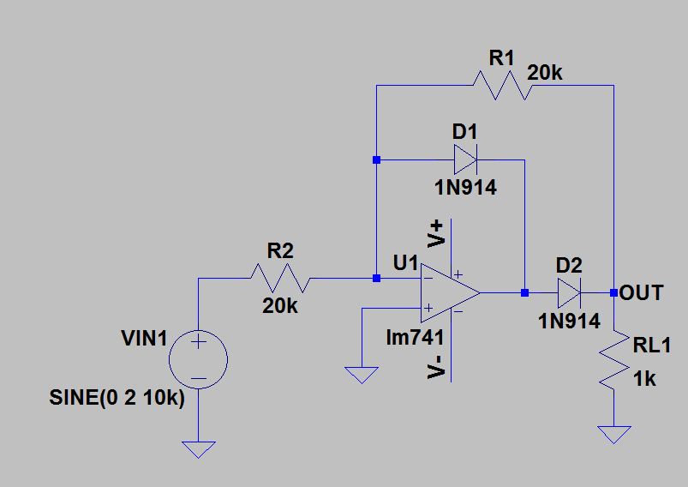

Figure 4 – Super-duper diode

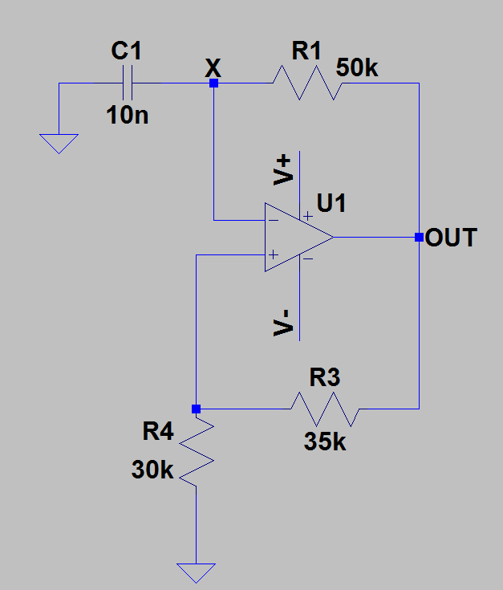

Figure 5 – Astable multivibrator

First verify that the frequency of the output signal is equal to 1kHz, using hand calculation. Then run transient analysis and plot the output voltage as a function of time. When you simulate this circuit, you will see that it won’t work. Notice that this circuit does not have an applied voltage source at its input. Oscillators work in real world, because of the noise build up through positive feedback which causes the circuit to oscillate. Transient analysis is noiseless though, so once the DC operating point is calculated, the circuit will settle down at that point happily ever after – even if that DC point in unstable. A physical analogy for the operation of the bi-stable circuit is shown in Figure 6 (which is taken from your text). The ball cannot remain at the top of the hill for any length of time, the inevitably present disturbance will cause the ball to fall to one side or the other, where it can remain indefinitely (the two stable states).

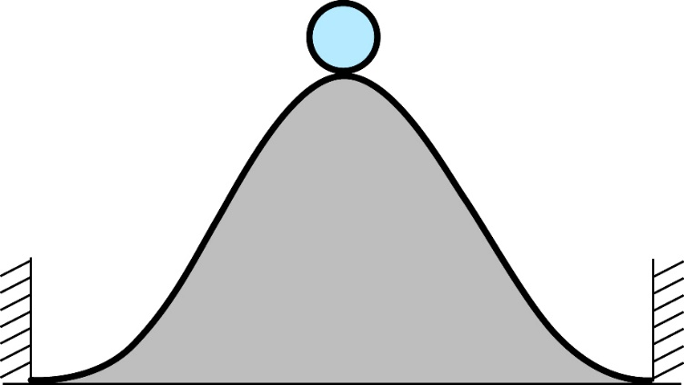

Figure 6 – Unstable operating point

How are you going to simulate the circuit then? There are 2 different ways to do that:

* You can connect a behavioral voltage source in series with C1 (between the capacitor C1 and the inverting input of the op amp) in Figure 5 and apply white noise.
* You can kick start the oscillator by defining an **initial condition**. This can be achieved by simply adding a spice statement such as $.ic V\left(X\right)=15$. This sets the initial voltage at node X.

Choose one of the two options and apply transient analysis again. Plot $V_{OUT}$ and $V_{X}$ as a function of time. Explain in your own words how that circuit works.

6. In order to create a triangular wave out of a square wave, we need to build an integrator circuit and connect it to the output of the astable multivibrator. This is shown in Figure 7.

Note that it will take some time until the circuit reaches steady state. So make sure that you simulate long enough.

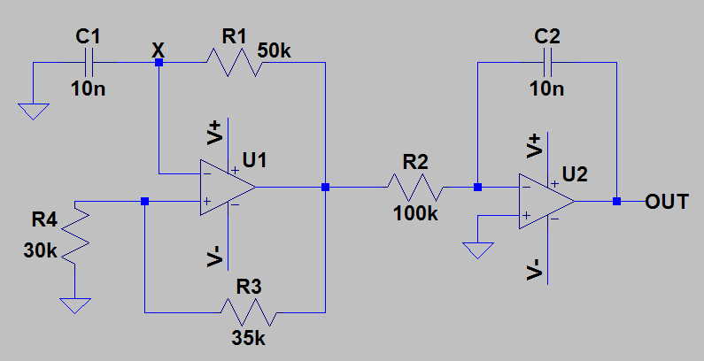

Figure 7 – A basic function generator

7. Remember that any periodic signal can be written as a sum of sinusoids by using Fourier series. A square-wave with frequency *f* and amplitude 1 can be written as,

$x\left(t\right)=\frac{4}{π}\left(\sin\left(2πft\right)+\frac{1}{3}\sin\left(6πft\right)+\frac{1}{5}\sin\left(10πft\right)+⋯\right)$.

Using this fact and an astable multivibrator from part 5, design a circuit that will generate a sine wave with a frequency of 5kHz, an amplitude of 5[V] and a DC offset voltage of 3[V].There won't be any input signal.

First design the circuit on paper. Come up with a rough sketch of the building blocks that will be connected together. Then build it in LTspice to verify your design. You will need to use an LPF with a sharp frequency response. Note that the first order LPF circuits that we worked on, do not have such a sharp frequency response and thus won’t be able to eliminate the high order harmonics (signal components at 3*f*, 5*f* and so on). So use a commercial LPF that is already provided in LTspice libraries. You can use the 5th order Butterworth LPF that is posted on Blackboard. You can copy and paste this circuit into your design (using F6 on your keyboard). Note that, the cut-off frequency can be adjusted by setting the $f_{C}$ parameter. If you apply a 5kHz square wave to this LPF circuit and if you set $f_{C}$ to 4kHz, you will get a sinusoid at the output with a frequency of 5kHz. You should set $f_{C}$ to a frequency a little lower than the desired frequency (5kHz in this case), since you don’t want to lose the signal at 5kHz.