ECE 3355 – ELECTRONICS
HOMEWORK #8

Problem 8.1:
The op amp in the precision rectifier circuit of Fig. P4.83 is ideal with output saturation levels of ±13 V. Assume that when conducting, the diode exhibits a constant voltage drop of 0.7[V]. That is, assume the diode can be modeled with a piecewise-linear diode model, where V_{f} = 0.7[V], r_{d} = 0, and I_{s} = 0.
Find v₋, v_{O}, and v_{A} for:

(a) v_{I} = +1V
(b) v_{I} = +3V
(c) v_{I} = −1V
(d) v_{I} = −3V

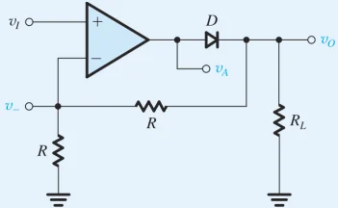
Figure P4.83 Taken from Sedra and Smith, 8th Edition.

Also, plot the output waveform at v_{O} and find the average output voltage obtained when v_{I} is a symmetrical square wave of 1-kHz frequency, 5-V amplitude, and zero average.

Problem 8.2:
The op amp in the circuit of Fig. P4.84 is ideal with output saturation levels
of ±12 V. The diodes exhibit a constant 0.7[V] drop when conducting. That is, assume the diode can be modeled with a piecewise-linear diode model, where
V_{f} = 0.7[V], r_{d} = 0, and I_{s} = 0.
Find v₋, v_{A}, and v_{O} for:

(a) v_{I} = +1V
(b) v_{I} = +3V
(c) v_{I} = −1V
(d) v_{I} = −3V
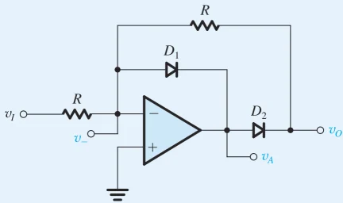
Figure P4.84 Taken from Sedra and Smith, 8th Edition.

Problem 8.3:
Find the frequency of oscillation of the circuit in Fig. 15.23(b) for the case
R₁ = 10[kΩ], R₂ = 15[kΩ], C = 1[nF], and R = 62[kΩ]. Assume that the op amp saturates at +15[V] and -15[V]. To use the Sedra and Smith notation, this means that using L₊ = 15[V], and L₋ = -15[V].

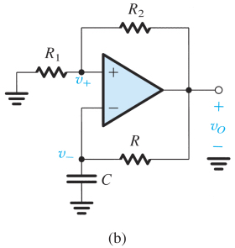
Figure 15.23(b) Taken from Sedra and Smith, 8th Edition.

Problem 8.4:
Repeat Problem 8.3, but solve using L₊ = 15[V], and L₋ = -8[V].

Problem 8.5:
For the circuit shown below (Figure P3.65 from 4th Edition of Sedra and Smith), solve for and plot the transfer characteristic, v_{O} vs v_{I}, using a piecewise linear diode model for each of the diodes, with V_{f} = 0.6[V], r_{d} = 10[Ω], and I_{s} = 0. Use an input range –15[V] < v_{I} < +15[V].

Problem 8.6:
Design of an ac Voltmeter

Using the ideas discussed in class for an ac voltmeter, design such a device using a “super-duper diode” and op amp filter(s). Your design should satisfy the following specifications.

i) The output of the meter should be a dc signal proportional to the amplitude of a sinusoidal signal at the input. However, we also want some dc gain (i.e., amplification of the signal amplitude); this must be at least 20[dB].
ii) The minimum operating frequency of your voltmeter should be 100[Hz].
iii) Although the voltmeter output is nominally dc, you may have sinusoidal signals in your output (i.e., ac signals that pass your filter), but any such signal must have a gain of no more
than -20[dB].
iv) For reasons that have not been made clear to you, your customer stipulates that you cannot use resistances larger than 10[kΩ], or capacitors larger than 10[μF].

