December 08, 2014
Fabiana Cirino
4800 Calhoun Rd.
Houston, TX 77004

Dr. David R. Jackson
N 308 Engineering Building 1
Houston, Texas 77204-4005

Dr. Jackson,

I am writing you on behalf of the Cougar Charging project that my colleagues, Artemio Villarreal, Sho Misawa, and I are currently developing. We are designing a platform that will be able to wirelessly charge a Lithium-Polymer rechargeable battery for the use in a quad-copter. The system will be based on the quad-copter’s specifications.
The following report will discuss the goal and deliverables of the project. It will include an overview of the new system and will discuss the purpose of our project. The new engineering specifications and constraints are outlined along with a detailed description of the project. A brief description of the budget is also included.
The final design is almost complete and some parts have been ordered. The next steps consist of testing and implementing the design. The project is on target to a successful completion. Thank you for supporting our team.

Sincerely,

The Cougar Charging Team

Cougar Charging
Final Technical Report

Sho Misawa, Artemio Villarreal, Fabiana Cirino
11-27-2014
Advised By Dr. Jackson

Abstract:
In the emerging field of autonomous flight vehicles, battery life is a huge concern. The capacity of the battery will not only indicate the time that the vehicle can be in use but will also dictate the mission that it can be used for. Current methods of charging the batteries for these vehicles require the operators to physically disconnect the batteries and connect them to the chargers. This method of charging requires operator interaction and also limits these vehicles to a certain distance before the vehicle has to return to home station to recharge. The use of wireless charging using electromagnetic theory will greatly aid this problem. This could be beneficial to not to only lengthen the distance of travel for these vehicles but it can also broaden their mission and usefulness. The design of these charging stations will be discussed in this paper to include the background, the goal analysis, and the current design specifications. The proposed budget for this project is also a matter of concern. Currently, the project is still within budget with the largest expensed being labor.

Background and Goal
The purpose of this project is to develop a wireless charging station using electromagnetic induction that will allow a quad-copter to autonomously charge its batteries when it detects a low charge. The wireless charging system will be composed of two parts: the charging station where the quad-copter will land and the charging circuit that will be installed on the vehicle. Each section will consist of a conducting coil and their respective circuitry necessary to transfer power from the charging station to the vehicle’s batteries. This is possible using electromagnetic theory to approximate the power transfer between coils. One law used is the law of Biot-Savart which states that

$B_{z}=\frac{μ_{0}N_{p}Ir^{2}}{{2\left(z^{2}+r^{2}\right)}^{\frac{3}{2}}} \left[A/m\right]$. | (1)

This law calculates the magnetic flux density in the center of the coil, $B_{z}$where $μ_{0}$the permeability is constant for free space, $N_{p}$ is the number of turns in the primary coil, $I$ is the current through the primary coil, $r$ is the radius of the primary coil, and $z$ is the distance between the two coils’ centers. This equation is used in conjunction with Faraday’s law of induction [2]

$emf=-jωB_{z}A_{s} \left[A/m\right]$, | (2)

where emf is the voltage induced at the receiver coil, $ω$ is the frequency at which the system operates, $B_{z}$ is the magnetic flux density produced by the transmitter, and $A_{s}$ is the area inside the receiver coil. Both equations (1) and (2) are used to determine the voltage induced on the receiver coil to power the charging circuit. Each variable can adjusted to meet the needs of the charging circuit.
The voltage is induced on the secondary coil and will provide enough power to charge a Lithium-Polymer 3S battery located on the quad-copter. The final objective will be a complete wireless power system consisting of a receiving circuit that will be mounted on the quad-copter along with a platform that will transmit the power. The goal for this semester is to have most of the system designed and the parts ordered.

Problem, Need and Significance
In the emerging field of quad-copter technology, many features have been made completely autonomous except the battery charging. This presents a huge obstacle because of the strong dependence on human interactions to ensure that the quad-copter’s batteries have sufficient charge at all times.
The purpose of this project is to enable the quad-copter to independently charge it’s batteries autonomously. A charging station with wireless power capabilities will be the ideal solution. Since wireless power transfer is also an emerging technology, many standards are currently being developed. Currently, there is a growing interest in this type of technology. A successful and efficient implementation of a wireless charging system for quad-copters could potentially attract big companies such as Amazon, who are interested in implementing drones to deliver packages.

User Analysis
The wireless charging station is designed to be a stand-alone system. Theoretically, a quad-copter will be able to locate, identify, and successfully land on the station without the need of external guidance. This eliminates the need for user interaction to recharge the batteries. This concept could potentially attract any user looking to ease the charging process of their robots, remote control vehicles, or any UAVs. This would also be of interest to companies that use drones for delivery purposes. In this case, our wireless charging stations can be implemented to increase the flight time and extend the distance these autonomous vehicles can travel by charging along the way to their destination. Once integrated into the flight paths, this system would require no external input from the user when the stations are commissioned.

Overview Diagram
The overview diagram shown in figure 1 illustrates the conceptual design of the system. It includes the main components necessary to transmit power to the quad-copter using electromagnetic induction. The transmitter circuit will be implanted inside the charging station and the receiver circuit along with the coil will be integrated on the quad-copter. The two Arduino micro-controllers will handle all the controls and communications between the two circuits. They will monitor every aspect of the system operation.
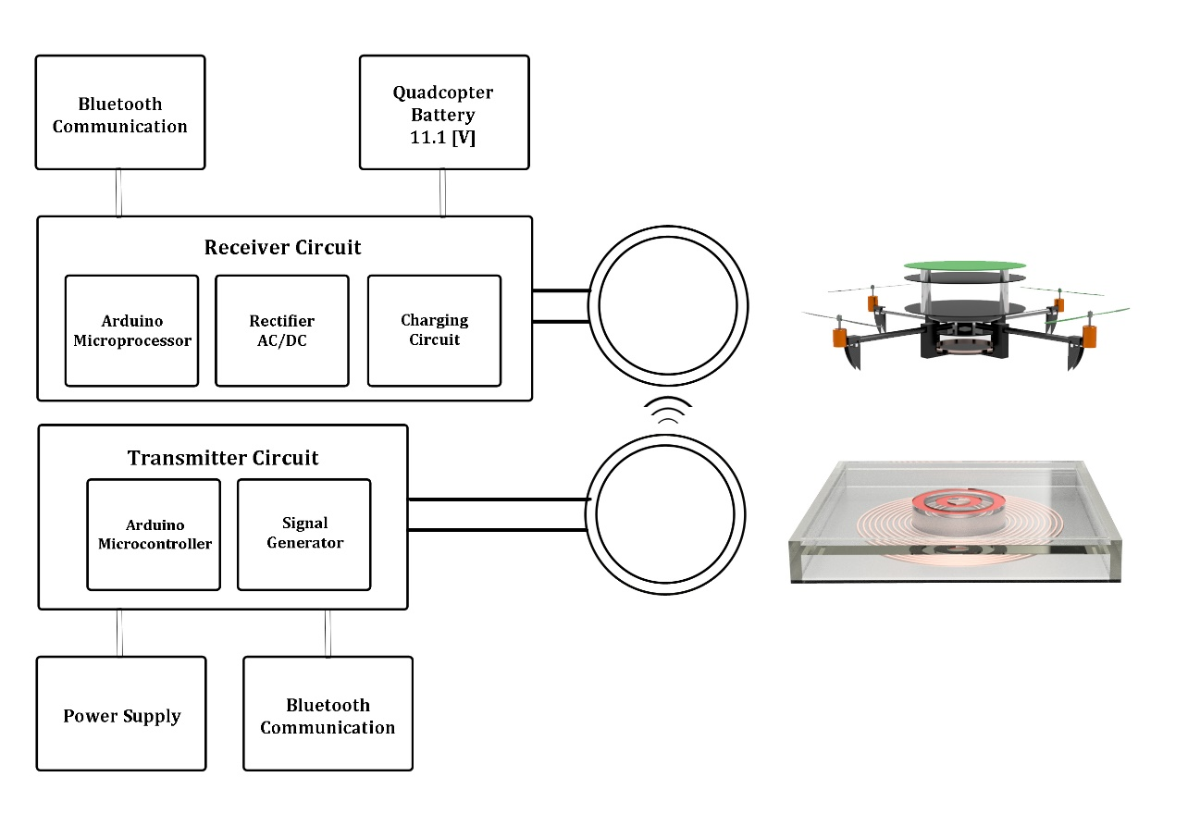
Figure 1: Overview Diagram

Target Objective and Goal Analysis
As previously stated, the overall objective of this project is to safely and wirelessly charge a Lithium-Polymer 11.1 [VDC] battery located on a quad-copter. A time varying magnetic field will be produced by the transmitting coil with the intensity of the field being proportional to that of the current going through it. As a result, the magnetic flux generated will be picked up by a receiving coil inducing a voltage that will be used to charge the battery. Figure 2 below demonstrates the goal analysis of our system. The boxes represent the observable and testable tasks that the wireless charging system will perform autonomously.

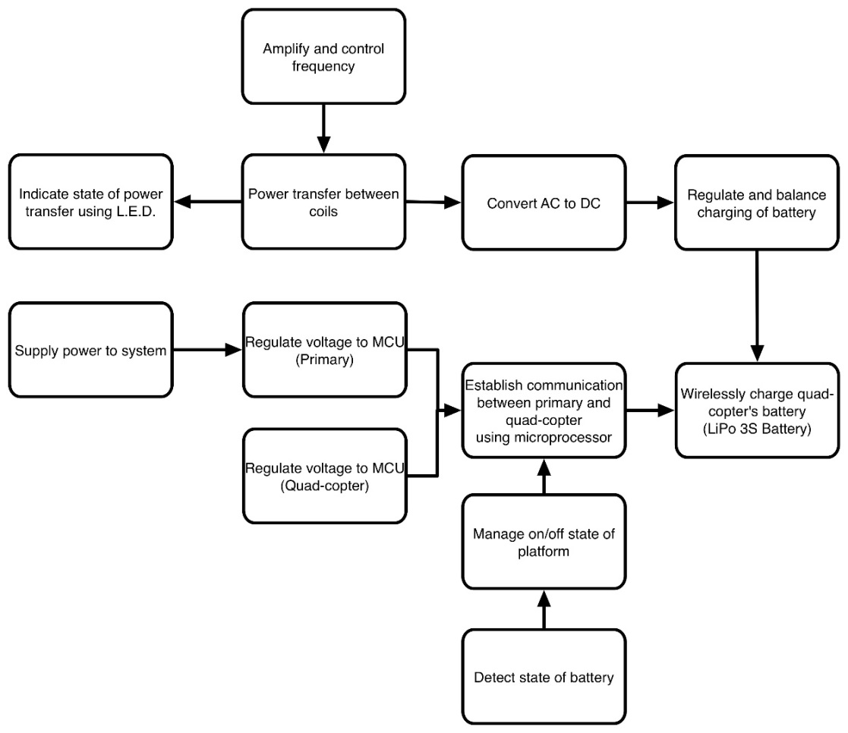

Figure 2: Goal Analysis of Wireless Power System
These are supposed to be things the system does. So:
- We do not amplify frequency. What you need in that upper left area is an objective indicating that the system needs to generate a sinusoidal signal of appropriate and adjustable frequency.
- Another objective is to amplify the signal to the appropriate power (which is then part of your specs).
- “Regulate and balance” is vague. What does this mean in terms of providing charging?
- “Supply power to system” is not something the system does so it is not an objective.
- “Manage on/off state” is vague. Does the system need to detect the presence of the copter? If so, the lower right area needs to have something like “system detects presence of quadcopter”, I would think. Are you going to detect the battery level in flight? Your system doesn’t do anything until the copter gets there.
I realize nothing has been built, but you should have had some discussion of the circuits in the appendix. Do these designs lead to completing your specifications?

The primary circuit will be powered by a DC power supply delivering 5 [VDC] to power the main Arduino microcontroller. The microcontroller will be able to communicate with the quad-copter via Bluetooth. It will be responsible for controlling the state of the charging station as well as the charging status. The frequency generator will produce a high frequency signal necessary to produce the alternating magnetic field. The signal will later be amplified to ensure a strong magnetic field is present at the secondary coil. This circuit is still being developed.
The alternating current generated at the secondary coil will be rectified to direct current using a solid state rectifier. Once rectified, a voltage regulator will ensure a stable output of 15 [VDC] to the battery charger. The battery charger will then be responsible for balancing and charging the batteries. This section will be capable of monitoring and sensing the temperature of the battery to prevent damage to the quad-copter.
The objectives shown on the goal analysis are conceptual and are still in development. A full preliminary drawing for the receiving circuit has been created and is shown in the appendix section. Components outlined are subject to change as each task is further developed and tested.

Engineering Specifications
- Operating frequency: 300 [KHz] Range
- Power supply: 120[VAC]
- Rectifier Output: System will supply 15[VDC]
- Battery Charger: Vin:12-15[VDC] at 1 [A]
- Size of Platform: 3 x 3 [ft]
- Diameter of Primary coil 7 [in]
- Diameter of Secondary coil 6 [in]
- Max Transmission distance: 6 [cm]
- Magnetic Wire: Gauge 18, Max Cont. Current= 2.3[A]
- Battery: 11.1 [VDC]
- Arduino Uno MCU: Operating Voltage: 5 [VDC]

Budget
As part of this project, time allocated by individuals, as well as any purchases, have been carefully logged. Table 1 displays the projected and actual expenditures for this project up to date. Labor costs are determined upon an hourly rate. Advisors have a rate of one hundred dollars per hour and the team members have a rate of fifty dollars per hour. The fixed resources include the expenditures made on parts and presentation materials as required.

Table 1: Budget
Time Resources | Spent | Projected
Artemio Villarreal | $5,025 | $12,050
Sho Misawa | $5,025 | $12,050
Fabiana Cirino | $5,025 | $12,050
Dr. Jackson | $525 | $1,050
Dr. Trombetta | $200 | $500
Dr. Marpaung | $200 | $400
Fixed Resources | Spent | Projected
Electronic Parts | $154 | $0
Presentation Materials | $50 | $100

Figure 3 below is a graphical representation of projected costs versus total money spent. As shown in the graph, the project is well within the projected amount.

Figure 3: Projected Costs vs. Total Spent

Conclusions
In conclusion, the Cougar Charging project will be able to wirelessly charge a quad-copter’s battery wirelessly using electromagnetic induction. This project when completed, will eliminate the dependence on user interaction and extend the distance that a quad-copter can travel without returning to base station. Preliminary drawings for the receiver circuit have been completed and the components for this have been placed on order. The design for the primary circuit is still under investigation to find the best signal generation circuit for this application. The team has had a few set-backs at the beginning of the project period but is well under way to accomplishing the end goals. All tasks for the semester have been completed in time and have been successfully submitted.

Appendices
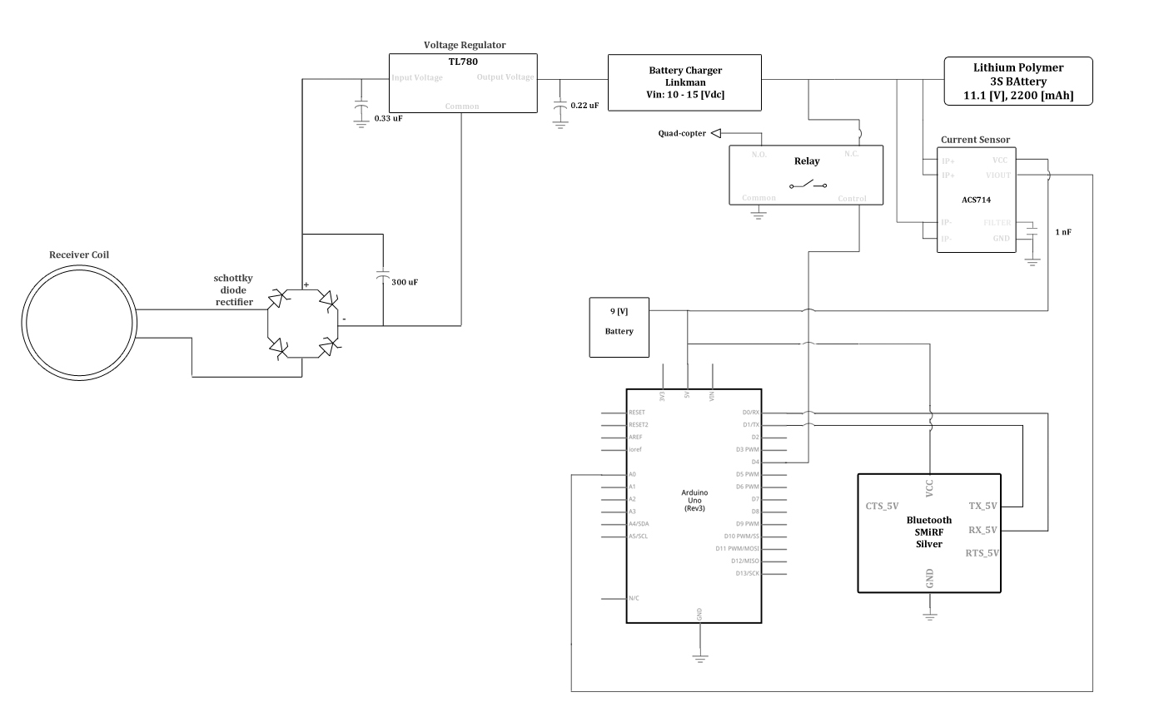
Figure 4: Receiver Schematic
Figure 4 above shows the current wiring schematic for the receiver circuit. The circuit is composed of the following components:
- Reciever coil
- Arduino micro-controller with Bluetooth module
- Current rectifier
- Voltage regulator
- Battery charger
- Relay
- Current sensor
- 9 Volt battery
The micro-controller will control the entire charging operation for the quad-copter. It will be able to communicate with the charging station with the Bluetooth module attached to it and is powered by the 9 [V] battery. The rectifier will convert the alternating current from the coil into a direct current that the charging system requires. The voltage regulator will then regulate the voltage to a constant 15 [VDC] to charge the battery. The current sensor will be used to determine when the battery is no longer being charged. This will send the command to the micro-controller to end the charging sequence using the relay to disconnect the battery from the charger.

