Dr. Julius Marpaung
Dept. of Electrical and Computer Engineering
N 308 Engineering Building 1
Houston, Texas 77204-4005

Dear Dr. Marpaung,
This report describes the technical overview of our ongoing “Mercury Robotics Challenge” project. The objective of the fall semester was to complete the motor control design which can take commands over Wi-Fi using internet. A ‘Goal Analysis Diagram’ was created with smaller milestones. As explained in the report, each milestone has been successfully accomplished. Design, development and testing of the motor hardware is successfully completed. Our robot can move in all directions with different speeds and climb up a 30 degree ramp. Wi-Fi connection is established and the robot can receive signals via internet and perform actions accordingly. We are satisfied with our progress so far and confident that we will finish the entire project next semester in time.
If you have any question, please contact me at 919-457-8516 or afatma@uh.edu.

Thank you,
Aman Fatma
Senior Design 1-Team Mercury (Fall 2014)
Cullen College of Engineering
University of Houston
What you have is pretty good. But you conducted tests to determine that your robot was doing what it was supposed to do and I wanted to see some description of all of that. Simply saying you met your objectives is just the start.

OSU Mercury Robotics Competition
Steven Do, Aman Fatma, Erick Saucedo
Final Technical Report: Fall 2014
December 09, 2014
Sponsor: Dr. Julius Marpaung

Abstract
Safety for people working with hazardous material is a big concern. A machine which can handle the hazardous substances and can be controlled from safe distances is highly desirable. Mercury robotics competition promotes the development of such machines or robots. The next Mercury competition will be held on April 18th, 2015. Our senior design team will be participating in the competition and will represent University of Houston. This document explains the technical report of the designing and development of robot which will take part in the competition. According to the competition rules, the controller of the robot must be 50 miles away from the competition site and should use internet to control robot. The robot must be able to accomplish certain sophisticated task such as maneuvering through an 18 inch maze and passing through a dark tunnel without touching the walls. It should be able to pick up a golf ball, climb up a 30 degree ramp and drop the golf ball in the designated space. To construct the fully functioning robot, work was divided into two parts. The objective of first part is to complete the motor control design which can take command over Wi-Fi using internet. The design and development of robotic arm will be done in the second part which will be done in next semester. This reports discusses the technical details of first part. To accomplish the project goal by the end of the semester, it was divided into various smaller milestones. This report discusses the completion of all objectives in the ‘Goal Analysis Diagram’. Design, development and testing of the motor hardware is successfully completed. Our robot can move in all directions with different speeds and climb up a 30 degree ramp. Wi-Fi connection is established and robot can receive signals via internet and perform actions accordingly. Budget of the project has been estimated for the semester to be $39,442.37 including labor cost and parts used in the project. The team is on schedule and project is under the budget.
Background and Goal
The Mercury Remote Robotic competition is an international robotics competition and the challenge is to design and build a wireless controlled robot capable of performing a certain mission. The robot must be remotely controlled from at least 50 miles ways from its location. The challenge mission includes maneuvering in a dark tunnel, picking up a ball, travelling across a bridge with a 30 degree incline, and depositing the ball at a pre-determined destination. In addition, the robot must also demonstrate speed in sprinting to the finish line.[1]
The purpose of this report is to summarize our accomplishments in Senior Design I and an overall scope of our entire project. This report will mainly focus in the following topics: problem, need, user analysis, overview diagram, target objective, goal analysis, engineering specification, constraints and budget.
Our ultimate goal is to build a wireless controlled robot which we will use to compete with other universities at Mercury Robotic Competition 2015. The robot should be capable of sending and receiving data via wireless connection, which use to determine the surrounding area and maneuver thru obstacle path. The operator must able to track and operate the robot at least 50 miles away from its location. Also it should be able to perform a few certain tasks such as navigation in dark tunnel, picking up and depositing the ball at destination. For fall semester, our target objective is to design the robot’s chassis with a motor driver capable of driving 4 wheels simultaneously and establishing wireless communication over Digi’s cloud network. It should be capable of receiving the command from the cloud network and operate some basic tasks such as moving forward, reverse, left or right, climbing and descending on 30 degree inclines.
Problem, Need, and Significance
The robot must be able to complete all the challenges by obtaining the maximum number of points and performing the loss of signal test in order to win the Mercury Robotics Competition 2015. The challenge includes navigation through several challenge paths, capturing the ball and depositing at destination. For the challenge paths, it must able to maneuver thru a dark tunnel with a 90 degree turn, a zigzag area with repeated U-turns, a bridge with 30 degree incline, a whirl pool area and a final sprint which is 45 feet long.
We need to design a robot which can be controlled from long distance through a Wi-Fi internet connection. It must have a robust arm in order to capture a ball from the ground and transport it to a designated location. It must have a motor driver sufficient enough to navigate through the challenge’s paths as well as up 30 degree ramp inclines. In addition to these components, it should also be able to detect the wall and redirect the user to avoid any collision.
The significance of this project lies in the experience gained in regards to wireless control systems. Wireless controlling or robots can prove to be a boon on safety equipment, namely for those who work with hazardous materials. A wirelessly controlled robot can provide a means of distancing a worker from potentially dangerous situations, giving them peace of mind while also helping the employer from having to face any costly litigation.
User Analysis
The goal of this project is to design a wirelessly controlled system that can be operated by the user from several miles away. Mainly, this project is designed to be controlled by our team members but the ultimate goal is to design it in such a way that anyone can easily control without having to resort to any sort of training. Nonetheless, the user should have some technical background about internet protocol and C language in case they need to manually configure the machine to establish a wireless connection.
Overview Diagram
An overview of the entire system can be seen below in Figure 1. One can split this into three systems, namely the servo arm seen to the left, the motor chassis on the bottom, and the controls system seen on the right. At the heart of our system, one can see the XBee Wi-Fi module which receives and sends information from the cloud service and the Arduino. The Arduino itself will govern the controls of the motors as well as control of the arm.
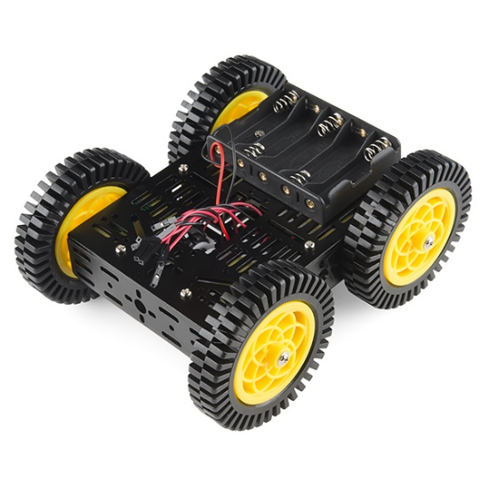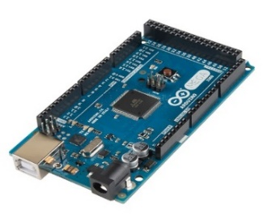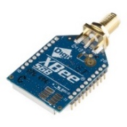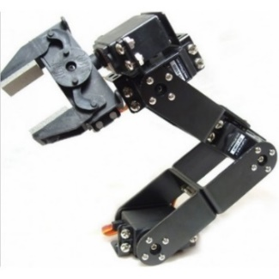
Etherios™ Cloud Service
Control Program _ □ ×
<User Interface>

Sensor Values & Feedback
Control Commands
Figure 1. Overview of the Deliverable for the Project
Target Objective and Goal Analysis
For the semester of Fall 2014, our target objective was to create a robot that could move according to a user’s wireless input. In order to achieve that goal, though, we had to set a number of smaller goals, which can be seen below in Figure 2. Currently, all of the goals for this semester have been accomplished. The robot is currently able to move in a variety of directions, all according to what the user inputs. As for the semester of spring 2015, our goal will be to have a complete robot that can move according to user input and can pick up a golf ball.
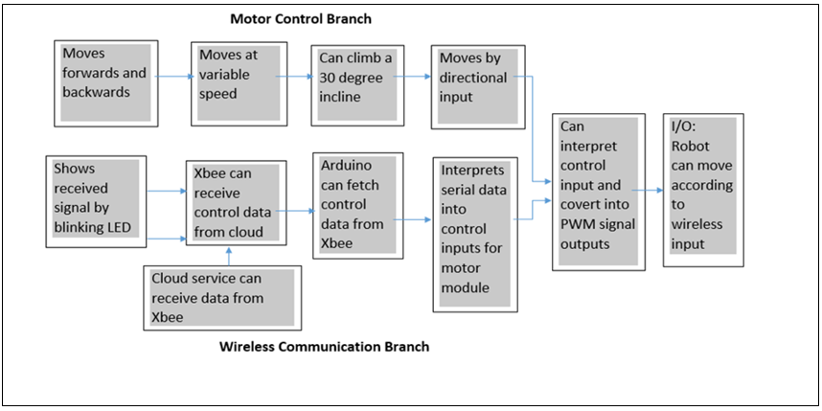Figure 2. Goal Analysis for the Fall 2014 Semester
Engineering Specifications and Constraints
Because this project is a part of a competition, we have to adhere to a certain set of rules in order to ensure that we can maximize our score and more importantly, avoid disqualification. According to the competition rules, our machine must be able to navigate a track that is 18” in width and must be able to fit through a tunnel that is 12” in height. Our robot must be made with these measurements in mind or else points will deducted for each time that we make contact with one of the walls. As for the speed and power of the motors, it must be able to carry our robot over a bridge with 30 degree inclines. The motors that we choose must be chosen with a balance of speed and maneuverability in mind. Although choosing the fastest motors may sound ideal, it would leave us unable to maneuver the robot through the course without hitting the walls. In addition, the robot must be controlled strictly via a Wi-Fi internet connection from a distance of at least 50 miles. At most, two connections to the provided access point will be allowed, which will allow us only one connection for control purposes, since the other connection will most likely be used for a video feed. Finally, the control communications must be two way. In other words, the robot has to communicate with the user in addition to the user communicating with the machine.
For our project, we have designed our robot in order to explicitly abide by these constraints. Our robot is currently designed with measurements of 10” by 8” by 7” in order to provide maneuverability through the course in addition to providing enough room to fit our various components. Our motors were chosen in order to provide a torque of at least 80 oz-in. so that our projected load of 4 kg. can be transported over the 30 degree incline. In addition, our motors were chosen in order to attain an RPM of at least 115 which, for a wheel radius of 1”, translates into a speed of roughly 1 ft./sec. Calculations for the torque can be seen in the appendix.
Budget
For the semester of Fall 2014, we have, to-date, spent a total of $39,442 in order to realize our current iteration of the robot. As can be seen below in Table 1, our expenditures have been mostly spent on labor costs for the team members in addition to some labor costs for the engineering advisors. So far, labor expenditures have totaled to $38,800 while parts expenditures have added up to roughly $642. For the upcoming semester, we expect to spend roughly $400 on parts: a smaller quantity due to the fact that the only costs lie in development of the servo arm. We do expect to work a bit longer, taking up the weeks before the beginning of the semester, totaling to fourteen worked weeks, resulting in a higher labor cost of $44,900. Calculations for these two values can be seen below in Table 2.
Expenses | Name | Weeks worked | Hrs/Wk | Hourly pay rate | Total cost
Labor Cost | Aman Fatma | 12 | 20 | $50.00 | $12,000.00
 | Steven Do | 12 | 20 | $50.00 | $12,000.00
 | Erick Saucedo | 12 | 20 | $50.00 | $12,000.00
 | Dr. Trombetta | 8 | 1 | $100.00 | $800.00
 | Dr. Marpaung | 10 | 2 | $100.00 | $2,000.00
 | Description |  | Qty. | Cost
Parts Cost | Xbee S6b Wifi Module |  | 3 | $34.95 | $104.85
 | Sparkfun Xbee Explorer |  | 2 | $24.95 | $49.90
 | Seed Wireless Shield |  | 2 | $9.99 | $19.98
 | Arduino Mega 2650 R3 |  | 1 | $45.95 | $45.95
 | Arcylic Chassis |  | 1 | $19.99 | $19.99
 | Pololu Gear Motor |  | 4 | $21.95 | $87.80
 | Pololu Wheel and Mounting kit |  | 1 | $13.90 | $13.90
 | Miscellanous Items |  | 1 | $300.00 | $300.00
Total Expense of Fall semester |  |  |  |  | $39,442.37
Table 1. Expenses for the Semester of Fall 2014

Expense | Name | Projected Weeks worked | Hrs/Wk | Hourly pay rate | Total cost
Projected Labor Cost | Aman Fatma | 14 | 20 | $50.00 | $14,000.00
 | Steven Do | 14 | 20 | $50.00 | $14,000.00
 | Erick Saucedo | 14 | 20 | $50.00 | $14,000.00
 | Dr. Trombetta | 5 | 1 | $100.00 | $500.00
 | Dr. Marpaung | 12 | 2 | $100.00 | $2,400.00
Projected Parts Cost |  |  |  |  | $400.00
Total Projected Expenditures |  |  |  |  | $45,300.00
Table 2. Projected Expenses for the Semester of Spring 2015

Conclusion
For the current semester, we have accomplished our goal of creating a wheeled robot that can be controlled via wireless user input. In regards as to how our machine is performing, its current H-bridge setup, allows movement both forwards and backwards, with turning being accomplished via a combination of differing directions and differing duty cycles for the individual motors. For the next semester, work will be focused on development of the robot arm as well as improvements to both the motor driver and the wireless control system.

Appendix
Torque Calculations
In order to accurately design our machine, we had to take into account how much force will actually be needed in order to carry us up a ramp of 30 degrees. Through these calculations, several assumptions were made. The two most important assumptions were the weight of our robot, which is assumed to be 4 kg., and the speed with which we wanted to climb the ramp, which is 1 ft/sec. The calculations can be seen below.

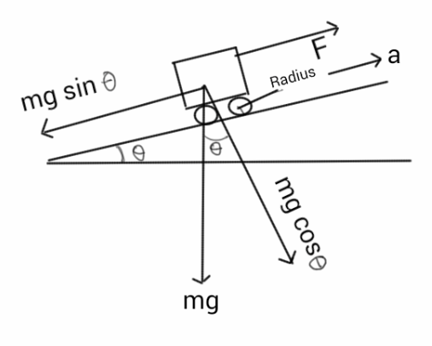
Weight of robot- 4 kg.
Max Speed -1ft/sec=0.304 m/s
Acceleration for max speed in 2 sec
$a=\frac{0.304}{2}=$.152 $m/s^2$
Radius of wheel- 1’’= .0254 m
Angle -30 degree
$$Torque=4×(9.8×\sin{30+.152)×0.0254=0.57 Nm}$$ $=80.7 OzIn$

Sources
[1]. Oklahoman State University Mercury Robotics, Mercury Challenge 2015 Manual. Available at: https://mercury.okstate.edu/content/mercury-challenge.
Image sources:
[1] Sparkfun Electronics. Arduino Mega 2560 R3. [Image] Available: https://www.sparkfun.com/products/11061
[2] Sparkfun Electronics. XBee WiFi Module - RP-SMA Connector [Image] Available: https://www.sparkfun.com/products/12569
[3] Sparkfun Electronics. Multi-Chassis - 4WD Kit (ATV) [Image] Available: https://www.sparkfun.com/products/12090
[4] DFRobot. 5-DOF Robotic Arm [Image] Available: http://www.dfrobot.com/wiki/index.php/File:5-DOF_Robotic_Arm.jpg

