December 9, 2014

Andrew Tucker
AggieSat Lab - Aerospace Engineering Department
TAMU 3141
611C H.R. Bright Building
Texas A&M University
College Station, TX 77843-3141

Dear Mr. Tucker,

CoogCrew is writing to formally relay and elaborate on the status and success of the University of Houston AggieSat4 collaboration with the AggieSat Lab in regards to the development of the AggieSat4 (AGS4) satellite.

From the attached document, it is CoogCrew’s hope that it is apparent that the team has accomplished the agreed upon semester goal of developing the Visual Data Capture System (VDCS) and Ground Support Communication (GSC) subsystems of the AGS4 satellite.

Please review the supporting content associated with the on schedule completion of CoogCrew’s Fall 2014 goal.

If you have any questions, please contact our team leader, James Annis, by email at jeannis@uh.edu or by phone at 713-591-1638.

Sincerely,

James Annis
Brian McNeil
Tori Speer-Manson
Sean Strickland

University of Houston

AggieSat4 Collaboration

Final Technical Report

AGS4 - CoogCrew Members:

Emery Annis
Brian McNeil
Tori Speer-Manson
Sean Strickland

Due: December 9, 2014

Project Sponsors:
AggieSat Lab (Texas A&M)
Dr. Robert Provence (NASA)

Abstract
The University of Houston AggieSat collaboration team, CoogCrew, developed two subsystems over the semester for the AggieSat Lab’s Low earth Orbiting Navigation Experiment for Spacecraft Testing Autonomous Rendezvous (LoneStar) campaign. This program is intended to research novel low cost autonomous rendezvous and docking for small satellites. The two subsystems developed were the Visual Data Capture System (VDCS), software developed to support the camera in this mission, and Ground Support Communications (GSC), software to interact with the satellite’s flight computer while it is on the ground. It was necessary for the flight computer to be replicated in this project to confirm that the developed subsystems would work with the satellite. The flight computer was constructed and successfully certified as a replica to the AggieSat4 (AGS4) flight computer. The flight computer would run an exact copy of the AGS4 code including the Command Data Handling (CDH) subsystem, the state machine process that directs data and programs access to satellite hardware. Both developed subsystems were integrated with the flight computer and camera hardware and operated as expected. These subsystems complete the deliverable portion of our project for this semester.

Background and Goal
This document describes the University of Houston, AggieSat “CoogCrew” team’s collaboration with Texas A&M AggieSat Lab (AGSL) in the development of AggieSat4 (AGS4) satellite subsystems Visual Data Capture System (VDCS) and Ground Support Communication (GSC).
The AGS4 satellite is being developed by AGSL and will launch in Spring 2015 aboard a SpaceX Dragon capsule. AGS4 is part of the Low earth Orbiting Navigation Experiment for Spacecraft Testing Autonomous Rendezvous and Docking (LoneStar) [1] campaign’s 2nd mission designed to research autonomous rendezvous and docking of small spacecraft in low earth orbit. Research will be accomplished by releasing and tracking Bevo-2, which is a cube satellite developed by University of Texas at Austin.
The primary purpose of VDCS as outlined in the AGS4 Mission Operational Timeline [2], will be to capture images before, during, and after AGS4 release of Bevo-2. The GSC subsystem is designed to aid in the command and diagnostic of AGS4 during all pre-flight testing on earth via a user terminal connected externally to the satellite. All systems aboard the satellite are due to be delivered to AGSL by December 31, 2014. The development of the VDCS and GSC subsystems represent the target objective for the UH CoogCrew’s first semester of work. For the final semester, the UH CoogCrew will remain on call to support the testing and final development of the AGS4 satellite due to be delivered to NASA on February 22, 2015. The UH CoogCrew will also finalize and test the integration of all satellite modules to ensure all modes have been developed and ordered sequentially to complete each mission sequence.
The remainder of this document will outline the significance of the project and include an analysis of the projects need and user requirements. It will also include a technical description of the developed subsystems and details pertaining to the final product. Finally, the overall budget and discussion for next semester goals will be discussed.

Problem, Need, and Significance
Aerospace engineering has a need for low cost autonomous rendezvous systems, hence the LoneStar program. In order to test these developing systems two space-borne objects in close proximity need to be able to track one another’s position. In prior AggieSat projects, AggieSat2 in particular, the two satellites did not separate after their deployment. This mission was considered a failure as Bevo-1 and AggieSat2 were unable to separate, establish a communication link, and share relative GPS navigation data.
This failure of satellite separation was taken into consideration for the next AggieSat mission and it was concluded that a Visual Data Capture system would be implemented to provide visual data of the separation. This would capture the release event of the two satellites, and would allow the team to tell if and when a problem occurred during separation. Additionally, this camera system would be able to provide visual feedback of their separation to validate the effectiveness of the tracking system. This is a high priority on the AGS4 mission, any failure of the VDCS would be considered a failure for the entire project. The VDCS subsystem will be required to capture images before the release event, during the release event and after. Furthermore, this subsystem is to be self-monitoring, checking whether the camera is capable of taking images given its temperature or memory status.
Once the satellite is built and sealed it must be able to complete a Day in the Life (DITL) testing sequence performing all operations it would in space for validation. Only until this point would the satellite be able to run an entire mission script that has been pre-programmed to memory and respond to limited commands over wireless communications. During pre-flight testing of the AggiSat4 satellite there are no subsystems available in place to aid diagnostic checking of the satellite or to provide commands to the flight computer.
A new subsystem called Ground Support Communications would be required to aid in this process as a diagnostic tool. The GSC subsystem would need to be able to execute command modes and upload new code or data to the satellite’s flight computer while on the ground allowing the ground crew to check the satellite’s status and interact with it during testing.
The AggieSat Lab requires these subsystems to be completed by December 31, 2014 in time for pre-flight testing to begin at the NASA Johnson Space Center on February 22, 2014. In order to validate all systems, the satellite must be fully operational with the VDCS subsystem ready for flight and the GSC subsystem ready for the pre-flight testing.
Completing development of these subsystems is the goal for the end of this semester. This leads into the goal for next semester, which is to provide support to the AGSL’s ground crew by aiding with any of the testing procedures and the usage of the developed subsystems.

User Analysis
The AGS4 satellite will be entirely controlled by the AGSL ground support team located in Texas A&M, which includes a group of aerospace engineering graduates and undergraduates as well as other engineering discipline majors. Dr. Helen Reed, who is the Principle Investigator for AGSL and supported by many at NASA, leads the group. Communications and data transmissions will be provided by TAMU’s Riverside radio station.
The user that implements these developed CoogCrew subsystems will be an operator from the AGSL. The operator will have in depth knowledge to the AggieSat4 program, have detailed understanding of the developed subsystems as well as generally experienced in aerospace engineering. The developed subsystems will have been documented in detail so that any aerospace engineer who builds the mission scripts may implement these systems by following specified guidelines.
Engineers from AGSL and NASA will operate the GSC subsystem during the pre-flight testing sequence. The VDCS subsystem will operate more autonomously by switching between pre-established mission modes as commanded by ground support from AGSL.

Overview Diagram
CoogCrew’s goal for this semester was to develop the Visual Data Capture and Ground Support Communication subsystems for the AggieSat4 satellite. Completed deliverables of this goal will be submitted to AGSL by December 31, 2014.
The team’s goal for next semester is to be available to AGSL for maintenance and debugging purposes in regards to VDCS and GSC. CoogCrew will also be affiliated with the testing process involving the two subsystems, which will be implemented at the NASA Johnson Space Center in February.
Figure 1 provides an overview diagram of how the VDCS and GSC subsystems will interact with the AGS4 satellite as of the Fall 2014 semester.
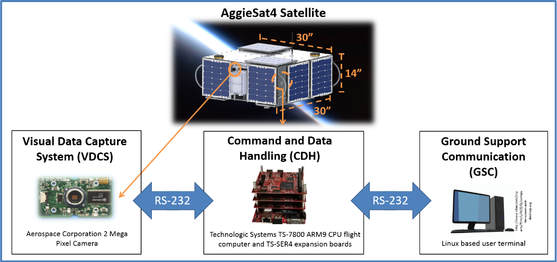
Figure 1 - University of Houston, CoogCrew developed AggieSat4 subsystems include the Visual Data Capture System (VDCS) and the Ground Support Communications (GSC).

The Aerospace Corporation 2 mega pixel camera associated with the VDCS will be located on the side of the AGS4 satellite right above where Bevo-2 will be released from the bay as depicted by the diagram above. Essentially the following event should occur for the image capturing process. The AGS4 satellite will rotate to where the back of the satellite (the side that the camera is not on) is facing toward the sun so that light will potentially be shining toward the cube satellite during the release event ensuring a viewable captured image. Once this occurs, Bevo-2 can then be released. Anticipating that the release event will occur rapidly, to guarantee a captured image, the camera will instantly and continuously be capturing images during the event using Bevo imaging mode, which utilizes the rapid-fire camera function.
GSC comprises a Linux-based user-terminal communicating serially via an RS-232 to the Technologic Systems, TS-7800 flight computer. This subsystem will aid AGSL with pre-flight testing utilizing user-terminal associated menu functions. GSC will also serve as a communicative tool for mission control to check the status of the satellite and its various subsystems and to easily change the mode of operation of the satellite.
The Command and Data Handling state machine is capable of communicating with all subsystems associated with the ASG4 satellite. CDH serves as a manager of the satellite executing pre-developed event sequences or commands transmitted via GSC from mission control.

Engineering Specifications and Constraints
The project will be in a space environment dictating the robustness and cost of the hardware. The hardware must be vigorous enough to handle space transportation and light enough to reduce expenses. The hardware must be able to withstand the temperatures of space as well as working isolated with limited communications and power. The software should be protected from single event upsets and be reliable to recover should one occur. All of the hardware and software associated with the AGS4 satellite must comply with NASA and AGSL regulations. See the constraints associated with the overall project in Table 1.
Table 1 – AGS4 Constraints

VDCS Specifications
For the VDCS subsystem, the camera hardware must be able to capture images varying in resolution and compression ratios. Additionally, in terms of function, the camera must be able to rapidly take pictures to track the position of the deployed small satellite. Table 2 illustrates the specifications for the VDCS subsystem.
Table 2 – VDCS Subsystem Camera Specifications.
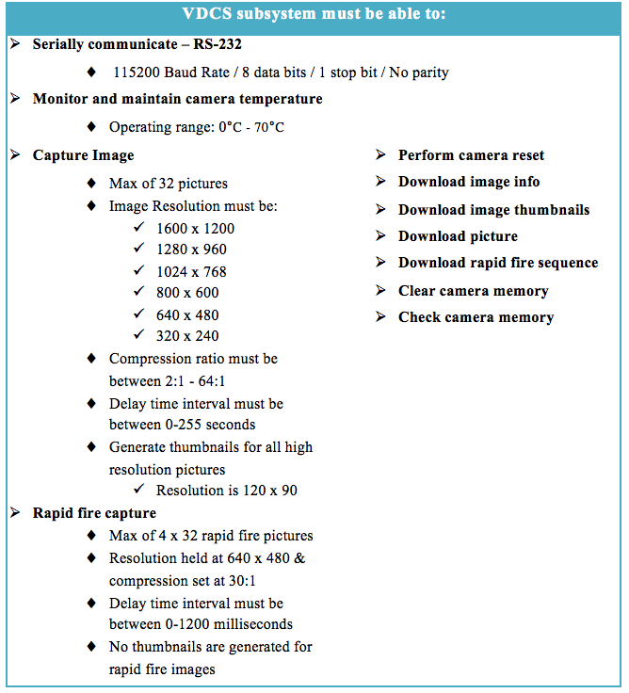

The software controlling the camera must be able to perform a reset should the system fail. The VDCS subsystem must also be able to download image information, thumbnails, and pictures. Checking and resetting memory also should be performed by the VDCS software as well as monitoring the cameras temperature when the camera is powered on.

GSC Specifications
The GSC user-terminal developed by the team is intended for testing and interfacing with the satellite’s flight computer and hardware as a black box on the ground. This capability enables the ground crew to interact with the satellite on the ground to ensure its normal operation after the rigors of pre-launch testing. This subsystem must be able to serially communicate between a PC based terminal and the flight computer. From the terminal, the ground support crew must be able to issue all commands as defined in the GSC specifications seen in Table 3.
Table 3– GSC Subsystem Specifications

The GSC subsystem is utilized for user-AGS4 communication. The specified communication method is through an RS-232 serial path. This subsystem must be able to connect and disconnect to the satellite to send commands, perform functions and change between various modes associated with the satellite. Furthermore, GSC should be capable of launching event sequences, transmitting files and performing Linux BASH commands directly to the flight computer as well as the capability to completely shut down all subsystems.

Target Objective and Goal Analysis
CoogCrew’s target objective of demonstrating the VDCS subsystem integrated with CDH, and as commanded by GSC, has been successful and is on schedule for completion by December 31, 2014. Objectives completed leading up to the target objective can be seen in Figure 2, the most up to date goal analysis for this semester.
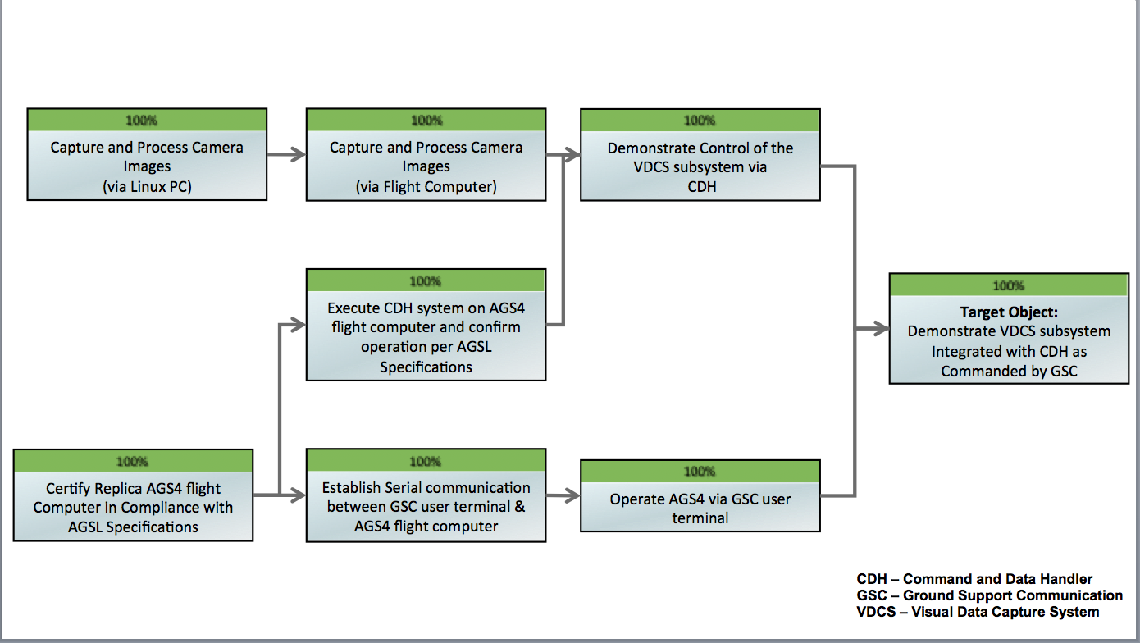
Figure 2- Goal Analysis and Target Objective for University of Houston CoogCrew first semester.

Capture and Process Camera Images (via Linux Pc)
The starting objective related to the VDCS camera development was to capture and process camera images on a Linux PC. This objective included developing a menu based software program where a user can command the camera hardware to capture images within AGS4 -VDCS specification (Table 2). The images captured had to be able to be downloaded, processed, and displayed in any typical image viewing application.
Before developing software to communicate to the camera, the camera command set manifest provided by the manufacturer was verified and updated. The manifest is a document containing every byte stream command argument that could be transmitted to the camera along with the expected camera responses per transmission. For verification, each commanding argument was tested using RealTerm software, which allows for anticipated byte sequences to be sent and received over an RS-232 serial port. After successfully capturing and receiving image data, very few discrepancies were identified and documented throughout the testing process.
The software development began with programming library functions (or drivers) to bridge the gap between software and hardware. Several library functions sets had to be developed in order to achieve the capabilities stated within the specifications. The developed functions would also serve as a starting foundation for all future branch objectives. Simpler function sets would send two or three command bytes to the camera and wait for an acknowledgement response to confirm successful execution of the function. More complex functions, such as downloading standard images, rapid-fire images, and thumbnails all required post JPEG file processing because the raw data received directly from the camera was an incomplete file and un-viewable. These functions required the pre-pending of a JPEG header section, which contains data specific to the image resolution and compression ratio as well as the encoding scheme.
A user interface menu program was developed for a user to execute any of the developed function sets. The main menu functions are shown below in Figure 3.
Figure 3 - User interface menu program developed for camera control.

All of the software was developed using C++ in a Linux environment configured to replicate the Linux environment of the AGS4 flight computer.
Once the software was developed, it was debugged and verified that each library function could accomplish its purpose to within VDCS specifications (Table 2). For example, images of all valid resolutions and compression ratios were captured, downloaded, and processed by the library functions and viewable by any common image viewing application. All generated data indicated the proper operation of the software’s ability to control and receive data from the camera. The software was documented, submitted, and demonstrated to AGSL.

Capture and Process Camera Images (via Flight Computer)
The next objective, to capture and process images via the flight computer, was simply a migration of the camera’s menu based program operating on a Linux PC over to the TS-7800 flight computer. This required the completion of objectives specific to the configuration of the flight computer to AGSL standards (discussed later). In order to satisfy objective requirements, all of the previously developed software library functions must operate on the TS-7800 and meet VDCS specifications (Table 2). If the software didn’t perform correctly then corrections would have been made. Because the C++ encoding environment was setup to emulate the TS-7800’s Linux environment, all library functions migrated without error. Tests were conducted on an AGSL spare flight computer, and confirmed to properly achieve all camera functionality to with the specifications.

Replicate a Certified AGS4 Flight Computer
The flight computer was to be replicated in order to verify that the subsystems would perform appropriately with the actual AGS4 mission. The replica flight computer is the Technologic Systems TS-7800 containing the ARM9 processor, which is commonly used for small satellite operations. Code for this board is open source and has been verified by other users (?). This processor allows expandable memory such as the SD and micro SD ports that the operating system would be stored on. This processor has PC-104 bus structure expandability allowing for multiple expansion TS-SER4 boards with serial ports to be added. This expandability allows for a multitude of satellite hardware to be interfaced with this flight computer. The hardware and software loaded to the satellite must meet AGSL specifications. These specifications include installing jumpers to configure each boards COM port and IRQ settings as well as installing the Linux operating system.

In order to certify the replica AGS4 flight computer in accordance with AGSL specifications, checklists outlined in the documents referenced in Table 4 were completed and submitted to AGSL.
Table 4 - AggieSat 4 Flight Computer Installation Checking and CDH Software Design documentation.
AGS4-02-04-005-R2 CDH Computer Hardware Assembly | Checklist for hardware installation includes board number identification and all jumper configuration
AGS4-02-01-003-R0 CDH Flight OS Description | Description of each OS Boot Script available and instructions for how to switch between each
AGS4-02-04-006-R0 CDH Flight Operating System Installation Procedure | Checklist for Operating System installation procedure includes loading of Linux operating system and partitions

Execute CDH Process on a Certified AGS4 Flight Computer
The next milestone was to execute the flight computer’s master process, Command and Data Handling (CDH). In order to do this, CoogCrew had to learn all of the CDH processes as documented in the CDH Software Design Overview document [3]. CDH is a master process of a larger state machine that routes commands to other subsystems on the satellite and controls the flow of events and information. Figure 4 details the AGS4 state machine architecture.
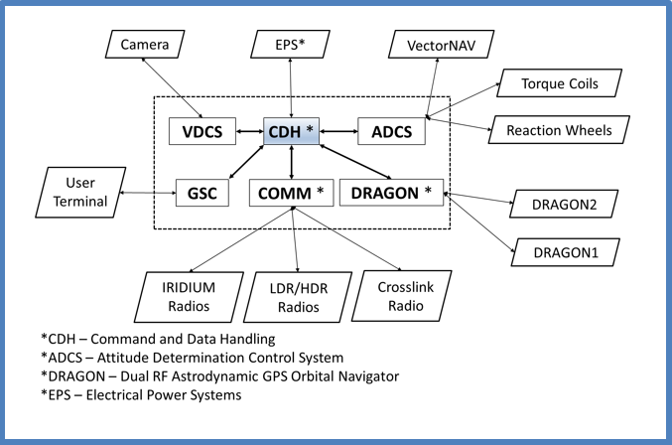
Figure 4 - Flight computer state machine architecture. CDH is a master process controlling all other subsystems. Each subsystem must work autnomously and in conjuction with one another.

In order to certify that CDH and all other subsystems were launching properly, the sample output of a successful flight computer boot and initiation of master_script, which starts each of the subsystems, is included in Appendix A.

Demonstrate Control of VDCS Subsystem via CDH
The final objective pertaining to the camera subsystem was for the development of a VDCS subsystem, which would interface between CDH and the developed camera library functions. To meet this objective a higher level of software, the VDCS subsystem, was developed in C++ to receive commands from CDH and execute them accordingly while also maintaining the camera hardware. The VDCS subsystem is designed to execute a specific sequence of camera related events in order to accomplish a greater task such as capturing the release of Bevo-2. VDCS commands the camera indirectly by calling the camera library functions. The functions were further improved to include return arguments in order for the VDCS subsystem to determine if the function executed properly or not. This is currently only used for error reporting, but in the future will likely be expanded to include recovery cases should an error occur. For example, if communication is lost with the camera, VDCS should attempt to reset the camera, and possibly even cycle power to the camera and resume its intended mode of operation immediately.
The VDCS subsystem can be placed into a single “mode” at any time by CDH. A full list of the modes can be seen below in Table 5.
Table 5. Listing of VDCS subsystem modes.
System Checkout | Verifies proper operation of camera hardware
Idle | Subsystem is active with camera hardware off
Prepare Camera | Power on and Initialize camera for usage
Bevo-2 Imaging | Captures specific image types of Bevo-2's release
Earth Imaging | Captures specific image types of Earth
General Imaging | Captures images for an unspecified event
Get Image Info | Obtains data about images stored in memory
Download | Downloads all JPEG data (including thumbnails)
Erase Memory | Erases cameras memory
Temp Reset | Resets a temperature alarm condition
Shutdown | Stops VDCS subsystem process

Each of the listed modes performs a sequence of camera hardware events in order to achieve the mode’s objective while also simultaneously monitoring the camera’s temperature and updating the IPC watchdog (ensures VDCS subsystem is still active). For example, the system checkout mode will be executed sometime shortly after AGS4 powers on for the first time. This mode executes many camera functions and will generate a small data log file easily transmittable to earth through the low data rate radios (low bandwidth communication) for a flight controller to review. This data file contains key information to deem the VDCS subsystem mission ready or alternatively provides information relative to a problem for further review and potential troubleshooting. An example of the log file is in Appendix B. Each mode will actually log in a similar fashion while the overall VDCS process is logged in detail into a larger data file should problems arise requiring more data. The generated log files (Appendix B) provide useful data, which helped easily certify that the objective was met. Each mode that was developed was verified that it achieved its designed objective and produced data conforming to the VDCS specifications (Table 2).
At this time, the exact specifics of each mode are being discussed with AGSL, but tests indicate that VDCS is properly executing CDH commands to accomplish the specific mode function. Using an event sequence file (processed by CDH), VDCS specific events were sequenced by CDH to command VDCS to execute each mode listed in Table 5. To ensure the proper operation of each mode, all generated data was reviewed for proper execution. The data includes JPEG files, image information files, mode specific data logs, and the detailed VDCS master subsystem data log file.

Establish Serial Communication between GSC User Terminal and CDH
In order to meet the specifications for GSC as established in Table 3, RS-232 serial communication was established between a C++ developed user terminal and the AGS4 satellite. Due to the criticality of transmission and the fact that the data segment of transmission including file names and content could be of unknown length, a packet delivery system was established. Each packet included the header, which was comprised of the sender ID, noting whether the packet is from the GSC terminal or the AGS4 satellite, and the command ID, which denotes the actual command function that the satellite is to perform. Additionally, the undetermined data length must be terminated with a string “T3RM|N” to identify this is the end of the sent packet. An illustration of the GSC Data and Command Packet can be seen in Figure 5.
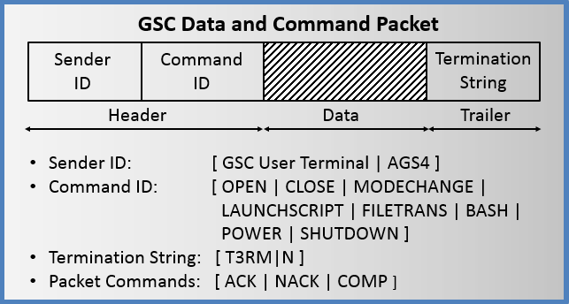
Figure 5 – GSC Data and Command Packet illustrating the Header containing the sender ID and command ID, the data segment, and the termination string trailer.

Send and receive packet functions were established on both the user terminal and the AGS4 satellite to append/prepend the header and trailer segments upon transmission and strip them upon receiving before being passed to the command handler on each system. The serial communications were tested and validated by testing send_ACK, send_NACK, and send_COMP functions between AGS4 and the user terminal.

Operate AGS4 via GSC User Terminal
In order to implement the more advanced functions specified for GSC in Table 3, a menu program was developed in C++ to run in Linux to command the AGS4 satellite. The menu program is illustrated in Figure 6.
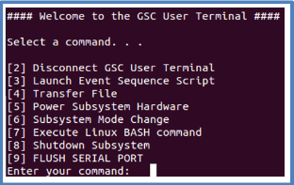
Figure 6 - Ground Support Communications (GSC) user terminal supported functions.

The first function implemented was the ability for the user terminal to connect and disconnect from the satellite successfully without interfering with its function. This allows the engineer to connect and disconnect from the satellite throughout the testing sequence, which could last for days or weeks. The terminal must also be able to change subsystem modes. For example, it must be able to change from the VDCS subsystem, Bevo Release Capture Mode to the COMMS subsystem, Bevo-AGS4 Radio Uplink. Next, the GSC terminal must be able to launch event sequences, which could include many mode changes between various subsystems. The event sequence script files were assumed to already exist in the mission scripts directory on AGS4 and GSC would simply launch those scripts into CDH. The GSC terminal must also be able to power on or off satellite hardware such as the VDCS camera or Communications Link Radio.
The next command implemented was the ability to transmit files to and from the satellite. These files include data such as pictures, log files, mission scripts, as well as new code or functions to be uploaded to the satellite. The next function was to be able to send Linux BASH commands. The commands would be received by CDH and passed to Linux to be executed. The output would then be captured and returned back to the user terminal. Finally, the GSC terminal must be able to issue system shut down commands allowing the satellite to be gracefully shutdown in preparation for flight. Each of these functions were implemented with multiple handshake sequences to ensure each command was successfully received over the serial communications and executed without error.

Target Objective: Demonstrate VDCS and GSC Subsystem Integration with CDH
CoogCrew demonstrated all of these subsystems operating on the flight computer by launching a VDCS event sequence through the command data handler as issued as a command from the Ground Support Communication subsystem. A sequence to simulate the Bevo satellite release and capture photos is illustrated in Figure 7 and includes the camera being commanded to take 10 rapid-fire images, 2 images at high resolution, and then download all of these images and thumbnails. During this mode the camera is also continuously monitored for successful operation and valid operating temperature range.
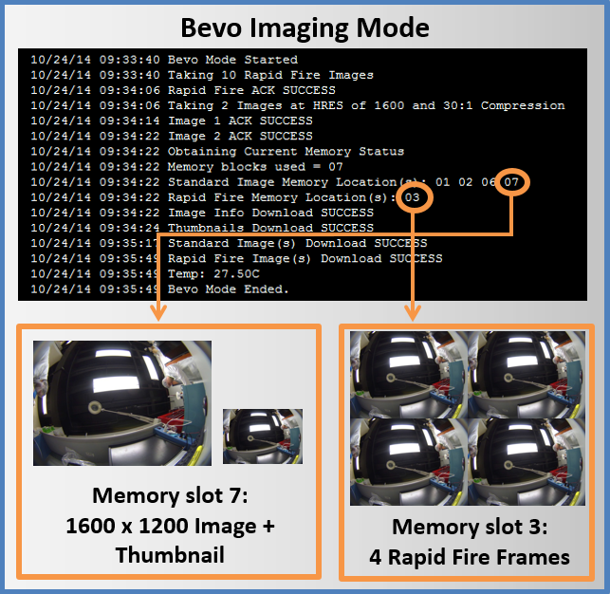
Figure 7 - Ground Support Communications (GSC) user terminal supported functions.

The ground support user terminal was then utilized to download the various images captured and log files generated. The GSC code and documentation has currently been delivered to AggieSat Lab and is currently being used to test and validate other systems in preparation for delivery to NASA.

Budget
A budget was created for this semester to ensure time and money was spent effectively. Test plan cost, weekly team meetings, facilitator/advisor cost, miscellaneous hardware, and travel time to Texas A&M’s AGSL for the semester were essential to record as expenses. Table 6 illustrates total expenditures spent for this semester.
Table 6 - Total expenditures (ECE 4335)
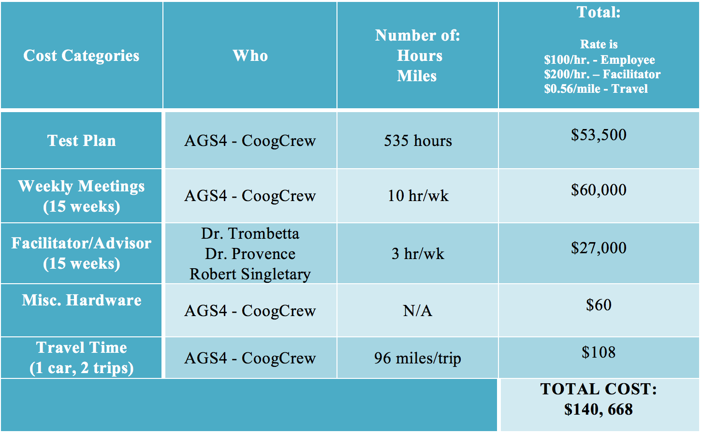
The total cost for the test plan included research and manual labor applied to complete all objectives leading up to the target objective. Weekly meetings included class time, team meetings, and AGSL videoconferences that were attended throughout the semester. Facilitators and advisors were paid for class time and guidance provided to us. For subsystem related hardware, AGSL provided the Technologic Systems TS-7800 flight computer and the Aerospace Corporation 2 Mega Pixel camera. These expenses were not included within the budget, however, miscellaneous hardware was purchased, which included RS-232 cables and equipment associated with building the flight computer. In regards to travel time for the semester, AGSL was visited once so far and another visit to deliver all developed systems has been scheduled for the near future.
An anticipated budget has been created to prepare for next semester, ECE 4336, which can be seen in Table 7.
Table 7 - Anticipated Expenditures (ECE 4336)
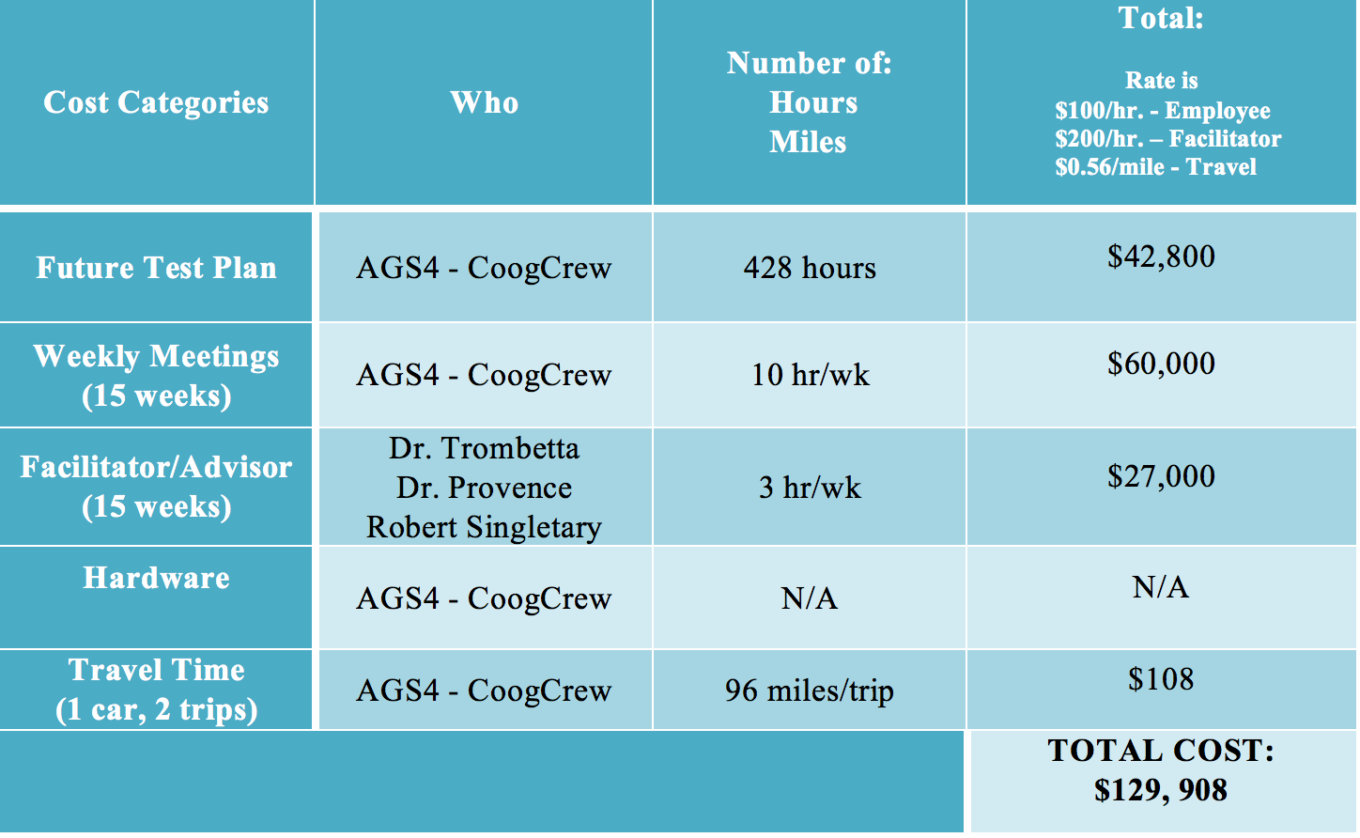
Much like the budget for this semester, the anticipated budget for next semester includes future test plan cost, weekly team meetings, facilitator/advisor consultation, hardware, and travel time. The amount of manual labor predicted to be applied to the future test plan is much less than this semester due to the fact that VDCS and GSC will have already been completed and delivered to AGSL by the December 31, 2014 deadline for testing and approval. Once AGSL has completed the testing process, it is possible that errors and/or system malfunctions could arise, which is where the CoogCrew will be needed for repairing purposes. Not only will the team be responsible for debugging the two subsystems, documentation and testing procedures will also need to be written. The weekly and facilitator/advisor meeting costs are anticipated to be very similar to this semester; therefore, there has been no change to the total cost of those two budget categories. At this time, the team does not foresee needing any additional hardware, however, this could change between now and then. In regards to travel time, it is expected that at least one, if not two trips will be made to Johnson Space Center in order to observe and assist with the testing procedures performed on the VDCS and GSC subsystems.

Conclusion
In conclusion, the University of Houston AggieSat Lab collaboration CoogCrew was able to successfully develop two subsystems of the AggieSat4 satellite, the Visual Data Capture System (VDCS) and Ground Support Communication (GSC), according to NASA and AggieSat Lab requirements. By December 31, 2014, all code and documentation will have been submitted to the AggieSat Lab for testing and approval. As for next semester, CoogCrew is ready to perform maintenance on the two modules where repair is needed. With AggieSat4 being launched in Spring 2015, it is CoogCrew’s hope that the VDCS and GSC will aid in the success of LoneStar’s 2nd mission designed to research autonomous rendezvous and docking of small spacecraft in low earth orbit.

References
[1] “National Aeronautics and Space Administration,” 29 July 2014. [Online]. Available: http://www.nasa.gov/mission_pages/station/research/experiments/859.html. [Accessed 26 November 2014].
[2] H. Hasan, “Mission Operational Timeline – AGS4-09-02-001-R0,” AggieSat Lab, College Station, 2012.
[3] Robert Singletary, “CDH Software Design Overview – AGS4-02-01-001-R0,” AggieSat Lab, College Station, 2012.

Appendix A: Sample Output of Successful Flight Computer Boot
In order to verify the successful launch of AGS4 flight software including CDH and other subsystems, the sample output below was provided.
>> TS-BOOTROM – built May 11 2011
>> Copyright (c) 2008, Technologic Systems
>> Booting from microSD card…
Uncompressing Linux… done, booting the kernel.
Setting Up TS7800
* Installing TS7800 Drivers
* Mounting Filesystems
* Mounting Debian Partition
Checking for USB Update
* Installing Drivers
* Checking for USB Device
Installing Serial Ports From TS-SER4s (x3)
* Installing Board B
* Installing Board C
* Installing Board D
Installing USB Ports for LDR Radios
* Installing USB Serial Drivers
* Setting up Serial Ports
Mounting SD Card
* Creating /agsl Folder
* Mounting SD Card to /agsl
Running 0script
Clearing Environment of: ./14.30.01
Environment Cleared
Version: ./14.30.01
Running master_script
Master Script starting on …
Clearing FIFOs Folder
Clearing Log Folder
Compiling Processes
* Compiling Libraries
* Compiling CDH
* Compiling ACS
* Compiling ADS
* Compiling COMM
* Compiling HDR
* Compiling VDCS
Setting Permissions
Running Processes
* Running CDH

Beginning Setup Sequence
* Starting ACS IPC
IPC acs: Server Creating FIFOs
IPC acs: Server Opening STX FIFOs
* Running ACS
IPC acs: Server Opening SRX FIFOs
IPC acs: Server Setup Complete
acs: Side: 0 STX: 3 SRX: 4 CTX: 6 CRX: 5
acs: Filenames: ‘/agsl/0fifos/acsst’, ‘/agsl/0fifos/acssr’, ‘/agsl/0fifos/acsct’, ‘/agsl/0fifos/acscr’
* Starting VDCS IPC
IPC vdcs: Server Creating FIFOs
IPC vdcs: Server Opening STX FIFOs
* Running ADS
* Running VDCS
IPC vdcs: Server Opening SRX FIFOs
IPC vdcs: Server Setup Complete
vdcs: Side: 0 STX: 7 SRX: 8 CTX: 10 CRX: 9
vdcs: Filenames: ‘/agsl/0fifos/vdcsst’, ‘/agsl/0fifos/vdcssr’, ‘/agsl/0fifos/vdcsct’, ‘/agsl/0fifos/vdcscr’
* Starting COMM IPC
IPC comm: Server Creating FIFOs
IPC comm: Server Opening STX FIFOs
* Running COMM
IPC comm: Server Opening SRX FIFOs
IPC comm: Server Setup Complete
comm: Side: 0 STX: 11 SRX: 12 CTX: 14 CRX: 13
comm: Filenames: ‘/agsl/0fifos/commst’, ‘/agsl/0fifos/commsr’, ‘/agsl/0fifos/commct’, ‘/agsl/0fifos/commcr’
* Running HDR
> Setup Complete

Appendix B: Sample Output of VDCS as commanded by CDH
In order to verify the VDCS subsystem was successfully integrated with CDH, all of the modes of operation were tested using an event sequence script which could be configured in CDH to load upon boot. The event sequence commands are listed here along with the expected successful operation of each.
// VDCS EVENT SEQUENCE SCRIPT COMMANDS
v –m 1 // System Checkout
t –p v
v –m 9 // Ready Camera Mode
t –p v
v –m 8 // General Image Mode
t –p v
v –m 4 // Bevo Mode
t –p v
v –m 3 // Get Status Mode
t –p v
v –m 6 // Download Mode
t –p v
v –m e // Erase Mode
t –p v
v –m a // Idle and monitor Temperature

// VDCS EVENT SEQUENCE SCRIPT OUTPUT FOR EACH MODE
07/01/15 12:01:16 System Checkout Started
07/01/15 12:02:27 Temp: 28.50C
07/01/15 12:02:27 Firmware: 0c1d0a(HEX)
07/01/15 12:02:27 Memory Cleared ACK SUCCESS
07/01/15 12:02:27 Memory Remaining: 32
07/01/15 12:02:33 1600x1200 30:1 ACK SUCCESS
07/01/15 12:02:45 1600x1200 10:1 ACK SUCCESS
07/01/15 12:02:52 Rapid Fire 4 ACK SUCCESS
07/01/15 12:02:52 Memory Remaining: 29
07/01/15 12:02:52 Standard Image Memory Location(s): 01 02
07/01/15 12:02:52 Rapid Fire Memory Location(s): 03
07/01/15 12:02:52 Image Info Download SUCCESS
07/01/15 12:02:52 Thumbnails Download SUCCESS
07/01/15 12:03:26 Standard Image(s) Download SUCCESS
07/01/15 12:03:32 Rapid Fire Image(s) Download SUCCESS
07/01/15 12:03:32 Memory Cleared ACK SUCCESS
07/01/15 12:03:32 Memory Remaining: 32
07/01/15 12:03:32 Temp: 29.00C
07/01/15 12:03:32 System Checkout Ended

07/01/15 12:03:32 Ready Camera Mode Started
07/01/15 12:03:32 Powering On Camera
07/01/15 12:03:32 Waiting for Camera Hardware to Initialize
07/01/15 12:03:37 Temp: 29.00C
07/01/15 12:03:37 Verifying That Memory is Clear
07/01/15 12:03:37 Memory blocks used = 00
07/01/15 12:03:37 Temp: 29.00C
07/01/15 12:03:37 Ready Camera Mode Ended.

07/01/15 12:03:37 General Image Mode Started
07/01/15 12:03:37 Temp: 29.00C
07/01/15 12:03:37 Obtaining Current Memory Status
07/01/15 12:03:37 Memory blocks used = 00
07/01/15 12:03:37 Taking 2 Images at HRES of 1600 and 30:1 Compression
07/01/15 12:03:43 Image 1 ACK SUCCESS
07/01/15 12:03:49 Image 2 ACK SUCCESS
07/01/15 12:03:49 Obtaining Current Memory Status
07/01/15 12:03:49 Memory blocks used = 02
07/01/15 12:03:49 Temp: 29.00C
07/01/15 12:03:49 General Image Mode Ended.

07/01/15 12:03:49 Bevo Mode Started
07/01/15 12:03:49 Taking 10 Rapid Fire Images
07/01/15 12:04:08 Rapid Fire ACK SUCCESS
07/01/15 12:04:08 Taking 2 Images at HRES of 1600 and 30:1 Compression
07/01/15 12:04:14 Image 1 ACK SUCCESS
07/01/15 12:04:21 Image 2 ACK SUCCESS
07/01/15 12:04:21 Obtaining Current Memory Status
07/01/15 12:04:21 Memory blocks used = 07
07/01/15 12:04:21 Standard Image Memory Location(s): 01 02 06 07
07/01/15 12:04:21 Rapid Fire Memory Location(s): 03
07/01/15 12:04:21 Downloading Unexpected Contents from Memory.
07/01/15 12:04:21 Image Info Download SUCCESS
07/01/15 12:04:21 Thumbnails Download SUCCESS
07/01/15 12:04:55 Standard Image(s) Download SUCCESS
07/01/15 12:05:10 Rapid Fire Image(s) Download SUCCESS
07/01/15 12:05:10 Temp: 30.00C
07/01/15 12:05:10 Bevo Mode Ended.

07/01/15 12:05:10 Get Status Mode Started
07/01/15 12:05:10 Temp: 30.00C
07/01/15 12:05:10 Obtaining Current Memory Status
07/01/15 12:05:10 Memory blocks used = 07
07/01/15 12:05:10 Image Info Download SUCCESS
07/01/15 12:05:10 Standard Image Memory Location(s): 01 02 06 07
07/01/15 12:05:10 Rapid Fire Memory Location(s): 03
07/01/15 12:05:10 Temp: 30.00C
07/01/15 12:05:10 Camera Turned Off
07/01/15 12:05:10 Get Status Mode Ended

07/01/15 12:05:11 Download Mode Started
07/01/15 12:05:11 Powering On Camera
07/01/15 12:05:11 Waiting for Camera Hardware to Initialize
07/01/15 12:05:16 Temp: 30.00C
07/01/15 12:05:16 Obtaining Current Memory Status
07/01/15 12:05:16 Memory blocks used = 07
07/01/15 12:05:16 Image Info Download SUCCESS
07/01/15 12:05:16 Standard Image Memory Location(s): 01 02 06 07
07/01/15 12:05:16 Rapid Fire Memory Location(s): 03
07/01/15 12:05:16 Thumbnails Download SUCCESS
07/01/15 12:05:50 Standard Image(s) Download SUCCESS
07/01/15 12:06:05 Rapid Fire Image(s) Download SUCCESS
07/01/15 12:06:05 Temp: 30.50C
07/01/15 12:06:05 Camera Turned Off
07/01/15 12:06:05 Download Mode Ended

07/01/15 12:06:05 Erase Mode Started
07/01/15 12:06:05 Powering On Camera
07/01/15 12:06:05 Waiting for Camera Hardware to Initialize
07/01/15 12:06:10 Temp: 30.50C
07/01/15 12:06:10 Obtaining Current Memory Status
07/01/15 12:06:10 Memory blocks used = 07
07/01/15 12:06:10 Memory Cleared ACK SUCCESS
07/01/15 12:06:10 Verifying That Memory is Clear
07/01/15 12:06:10 Memory blocks used = 00
07/01/15 12:06:10 Temp: 30.50C
07/01/15 12:06:10 Camera Turned Off
07/01/15 12:06:10 Erase Mode Ended

