December 5th, 2014

Dr. Leonard P. Trombetta
Associate Professor, University of Houston
4800 Calhoun Road
Houston, TX 77204

Dear Dr. Trombetta:

Enclosed is the final report of our project Robocharge for the fall semester of 2014. The project overall goal is to create an unmanned vehicle that charges Energy Harvesting Sensor Devices wirelessly in less accessible areas. The report details the project background, overview and milestones completed this semester.
Please feel free to email if you have any questions or would like further information.

Sincerely,
Meagan Shores
Team Member, Team Robocharge

Senior Design Project: Final Report

“RoboCharge”
An Unmanned Wireless Charging Vehicle

Members: Rabal Sheikh, Meagan Shores, Kevin Adams, & Robert Boswell

ECE 4335

[Submitted: December 9, 2014]

Abstract
Applications of wireless sensor networks (WSNs) are inhibited by the limited battery power provided to the sensors. As opposed to using battery power, supercapacitors in the sensors can be used to storeRadio Frequency (RF) energy for power. To increase the ease of harvesting energy for WSNs in less accessible areas, our team will use an unmanned vehicle to transmit RF signals to an energy-harvesting device to then provide power to a wireless sensor network. The team will use National Instruments Universal Software Radio Peripherals (USRP) and localization methods to determine the location of the vehicle and sensors. An ERA MOBI robot will be used as the unmanned vehicle in conjunction with the energy harvesting equipment from Powercast Corp. This report documents the final progress of this project deemed “RoboCharge” during the fall 2014 semester. It includes a detailed background and overview as well as goals and milestones that have been achieved.

Goal
The overall goal of the project is to create an unmanned vehicle that wirelessly charges sensors from a wireless sensor network in less accessible areas.

Background
A wireless sensor network (WSN) is a wireless network consisting of spatially distributed autonomous devices using sensors to monitor physical or environmental conditions [1]. Wireless sensor networks (WSNs) have many functions ranging from health care monitoring to environmental sensing to industrial monitoring. In less accessible areas, such as forest fire detection and air pollution monitoring, an extended period of unattended operability can occur which makes powering the WSNs difficult.
The project is part of highly popular research in the field of wireless charging. Particularly, the project utilizes Energy Harvesting devices connected to the sensors of a WSN to relay information without the use of batteries. This is done through harvesting the energy of the transmission of RF waves to a receiver. The technology in the project can be used in many different applications to monitor information in areas that are less accessible such as forests or deserts. The innovative part of the project is that the wireless charging techniques are done without the use of batteries. Battery usage brings the need of battery maintenance such as battery or charger replacements. This maintenance can be a problem in areas that are less accessible. Through the use of energy harvesting sensor devices, sensors that relay information can be turned online whenever required simply by sending a transmission signal to the device. This requires much less maintenance than batteries because the device is only working when needed. There are many advantages of this technology. The cost is much less in that the equipment is only on for the needed time as opposed to keeping batteries charged constantly. Also the cost is reduced because there is no labor cost associated with maintenance in a possibly harsh environment. This technology has the possibility to change the way information in less accessible areas is relayed in the future.

Problem
Wireless charging is underutilized and inefficient. Applications of wireless sensor networks are inhibited by the limited battery power provided to the sensors.
Inductive charging, or “wireless charging”, uses an electromagnetic field between two objects to transfer energy. Energy is sent through inductive coupling to an electronic device that then uses that energy to charge the batteries. Inductive coupling is two conductors configured such that change in current flow through one wire induces a voltage across the ends of the other wire through electromagnetic induction. [7]
Charging devices wirelessly dismisses the need for physical power cables that tend to tangle easily and corrode over a period of time. IMS Research estimated that wireless charging would have a market value of $4.5 billion in the next two years and Pike Research estimated it would have a market value of $15 billion by 2020. Wireless charging is also more environmentally beneficial because plastic, packaging, and electronic waste from power cables is reduced. [5] This project has great potential to become the next greatest technological advance of this generation.
Need
Optimization is needed to allow wireless charging to see more commercial use and less accessible areas are even greater hindered because of the inability to reach sensors easily. From a consumer perspective, the annual replacement of mobile communications and portable rechargeable devices is over 50% with that number steadily increasing. For every replacement, more waste of plastic, packaging, and power cables is added to the environment. From a manufacturing and retail perspective, wireless charging decreases recycling, design, and packaging costs (approximately 20% of the cost). [6]
Significance
Consumers and retailers should both be concerned with advancing this technology because of how beneficial it is to each side and also the environment. More money saved and less ecological waste. Time, costs and power consumption can be reduced greatly.
User Analysis
This project has many applications. Any areas using RF Energy Harvesting Sensor Networks will be able to access the wireless charging capabilities. The Sensor Networks can supply power from a radio environment. It can be useful for physical and environmental situations such as air pollution monitoring and forest fire detection. As long as the user is knowledgeable about wireless sensor networks, Powercast Transmitters, and Universal Software Radio Peripherals will be able to apply this project.
Overview Diagram
The USRP or Universal Software Radio Peripheral is used to both transmit signals and receive signals to be processed. Four USRP’s are placed in each of the corners of the room. This is done to ensure signals can be processed throughout the entire room. Three targets or sensors with Energy Harvesting Devices connected to an antenna and receiver are placed randomly throughout the room. The targets communicate voltage levels of a supercapactior located on the Energy Harvesting Device. This information is then used in conjunction with localization methods to determine their locations and the lowest charged target. The USRP’s will also process signals from the robot to determine its location. The robot is carrying a RF signal transmitter or the signal that we will be harvesting the energy from. When the locations of the targets and robots are known as well as which target to go to first, the robot will then drive to the correct target to charge it. The process will then be repeated until all targets have been charged. A visual of the project can be seen below in Figure 1.
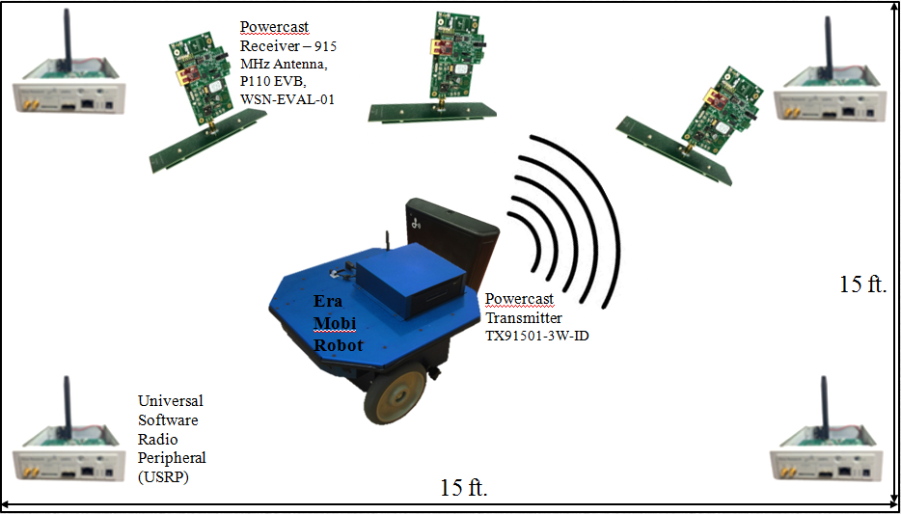 Figure 1. Overview Diagram.

Target Objective & Goal Analysis
The target objective for the overall project is to execute RF signal transmission for wireless charging with an autonomous robot. The target objective for the fall 2014 semester was to detect robot communication, execute robot motion and execute RF signal transmission. The Zigbee signal allows the target device to communicate with the USRP to determine the target’s location and its voltage levels. The same communication process as with the targets also needs to be completed with the robot. The USRP will be used to help determine the robot’s location and the information will then be relayed to the robot with commands to drive to the correct target location. Once the locations of the target and robot are successfully determined as well as the robot can successfully execute motion, the project’s overall target objective should be able to be completed.
The milestones we initially wanted to complete during the fall 2014 semester are indicated with red boxes in the goal analysis diagram shown below in Figure 2. We wanted to complete the lower branch of the goal analysis that consisted of the robot related milestones. Due to the longevity of receiving the robot, the group worked on milestones from the upper branch to make progress. The milestones completed for the fall 2014 semester are shown with red boxes in Figure 3.

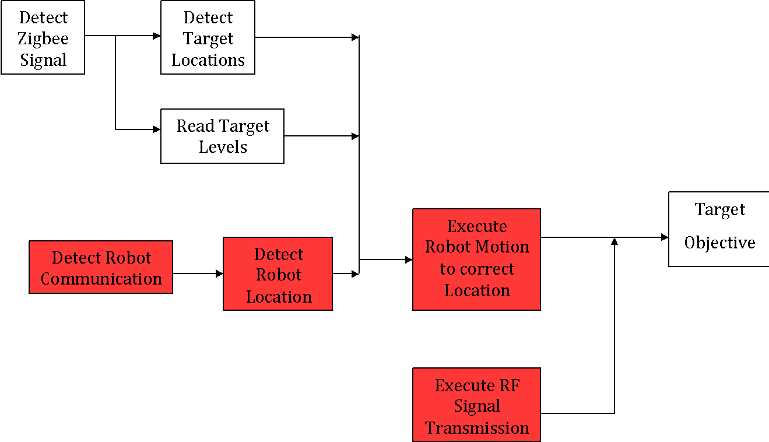

Figure 2. Initial Goal Analysis.

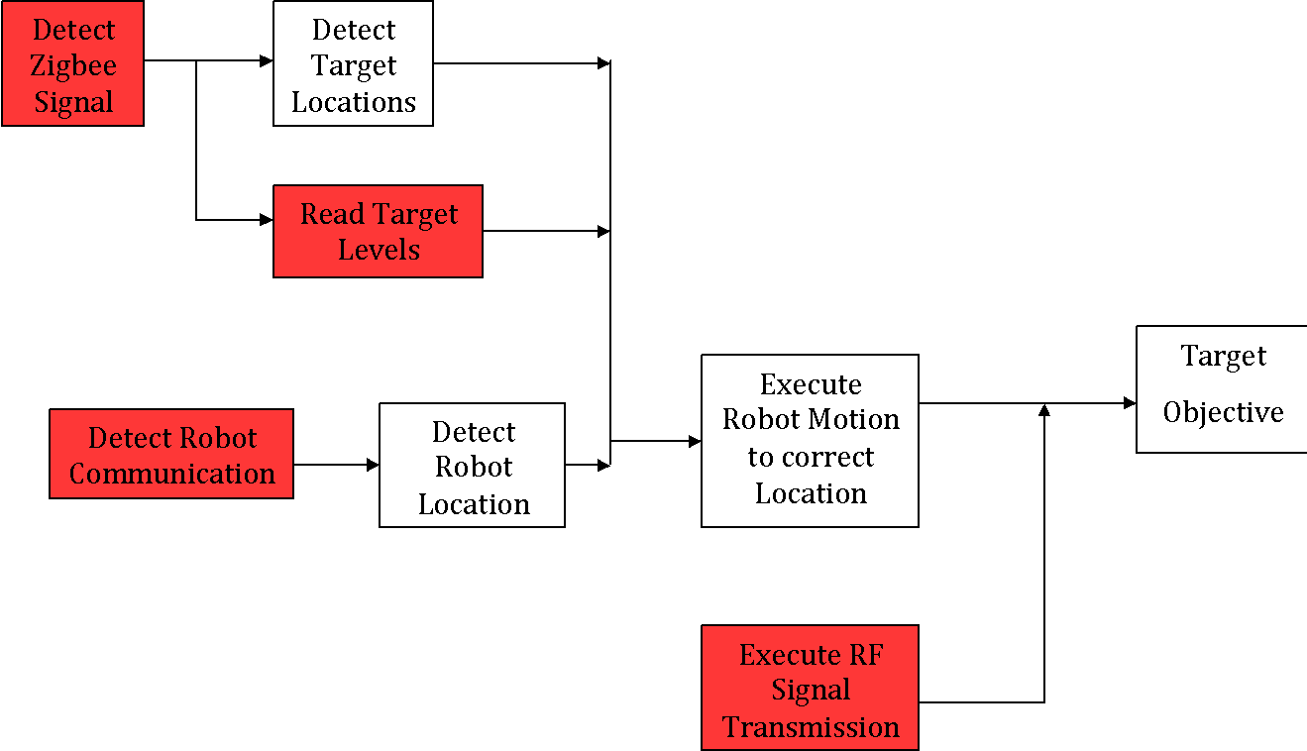
Figure 3. Fall 2014 Final Goal Analysis.

Specifications and Constraints
The specifications were determined based on the hardware given to use in the project and the project constraints. They can be seen below in Table 1.

Table 1. Specifications.
Robot
Carry load | 5 lbs.
Speed | $$≥16 ft/min$$
Carry size | 9″L x 8″W x 4″H / 22.9cm L x 20.3cm W x 10.6cm H
Angle orientation | 30 degrees
TX91501 Powercaster Transmitter and P2110 Power Harvester Receivers
Distance | $$≤1 m$$
Voltage levels | 0
Distance between two receivers | $$≤21.21 ft.$$

The constraints that determined the specifications are given below and were predetermined at the start of the project.
 | Table 2. Constraints.
Room | Size | 15 ft. by 15 ft.
Money | Budget | $8500
Antenna | Frequency | 915 MHz (industry standard)
Super capacitor | Power life | 10 minutes

The robot that will be used in this project is the ERA-MOBI robot. Its specifications can be seen in Appendix A. It’s platform size is 40 cm (L) x 37 cm (W) x 18 cm (H) which will be large enough to hold the transmitter device or required carry size spec of the project. The robot has a payload spec of 20 kg which also is more than enough to hold the transmitter. The robot has a speed spec of 2.0 m/sec or about 393 ft/min, and a rotational speed of 720 deg/sec. This is much faster than the required speed spec of 13 ft/min the project determined by the size of the room and number of targets. The PC is 16 cm (L) x 16 cm (W) x 5.5 cm (H), and consists of an Intel Celeron-M 1.4 GHz processor, with 512 MB of random access memory. 40 GB of storage and USB 2.0 compatibility make connecting and storing data very simple. The robot’s communication will be done through IEEE 801.11 b/g (Wi-Fi). The Robot can be controlled by the off-board computer using two clients; playerjoy, which controls the robot via a joystick or the keyboard, and can control both directions and speed. Player presents the user with a graphical interface for viewing the robots laser rangefinder, and for moving the robot by dragging the control icon in the desired movement direction.

Budget
We decided to pay our group members an hourly rate of $45. We decided to pay our faculty support $100 per hour. The hours worked this semester came to a total of $4500. We did not have to purchase the robot so we saved about $250. The fixed resources budget of $100 is shown in the budget breakdown in Appendix 2. Our budget for this semester came to a total of $5,083.

Objectives Accomplished
We have completed objectives from several milestones in the goal analysis shown in Figure 2. While waiting for the approval and purchase of the robot, the group started working on the milestone of detecting the Zigbee signal. The task of investigating the energy harvesting sensors and how they operate was completed for this milestone. Energy harvesting devices captures energy in various forms and harvests the energy by converting it into electricity [1]. The most widely known types of energy harvesting devices are solar panels and wind generators. We will use the Powercast P2110 receiver as an RF energy harvesting device. It converts RF waves to DC power and stores the energy in a supercapacitor. The kit we are using contains an evaluation board (P2110-EVB) and a 915 [MHz] antenna to communicate with the P2110 Powerharvester Receiver. [2]
The task of investigating Zigbee communication was also completed for this same milestone. Zigbee is a form of wireless communication such as Bluetooth or Wifi. We chose Zigbee communication for our project because it is low cost, reliable, and consumes very low power [3]. Zigbee communication however does not have a high peak information rate as other communication forms. Our project does not require data to be transmitted and received very quickly therefore Zigbee’s lower information rate should not affect our project.
Using the Powercast software we were able to execute RF signal transmission, to charge and then read the levels of an individual sensor. We turned on the Powercast transmitter, and held the evaluation board and antenna near to it. The sensor charged its supercapacitor and communicated to the USRP via Zigbee its voltage level, temperature and time elapsed. The USRP was connected to a PC where we could view this information.
The task of researching robots and microcontrollers was completed to pave the way for the milestone Detect Robot Communication. The ERA-MOBI robot was approved [4]. This robot was chosen because it fit all of the criteria outlined in the specifications. Using the software that came with the robot we were able to communicate with the robot via Wi-Fi, and then using the program playerjoy, we were able to control the robots movement with the direction keys of the PCC we were using. An alternative program player can also be used to move the robot, by presenting a graphical representation of the robots laser rangefinder and dragging a control icon in the desired movement direction.

Objectives Remaining
The objectives remaining for the spring 2014 semester involve localization. We need to be able to detect where the robot is in relation to the USRP’s. Then we need to determine where the sensors are located in relation to the USRP’s. Once we are able to map out where everything is, we can begin the task to combine robot motion, reading the sensors levels, and RF signal transmission to allow our robot to move towards the most needed to be charged sensor.

Conclusions
The budget was adjusted slightly to take into account the change in cost of the robot. We have completed the majority of the project tasks on time as indicated in the initial schedule. The tasks associated with the robot have been completed which will allow us to continue forward with the further milestones as stated. With these completed tasks running smoothly, the group will be able to complete the target objective for the spring 2014 semester.

Works Cited
[1] “Energy Harvesting”. Mouser Electronics. Retrieved November, 2014. Available: http://www.mouser.com/applications/energy_harvesting/
[2] "Powercast Products". Retrieved November , 2014 Available: http://www.powercastco.com/products/powerharvester-receivers/
[3] RANJAN, P , "Wireless Communication using Zigbee". Dhirubhai Ambani Institute of Information and Communication. Retrieved November , 2014 Available:http://intranet.daiict.ac.in/~ranjan/sn/presentations/Wireless%20Communication%20using%20Zigbee.pdf
[4] "ERA-MOBI: Mobile Robots". Robot Intelligence Lab. RetrievedNovember , 2014 Available: http://robinlab.uji.es/era-mobi-mobile-robots
[5] Ferris, David. "How Wireless Charging Will Make Life Simpler (And Greener)." Forbes. Forbes Magazine, 24 July 2012. Web. 27 Sept. 2014.
[6] Convenient Power. "ConvenientPower HK Limited." ConvenientPower HK Limited. Convenient Power, n.d. Web. 26 Sept. 2014. <http://www.convenientpower.com/1/faq.php>.
[7] Wikipedia. "Inductive Charging." Wikipedia. Wikimedia Foundation, 23 Sept. 2014. Web. 25 Sept. 2014. <http://en.wikipedia.org/wiki/Inductive_charging>.

Appendix 1 – ERA-MOBI Robot Specifications
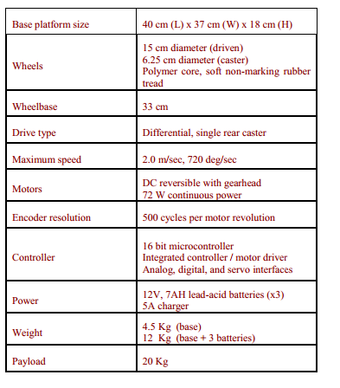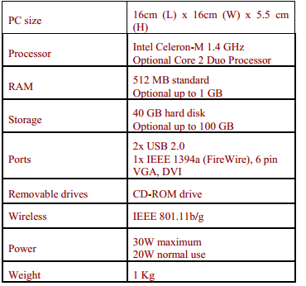
Appendix 2 – Overall Project Budget Breakdown
Overall Project Budget
Time Resources | $4532
Meagan Shores | $45/hr
Rabal Sheikh | $45/hr
Kevin Adams | $45/hr
Robert Boswell | $45/hr
Dr. Trombetta | $100/hr
Dr. Marpaung | $100/hr
Dr. Han | $100/hr
Fixed Resources | $100
Robot and Microcontroller | $0
Sensor Devices | $100
Contingency | 10%
Total Project Cost | $5083

