Date: December 9, 2014
Subject: Fall Term Technical Report for Automation of Chemical Compatibility Testing
To: Dr. Candice Landry, IP Liaison
Multi Chem Group
15865 International Plaza Dr Suite 200
Houston, TX 77032

Dear Dr. Landry:

This report documents the progress made by the University of Houston ECE senior design team in developing the automated chemical compatibility testing equipment for Multi Chem Group. We have successfully ironed out all of the details to push forward in the development of the apparatus. We have already created a skeleton for the software that the user will use to control the equipment and will be showing that to you for your approval. The parts have been ordered and we have started developing lower level implementation details. Included design documents are system overview diagram, goal analysis, specifications, statement of accomplished objectives, test plan, and budget.

Sincerely,

Halliburton Senior Design Team
University of Houston

Encl: Fall Term Technical Report

You know a lot about how this system will work, or you should since you ordered parts, that is not described here. You have a nice process flow diagram (Fig. 4) that could have been elaborated on much more than you did. You gave considerably more detail in the demo. On that note: you indicated several things in your report as being deliverables that we did not see in the demo…

Automation of Chemical Compatibility Testing
Fall Term Technical Report

Sriram GopAraju
Brian Lee
Shehnil Ali
Alvaro Ordonez
Jereomy Lopez
Alamdar Syed
Sponsored by Multi-Chem, a Halliburton Service

December 9, 2014

Abstract
The following report details the target objective and the work to date in automating Multi Chem Group’s chemical compatibility testing process to be accomplished by the University of Houston Halliburton senior design team. The work has been broken down into Fall and Spring Term deliverables where Spring is the delivery of the automated device and Fall is the delivery of the software front-end of the device. Multi Chem Group desires a reliable and simple solution to automate chemical compatibility testing. The compatibility test consists of mixing two chemical treatment products to determine whether or not they will be able to deliver their individual solution or conflict with each other. The current process leads to inconsistent results due to operator bias. Our solution will automate the chemical dispensing, heating, mixing, and image capture phases of the samples within a single device thereby removing inconsistency and providing simple points of input and output to minimize complexity of use. Our device will be able to regulate desired temperature within +/- 5 °C and dispense chemical samples with accuracy of +/- 0.1 ml. The device is also constrained to occupy an area no larger than 3’ x 3’. Multi Chem has not set a budget on this project, but we have taken it upon ourselves to make financially responsible decisions. Our current expenditures reflect a reduction in previous estimates due to changes in vial sizing and subsequent equipment to be used. The software representing the Fall deliverable has been completed and, upon interfacing with hardware, will give the user ability to choose heating temperature, mixing time, observation time, and number of images to capture.
Background, Problem, and Significance
Multi Chem Group satisfies a key niche in the oil and gas service industry by formulating unique chemical treatment products to control and optimize process flow. The product portfolio of Multi Chem is sufficiently diverse as the company deploys products in upstream, midstream, and downstream oil and gas. As a result, there is an uncertainty because interactions may occur between trace amounts of these products. In order to quantify this unknown, Multi Chem employs a chemical compatibility test which consists of mixing together and agitating a solution of two chemicals. After the solution has been sufficiently agitated, a technologist roughly estimates the degree of its mixing and records his or her observations for record. By providing an automated solution to the chemical compatibility test, data may be consistently collected and Multi Chem Group may deploy their products conscientiously.

Goal and Target Objective
The current test methodology inherently presents operator bias as there is not much precision enforced through the testing process. Multi Chem Group seeks an automated solution to remove the operator bias and provide consistent data. The overall goal of this project is therefore to provide Multi-Chem a reliable machine that automates their chemical compatibility testing process. Our deliverable for this Fall is to develop the GUI front-end of the system where the end user will provide the input parameters of heating temperature, mixing time, observation time, and number of images to capture and where the images captured of the mixed samples will be output.

User Analysis
The automation device has been designed to minimize usage complexity as the end user will be either a technologist or chemist with limited hardware background, and as a result little to no training will be required to operate the device. The role of the technologist is limited to loading the vials into the holding tray and positioning the tray into its designated spot within the device. The technologist will also need to set the testing parameters using a simple user interface provided. The testing parameters include setting the concentration of two liquids to be tested, testing temperature, actuation time and duration of video recording.

Figure 1. Points of interface for system input and output.

Overview
The following diagram illustrates the subsystems specified and their hierarchy with respect to the system front-end. The system front-end will consist of the GUI in which IO interfacing will be accessible.

Figure 2. Overview of primary subsystems to automate chemical compatibility testing; the computer is the system front-end.

Target Objective and Goal Analysis
As has been stated previously, the overall target objective for the project is to automate the chemical compatibility test used by Multi Chem Group. Several branches of milestones have been defined as a result which correspond to each subsystem, chemical mixing, chemical dispensing, temperature regulation, and image capture respectively.
For chemical mixing, the test tube rack motion must be actuated. This involves establishing proper communication through electrical interfacing and serial data framing with the linear actuators to be used. After the basic communication protocol has been implemented, the mixing mechanism must be developed by accomplishing variable speed adjusted based on positional feedback referred by mixing speed control.
The chemical dispensing mechanism is split into two independent processes. The first is similar to the chemical mixing core process wherein the needle to inject the chemical samples will be actuated laterally. Preceding this, the rail actuation will be accomplished with the use of H-bridged motors. The second part of the process consists of establishing communication with the pump drive and enabling isolation of the peristaltically pumped sources using solenoid valves.
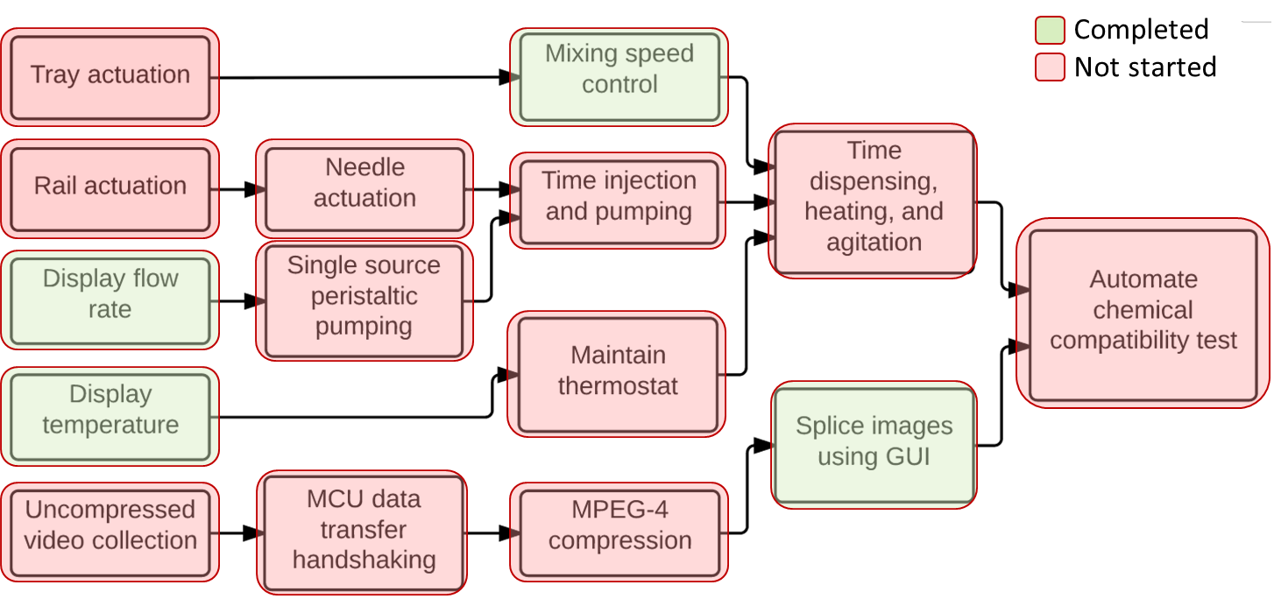
Figure 3. Goal analysis and target objective of the system.
The thermal regulation subsystem consists of developing the communications protocol between the MCU and the incubator and exploiting the internal feedback system to accomplish thermostat functionality.
The image capture subsystem involves developing communications between the camera unit and MCU for uncompressed video collection, establishing a reliable handshaking scheme with the MCU for data transfer to the FPGA, and developing the MPEG-4 compression algorithm on the FPGA. After these milestones, the compressed video will be transferred to the computer and functionality for image extraction based on the input parameters will be developed. With all of these milestones accomplished, the chemical compatibility testing automation will be completed. The following diagram demonstrates the communications protocols to be used for each of the subsystems.
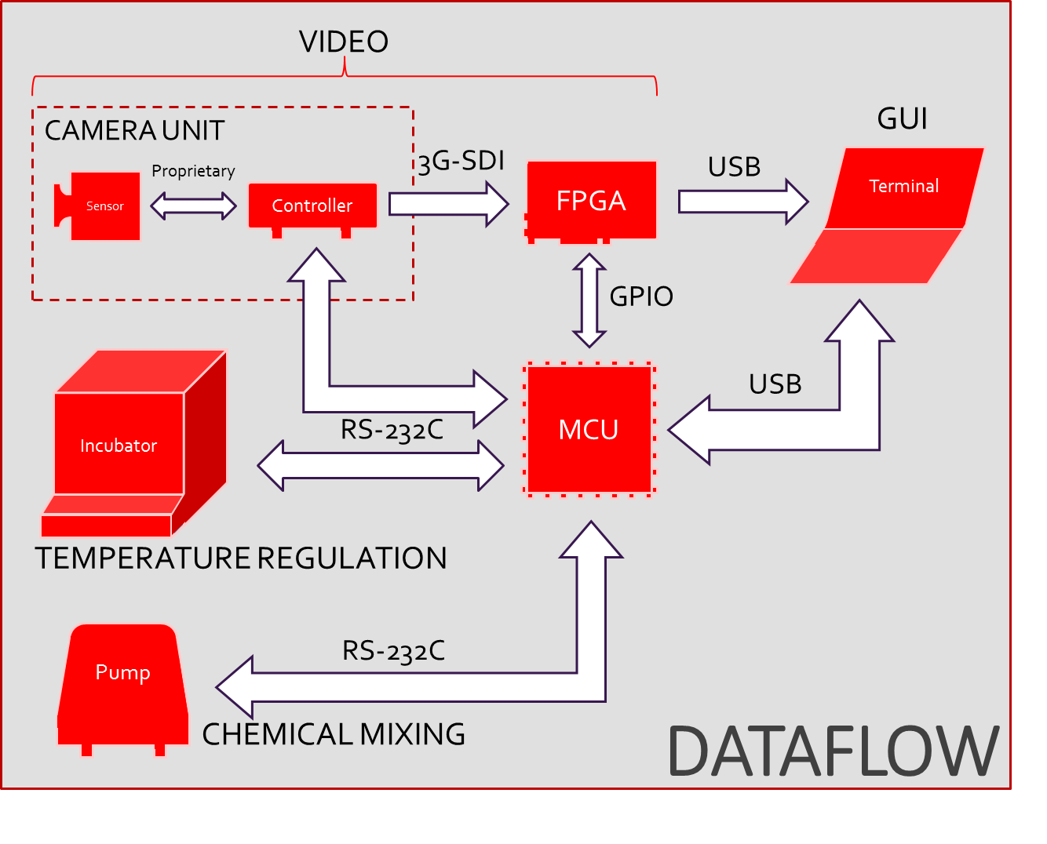
Figure 4. Communications of the automation system. RS-232C and USB are the primary modes of handshaking.

Fall Deliverable and Objectives Accomplished
Due to our equipment’s spring anticipated arrival, we were unable to develop the hardware and communications protocols with the MCU. As a result, our fall deliverable was modified to developing a software front-end with which functionality would be mapped to the hardware based on equipment turnover. The GUI therefore is wrapped around test parameter input, diagnostics display, and image output. For displaying flow rate and temperature, it will not be possible to acquire real data, but a serial port can be emulated and simulated data may be monitored. Mixing speed control similarly will not be able to be accomplished in full, but the system front-end of the handshaking scheme and a simple feedback algorithm may be developed. Finally, while the images cannot be spliced from actual video obtained from the video sensor, a dummy mp4 file may be used and frames may be extracted for verification of the underlying functionality.

Specifications and Constraints
There is a wide range of engineering specifications and constraints as a result of the system being very complex. In spite of our project not having budgetary constraint, we are exercising financial prudence as with any engineering project spending must be justifiable. There are safety constraints with this project as well. The design of the device calls for an incubation system which is basically a small oven, and the specifications of the design require that the oven be able to heat between 20-100 °C. Aside from the high operating temperatures the chemical compatibility testing device also has many actuators and sharp moving objects that must be deemed safe for user operation. As a result, physical placement and outer design may be constrained to incorporate sufficient insulation and enclosure to isolate internal equipment from the end user. Another major constraint imposed on this design is size. The device must not only accomplish automation of the process flow, but it must do so by occupying no more than 3’ x 3’ of counter space.
The following table summarizes subsystem specifications.
Specifications
Sample Dispensing | Variable flow | 2mL
Heater | 20-120°C | 1°C
Bottle Capacity | 10mL
Video | MPEG-4 | 1080p
Image | PNG | 1080p
UI Display |  | 1080p
Mix/Obs Time Range | 5-120 mins
Table 1. Specifications for various subsystems and IO.

Budget
As mentioned previously, Multi Chem Group has not given the budget a rigorous limit. The budget has risen and lowered, but most recently the budget has climbed again due to underestimated personnel costs. The following tables illustrate the current hardware and personnel budgets.
Hardware | Amount | Price
Pumping | 1 | $2200/ea
Solenoid Valves | 2 | $300/ea
Tubing | 2 | $50/ft
Connections | 14 | $50/ea
Actuation | 3 | $500/ea
Incubator | 1 | $5,000/ea
Microcontroller | 1 | $50/ea
FPGA | 1 | $7000/ea
Camera | 1 | $5000/ea
Previous Projection | $33,525.00 | $22,450.00
Table 2. Hardware budget. Some items have been finalized and committed.

Personnel | Role | Billing | Hours | Weeks
Sriram Goparaju | Team Lead and Video | $50.00/hr | 10/week | 12
Alamdar Syed | Mechanical Integration | $50.00/hr | 10/week | 12
Brain Lee | Mixing | $50.00/hr | 10/week | 12
Shehñil Äli | Software | $50.00/hr | 10/week | 12
Jereomy Lopez | Heating | $50.00/hr | 10/week | 12
Alvaro Ordoñez | Pumping | $50.00/hr | 10/week | 12
Dr. Leonard Trombetta | Supervisor | $75.00/hr | 10/week | 12
Dr. Julius Marpaung | Technical Advisor | $75.00/hr | 10/week | 12
Previous Projection | $36,000.00
Current Projection | $54,000.00
Table 3. Personnel budget for Fall 2014.

Conclusion
By automating Multi Chem Group’s chemical compatibility testing process, their personnel will be able to visually assess the degree of compatibility much more consistently. The subsystems that will be automated include thermal regulation, chemical dispensing, chemical mixing, and image capture. The system design is intended to minimize usage complexity as the end user is anticipated to have limited hardware knowledge. The Fall deliverable will demonstrate the functioning software front-end with code stubs intended to interface with anticipated hardware. Specifications for each subsystem have been defined in addition to constraints for overall system usage. Due to changes in sample size constraints from 100 mL to 10 mL, the hardware budget has decreased by approximately $10,000 predominantly from incubator downgrading, whereas the personnel budget has increased by $18,000 due to previously underestimated man hours.

