The Falcon V Team
4800 Calhoun Road
Houston, TX 77004
December 15, 2015
Dr. Trombetta and Dr. Contreras-Vidal
University of Houston
4800 Calhoun Road
Houston, TX 77004
Dear Dr. Trombetta and Dr. Contreras-Vidal,
We are presenting this document to you in order to outline the progress made on the Falcon V project this semester. This document will emphasize the overall purpose of the project, what has been accomplished to date, and the current functionality of our project.
The premise of the Falcon V project is to combine the existing technology of virtual reality and quadcopter drones into a new device which can be used to survey dangerous areas, provide aerial coverage of sporting events, or the countless other similar applications by controlling the quadcopter through hand movement and controlling the cameras through head movement. This system will give the user the feeling of actually being at the location that they are viewing.
The problematic areas of our project are constructing a quadcopter that can handle the weight of the cameras, setting up communications between the camera, quadcopter and user, as well as implementing a control algorithm that can control the flight of the quadcopter and cameras through hand and head movement. As outlined in this document, we have broken each of the above problems into smaller, more manageable pieces.
Thank you for your time and feedback!
Sincerely,
The Falcon V Team
Falcon V final report

Team Members:
Mark Admani
Justin Loveless
Andrew Maicke
Dominic Mak
Justin McGee

December 15, 2015

Abstract:
Our target objective is to have quadcopter flight controlled by phone and glove commands, with live video broadcast to a headset. Therefore, our project has three main pieces; a headset with a phone, a quadcopter with a camera mounted on it and a glove. Based on the movement of the glove, commands will be sent to move the quadcopter. Similarly, how the headset moves dictates how the cameras on the quadcopter will move. The cameras on the quadcopter will send live video back to the user which will be viewable through the phone attached to the headset. This system will allow a user to view hard-to-reach or dangerous areas in an intuitive and easy manner versus trying to operate a traditional radio controller.
The main progress up to now has been collecting the raw sensor data, ordering the necessary parts, and getting them to work properly. We have successfully retrieved sensor data from the Sensortag, built the quadcopter, manufactured a headset and successfully transmitted live video from the Raspberry Pi Camera over HTTP to any location with internet access.
We were unable to meet some our fall goals because we had several unforeseen difficulties with deciding which camera system would be the best option for our project. We also decided to build more of the components ourselves to achieve the best results, such as the quadcopter, instead of buying them. Both of these led to unforeseen delays. Even though we have four boxes on our goal analysis to still check off for the fall, they all involve phone communications and will all be completed quickly once communications are established. Therefore, we will be able to catch up in the spring. The next phase of the project, which will take place in the spring semester, is integrating these pieces into a functional system.
Purpose:
The purpose of our project is to generate interest for wearable technology by winning Intel’s Greatest Makers competition. The competition asks applicants to submit ideas and designs for an application of wearable technology that is new, interesting or different. If Intel deems the submitted idea to be worthy of creating, they will accept that submission and ask the applicant to create their design to compete with the remaining applicants. Regardless of whether or not our submission is accepted, we will build our design for other purposes.
Our goal is to combine the existing technologies of virtual reality and controlling a quadcopter through hand motions into one device that can be used to survey dangerous or hard to reach areas. Our design has three main pieces: a headset, a quadcopter with stereoscopic cameras mounted, and a glove. Each piece will now be explained in greater detail.
The headset will have the purpose of holding a phone in front of the user’s eyes in order to display the video feed through the Google Cardboard application. Holding the phone in front of the user’s face will provide the virtual reality element. The accelerometer data on the phone will also be used to move the cameras on the quadcopter. That way, when the user moves their head to look around, the cameras will move accordingly.
The glove will fulfill the purpose of telling the quadcopter how to move based on the motion of the users hands. The user will wear a glove which will also contain an accelerometer. For example, if the user tilts their hand to the right, the quadcopter will also tilt and move to the right. We are also adding buttons on the tips of the fingers on the glove for the purpose of moving straight up, straight down or taking pictures. The goal of this is to create a quadcopter that is easier to control and more intuitive for the user than the traditional RC controller experience.
The last of the three pieces is the quadcopter itself. The quadcopter will contain two stereoscopic cameras which will stream video back to the phone to display to the user in real time. The quadcopter is also receiving commands from the glove and headset to determine its flight path and camera position. These three things working together will enable users to survey dangerous or hard to reach places without having to go there in person.

Problem and Need:
Currently, there is untapped potential in the field of wearable technology. We intend to address this problem by creating a quadcopter control system that will primarily function through head and hand movements. This system will be more intuitive and require less expertise than a traditional radio controller. Loss of human life will also be reduced as this new technology will remove humans from dangerous situations.
User Analysis:
Although there exists a wide variety of ways in which our product could be used, we are designing it for use by individuals who need to survey either hard to reach or dangerous areas. The idea behind our design is that the glove control would be much more intuitive and easier to use than the traditional radio controller. Therefore, all a user needs is fine motor skills to operate our product.

Overview Diagram:
Commands

Video

Quadcopter
Commands

Figure 1. Overview Diagram

Glove
Headset

Target Objective and Goal Analysis:

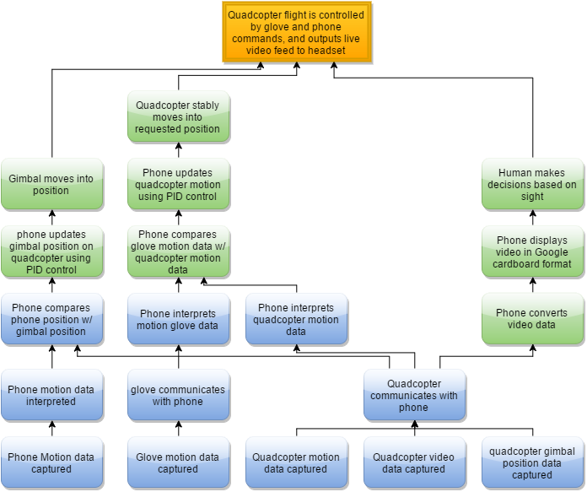
Figure 2. Goal Analysis

Specifications:
- The video quality is to be 640 x 480p at 30 frames per second
- User viewing angles: 180 degrees horizontally and 150 degrees vertically
- The headset, camera and quadcopter will communicate via Bluetooth
Constraints:
- Distance between the quadcopter and user cannot exceed 10 meters
- The maximum flight time is 15-20 minutes due to power considerations
- There will be a lag time of less than one second due to technological limitations for the live video stream
Statement of Accomplishments:
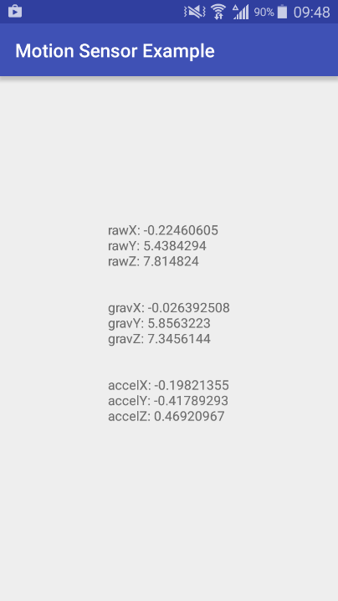
This semester, we focused on being able to obtain data readings from the various sensors that we are using as well as building the core components for this project. First, we decided to use TI’s Sensortag for our glove as well as our quadcopter. By using TI’s computer application, we were able to obtain readings for position as well as acceleration. We were also able to retrieve the accelerometer readings from an Android phone. An example of these readings can be seen in figure 3. These readings will be used in order to transmit flight commands from the glove to the quadcopter, as well as maintaining a stable flight system for the quadcopter.

Figure 3. Android Accelerometer Readings

Second, we successfully 3D printed a headset that will be used to hold the phone to the face of the user. We installed lenses into our headset so that the virtual reality effect of using the Google Cardboard Android application is effective.
Third, we bought a gimbal that will hold the camera onto the quadcopter. We are using a Raspberry Pi in order to stream the video to the phone. We successfully setup communications between the Raspberry Pi and the phone and transmitted the live video feed to the phone via Wi-Fi. The lag time is less than one second. We have not yet gotten the video to stream through the Google Cardboard application. We have gotten the gimbal to balance the camera and display its orientation to a computer screen. The gimbal is also controllable through computer commands.
Fourth and finally, we have built the body for our quadcopter. We are using the Mini 250 FPV Multirotor Frame for our quadcopter. We have also mounted the electronics onto the body of the quadcopter.
We were unable to set-up complete communications between the quadcopter, glove and phone. This is because we ran into unforeseen problems with selecting a camera system that would introduce minimal lag. We also decided to build several components ourselves, such as the quadcopter, to achieve optimal results due to our specific weight requirements. Both of these led to unforeseen delays. However, all four of the boxes that remain for the fall semester in our goal analysis will be able to be checked off quickly once communications are successfully created. Therefore, we will be able to quickly check these off and make-up time in the spring semester. Now that we have a solid foundation of individual components that work, we have set ourselves up to have a successful spring semester with getting them to work together.

Engineering Standards:
Once we complete the quadcopter, we will have to select the proper power supply to allow it to fly for fifteen minutes. ANSI is the organization in America that implemented the standard for battery nomenclature. This system allows us to know what the voltage, number of cells, capacity and discharge rate of a battery by reading the code given to each battery. This allows us to easily select the proper battery since this code is uniformly applied to all batteries due to this standard.

Our project also relies on Bluetooth communication. The existing standard for Bluetooth communication is IEEE 802.15.1. This standard set up the foundation upon which Bluetooth operates. One important specification that was created by this standard was the frequency that all Bluetooth devices are to operate at. This ensures that we will be meeting FCC requirements by not operating in a prohibited frequency range since the Bluetooth frequency has already been approved due to this standard.

Finally, since our project will be flying, it is important to know the standards set in place by the FAA regarding recreational use of unmanned drones. The most important part of this standard is that unmanned drones are not to exceed 400 feet in the air. We will be well under this limit. Following this standard and including it in our design process will ensure that our project does not violate U.S. air space laws.

Risks:
One area of our project that draws some concern is the live video stream. Using a digital system will introduce lag. Since the user is moving their head in real time to move the cameras on the quadcopter, this could cause some issues. Our initial research and findings lead us to believe that the lag time will be of such a short duration that it will be inconsequential to the functioning of our product. However, should the lag time be a major issue, we would then switch to an analog system to avoid this problem. Another area of concern is the split video stream. In order to mimic the human eye, the cameras will have to also imitate the proper separation that exists in the human eyes. If not done properly, this can cause major problems when the user attempts to view the dual video streams at the same time. If this becomes a major issue, we will simplify the system by going to a single video stream that is output onto a normal phone screen. This may take away from the virtual reality effect, but will still allow the user to view what he or she desires.

Budget:
Expenses to Date:
Labor:
Team Member | $ / Hour | Hours / Week | # Weeks | Total Pay
Mark Admani | 50 | 15 | 16 | $12,000
Justin Loveless | 50 | 15 | 15 | $11,250
Andrew Maicke | 55 | 15 | 16 | $12,000
Dominic Mak | 50 | 15 | 15 | $11,250
Justin McGee | 50 | 15 | 16 | $12,000
 | Total Labor Expenditure: $58,500
Advisors:
Name | $ / Hour | Hours / Week | # Weeks | Total Pay
Dr. Marpaung | 100 | 10 | 14 | $14,000
Dr. Trombetta | 100 | 5 | 16 | $8,000
Dr. Contreras-Vidal | 100 | 5 | 16 | $8,000
 | Total Advisor Expenditure: $30,000
Parts:
Item |  |  |  | Cost
RaspberryPi Camera |  |  |  | $25.01
RaspberryPI USB Wi-FI |  |  |  | $10.92
Convex Lenses |  |  |  | $5.50
Quadcopter Frame |  |  |  | $12.99
GoPro Gimbal |  |  |  | $56.00
Filament |  |  |  | $40.00
 | Total Parts Expenditure: $150.42

Aticipated Expenses:
Labor:
Team Member | $ / Hour | Hours / Week | # Weeks | Total Pay
Mark Admani | 50 | 15 | 16 | $12,000
Justin Loveless | 50 | 15 | 16 | $12,000
Andrew Maicke | 55 | 15 | 16 | $12,000
Dominic Mak | 50 | 15 | 16 | $12,000
Justin McGee | 50 | 15 | 16 | $12,000
 | Total Labor Expenditure: $60,000
Advisors:
Name | $ / Hour | Hours / Week | # Weeks | Total Pay
Dr. Marpaung | 100 | 10 | 14 | $14,000
Dr. Trombetta | 100 | 5 | 16 | $8,000
Dr. Contreras-Vidal | 100 | 5 | 16 | $8,000
 | Total Advisor Expenditure: $30,000
Parts:
Item |  |  |  | Cost
Quadcopter Rotors |  |  |  | $10.00
Quadcopter Motors |  |  |  | $60.00
Gloves |  |  |  | $15.00
Digital Buttons |  |  |  | $10.00
Custom Sensortag |  |  |  | $30.00
 | Total Parts Expenditure: $125.00

Conclusion:
Strong progress has been made this semester. The major individual components for our project are built and functional. The main points of progress up to now have been collecting the raw sensor data, ordering the necessary parts and getting them to work properly. We have successfully retrieved sensor data from the Sensortag, built the quadcopter, manufactured a headset and successfully transmitted live video from the Raspberry Pi Camera over HTTP to any location with internet access. Even though we were unable to achieve all of our goals, we still made plenty of progress and have individual components that are functional. The next phase of the project, which will take place in the spring semester, is integrating these pieces into a functional system. Because of our progress this semester, we are in a good position to make-up time and finish our project by the end of the spring semester.

