Aubrey Peloubet, Jordan Bowman, Sagar Kataria, Antonio Cashiola, David Salinas, Ali Siddique, Tiffany Stoecker
Senior Design - Team 8 & 9
University of Houston
Cullen College of Engineering
aubrey.peloubet@gmail.com
May 8th, 2015

Dr. Leonard P. Trombetta, PhD
Cullen College of Engineering,
4800 Calhoun Road,
Houston Texas, 77004

Dear Dr. Trombetta,

Enclosed is the final technical report describing the status of our team’s project. It is designed to showcase our progress and accomplishments in technical detail in order to assure yourself, Dr. Trombetta, and Dr. Glover that our team is making due progress and will complete our project by the end of Fall 2015. Included are the design and prototyping of part of a mesh net which is flexible yet light with ferrous material and a robot with magnetic wheels that can traverse the net.

These accomplishments required extensive research into materials and prototyping. We have also included plans for the future such as a robot with sensors and the ability for the robots to traverse the net upside down and at various degrees of incline. Notes about future iteration of the project has also been included since this project is considered proof of concept.

If you have any questions, comments or concerns with any aspect of the project, please feel free to contact myself, Aubrey Peloubet at 832-472-5645 or at aubrey.peloubet@gmail.com.

Thank You

Sincerely,
Aubrey Peloubet

SpaceNet/NEO-Bug

Final Report

Submitted on:
May 8, 2015

Submitted by:
Aubrey Peloubet, Ali Siddique, Jordan Bowman
Antonio Cashiola, Tiffany Stoecker,
David Salinas, Sagar Kataria

Sponsored by:
Dr. Provence, Dr. John Glover

Abstract
To expand our basic knowledge of the universe and of near-Earth objects (NEOs) such as asteroids, Senior Design Team 8 & 9 have created a prototype robot and net to showcase a proof of concept for an autonomous asteroid exploration system: the SpaceNet/NEO-Bug project. In the future, NASA plans to use a net to capture and reposition an asteroid. The net will conform to the surface of the asteroid and provide ferrous pathways. Autonomous rovers, NEO-Bugs, will traverse the net using magnetic tracks and collect data with multiple sensors. The robot will also be able to avoid other robots while navigating the net showcasing group thinking algorithms. The net will provide the NEO-Bugs with a navigation system, communications, and a power source. The net was designed with a hexagonal pattern and triangular nodes to provide efficient coverage of an asteroid’s surface while simplifying pathfinding.
SpaceNet/NEO-Bug will be tested on Earth by placing the net at various angles and verifying that the robot can traverse inclined or inverted sections of the net. As of May 8th, 2015, a prototype net segment and robot have been constructed. The net segment includes two nodes linked by a path. The robot is equipped with magnetic tracks, but sensors have not been installed yet. The robot weighs 11.2 oz, and the magnetic tracks can support 32 oz. The current robot design has insufficient tension in its tracks, preventing it from climbing steep inclines or travelling inverted. Addressing the track design flaws will be the first priority moving forward.
Goal
The goal of the SpaceNet/NEO-Bug project is to enable robotic asteroid exploration to increase human knowledge of our solar system. Asteroids provide a snapshot into the formation of our solar system since they contain many of the elements and compounds that existed at its formation. Learning more about the composition of our solar system’s asteroids will further expand our knowledge of our universe.

Background
A proposed future NASA mission is to capture an asteroid or a near-Earth object (NEO) inside a large net and tow it to a more convenient orbit for study. A NASA mockup of the smart net idea is shown in Figure 1. From launch, it will be at least three years to move the asteroid into position which will advance basic scientific research in space by a network of robots called NEO-Bugs.

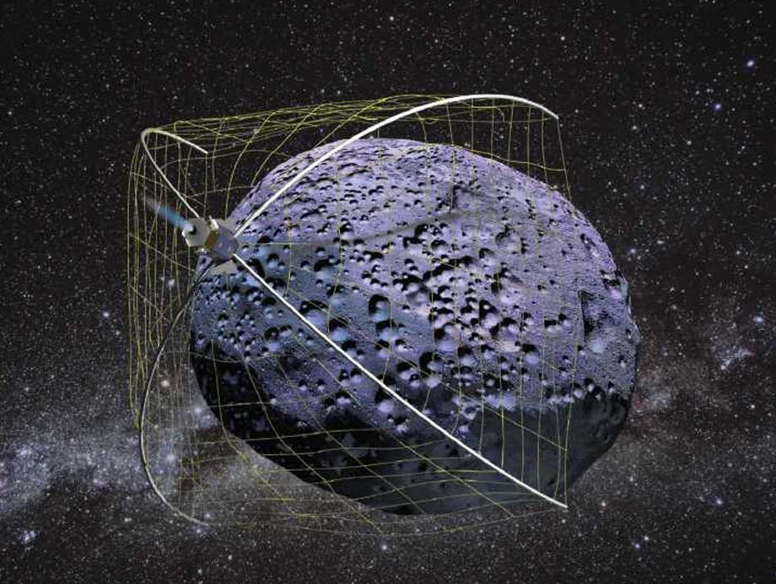
Figure 1: NASA design concept of the smart net [1]

NEO-Bugs will crawl along the net to survey the asteroid. The smart net will include integrated electronics to support the activities of the NEO-Bugs. A smart net with these items placed inside can act as infrastructure for the robots. By placing power and communication cables inside of the net's strands and incorporating microprocessors and support electronics at key nodes in the net, power, communication, and navigation functions can be offloaded from the NEO-Bugs to the net. This frees space on the NEO-Bugs for sensors and instruments, and enables them to minimize their mass. Additionally, the net will provide a surface for NEO-Bugs to cling to and crawl along in the low-gravity environment of an asteroid's surface.
The NEO-Bugs will be designed to stay in contact with the smart net and not touch the asteroid in order to avoid surface disturbance. The robot must be able to take measurements of the asteroid. To achieve this goal, the smart net has been designed with a ferrous surface and the robot has been designed with magnetic tracks. Because this proof of concept will be demonstrated on earth the magnetic force between the robot and the net must overcome earth’s gravitation force and this has been a major design focus during the early stages of the project.

Problem, Need, and Significance
Budget constraints and limitations of current technology limit the distance manned missions can travel from Earth. In order to keep manned missions financially feasible, making preliminary autonomous research necessary. The balancing act between weight and fuel for long distance space travel is the technological dictator of how far out manned missions can travel. The spacecraft for manned research expeditions have a much higher weight than that of the spacecraft for robotic missions, due to factors such as size of the spacecraft, life support needs of the crew, and the weight of the extra fuel needed. This increase in fuel continuously compounds the weight problem, as the more fuel one takes, the more you need to transport the extra fuel. NASA’s Near-Earth Object Program (NEO Program) and its subsidiary the Asteroid Redirect Mission (ARM) are designed to push technology forward and test new propulsion designs and fuels in the hope of solving this problem.
Since manned research of asteroids is not feasible from either a financial or technological perspective, it is necessary to develop a robotic solution to further our knowledge of our solar system through the study of asteroids. This smart net will be capable of providing networks of power, communication, and navigation and provide an autonomous robot network that can map and do spectral analysis of the asteroid’s surface without disturbing it. It will then send the collected data to Earth after the NEO-Bugs have begun their analysis of the surface. By sending a network of robots to the captured asteroid to gather data while it is in transit we will have enough information about the surface and composition of the asteroid that any proposed manned missions to the asteroid, now that it is in range of manned space travel, can be tailored to what we specifically want to study in detail. The astronauts need not spend time exploring every inch of the asteroid’s surface, and can head directly to the portions of the asteroid that require more detailed study. This will also decrease the number of manned missions needed to study the asteroid, thereby reducing the total cost of studying this asteroid.
While proof of concept for the smart net and robot network is the next step for this project, the significance of this project is in the development of new technologies and improvement of current ones. NASA sees robotic missions to capture, retrieve, and study asteroids as the next step toward sending manned missions to Mars. The development of technologies for propulsion and protection from radiation exposure promise to begin overcoming mission weight issues. For scientists studying the formation of solar systems and planetary bodies, the data about the composition of the asteroids in our system may be the key to unlocking some of the secrets of our solar system’s birth. Finally, since many asteroids contain significant deposits of heavier rare earth minerals veined throughout them, instead of settled deep in the interior like on Earth, the technology to capture and remotely study asteroids has the potential to increase the viability of asteroid mining in our economy.

User Analysis
SpaceNet/NEO-Bug will be used by NASA scientists and engineers as well as future senior design students as a proof of concept for creating an actual space net. For this reason, our team has included notes in the report and design implementations that may not be necessary for us but will come of use when future teams are designing the concept further until it is eventually space ready. Our team considers this project to be the first step in a multi-year plan to create a functioning asteroid capturing net in space. The expertise level for our project must at least be a senior year Electrical or Mechanical Engineering student or a NASA engineer or scientist. The interface of the robot and net is to showcase the benefits and drawbacks of prototyping an actual space net. For this reason, our team has made a project fairly straightforward to use but with the underlying assumption that the user understands standard engineering and programming principles of mechanics and ferrous materials. The user must be able to understand the underlying assumptions with topics such as magnetism.

Overview Diagram
Our overview diagram can be seen in Figure 2 below.
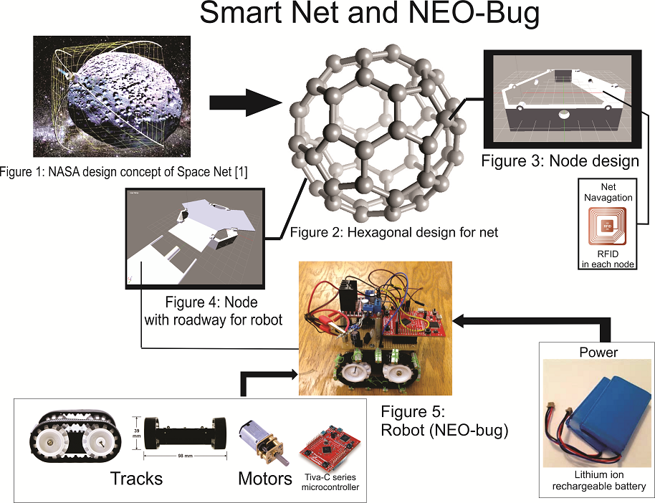
Figure 2: Overview diagram for the robot design and the Space Net. It is important to note the robot’s lightweight structure and magnetic wheels allowing it to move upside down or on a slanted surface. Additionally, the net provides a steady but amorous surface for the robot to move as well as recharge and deliver information.

The robots will be driven by the use of two DC geared motors with 100:1 gearing ratios. These motors were chosen because they are reasonably small, light, and provide the force necessary to move the robot in all directions. Batteries will be recharged through the space net with a physical connection. A radio frequency identification (RFID) tag will be used for positioning on the space net, and a gyroscope will be used to determine the orientation of the robot at any one time while on the Space Net. It should be noted that the gyroscope will be used to determine the torque necessary for the robot while under the force of gravity and not for path determination. Because of this the gyroscope is unnecessary for designs targeted for space or neutral-buoyancy tank testing.
The hexagonal shape of Space Net will optimize the decision making logic for the NEO-Bugs and also the amount of area of the asteroid that can be studied. This will allow the net to be easily expanded in the future. Additionally, the metal mesh on the top of the net will allow a smooth surface for the robots to move upon. On the bottom side of the net the power and communication cabling will be suspended in strong, flexible, and lightweight conduits between the nodes.

Target Objective and Goal Analysis
Our target objective for the project is to create a robot that can move inverted or uninverted in relation to gravity, as well as a net comprised of a pathway and two nodes. To complete this target objective, it has been split up into smaller sub-objectives and their dependencies mapped as shown below in Figure 3. Yellow boxes signify completed objectives and white boxes signify in progress objectives.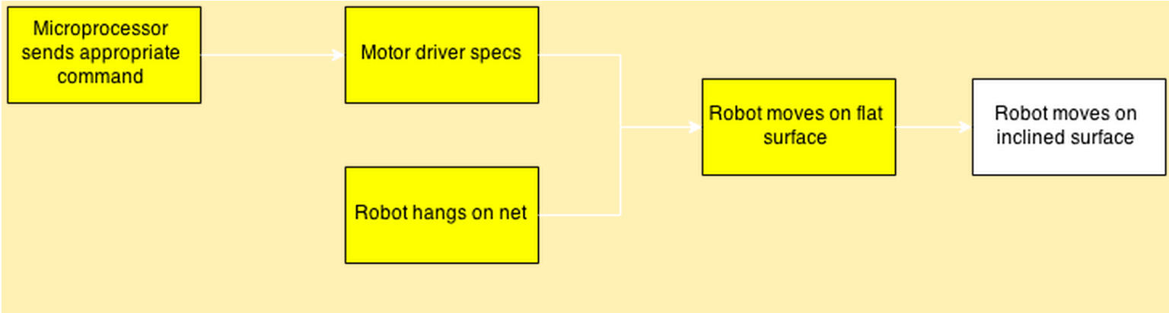
Figure 3: Goal Analysis for Spring 2015

Completion of this target objective means the robot is past the initial stages of being able to traverse the net in all orientations, with relation to gravity, and directions, with relation to the forward motion of the robot, while the net hangs in abnormal conditions under some weight. To accomplish this goal, we had to overcome a number of hurdles. One important hurdle was the robot hanging on net without falling. This involved designing a locomotion system with enough surface area to contain magnets that can hold the robot’s weight at any angle and any orientation. We finally found the perfect balance of surface area and design simplicity by using magnets adhered to a set of rubber continuous tracks, commonly referred to as tank tracks. Figure 4 below shows the forces acting on the robot using continuous tracks when moving directly opposite the pull of gravity.
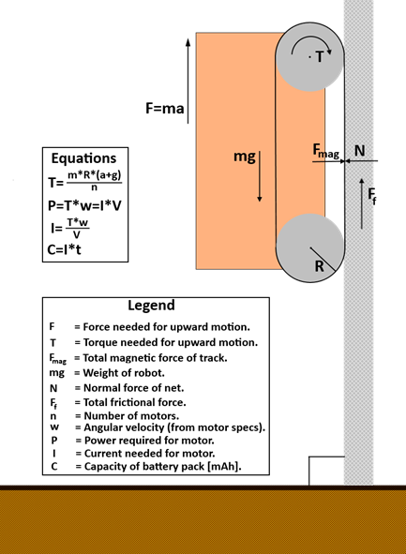
Figure 4: Forces on robot
Eleven magnets were sewn onto each track for greater surface area contact with the net. As the pathway’s degrees of elevation increased a problem with the robot peeling off of the mesh, front end first, while moving upward after a critical point. The failure of the design was due to the treads not maintaining enough tension around the gears. The looseness of the treads allowed the motors’ torque to pull the tracks off of the net’s surface. The robot does successfully move when the pathway’s degrees of elevation are 45° or less with 0° being uninverted with respect to gravity. We believe this partial success means that our design will be successful with minor modifications.
Another important step in accomplishing our target objective was creating a portion of the net comprised of a pathway connected between two nodes that was strong, flexible, and providing enough ferrous material for the robot to maintain adhesion while moving across the net. We did this by using two layers of the metal mesh, one directly on top of the other. The two layers provided enough ferrous material for the robot to maintain magnetic adhesion, while keeping the weight of the net minimized. The mesh for the pathways was kept in tension across its width by two 0.25 inch diameter pine dowels which stabilized the surface and increased its strength. The metal mesh that formed our pathway was then connected between two nodes by the wooden dowels. By connecting the pathway to the nodes with the dowels, the distance between the dowels necessary to keep the pathway in tension was maintained. A section of the path is shown below in Figure 5.
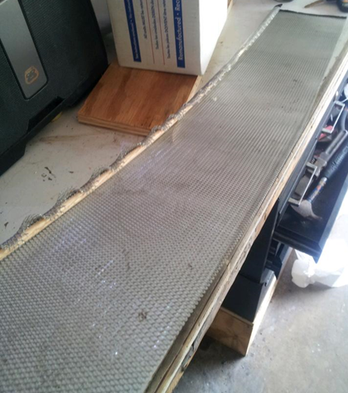
Figure 5: Steel Mesh section of net. Bottom of the net is shown, revealing wooden dowels.

The prototype nodes were created out of wood because of cost and ease of construction. The final version of the nodes will be made with 3D printing technology after final optimum dimensions are determined. The nodes are triangular in shape and covered with the metal mesh for the robot to move across with its magnet tracks. Connecting our pathway between two nodes we then tested this portion of the net to confirm it could successfully hold the weight of the robot without breaking. With the testing of this portion of the net successfully completed, the creation of a single pathway connected between two nodes was achieved this semester.

Engineering Specifications and Constraints
Several constraints had to be taken into account when designing the net and robot. The net needed to provide a path for the robot to traverse while remaining flexible. The robot has its own set of constraints. It required motors that could propel it up a 90° incline. These constraints led to a set of specifications for the net and robot. The net's path needed to have enough ferrous surface area to support magnetic adhesion.
The net constraints are the following:
- The smart net must be flexible in order to wrap around the asteroid.
- It must provide a smooth surface for the robot to traverse.
The robot constraints are the following:
- The robot must stay on the net without falling off. This includes upside down and all other angles.
- The robot must be small and lightweight.
- The robot must be a maximum of 4 inches in width.
The net specifications are the following:
- Hexagonal sections comprised of steel mesh with 0.25 inch holes
- Triangular nodes to house RFID chip and wiring for power, communications, and navigation.
- The pathway is 8 inches wide and 3.5 feet long.
The robot specifications are the following:
- The robot weighs 11.2 ounces.
- The width must be less than 5 inches.
- The magnetic wheels provide 32 ounces of weight.
- Both 5 and 6 volt regulated voltages sources.
- DC geared motors that have 12 in∙oz of torque.

Statement of Accomplishments
Our main accomplishments this semester was creating a pathway with prototype nodes. Additionally, the robot was able to move on a zero incline and hang upside down. To accomplish these milestones, we had quite a few challenges. One of the biggest challenges for the project was to find a way to hold a robot on an inverted or steeply inclined pathway. Magnetic wheels and a steel path were chosen early on, but the design went through several iterations. The first approach was to use diametrically-magnetized wheels; each wheel would be a single cylindrical magnet. Figure 6 shows an example of a diametrically-magnetized cylinder.
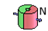
Figure 6: Diametrically-magnetized cylinder
Weight testing gave promising results, but roll testing revealed a problem. The magnets were each capable of supporting three pounds when their poles were in contact with the mesh. When the axis of magnetization was parallel to the surface, the wheels produced zero net force. One proposed solution to this problem was to make each wheel from three magnets side by side, each rotated by 120°. This was intended to guarantee that the total force generated by each wheel would not change significantly as the wheels rotated. Constructing these wheels proved infeasible, however. Achieving a 120° rotation meant working against the magnets' natural tendency, and the resulting wheels would have greatly increased the robot's width. A different approach was needed.
Continuous tracks were selected to replace the wheeled design. Axially-magnetized bars were placed at regular intervals along the track. Figure 7 shows an example of an axially-magnetized object.
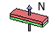
Figure 7: Axially-magnetized bar
Each bar magnet could only support four ounces, but with eight magnets in contact with the mesh, the pair of tracks could support 32 ounces. A tracked configuration shows promise, but there are mechanical issues that must be addressed. The robot chassis lacked a tensioner for the tracks, so the tracks were found to be too loose while going up steep inclines. Figure 8 shows the tracks separating from the ferrous surface.
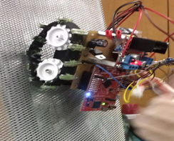
Figure 8: Robot on incline

Engineering Standards
The engineering standards relevant to this semester’s deliverable relate to the microcontroller, battery, and wiring. The Tiva-C Microcontroller complies with the IEEE 754 floating-point standard. The lithium-ion battery meets the IEEE 1625 standard for rechargeable batteries. The wiring will need to meet two standards: IPC J-STD-001ES (superseding the cancelled NASA-STD 8739.3) for wiring and soldering for space travel; and NASA-STD 8739.4 for crimping, interconnecting cables, harnesses, and wiring. As of May 8th, the existing deliverable has not been verified to meet IPC J-STD-001ES or NASA-STD 8739.3, but these standards will inform the future development of SpaceNet/NEO-Bug hardware.

Budget
The total budget to date for the Spring 2015 semester and projected Fall 2015 expenditures are shown in Table 1 below. The budget includes both labor and material costs. The total material cost for the entire project is estimated to be $1255.00.

Table 1: SpaceNet/NEO-Bug budget
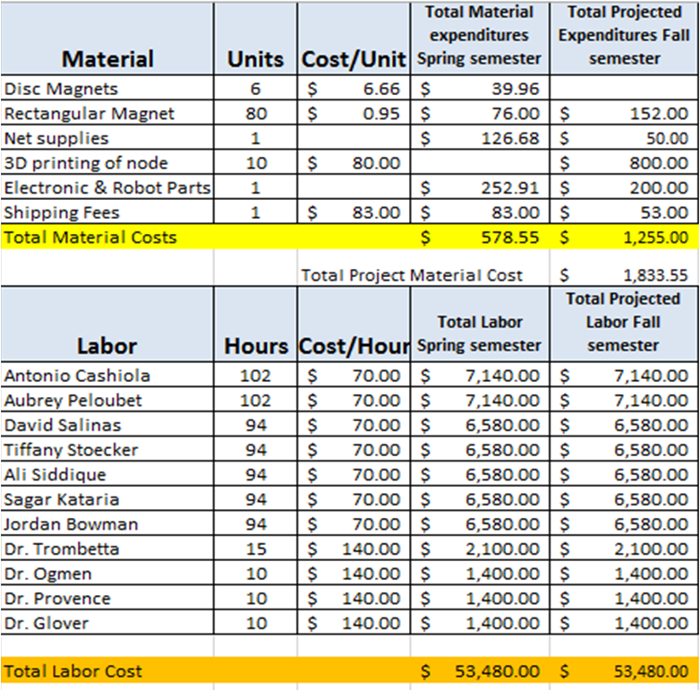

Conclusions
The goal of the SpaceNet/NEO-Bug project is to enable robotic asteroid exploration, and in doing so, to increase human knowledge of the solar system. A significant amount of progress has been made towards the Spring 2015 target objective. Prototypes of the net and robot have been tested, and the magnetic adhesion concept has been validated. While the semester target objective was not met, a redesign of the magnetic tracks is expected to solve the tension problem. Work on the tracks will continue through the summer.
For the fall semester, the design of the power network and charging stations for the robot will be finalized and then implemented. The RFID tags that will comprise the navigation network will be installed on the net, and the algorithm needed to use them for robotic navigation will be developed and implemented. The protocols and physical installation of the ad-hoc network for robot to robot communication will also be designed and implemented. Finally, sensors needed for navigation and data collection will added to the robot.

Works Cited

[1] Hoyt, Robert. (2014, June 4). WRANGLER: Capture and De-Spin of Asteroids and Space Debris. [Online]. Available: http://www.nasa.gov/content/wrangler-capture-and-de-spin-of-asteroids-and-space-debris/#.VOKf7fnF-WY

[2]NASA Technical Standards .[Online]. Available: http://www.hq.nasa.gov/office/codeq/doctree/87394.pdf

[3]IPC J-STD-001ES (December 2010). [Online]. Available: https://www.ipc.org/4.0_Knowledge/4.1_Standards/IPC-J-STD-001ES.pdf

[4]Hales, T. C. "The Honeycomb Conjecture." 8 Jun 1999. http://arxiv.org/abs/math.MG/9906042.

