University of Houston
Cullen Building, 2nd floor
4800 Calhoun Rd.
Houston, TX 77004

May 7, 2015

College of Engineering
University of Houston
4800 Calhoun Rd.
Houston, TX 77004

Dear Dr. Aaron Becker:

Attached here, is a report regarding the senior design approach for the gimbal airjet.

This report explains the background and goal, the need and significance, overview diagram, budget, and conclusions among other topics for the gimbal airjet project. At this stage, the gimbal airjet is able to move 45° in the θ direction and 180° in the ϕ direction using spherical coordinates. However, spherical objects can only be balanced 20° in the θ direction and 180° in the ϕ direction. The gimbal airjet is also able to shoot small spherical objects at an angle. The gimbal airjet is controlled using a joystick to change positions, and a knob to regulate pressure. All controls have been integrated in a hand held device. The gimbal airjet still has work to be done, but the target objective was reached. The gimbal airjet is able to move objects from one plane to the next using an air stream.

If there are any questions regarding this report, feel free to contact me at
apgandhi@uh.edu

Sincerely,

Avish Gandhi

Student

Gimbal Airjet Design
Team 6
Senior Design I
Final Technical Report

May 7th
Spring 2015

Members:
Avish Gandhi
Carlos Saenz Garcia
Makis Minetos
Sinh Pham

Sponsored by Dr. Aaron T. Becker

Abstract
Robotic arms are regularly used to move objects from place to place. However, robotic arms must be designed to suit a particular application and need to be constantly maintained which costs a lot of money. In addition, the range of the robotic arm is always limited due to the arm length. If the robotic manipulation works in a large area, a longer arm would be required to handle objects. The goal for the gimbal airjet is to provide a safe and economical way to handle spherical objects. By completing the target objective, there is now an airjet that lifts objects and shoots them into the air at a specific angle, from one point to another. The gimbal airjet is constructed by using a leaf blower, two servomotors, an Arduino microprocessor, and a controller. The objective starts by communicating between the Arduino microprocessor, the servomotors and the controller. The controller controls the movement of the gimbal, and rotates it from -90° to 90° in the x-z plane and y-z plane which accounts for the 3-D movement. One of the major problems is the sensitivity of the airflow which causes objects to be very unbalanced and fall off of the gimbal airjet. Due to this problem, objects can be balanced up to 18° in the air. The gimbal airjet is an economical solution which can be manufactured for a budget cost of $555.

- Background and Goal
The purpose of this document is to examine and introduce the gimbal airjet system. By following a test plan, the target objective was achieved through meeting specific objectives. The goal is to provide a safe and economical way to handle small, spherical objects. By fall 2015, there will be two gimbal airjets that can communicate between each other and the camera system. This will be a hands-free system that will react based on the environment. The gimbal airjet resembles the labyrinth game with a nozzle in the middle of it that allows air to flow through at varying velocities. The idea is to be able to lift objects with air rather than with a robot. The motivation for this project is impart because of the cost for robots. To build a robot that can lift objects is expensive and is limited to lifting a certain object. This approach is cost effective and is not object specific.
As of now, we have a system that is controlled with a joystick controller. The airflow is controlled with the potentiometer from the leaf blower that was purchased. Currently we have half a sphere of area to maneuver around. The current target objective is to handle objects in the air by means of controlling an airjet that is operated by a joystick. The air flow is also controlled via a potentiometer which has been connected to a leaf blower for air control. Current objects that are being lifted include racquet balls, golf balls, ping pong balls, and stress balls.
The task moving forward for fall 2015 is to improve the current prototype, and stay under budget as well as improve the air flow. We have met this semester’s target objective, with some minor modifications from the original goal.

- Problem, Need and Significance
The manipulation of objects through the use of robots is expensive and limiting. An example would be a factory robot on an assembly line that which passes objects by using a robotic arm. This is limiting because it cannot handle soft and fragile objects. Another problem is the arm length since it determines the range they can travel; the factory would need several robots to pass objects across it. There is also the requirement of handling it with proper maintenance regularly in which labor and expense would have to be spent, but this is neither economical nor efficient.
The design of a second gimbal airjet, with the potential to economically transfer materials, will be implemented for fall 2015. The system will allow objects to move between two positions. Objects up to fifty grams in mass can travel about twenty feet by adjusting the air flow of the nozzle. Since object handling is done through the air, it will reduce maintenance costs. By handling the object in the air it also allows for handling fragile objects.
Gimbal airjets are useful in a diverse set of applications such as handling produce and 3-D imaging. When handling produce, it can scan which fruits and vegetables are rotten based on the substance inside of them. As for 3-D imaging, a packaging system can be set up to efficiently fit as many objects as possible into a single shipment without having too much empty space within the package.
- User Analysis
Scientists who deal with fragile materials will be fascinated by this device so they can make further advancements on it, allowing it to be more accessible and productive. They can be the basis of creating more ways of handling objects which have added features to allow technologically illiterate people to use them. It can also be improved to require less power. The post office and vendors can use the gimbal airjet to their advantage because of the 3-D image scanning for packaging multiple products together. Farmers and vendors can use it for checking produce so they know if it is good enough for consumption.

Overview Diagram
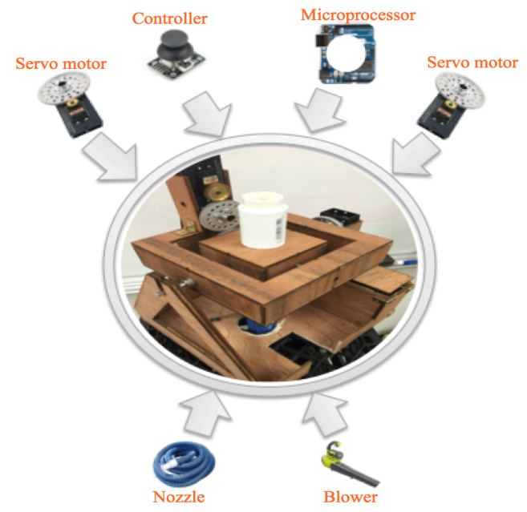
To control the movement of the gimbal in x-z and y-z planes, two servomotors are attached to the axels of rotation of the gimbal. One servomotor controls the outside of the gimbal, x-z, and the other controls the inside part, y-z. In addition, the joystick is linked with servomotors through an Arduino Microprocessor so that it controls the angular movement of the gimbal. The gimbal holds a 3-D printed funnel coming up from the hole in the middle and moves it into a half-sphere rotation. The air is transferred through the funnel which is connected to the hose is attached to a leaf blower at the bottom. When the whole system is connected together, it lifts objects into the air. The gimbal airjet consists of several components as shown below in Figure 1.

Figure 1: Gimbal airjet components
- Target Objective and Goal analysis
The goal of this project is to provide a safe and economical way to handle spherical objects. With the gimbal airjet, spherical objects can be moved from one place to another. Also, the gimbal airjet can shoot objects using an air jet. This project was divided into nine different objectives.
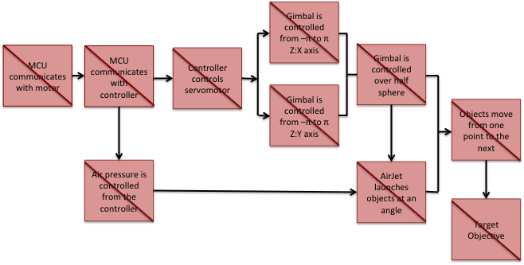
As of May 1, 2015 nine objectives have been done. The microprocessor communicates with the motor. The motor moves around as the microprocessor dictates. Also, the microcontroller is able to read position from the joystick controller. The joystick is used to move two servomotors. The servomotors were given a range of movement of 45° in θ direction and 180° in ϕ direction using spherical coordinates. The range was determined based on stability. Objects fall off the gimbal nozzle when the angle is less than 45° in θ direction. Figure 2, below, illustrates the overview diagram, and the objectives done as of May 1, 2015.

Figure 2: Goal analysis
Each objective was given a different time based on difficulty, and some of them are overlapping since they are to be done at the same time. The red color shows the completed objectives. As of May 1, 2015, all objectives have been done for the spring semester, and the target objective has been reached.
A brief explanation of the goal analysis is as follows. First the microcontroller communicates with the dc servomotors. The microcontroller sends a pulse width modulated signal to the motors to change their position. To test this step, a program in C (also using the Arduino Library) was written. The program increased the width of the pulse from 1.5 [ms] to 2 [ms], and from 1.5 [ms] to 0 [ms]. With this program, the servos moved from the central position to their maximum position in one direction. For the other direction, they moved back from the central position to the minimum position. The program was used to test the range of the servo motors by reaching their limits in both directions. The two potentiometers on the joystick each represent a different direction of movement. Each potentiometer is read from an analog to digital pin on the microcontroller. Once the potentiometers are read, the servomotors are controlled with the joystick. To test the objective, “Controller controls servomotors”, the microprocessor was connected to an oscilloscope and the waveforms were observed. The waves from the microprocessor ranged from 1 to 2 [ms] high and 18 to 19 [ms] low. This range of high voltage is the pulse width modulation required to move the servos to their maximum and minimum angles. When the oscilloscope was disconnected and the servos were attached to the microcontroller, the motors moved 90° in each direction. Once the servos were controlled from the joystick, a new program was written to give the servomotors the desired range of 45° in θ direction and 180° in ϕ direction using spherical coordinates. The servos were attached to the gimbal and the angles were measured using a protractor to ensure the range of movement. Additionally, once the microcontroller communicates with the controller, a potentiometer was added to control the pressure from the air blower to give it the ability to shoot objects from the gimbal airjet to another position. At this point, the target objective was reached. Objects can move from one place to another by either changing the air flow to shoot them or by hovering them from one place to the next, directly.

Specifications and Constraints
The specifications and constraints are the two important factors that will determine how the gimbal airjet will be designed, and allows the end user to see the capabilities of the final product.
The gimbal airjet must balance the object in the air at a particular angle that will be indicated by the joystick. At a given angle, it must move the object from point to point according to the rotation of the gimbal. The Gimbal shoots a spherical object by controlling the air pressure that comes from the leaf blower. The air pressure quickly jumps from 30psi to 100psi in less than a second to lift the object in a projectile motion.
To prevent the falling of the object in the air, the gimbal cannot move the object lower than 45° in θ direction.
There are five main parts that were considered for the gimbal airjet. These are the microprocessor, servomotors, joystick, hose and leaf blower. The cost for each part of the gimbal is limited because the overall cost has to be less than $4000.

- Engineering Standards
This project has not been previous completed so that it would be available to the general public. This product cannot be found through a vendor. Therefore, the standards are ambiguous for this particular project in that this would be the prototype if this was to be a permanent solution. This section has considerations for the outlet, the receptacle and the servo motor. The outlet is standard in the U.S. at 120 [V] and 60 [Hz]. The receptacle used is also standardized with the NEMA 5-20R through the Series II IEC 60038 modification [1]. Finally, servo motors typically have three terminals which is the case for our project. When servo motors have three terminals, there are two designated for DC supply, i.e. V_{IN} and V_{GROUND} while the third terminal is for the input signal, usually it is a Pulse Width Modulation (PWM). In this case it is being used for a PWM signal.
H. Budget
The sponsor, Dr. Becker, has allotted a budget of $4000 for this project, which comes down to $1000 per person. So far, the amount of money spent has been within the budget. In fact, the amount spent was just over half of what one student has been allocated, as shown below in Table 1.

Table 1: Budget Spent
Part | Quantity | Price | Total
Servo Motor & Bearings | 2 | $115 | $230
Funnel | 1 | $32 | $32
Arduino | 1 | $30 | $30
Relay | 1 | $14 | $14
Leaf Blower 1 | 1 | $40 | $40
Leaf Blower 2 | 1 | $99 | $99
Bearings | 1 | $53 | $53
Spool of Wire | 1 | $12 | $12
Hose | 3 | $15 | $45
Total (Current Expenditures) |  |  | $555

Even though it has been avoided to be wasteful, there have been instances where items had to be repurchased. The leaf blower and the vacuum tubes are two instances of this and have not pushed the overall budget that much. Moving forward, the budget will most likely double because the objective is to make a second gimbal airjet system for fall 2015. The labor cost for the amount of work put into making this gimbal airjet is shown below in Table 2.

Table 2: Salary and Labor Distribution
Team Member | Hours per Week | Total Weeks | Salary Rate | Total per person
Avish Gandhi | 4.5 [hrs] | 12 | $20 / hr | $1,080
Carlos Garcia | 5 [hrs] | 12 | $20 / hr | $1,200
Makis Minetos | 4 [hrs] | 12 | $20 / hr | $960
Sinh Pham | 4.5 [hrs] | 12 | $20 / hr | $1,080
Total |  |  |  | $4,320

- Conclusion
The goal of this project is to provide a safe and economical way to handle spherical objects. With the gimbal airjet, spherical objects can be moved from one place to another. The gimbal airjet is capable of moving objects by hovering them in the air, or by shooting them in the air using an air jet.
The gimbal airjet is capable of balancing objects in the air in a limited range. From experimentation using a tennis ball, the gimbal airjet was not capable of balancing objects at 45° in the θ direction. However, the range of the gimbal was about 20° in the θ direction. For this reason, the working area of the gimbal to move objects by hovering them in the air was 18° ± 2°. The gimbal airjet was not able to balance objects with accuracy due to the tubing used for the air because it was not flexible enough. Therefore, the angle is not controlled with precision. Also, the tubing does not provide a straight path for the air. When the air leaves the airjet nozzle, it reduces the angle for which objects can be balanced because there is more air converging on one side of the nozzle than the other. Another objective of the gimbal airjet was to shoot objects in the air. For this objective, the gimbal airjet was successful. The gimbal airjet is able to shoot Ping-Pong balls as long as the starting angle for θ is less than 35°.
The gimbal airjet needs improvement, but the project has reached its target objective since it allows for moving objects from one point to the next using an air jet. Moreover, the gimbal airjet is a safe tool that can be used by anyone without supervision.

Documentation
- "IEC 60038 New Voltage Systems - Voltage System Reference Books,Low Voltage System Integration EBooks." IEC 60038 New Voltage Systems - Voltage System Reference Books, Low Voltage System Integration EBooks. N.p., n.d. Web. 08 May 2015. <http://www.electricalengineering-book.com/voltagesystems.html>.

