May 8, 2015

Dr. Leonard P. Trombetta, Associate Professor
N 308 Engineering Building 1
Houston, TX 77204-4005

Dear Dr. Trombetta,

Attached please find Team 4’s First Semester Final Report. This document discusses the overall goal of project RoboMail as well as the analysis and design process and progress made by out team this semester. This report contains technical detail of our project including the constraints and specifications, a user analysis, engineering standards used, accomplishments, and future expectations for project RoboMail. This document will also include the significance of this project, an overview diagram, a detailed goal analysis, and a budget summary.
The team was successfully able to create the arm that can position itself and press appropriate elevator buttons. The locomotion basics are also complete and the robot has basic alignment capabilities. All sensors were successfully incorporated. We now have a complete platform for testing that will allow us to provide RoboMail with autonomous capabilities in the future. Our team is confident we can reach our goals this upcoming semester.
Should you have any questions or comments about this progress report, do not hesitate to contact Cesar Garcia, our project leader, at (832)-332-1717.

Sincerely,

Jordan Berry
Electrical Engineering Student
Cullen College of Engineering
University of Houston

RoboMail
First Semester Final Report
05/08/2015
Team 4:
Jordan Berry
James Crabtree
Jhony Medrano
Cesar Garcia

Abstract
This purpose of this document is to report on the progression and accomplishments of project RoboMail. RoboMail is an autonomous system that aims to improve autonomous transportation technology. The goal of project RoboMail is to save time and money by making package delivery within a multi-storied building more efficient. Personally delivering multiple or heavy packages in multi-storied buildings is time consuming, and can require lots of energy. A system that can autonomously operate an elevator and navigate a building while carrying multiple packages to desired locations is needed. This system could be easily adapted to be used for commercial or private use, such as in homes, hospitals, hotels, etc. With a simple interface, any user should be able to use RoboMail with an android device. Our system design is broken down into three main components. The locomotion component consists of an Arduino Mega ADK that operates 4 mecanum wheels and motors with encoders, ultrasonic distance sensors, a compass, and an altimeter. The mechanical arm component is made up of three stepper motors with acme threaded rods to provide precise 3D movement. Finally, the shape and image recognition is handled by an on board computer supporting LabVIEW software and a web camera. Team 4’s target objective for this semester is a system that autonomously operates an elevator. Accomplishing this requires a system that can easily maneuver inside an elevator as well as operate elevator controls. When designing RoboMail we considered the desired carrying capacity and velocity, the size of the robot to allow ease of movement, the necessary speed of image acquisition for real-time operation, and the arm range. From this, our robot was given a set of specifications to handle these constraints. The team was successfully able to create the arm that can position itself and press appropriate elevator buttons. The locomotion basics are also complete and the robot has basic alignment capabilities. All sensors were successfully incorporated. The total cost this semester, including labor expenses, was $21,779..
ii

Background and Goal
This document discusses the overall goal of project RoboMail as well as the analysis and design process and progress made by Team 4 this semester. This report will provide technical detail of our project including the constraints and specifications, a user analysis, engineering standards used, accomplishments, and future expectations for project RoboMail. This document will also include the significance of this project, an overview diagram, a detailed goal analysis, and a budget summary.
The goal of project RoboMail is to save time and money by making package delivery within a multistoried building more efficient. By the end of this project, we hope to contribute to the improvement of autonomous robot technology by designing a system with the capabilities to fully navigate a multistoried building without user assistance. Autonomous systems are popular and useful in situations where direct human contact is undesirable or dangerous such as mapping and exploring unsafe or unknown environments, transportation, or monitoring systems and equipment. The target objective of this semester is a system that autonomously operates an elevator. Our final target objective for the following semester and the conclusion of Team 4’s work on project RoboMail is a system that autonomously navigates a multistoried building to deliver a package to a desired room.

Problem, Need, and Significance
Personally delivering packages can be costly and inefficient. Businesses strive towards growth and development by improving upon the processes and systems they have put into place to smoothly conduct their business. The staff hired for such businesses will contribute more efficiently to their employers and the company by focusing on the jobs that they were hired to perform and that require their direct attention.
1
To solve this problem we need to create an autonomous robot that can transport multiple packages to a desired location inside a building within a reasonable time. If the company could put a new system into place to solve this problem, the improved efficiency in this one area would ripple throughout each department and thus contribute to the overall growth of the company itself. With this new system to take care of trite delivery tasks, employees could better focus on providing the most useful assistance they have to offer their place of work, be it great customer service, personalized patient health care, or even designing systems to solve other problems within the company.
Autonomous robot technology is nothing new, but it is a popular area of interest and advancement. It is being developed to assist humans in a wide range of functions and to improve daily life. Our team plans to focus on the transporting functionality of autonomous machinery and improve on the technology’s current limitations such as autonomous elevator operation. This is a worthwhile problem to solve as a robot that cannot operate in the human world and on the environments society has created would be a highly limited tool. By overcoming the elevator obstacle, the market and uses for autonomous technology would advance to accommodate people’s needs within any multi-storied building.

User Analysis
The RoboMail device created by our team is specifically tuned to operate within Engineering Building 1 at UH. This means our system will most likely only be used by our team or perhaps by the employees of the UH engineering department, as it will only be programmed and trained to navigate the school’s engineering building. However, the ideas and algorithms we will implement could be adapted to be operated by a hotel or hospital employee and be tuned for the designated building. The RoboMail project will include a simple user interface with android technology that sends the delivery commands to the device. The interface will offer a select set of commands and a set of room numbers to choose from. This interface will be easy and intuitive to use and therefore RoboMail can be operated by almost any user.
2

Overview Diagram
The system our team has designed to meet this need can be broken down into three components: the mechanical arm, locomotion, and image and shape recognition. The overview diagram detailing these components is shown below in Figure 1.
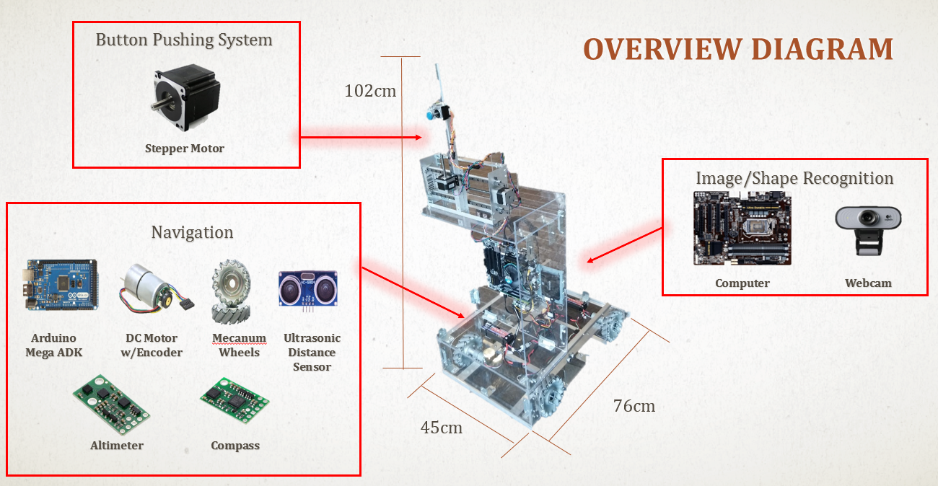
Figure 1. Overview Diagram of RoboMail
In order to push elevator buttons, RoboMail requires an arm with precise 3D movement. This is accomplished with an Acme threaded rod and stepper motor at its base. Two of these structures are combined to create an x-y axis providing precise horizontal and vertical movement. A third and smaller rod and stepper motor is added to create a z-axis and to serve as the button pusher.
3
The locomotion and navigation system is controlled with an Arduino Mega ADK. This microprocessor is designated to operate 4 mecanum wheels, 4 dc motors with encoders, and an array of sensors including many ultrasonic sensors, a compass, and an altimeter. Together and with a complex algorithm they will allow the robot to autonomously navigate a building by detecting walls and obstacles, keeping track of direction and distance traveled, and providing the robot with easy maneuverability.
Finally, the system is fit with an on board computer to handle the image and character recognition using a web camera and National Instruments’ LabVIEW and Vision software. This character recognition software is trained to locate and identify elevator doors and buttons as well as test for an empty elevator. This software will also be useful assisting the robot in verifying its location by recognizing door plaques and room numbers.

Target Objective and Goal Analysis
The ability to move between levels of a building is as key characteristic of the design of RoboMail. As such, it has become our Target Objective for this semester, and as a result all the development has been geared towards achieving this goal.
To better understand the Target Objective, a Goal Analysis has been formulated in order to break down the development into objectives that can be worked and verified independently. Fig. 2 shows the current Goal Analysis in which we can observe the interaction of the described systems shown on the Overview Diagram.
4
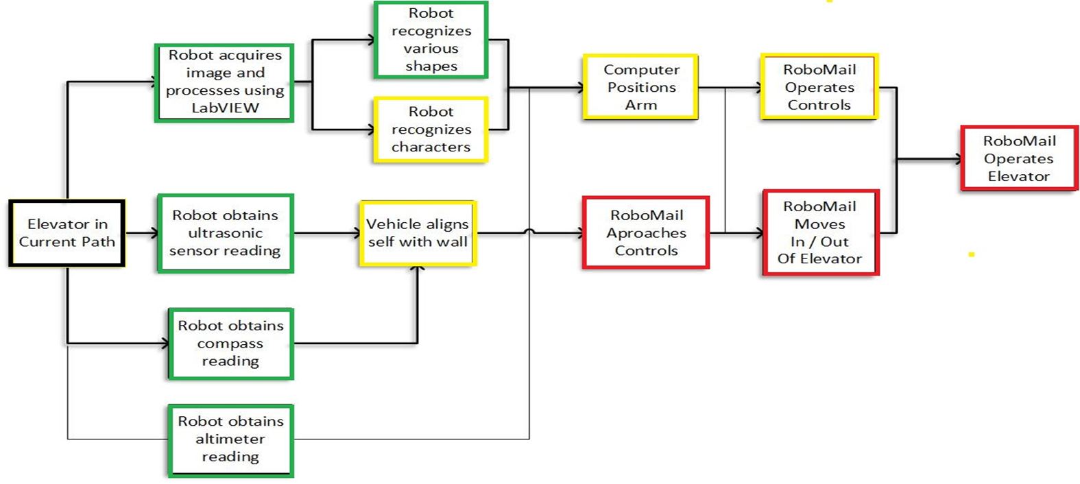
Figure 2. Target Objective (First Semester) with Goal Analysis
In this figure, boxes outlined in green are completed objectives, boxes outlined in yellow are objectives in progress or almost complete, and red outlined boxes are objectives that still need work. For RoboMail to be able to autonomously operate an elevator, the system should be able to identify the elevator and align itself to approach controls. Meanwhile, the Image and Shape Recognition Systems identifies key features that will allow the Button Pushing System to correctly press the required button. Once RoboMail calls the elevator car, it should enter and maneuver inside the elevator, taking into account the many variables that are present during this task, such as timing and in the future, object and people avoidance. In order for the robot to successfully align itself and approach controls, the system is equipped with an array of sensors to allow RoboMail to keep track of its position in the building. These sensor reading acquired include ultrasonic distance sensors, compass, and altimeter sensors. The process is repeated once more inside the elevator to properly select the correct level. Finally, RoboMail will exit the elevator at the correct floor.
5
The compass was tested in the Engineering Building where RoboMail will be operating. The output of the compass was tested by comparing to the iPhone compass app. The altimeter was also tested in this building at all floor levels and was found to be sensitive to temperature, This sensitivity was accounted for and we were able to provide the device with an accurate range to define its floor level. Ultrasonic sensors were tested by comparing results to real distance measurements. With all sensors operating together, we ran into a timing issue. To handle this, we used a second Arduino to handle just the sensors. We have tested a function that aligns the vehicle to a wall and keeps it align as we move to some success but we still need to work in the braking motion.

Engineering Specifications and Restraints
Requirements and specifications are very important components in the development of any embedded system. To begin the design process our team first considered what constraints our robot would be subject to. Because RoboMail is a package delivering robot, the robot’s carrying capacity needed to be considered. We also need to consider the robot’s velocity in order for it to efficiently deliver its load. Autonomous robots must operate in real-time in order to respond and make decisions in their environment. This means our system needs to quickly acquire and analyze images. The mechanical arm is constrained by its load and range. And finally the robot dimensions are constrained by the height of the elevator controls as well as the size of the elevator in order for the robot to easily maneuver within.
After considering these constraints, team 4 designed RoboMail with the following specifications. The robot's Gross Vehicle Weight Rate is 100 pounds. The altimeter we are using has a resolution of 0.5m [1]. The ultrasonic sensors are accurate in the range of 2cm-500cm [2]. For the robot to avoid obstacles in time, we have a maximum velocity of 5km/h. This is equivalent to average human walking speed [3]. The camera, which needs to analyze images within 2m of the robot, has a resolution of 5MP. For alignment and navigation purposes, we plan to keep the robot 5cm-20cm from the wall. The arm’s button pushing rod provides 10cm of movement in the z-direction. The horizontal and vertical arm movement has 28cm of linear movement to properly position the button pushing rod. Finally, the robots dimensions were set to 76 cm x 45 cm x 102 cm (L X W X H).
6

Statement of Accomplishments
Each of the objectives shown in the goal analysis are detailed below. Also included are some of the results of our tests.
- Image Acquisition
    - LabVIEW algorithm has been created and tested, taking into account brightness conditions of the areas using the 5MP webcam.
    - Artificial light may be necessary

- Shape Recognition
    - LabVIEW algorithm has been created and tested by matching the controls of the elevator to a previously obtained image.
    - Needs to build a data bank of images for matching purposes. We also need to limit the maximum velocity at which the vehicle can move and still produce a match while using this algorithm.

- Character Recognition
    - LabVIEW algorithm has been created and tested by reading the tag of a room at Engineering Building 1.
    - Needs to build a data bank of characters for the various types of tags around the building. We also need to limit the maximum velocity at which the vehicle can move and still produce a match while using this algorithm.
7
- Ultrasonic Algorithm
    - An array of 3 Ultrasonic Sensors has been wired and results compared to actual measurements
    - We determined the minimum time to avoid cross-talk between sensors and the amount of time to scan the surroundings as we add more sensors. It was necessary to employ a separate micro-controller that only handle data from the sensors in order to remain within reasonable time to act as the vehicle moves and approaches an object.

- Altimeter Algorithm
    - A single altimeter sensor was wired and tested an all floors of Engineering Building 1
    - To obtain reliable results, because of timing issues, the altimeter has its own micro-controller. As expected, the temperature of the surroundings affects the readings. The device has a temperature sensor to compensate for temperature changes.

- Basic Motion Algorithm
    - Motors were tested under 46 kg load. The algorithm is a closed loop system that provides different directions and allows RoboMail to move in a controlled manner. The speed was verified using a tachometer.
    - The system responds under load, and achieves 80% of its maximum velocity of 15 km/h. At the low end, the closed loop system allows for stable motion at around 1 km/h. At lower speeds a different approach is still in the works.

- Arm Positioning
    - The algorithm was created to accept (x, y) coordinates from the vision system. It operates the already built arm accordingly.
    - The system was testing with at home simulations using images of elevator buttons on the walls. The arm was able to successfully hit the button image.

- Compass
    - The sensor was wired and tested at various locations inside Engineering Building 1.
8
    - We compared the results with the integrated iPhone compass, and the results were similar.

- Complex Motion Algorithm
  - 20% Complete
    - This algorithm to provide RoboMail with autonomous navigation capabilities is still in progress. We have tested a function that aligns the vehicle to a wall and keeps it aligned as we move with some success but we still need to work in the braking motion.
The target objective of RoboMail autonomously operating an elevator was not complete this semester. This is mainly due to time constraints and the complexity of autonomous capabilities. Although we were not able to fully autonomously operate the elevator, the robot is fully constructed and well equipped to accomplish the goal in the near future. The robot was able to operate the elevator controls as well as use basic alignment capabilities to move about.

Engineering Standards
One of the standards our project adheres to is the I²C (Inter-Integrated Circuit) . This standard was developed by Philips Semiconductors, now NXP Semiconductors. I2C is a multi-master, multi-slave, bi-directional serial bus only using two wires to efficiently control ICs. These two lines are the serial clock line, SCL, and the serial data line, SDA. Bus speeds are available from 100kbit/s to 5Mbit/s [4]. We are currently using this standard with the compass and altimeter sensors.

Budget
A table of the itemized parts list is shown below.
Table 1- Current Expenditures
9
Part | Quantity | Unit price | Total cost
Gear Motor | 4 | $39.99 | $159.96
Dual Motor Controller | 2 | $59.90 | $119.80
Wheels | 4 | $67.25 | $269.00
Key Hub | 4 | $12.99 | $51.96
Motor Holder | 4 | $10.00 | $40.00
Stepper Motor | 2 | $32.95 | $65.90
Stepper Motor Controller | 2 | $8.95 | $17.90
Stamped L-Bracket | 2 | $3.95 | $7.90
Electric Solenoid | 1 | $10.93 | $10.93
Traveling Nut | 1 | $8.95 | $8.95
Power Supply | 1 | $44.50 | $44.50
Plexy Glass Sheet | 2 | $59.98 | $99.96
Microcontroller Arduino ADK | 1 | $45.95 | $45.95
Motherboard Set | 1 | $171.03 | $171.03
Web Camera | 1 | $29.99 | $29.99
L-connector | 12 | $1.50 | $18.00
Altimeter, Temp. Press. Sensor | 1 | $4.95 | $4.95
Ultrasonic Sensor | 7 | $0.95 | $6.65
Digital Compass | 1 | $1.60 | $1.60
New Actuator | 1 | $39.95 | $39.95
LabVIEW Software | 1 | $59.00 | $59.00
Mounting Hardware |  | $86.00 | $86.00
Total Purchased to Date |  |  | $1,368.95
Total Cost |  |  | $1,379.88

So far, all of the parts we expect to need to complete our project have been purchased. We do not foresee any future expenditures next semester however, we are allocating $100.00 for any unexpected purchases or for replacing any broken parts. The team labor cost for this semester is shown below in table 2.
100
Table 2. Labor Cost (First Semester)
 | Team Members |  | Labor cost per hour
 | Jordan Berry |  | $75.00
 | Jhony Medrano |  | $75.00
 | James Crabtree |  | $75.00
 | Cesar Garcia |  | $75.00
 | 2/16/2015 | 2/23/2015 | 3/2/2015 | 3/9/2015 | 3/16/15
 | Week 1 | Week 2 | Week 3 | Week 4 | Week 5
Jordan Berry |  | 5 | 6 |  | 8
Jhony Medrano | 5 |  | 6 | 3 | 7
James Crabtree |  | 5 | 6 |  | 8
Cesar Garcia | 5 |  | 6 | 3 | 7
Hours per week | 10 | 10 | 24 | 6 | 30
 | 3/23/2015 | 3/30/2015 | 4/6/2015 | 4/13/2015 | 4/20/15 | 4/27/15
 | Week 6 | Week 7 | Week 8 | Week 9 | Week 10 | Week 11
Jordan Berry | 5 |  | 12 | 10 | 10 | 12
Jhony Medrano |  | 10 | 10 | 9 | 9 | 9
James Crabtree | 5 |  | 12 | 10 | 10 | 12
Cesar Garcia |  | 10 | 10 | 9 | 9 | 9
Hours per week | 10 | 20 | 44 | 38 | 38 | 42

11
The total labor costs are shown below in table 3.
Table 3 – Total Cost of Project
 | Jordan Berry | $5,100.00
 | Jhony Medrano | $5,100.00
 | James Crabtree | $5,100.00
 | Cesar Garcia | $5,100.00
 | Hardware | $1,379.88
 | Grand total | $21,779.88

For our team to successfully reach our target objective next semester, we only anticipate needing to spend on costs for labor.

Conclusions
To satisfy the thriving demand for technology that addresses the shortcomings of existing mail delivery methods, we hope that systems such as RoboMail will be considered as a way to reduced expenditures and increase efficiency. We are making progress in designing and ultimately obtaining a working prototype that will not only be able to navigate in a human setting, but will be capable to use existing technology, and thus reducing the expenses when adapting new technologies to an existing environment.
This semester, team 4 has completed a platform for testing that will allow us to provide RoboMail with autonomous capabilities in the upcoming semester. RoboMail’s development will continue its current pace and we feel confident that we will be able to reach our final target objective of an autonomous delivery robot successfully. There are still obstacles to overcome and some of them may be out of our hands, but our team is dedicated and resolved to reach our goal.
12

13

References

[1] https://www.pololu.com/file/0J622/LPS331AP.pdf
[2] http://www.electroschematics.com/wp-content/uploads/2013/07/HC-SR04-datasheet-version-2.pdf
[3] http://www.westernite.org/datacollectionfund/2005/psu_ped_summary.pdf
[4] http://www.nxp.com/documents/user_manual/UM10204.pdf

