Date: May 8, 2015

Subject: Small Satellite Communications Project: End of Semester Report

To: Dr. Steve Provence, Professor

Dr. John R. Glover, Professor

N308 Engineering Building 1  
Houston, Texas 77004-4005

Dear Dr. Provence and Dr. Glover,

At the beginning of the semester, we stated that we wanted to create a more efficient small satellite communications system for communication between a small satellite and a ground station. We are excited to present the our completed objectives, to share what needs further research and testing, and aggregate progress on achieving that goal. Currently, we are on the precipice of creating a working prototype of a small satellite system that will help future CubeSat team’ explorations and experiments.

Enclosed with this letter is a report that explains the current state of our project. It contains what we have achieved in developing a system that reduces noise in satellite navigation with a Kalman filter, in producing a system that knows it’s location through GPS monitoring, in having plans for a power system that switches between 2 batteries being charged through solar arrays, and in moving forward with wireless communication between the satellite and a ground station with a Graphical User Interface. This lays the foundation for building a system that could maximize the transfer of the amount of mission data from a small satellite to a ground station, while the satellite is in range. This report explores the significance and importance of this project, what objectives are completed, and the progress towards what can be delivered at the project’s conclusion.

Although there is much that is completed, there is still a lot of progress to be made in order for this project to be successful. We are very much invested in the successful development of this project and as much as we can celebrate the successes of what was done so far, there is still much work to be done to see this project to its fruitful completion by the end of December. We are very excited about this endeavor and opportunity and look forward to achieving our goal.

Sincerely,

Matthew Casella

Dustin Holliday

Jared Kuntz

Keith Shirley

Encl: Small Satellite Communication Analysis Report

*The Development of a Small Satellite Communications System*

An End of Semester Report

By

Team 7: CubeSat Initiative

Matthew Casella

Jared Kuntz

Dustin Holliday

Keith Shirley

Submitted

On

May 8, 2015

For the

Facilitators of ECE 4335

**Abstract**

The goal of this project was to implement a more modular and efficient small satellite system. It is difficult and expensive to conduct experiments in space that are needed to further space technology and science. Our project aimed to address this concern by implementing a small satellite prototype that can be used and expanded on by future CubeSat teams who wish to add experiments and/or propulsion to the system. The target objective was to have a system that implemented a fully functioning avionics module that tracks attitude and position with real time data rendering, a communication module that sends and receive commands, and a power module that regulated and supplied power to the system. Although this objective was not fully met, progress was made into developing a method to accurately track the position and orientation of the satellite thru the use of Kalman filters. Accurate tracking will allow for more efficient communication between the satellite and ground station during the limited window of opportunity that exists for communication. Lastly, the project costs remained low and future costs are expected to remain low.

1. **Background and Goal**

**To implement a more modular and efficient small satellite system.**

Small satellite systems are the next generation of space exploration in terms of scientific research and the development of new technologies. However, it is very arduous to send and receive data to and from satellites once they are in low earth orbit due to the small window of time that satellites are in communication range. Additionally, there is a limit on how much data can be transferred due to constraints of time and signal strength. Our goal is to implement a more modular and efficient small satellite system that optimizes the process of sending and receiving data to Earth while in low Earth orbit while making it easier for researchers and developers to use.

The purpose of this document is to illustrate the progress of the development of this small satellite system up to the end of the first semester of the Capstone Senior Design course. Our current target objective was for a system that implements a fully functioning avionics module that tracks attitude and position with real time data rendering, a communication module that sends and receives commands, and a power module that regulates and supplies power to the system. The final target objective is for the system to be tracked and monitored while being able to send, receive, and store commands and data to and from a ground station. This document provides in depth information of what objectives have been accomplished, what objectives need more time and development, logistical data such as constraints, specifications, standards, and budget, and a statement of accomplishments.

1. **Problem, Need, and Significance**

*Problem*

Satellites are expensive and problematic to use for conducting scientific research due to issues in tracking and communication.

*Need*

The need for solving communication issues between the small satellite and the ground station is to increase the amount of scientific data that can be transferred to and from Earth and to promote the use of the small satellite as a vehicle for research experiments.

*Significance*

The significance of solving this small satellite communication problem is to create a more affordable, reliable, and desirable way to conduct scientific research in space for the advancement of science and space exploration.

One of the major limitations with small satellite missions is being able to swiftly transfer data between the ground and the satellite due to the satellite’s location in orbit relative to the ground station. Currently, data can only be transferred to the ground when the satellite is right above the ground station, and that window of opportunity changes every time the satellite passes by. Knowing the correct position, direction, and attitude of a small satellite greatly increases the opportunity to communicate and transfer information to and from Earth.

The development of the avionics module calculating the position and orientation of the satellite along with the development of the communication from the satellite to a ground station greatly contributes to the overall goal of reducing the costly inherent communication issues that plague the use of satellites for scientific research. Along with providing a sustainable power system, our developed small satellite system will be able to meet the needs of the scientific research community of creating an inexpensive modular satellite with more efficient communication capabilities. Having these capabilities was the target objective for this semester.

1. **User Analysis**

**The most likely user of the finished product will be future CubeSat teams and other potential scientific researchers.**

The users of this technology should have some sort of experience with embedded systems, but should also have experience in developing and working with small satellites. Ideally, future CubeSat teams working with NASA or small satellite researchers at the University level should use this technology.

The ground command station will have a user interface that allows the user to monitor the satellite in space and receive mission data from the satellite. The user will be in close proximity to the transmitter of the ground station in order to have no obstructions in data transmission. This technology is not ideal for children or unsupervised students. However, this small satellite system will be designed for ease of use, allowing for users who are unfamiliar with the technology to quickly learn how to use it.

1. **Overview Diagram**

Figure 1 shows the overview diagram of the small satellite system complete with its 3 unit (3U) system.  

Figure 1: 3U CubeSat System (Command, Payload Experiment, & Propulsion Modules) with Ground Station.

This figure emphasizes how each individual module interacts inside the command cube and how it is stationed in relation to the payload experiment cube and the propulsion cube. The figure also shows the wireless communication with the ground station i.e. the laptop computer. Most of the project is based on developing the master cube (Command Cube) and its interactions with the ground station. A more detailed description of the specific actions of each module will be illustrated and discussed in the *Target Objective and Goal Analysis* section.

1. **Target Objective and Goal Analysis**

**The target objective for this semester was to have a system that implemented a fully functioning avionics module that tracks attitude and position with real time data rendering, a communication module that sends and receive commands, and a power module that regulated and supplied power to the system**. These modules would additionally communicate through a CAN bus communication protocol.

The following figure shows the goal analysis complete with the power module and the avionics module. Each module has blocks that explain objectives that needed to be completed in order to reach the target objective. This figure represents a tangible alternative to the overview diagram in Figure 1 mentioned in the *Overview Diagram* section of this report.

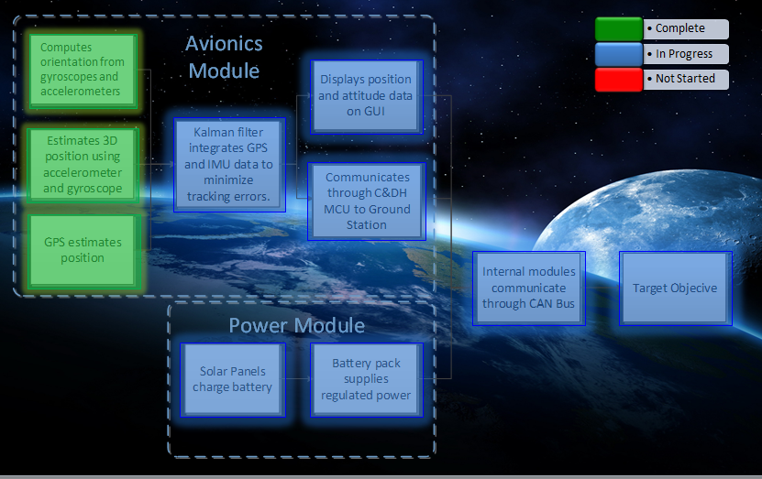

Figure 2: Small Satellite System Block Diagram with System Objectives

The boxes in green represent completed objectives while the boxes in blue represent objectives that are currently in progress. As the figure shows, most of this semester’s accomplishments involve computing the system’s ability to accurately track the position and orientation of the satellite. These objectives, explained in further detail with testing results in the *Statement of Accomplishments* section, were tested by isolating movements one axis at a time and by comparing that with the inertial measurement sensor (IMU) data, and by using GPS to measure exact positioning versus measured positioning. We were able to correctly reduce error to within our specifications of 3 [m] of positioning and 3 degrees of rotation.

Although most of the objectives are currently in progress, many of them have the design ready to be tested after extensive simulations and research. The Kalman Filter integrating GPS and IMU data, the power system, and communication through C&DH to Ground Station all fit this criteria of having a design in place but needing actual testing. Although we have a connection to the ground station GUI, the objective was for it to communicate wirelessly, which is still in progress. Finally, there is still a need to examine how the modules will communicate with each other through a Controller Area Network (CAN) bus. This objective was moved to the fall semester due to time constraints. The goal analysis truly illustrates how much of a feat it was to measure GPS, positioning, and rotation data and render it through a GUI.

1. **Engineering Specifications and Constraints**

**Specifications**

One of the most important specifications is that our small satellite hardware must fit inside of a 10 [cm3] cube framework. This includes our power system, our avionics module, and our communications module. These modules all have separate components that take space such as batteries, MCU’s, and RF transceivers. Another specification that is necessary is for the whole satellite system to consume no more than (?) 3 [W] of power. This balances the need for power to all of the system modules, the efficiency of power generation from our solar panels, and the amount of time that the system needs to be operating while in orbit to transfer data to the ground station. In terms of avionics, the system specifications are for the position error to be less than 3 [m] and for the attitude error to be up to 3 degrees. These specifications are met through the use of sensor fusing using a Kalman filter, a computational process that synthesizes data from the accelerometers, gyroscopes, and GPS to attain an accurate position. Finally, due to memory constraints, we need about 512 [KB] of flash memory to hold computational data to store data from positioning and rotation.

**Constraints**

As mentioned before, our satellite is only 10 [cm3]. This creates constraints on hardware selection and positioning. In terms of power generation, the use of solar panels is vital for recharging batteries; however, solar panels (especially for prototyping) are inefficient. Therefore, it is necessary to employ a system that operates on low power consumption. Additionally, position and rotation accuracy is a specification that arises from drift from being in orbit and computing current location and estimating future location in real time. Another constraint, one of our major constraints, is the amount of data that can be stored and transferred from the cube to the ground station. There is a limited time period that the satellite will be in range of the ground station to transfer data and clear its buffer. The following table (on the next page) displays sampled passes by the International Space Station over the ground station in Houston to exemplify this constraint.

Table 1: International Space Station selected ground passes over Houston for January, 2014

|  |  |  |
| --- | --- | --- |
| Date | Time (mins:secs) | Highest Elevation () |
| Jan 20 | 2:26 | 23 |
| Jan 20 | 1:01 | 11 |
| Jan 20 | 2:09 | 15 |
| Jan 22 | 3:12 | 78 |
| Jan 23 | 4:12 | 46 |

Therefore, it is importation to incorporate this constraint in planning and production. Lastly, we can only test the small satellite system on Earth. The system will only be exposed to an environment that experiences gravity, which must be accounted for.

1. **Statement of Accomplishments**

**Objectives Completed**

The following is a description of the objectives that have been completed:

*Computes orientation from gyroscope and accelerometer*

The ADIS16334 IMU comprises a gyroscope and accelerometer that were used to compute the orientation of the satellite. The gyroscope detected changes in the angular velocity about the three axes (roll, pitch, and yaw) which were integrated to determine the orientation of the satellite. This data is only good for a short amount of time because the gyroscope tends to drift, which introduces large errors over longer periods of time. A Kalman filter was needed to correct these errors. Likewise, the accelerometer detected changes in the acceleration about the roll and pitch axes. However, accelerometers are not able to detect changes about the yaw axis since it is perpendicular to the gravity vector. The data from the accelerometer was estimated using the trigonometric relationship between the body frame of the satellite and the sensed gravity vector across the roll and pitch axes. There is a question as to how the added centripetal force of the satellite in a high speed orbit will affect these calculations. But this can be addressed at a later time, as the concern for this project was to create a functioning Earth-based prototype. This objective was tested using a level to perform an accurate 90° rotation about each axis of the IMU, of which was compared to the angle measurement received over the serial port to the computer. The measurements were somewhat close, to within ±15°.

*Estimates 3D position using accelerometers and gyroscopes*

An accurate estimate of the satellite’s orientation was needed to estimate position. This is because the gravity vector must be subtracted out to determine the actual acceleration of the satellite. Figure 3 shows three images. The original orientation shows the original reference

frame, which is then physically rotated. The third image shows the body frame rotated back to

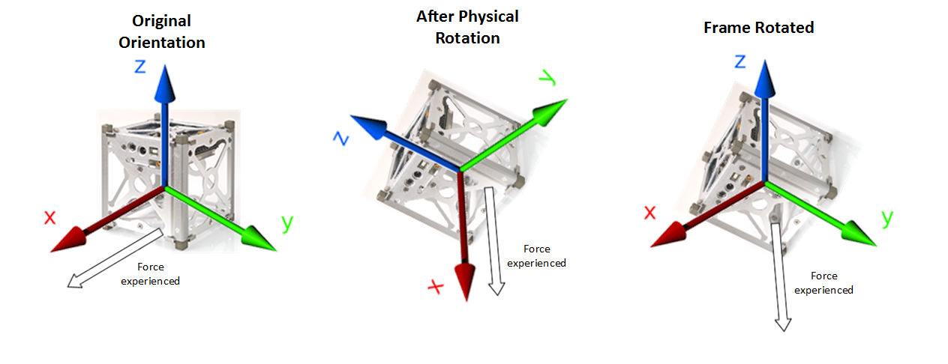

**Figure 3. The static reference frame is rotated with the body, and then rotated back to its original orientation**

the original reference frame. Only then could the (non-gravity) accelerations be truly estimated. This was achieved by using the inverse of the rotation matrix calculated from the prior objective at every sample point, then integrating twice to produce a positional estimate. This type of measurement is unreliable by itself due to the integration of noisy accelerations, which continuously add more error to the estimate over longer periods of time. These measurements will have to be continuously updated with GPS estimates to correct the position error at frequent intervals. This objective was accomplished by moving the IMU along its axes, one at a time, and comparing the position estimates received from the IMU against the known distances of a meter stick. It was found that these measurements had errors of ±9% in the short term, and much larger errors over longer periods of time.

*GPS estimates position*

The FGPMMOPA6H GPS standalone module was used to provide National Marine Electronics Association (NMEA) standard strings through the serial port to the computer which would give positional estimates of latitude, longitude, and altitude. Figure 4 shows an NMEA string that was received. This string was inaccurate by about several city blocks, due to it being tracked by only 3 GPS satellites at the time. However, subsequent NMEA strings utilizing 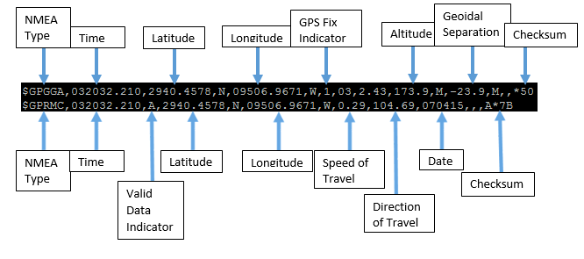

**Figure 4. NMEA string with the different data types indicated**

8 GPS satellites provided much better results. Figure 5, shown below, is a sample of one of those strings. This objective was tested using Google Maps. Figure 6 shows the GPS location using

http://i.imgur.com/ki4UK3a.png

**Figure 5. NMEA string received which utilized 8 GPS satellites.**

the coordinates received from the Figure 5 string. The error is about 2.2 m. It was discovered that the GPS module provides accurate and precise positional data to within the range of 0-3 m whenever the data was based on the estimates from 8 or more GPS satellites; and the objective was completed.

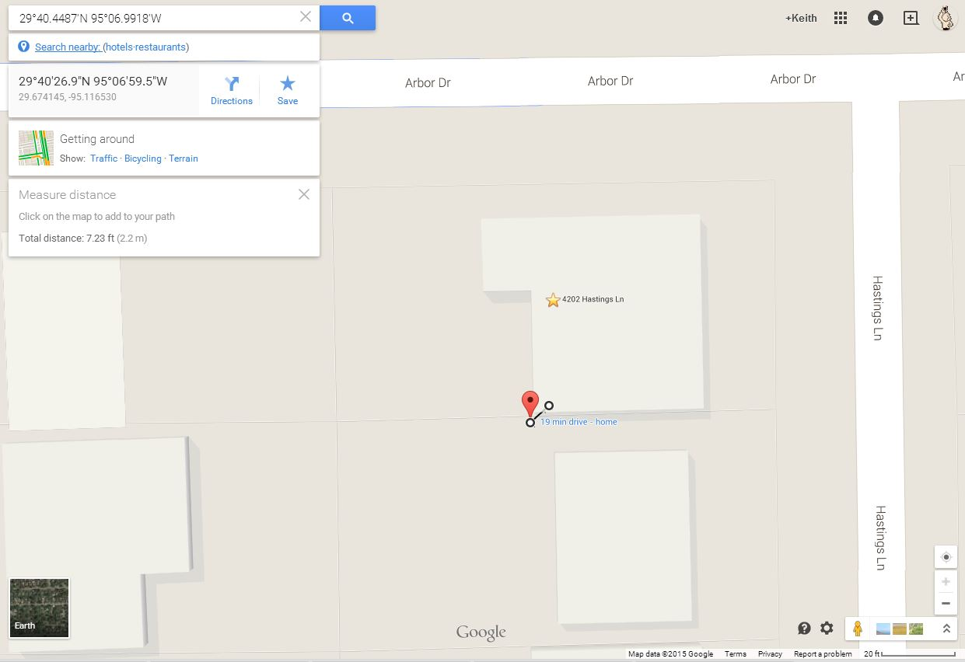

**Figure 6. The mapped location of the data from the Figure 5 NMEA string. The error in this sample is about 2.2 meters, as is indicated in the top left corner by the distance from the red pin to the GPS module’s actual location.**

**Objectives in Progress**

The following is a description of the objectives that are still in progress:

*Kalman Filter integrates GPS and IMU data to minimize tracking errors*

This objective requires that the GPS and IMU data be integrated through sensor fusion into a Kalman filter which will filter out most of the noise and provide better estimates of position and orientation. Matlab has been used to simulate the Kalman Filter program that was written. A lot of Gaussian noise was added to the angle measurement, of which was mostly filtered out as is seen below in Figure 7. The Kalman estimated angle is so close to the actual angle, that the two are hardly discernable from each other. Figure 8, also depicted on the next page, shows a zoomed-in portion of Figure 7. The estimated angle is almost identical with the true angle, thus showing that the Kalman Filter can provide accurate and precise data from the noisy measurements of the gyroscope and accelerometer.

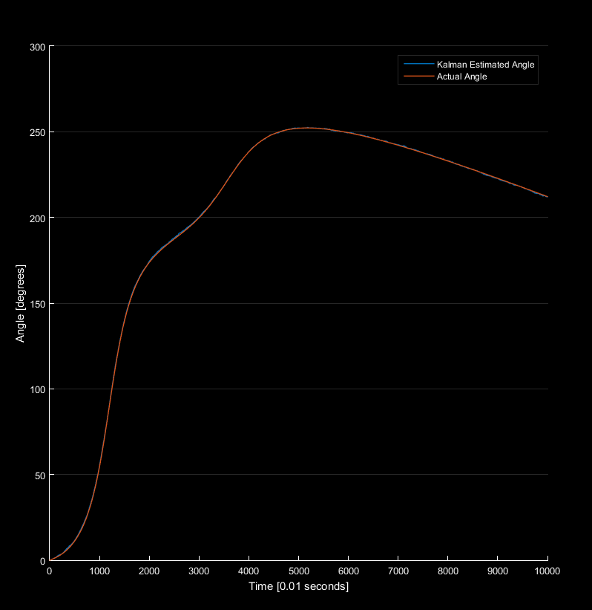

**Figure 7. The simulated angle measurement over time. Notice how the Kalman estimated angle is hardly discernable from the actual angle.**

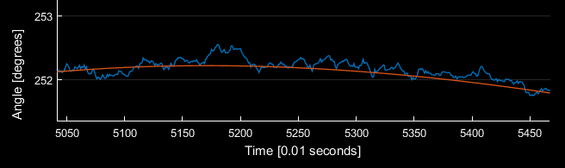

**Figure 8. The Kalman filter simulation shows minimized error in the angle estimate**

Furthermore, the Kalman filter continuously updates the angle estimates of the gyroscope and accelerometer to eliminate gyroscope drift. This part of the Kalman filter was realized, and was tested visually with the GUI (graphical user interface) that was developed in Matlab. The IMU sat stationary for one hour while being observed in the GUI. It was seen that the cube remained stationary at the starting reference point and never drifted, indicating that the Kalman Filter was effectively filtering out noise and properly updating the angle estimates. This objective was partially completed because the sensor fusion of positional data from the GPS and accelerometer had yet to be achieved. Simulations were performed in Matlab with positional data, and are shown in Figure 9..

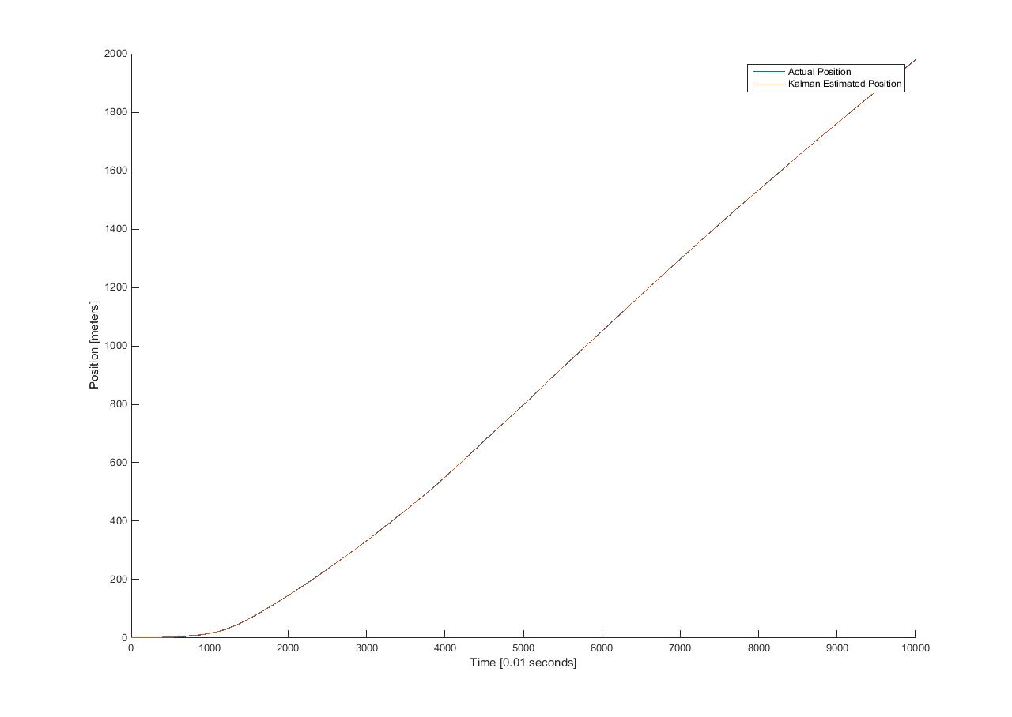

**Figure 9. The Kalman filter simulation of positional data**

Much like before, the two lines of the figure are barely distinct from each other. Figure 10 (displayed on the next page) shows a close-up section of Figure 9. Although there is some error, it provides reliable estimates of position. Further work needs to be done in converting the

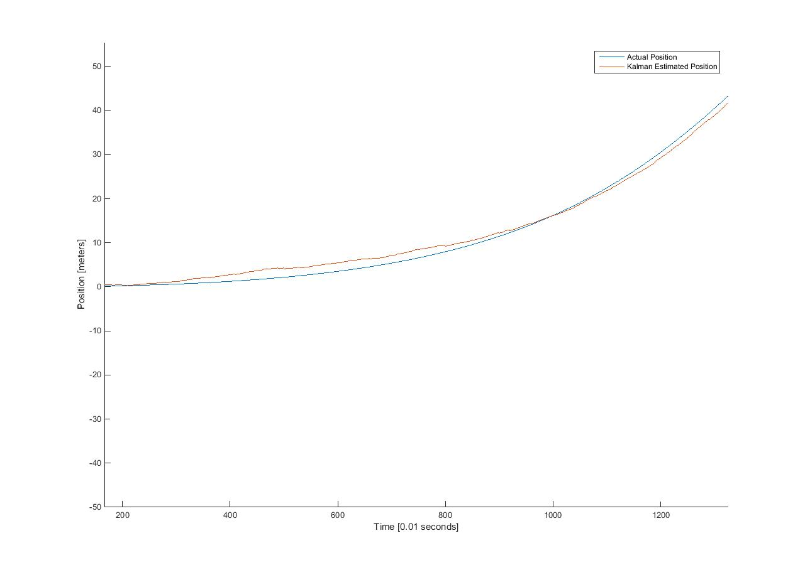

**Figure 10. A close-up section of the previous figure showing the minimized errors outputted from the Kalman filter**

accelerometer measurements into latitude, longitude, and altitude, so that it can be integrated with the GPS measurements through the Kalman filter to produce accurate, precise, and continual estimates of the satellite’s position. This will be achieved by software coding that will utilize the great-circle distance equations, allowing for such sensor fusion.

*Displays position and attitude data on GUI*

A GUI was needed to provide a visual depiction of the position and orientation of the satellite in real time. Matlab was chosen to be the GUI for this semester due to the team’s familiarity with that program. This objective was partially completed because only the orientation of the satellite was displayed. Figure 11 shows a screenshot of a video that depicts the cube rotating in real-time as the IMU is rotating. The two rotate in sync with each other.

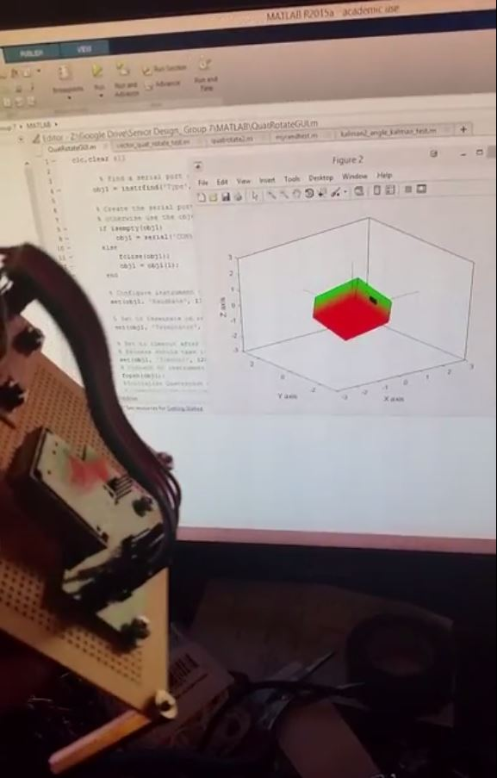

**Figure 11. A screenshot of a video that depicts the rotations of the IMU being displayed in real time using Matlab**

Once the fusion of position data is achieved through the Kalman filter, a similar interface can be used to depict the satellite’s position. The 3D animations of Simulink are optimal, and effort was put forth into making a Simulink GUI. The Simulink model that was created is shown on the next page in Figure 12. However, the team had difficulties in getting the serial data into Simulink. Due to time constraints, this idea was abandoned. Plans are underway to create a GUI based in C++ or JAVA for the Fall semester. This will allow for a faster interface that can easily be made into an executable file for future CubeSat teams to utilize.

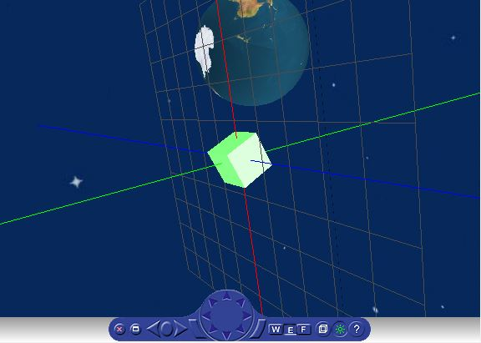

**Figure 12. The Simulink model that was created for the initial GUI**

*Communication through C&DH MCU to Ground Station*

This objective requires the use of integrating 2 RF transceivers to enable wireless communications between the C&DH module and the ground station. A lot of the issues that came up from this objective were the understanding of how the transceivers could connect and communicate with the MCUs, and what communication protocol standard could be implemented. There was a basic framework from the previous senior design CubeSat team that gave an initial background as to how it could be done; however, there are still more steps that need to be taken for the wireless communication to be implemented. This is mostly due to some inefficiency in the Tiva Ware software that the Tiva C microcontroller is programmed on, and the actual hardware connections themselves. We plan for the system to have operational wireless communication before the beginning of the next semester.

*Power Module*

The objectives of the power module are still in progress. Like many of the other objectives in progress, there is a finalized design for how the power system will work, but there is still a necessity for using parts that fit the specifications of the design i.e. using quality solar panels for power generation. The design of the power system calls for using two batteries and switching between each one so that while one battery pack is providing power, the other is charging from the solar panels. This switching mechanism would be implemented using a FET transistor. There is still research and testing that needs to see if the power can be sustained, but initial research tells us that this could be a possible avenue to pursue.

1. **Engineering Standards**

The following is a list of relevant communication standards that were utilized in this Project:

*UART (Universal Asynchronous Receiver/Transmitter)*

Based on the industry standard TL16C550 asynchronous communications element, the UART peripheral is a part of the MCU that translates parallel data for serial communications to other peripheral serial ports. UART takes bytes of data & transmits individual bits in a sequential fashion. This protocol is inherently simple and allows easy interfacing and communication between modules

*SPI/SSI (Serial Peripheral Interface/Synchronous Serial Input)*

SPI/SSI is a synchronous serial communication protocol developed by Motorola and based on RS-422 standards used for short distance communication between devices. It is mostly used for a Master-Slave relationship between central MCU modules and external peripherals. In our project, it is used to communicate between our MCU’s and RF modules for wireless communication.

*CAN (Controller Area Network)*

Defined in the ISO 11898 standard, the CAN bus communication protocol was developed for fast serial data exchange between electronic controls (for motor vehicles) without the need for host computer control. For our project, it will be used (instead of UART) for communication between our satellite modules.

1. **Budget**

The following table displays our total expenditures to date.

Table 2: Total Expenditures to Date including Hardware and Labor



In viewing the total expenditures to date, it is important to note two important points. First, our team has purchased the majority of our hardware resulting in $176.31, which is a very well below the expected budget. Also, these materials have been used for both testing and production of our small satellite system. Second, our labor budget is very cheap due to paying the national hourly minimum wage at 600 hours for the semester totaling $4,350. Although this may seem satirical in nature, it is actually representative of the middle ground between not being compensated as an undergraduate engineering student and a compensated engineer in industry. Ultimately, our budget still displays the trend that labor is the most costly part to our project.

The next table displays our projected future expenditures, complete with hardware and labor costs.

Table 3: Projected Future Expenditures including Hardware and Labor



As far as hardware is concerned, we only need to purchase solar panels for the power system and the final potential printed circuit board (PCB) when the project is complete. The PCB will be necessary in order to fit all of our hardware inside the small confines of the cube satellite. For our projected labor budget, we increased the amount of hours needed to finish the project due to the important factor of meeting our final deadline in the fall.

1. **Conclusions**

Although we did not reach our target objective for the semester, we made great strides toward doing so and look forward to being ready for the next portion of the Capstone Senior Design course. With more testing and implementation of our objectives in progress, we feel that we made an attainable step towards reaching our goal of implementing a more modular and efficient small satellite system. We laid the foundation for further progress and growth to be able to reach our target objectives and our goal.