Team Destiny
Cullen College of Engineering
E421 Engineering Building 2
Houston, TX 77204

May 08, 2015

Dr. Julius Marpaung
University of Houston
N308 Engineering Building 1
Houston, TX 77204

Dear Dr. Marpaung:

Attached below is the final technical report of the Ball Balancing Robot project. After purchasing all the necessary components for our project, we have successfully completed building a prototype of the robot. We have also established all the connections between the various components of our robot.

Unfortunately, we were not able to accomplish this semester’s target objective of balancing our robot upon a stationary ball; however there have been no problems with our prototype thus far. We will be presenting our prototype on May 7, 2015, to our professors and industrial advisory board.

If you have any questions or would like to talk about anything related to this project please don’t hesitate to contact us. We can schedule a meeting and talk about it more in detail.

Sincerely,

Vance Trevino

Ahmed Siddiqui

Jonathan Pham

Quyen Huynh

Enclosure: Final technical report on Ball Balancing Robot

Spring
15
University of Houston
Ball Balancing Robot (Ball-Bot)
Senior Design Final Report
- Vance Trevino
- Jonathan Pham
- Ahmed Siddiqui
- Quyen Huynh

08
Fall

Abstract
The purpose of this document is to provide technical details pertaining to the design and use of our senior design project. Our project is a ball-balancing robot that is designed to help both current and new students gain a better understand of the different concentrations of electrical and computer engineering. This in turn will enable students to effectively choose which concentration they would most like to pursue and help increase graduation rates. Our robot can successfully move in accordance to any change in the data that is read in from the on board sensors.
Background and Goal
The goal of this project is to show incoming engineering students the different concentrations electrical and computer engineering (ECE) has to offer and how each one can contribute in some way to the world. To accomplish this goal, we have chosen to construct a robot that can balance upright on a ball, as well as move around at the discretion of the user. Since our goal is to showcase the various concentration of the ECE department, we have chosen to include 5 of the offered concentrations in our robot. These concentrations include controls systems, power, electronics, embedded systems, and computer engineering.
Problem
The ECE department at the University of Houston offers 6 different concentrations that students can focus on during their last two years of college. The concentration area allows the student to choose a subset of Electrical Engineering that is of particular interest to the student, while still encouraging the student to take courses in related areas. Since there are so many concentrations, many students go into their junior year of college with little knowledge of what concentration to apply under. Due to this, a vast majority of incoming ECE students have a shallow perception of what ECE students actually study.
Need
Students are required to choose a concentration within the ECE department early on in their college career, however many students do not realize what concentration truly interests them until the end of their junior year. Our project will display the different aspects of ECE through the use of each component that our robot uses. By interacting with our robot, students will gain a better understanding of what each concentration has to offer thus allowing them to choose their courses more wisely.
Significance
To display the different aspects of Electrical and Computer Engineering, we built our robot to showcase five different concentrations that are offered by the ECE department. While using the robot, the user can visualize how each concentration is being applied and how it affects the functionality of the robot. The robot can be demonstrated in introductory level ECE courses that will help many students see what each concentration has to offer and assist them in choosing their concentration based on what part of the robot interests them.

User Analysis
Our Ball Balancing Robot can be used by anyone, whether it is a student or a faculty member. There is no set of expertise needed by the user to operate our robot, as the idea is really simple, the robot will balance on a ball and will have the ability to move around at the discretion of the user. However, our target user for this robot will be any professor in an introductory course where they can demonstrate and explain the robot. The professor will be able to explain how the robot functions as a whole as well as how it ties into electrical and computer engineering.

Overview Diagram
Shown below in Figure 1 is the overview diagram of our senior design project. Figure 1 displays how each concentration is being incorporated into our robot to allow it to balance on a ball. It can also be seen that our robot incorporates control systems, power, electronics, embedded systems, as well as computer engineering.
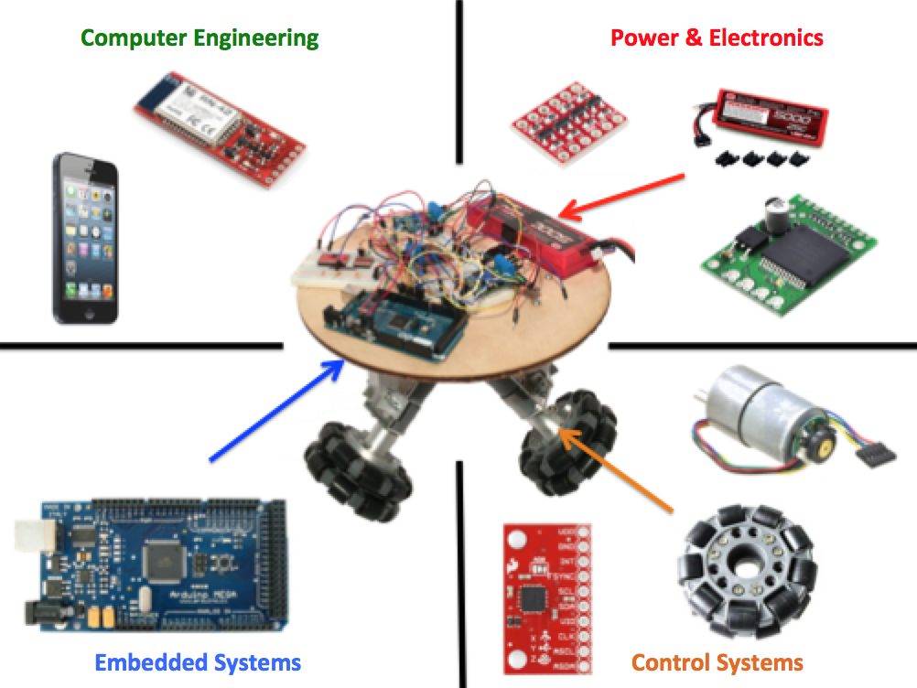
Figure 1: Ball-Bot Prototype
The control system concentration is displayed through the use of the omnidirectional wheels, gear motor, and the accelerometer/gyroscope. The accelerometer is used to measure the acceleration of our robot while the gyroscope is used to measure the angular velocity. This in turn helps our robot determine its position and how much it should turn the motor to correct itself.
Power and electronics is displayed through the use of the lithium-ion polymer battery, voltage regulators, and motor drivers. The battery is used to provide electrical energy to every component in our robot while the voltage regulator are used in conjunction to ensure that the proper voltage is maintained across every component. With this, we can ensure that our motor drivers always obtain the proper amount of voltage to control the speed and direction of our motors.
Embedded system and computer engineering is displayed through the use of the Arduino microcontroller. The Arduino is responsible for processing all the data that is obtained from our sensors and sending it to our motor drivers. This is done by using interrupts to periodically check the positional values of the encoders as well as the gyroscope and accelerometer.

Goal Analysis
For our goal analysis, our robot must complete a series of objectives to successfully reach our target objective. These objectives, our target objective, and our goal analysis can be seen below in Figure 2. The first set of objectives is to read in all of the appropriate data from the gyroscope, accelerometer, and encoders on our robot. The gyroscope will output the angular velocity of the robot, while the accelerometer will read the z-axis acceleration value, and the motor encoder will read the positional values of each of the three motors. After the first set of objectives has been achieved, the next objective is to convert each raw value from the sensors into values that will be used to control the speed and direction of the robot. The motor encoder positional values are to be translated into the velocity feedback for each wheel. The gyroscope values helped us determine the angular rate of the robot. Lastly, the processed data will be applied in the control systems algorithm used in the Arduino Mega. In combination, the angular rate and velocity feedback will help determine what speed and direction the three motors have to be in. After determining the velocity of the motors, the program will send out the appropriate PWM and digital signal to the motor drivers, which will cause the wheels to move accordingly and thus balancing our robot on top of a ball.
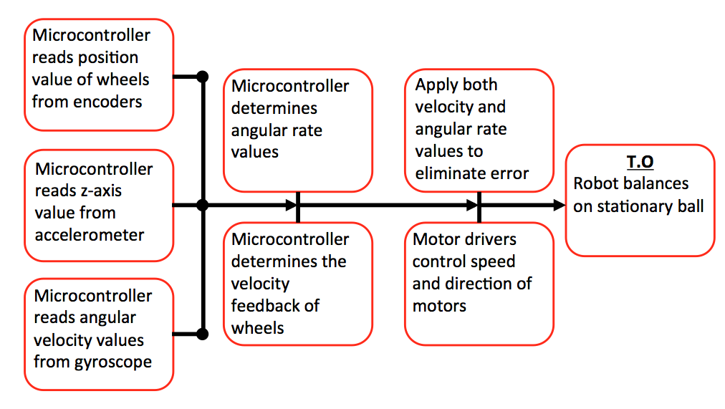
Figure 2: Goal Analysis

Specifications and Constraints
Throughout the course of the project, several specifications and constraints must be taken into consideration in order to accomplish our objective. The specifications include the ball’s size, the total weight that the robot can handle, and the angle at which the robot legs must be placed with respect to each other. The size of the ball will be approximately 27 inches in circumference, or roughly 8.5 inches in diameter. The maximum load that the omnidirectional wheels can handle without stalling is 20 [kg] and the stall torque of the motor at 12[V] is 220[oz · in], therefore to ensure that these values never become a problem we determined that the maximum weight of the robot must never exceed 10 [kg]. The last specification is the angle of the legs of our robot with respect to each other and the angle of the wheels with respect to the ball. The optimal angle of each leg with respect with each other was determined to be 120º; this is due to the fact that at this angle, each leg experiences an equal amount of the robot’s weight.
The constraints that we have determined for our robot include the environment that our robot is used in, the total amount of current drawn when the motor is applying its maximum torque, and the total run time of the robot without needing to charge the battery. The environment has to be an ideal flat surface without any obstacles, drops, or slopes that would interfere with the robot. The ball must be able to maneuver around the field without any obstruction. Each motor requires a continuous current of 300 [mA] to rotate freely, but maximum current drawn by the motor when applying its maximum toque is 5000 [mA]. This constraint leads to how long our robot can function properly under a single charged battery. Overall, these constraints in turn aided us in choosing the appropriate components for our robot.

Statement of Accomplishments
Referring back to our goal analysis in Figure 2, we have been able to accomplish everything but eliminating all possible error to balance our robot and our target objective. This can be seen below in Figure 3. We have been able to read in all of the appropriate values from the motor encoders, gyroscope, and accelerometer. From there we have been able to determine the velocity feedback and angular rate of our robot to control the speed and direction of our motors. However, we were not able to meet our target objective due to issues with our control algorithms.
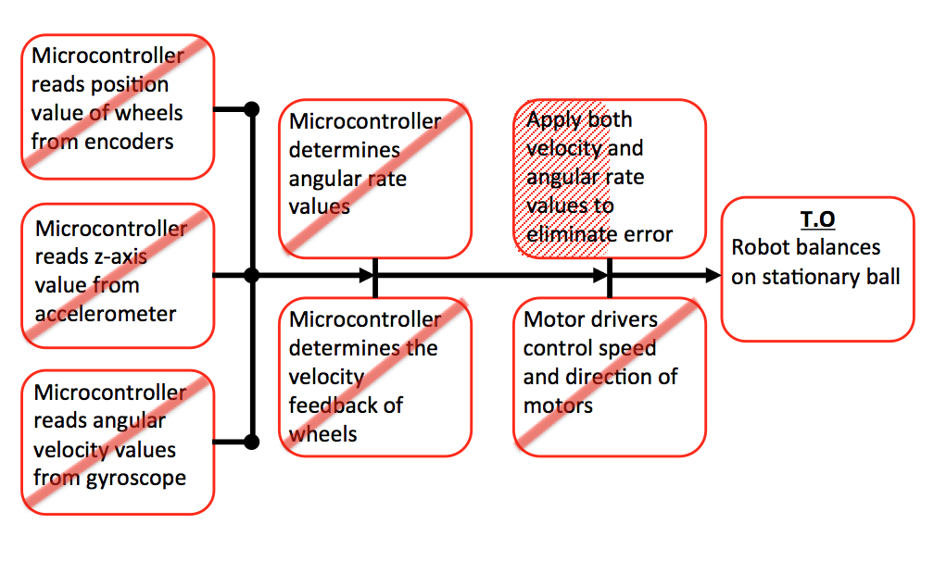
Figure 3: Accomplished Objectives of Goal Analysis
Budget
Shown below in Table 1 and 2 is the total parts budget for this semester as well as the total budget on labor. It shows the total amount of money we have spent so far this semester along with the hourly rate of each team member and total hours worked.
Table 1: Total Parts Budget
Total Parts Budget
Essential Parts | Price
Arduino Mega 2560 R3 | $45.95
Acrylic platforms | $50.21
Venom Li-PO Battery | $44.51
Gyroscope + Accelerometer | $50.65
DC Motor + Drives | $144.80
Omni Wheels | $60.48
Additional electronic parts | $50.00
Miscellaneous | $50.00
Total Component Price | $496.60
Table 2: Total budget for labor
Team Member | Hourly Rate | Hours worked (Weekly) | Total Labor Cost (8 Weeks)
Vance Trevino | $60 | 10 | $4,800
Jonathan Pham | $60 | 10 | $4,800
Ahmed Siddiqui | $60 | 10 | $4,800
Quyen Huynh | $60 | 10 | $4,800
Combined Labor Cost |  | $19,200

Shown below in table 3 is the total expenditure of our project. It displays the total money we have spent this semester on all of the parts and labor. It also shows an estimate of the total budget that plan of spending next semester.
Table 3: Total Expenditure
Total Expenditure
Total budget with parts and labor (Spring 2015) | $19,696.60
Total budget for next semester | $200.00
Conclusion
To reiterate, the main objective of this project is to showcase the many facets of Electrical and Computer engineering to incoming ECE students. Our team has been able to successfully build an actual prototype of the robot and we have been able to read in values from the encoder, motor, accelerometer, gyroscope and MCU. We have also been able to program a controls algorithm for the Arduino. Unfortunately, we were not able to accomplish our target objective of balancing our robot on a stationary ball but we were able to get the wheels to respond in accordance to the values we have obtained from our sensors. Once we perfect our control algorithm we will be able to fully accomplish our target objective and proceed further with our project.

