December 5, 2016

From: Team 6, Cohort 1
Subject: Pipe Inspection Robot: Final Report
Attn: University of Houston Electrical Engineering Senior Design Coordinators

Dr. Contreras-Vidal and Dr. Pei,

This report will cover all of the technical accomplishments we achieved throughout the semester, including the complications that arose, the solutions or changes made as a result, and the reasoning behind technical aspects of the design that went into our pipe inspection robot project. It contains some background information to acquaint the reader with the project and its purpose, goes through the design methodology, includes final results and recommendations, and it provides a financial summary.

The robot was completed as proposed, the live video feed pipe maneuvering were successfully completed. The robot isn’t; however, able to travel all 80 feet as proposed, it only managed a distance of about 35 feet before it started to become impractical. The project was completed almost completely within budget, exceeding it by only about one-hundred dollars.

Best Regards,
Team 6, Cohort 1

Pipe Inspection Robot: Final Report

Christian Krause
Alan Garza
Albien Fezga
Elsa Johnson

December 5, 2016
Abstract
Current popular methods for troubleshooting underground pipe systems suffer from a lack of maneuverability, specifically, they lack an ability to make turns inside pipes. For example, the camera snakes that are so widely used are good for feeding them in and withstanding high levels of physical stress, but are useless when one needs to make a T-turn or a rounded 90-degree turn, etc. We set out to address this deficiency in current methods by constructing a robot that fits in 6” pipes, is controlled via a joystick, which is in turn connected to the robot chassis itself via an 80-ft cable. The shell contains the DC motors and wheels to provide mobility, and a camera for live video feed at the user end, where a screen monitor is conveniently place behind the joystick. This allows the user to see exactly what the robot is seeing, in real time, and with the aid of the joystick, it can also make turns. Although we were able to complete the project in its entirety, we ran into some difficulties in two major areas. The first problem was that the robot had an increasingly more difficult time pulling all that wire the longer the distance it traveled. As a result of this, it was only able to reliably operate within a 25-ft range, versus our original goal of 80 feet. The second problem, which relates to the first, is that we found the chassis needed to be a bit heavier to maneuver more successfully through the pipes. We found that with added weight to the front of the chassis, it was able to operate and additional 10 feet further than without the weights, thusly yielding a range of operation of about 35 feet. Although this can still be useful, we concluded that a redesign which uses wireless connectivity might get around this problem and extend the range and functionality to a more practical and feasible level. We recommend this approach along with a much more flexible, thinner, metal wire attached to the robot just in case the robot gets stuck in a pipe due to debris or faulty, cracked pipes.
Table of Contents
Table of Contents………………………………………………………………iii
List of Figures….………………………………………………………………iv
List of Tables….………………………………………………………………..v
Introduction and Background….…………………………………..…………..1
Introduction and Background….…………………………………..…………..1
Statement of Goals….……………………………………………..…………..2
Statement of Goals….……………………………………………..…………..2
Specifications……….……………………………………………..…………..5
Constraints…………………………………………………………………….6
Risk Analysis and Management….……………………………..…………….7
Design and Methodology……..….……………………………..…………….7
Results……..….……………………………..……………………………….15
Conclusions……..….……………………………..………………………….16
Recommendations……..….………………………………………………….16
Financial Summary…………………………..……………………………….17

List of Figures

# | Title | Pg #
1 | PVC Tee | 2
2 | PVC Wye | 3
3 | PVC 90 | 3
4 | PVC 45 | 4
5 | Overview Diagram | 8
6 | Shell Prototype 1 | 10
7 | Shell Prototype 2 | 11
8 | Test course layout | 13

List of Tables

# | Title | Pg #
1 | Specifications | 5
2 | Results | 14
3 | Financial Summary | 17

Introduction and Background
The purpose of the project was to construct a robot that would be able to inspect sanitary sewer pipes that are underground by navigating through the pipes and providing video feedback to the user in order to diagnose any issues that arise within the sewer system. Over the years, underground sewer pipes can become disconnected, broken, or clogged. In order to fix them, plumbers need to know what the problem is as well as locate it. Current products used to inspect sewer pipes such as the pipe “snake” are basically rigid hoses with a camera at the end. The issue with the “snake” is that they are not able to execute any turns they encounter. The intent of our project is to be able to execute those turns to enhance the ability of the user to diagnose the problem within the pipe. Our final goal for the robot was to be able to fit inside and maneuver through a 6” PVC pipe and execute a 90 degree, 45 degree, wye, and “T” turn and additionally having a max travel distance of 80 ft. while providing live video feedback to the user who controls the robot via remote control joystick.
This report will go over the design of the robot including it’s components and it’s specifications as well as the test plan that was developed and used to test the capabilities of the robot. The results of the robot will be discussed as to how it met the majority of it’s goals such as the live video feedback to the user, completing all the required turns, and fitting inside a 6” PVC pipe however it did not meet the goal of the desired travel range of 80 ft.. The reasons why will be discussed in the conclusion as well as recommendations on how future teams could continue and improve on this project in the future.

Statement of Goals
The goals for the project that were reached at the end of this project were the following:
  - Robot fits and maneuvers inside a 6” PVC pipe
  - Robot provides live video feedback at 80 ft.
  - Robot can execute a 90, 45, wye, and tee turn
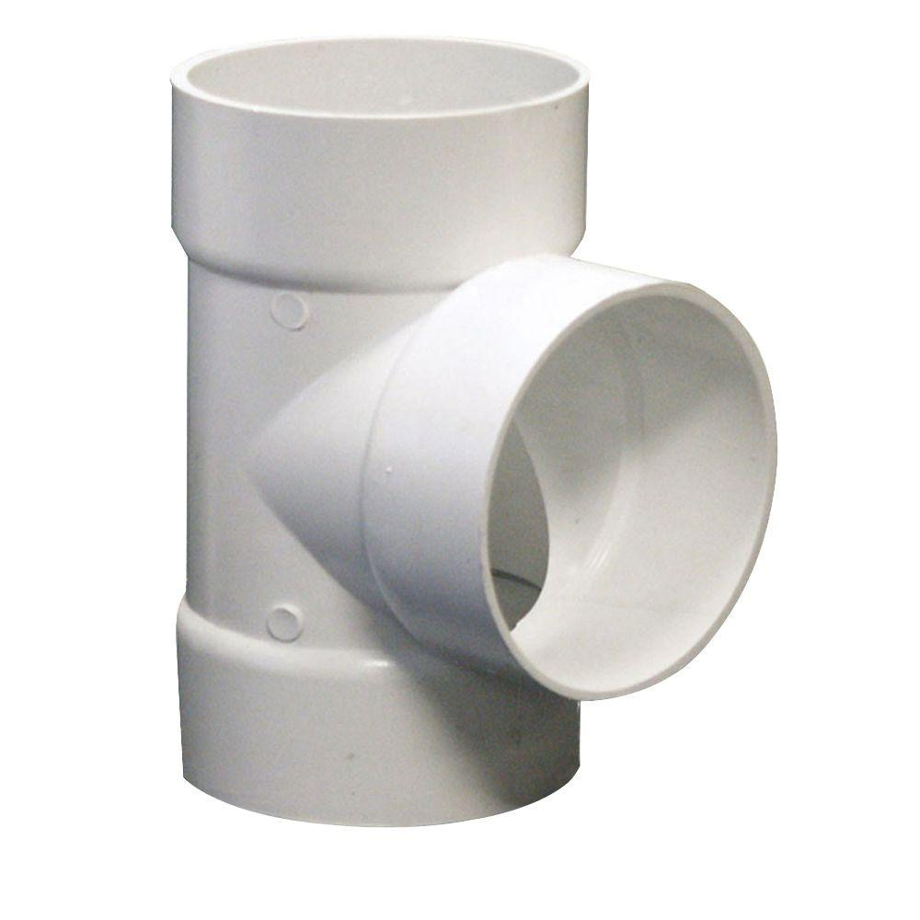
We set out to have a robot that would be able to operate in an actual PVC sewer system therefore we wanted to ensure that it would be able to fit inside a typical size sewer main for a building which is 6” PVC. We also wanted to ensure that it would be able to execute any kind of turn the robot would encounter in the field. The figures below show typical kinds of fittings used in a PVC sewer system.
Figure 1 - PVC Tee

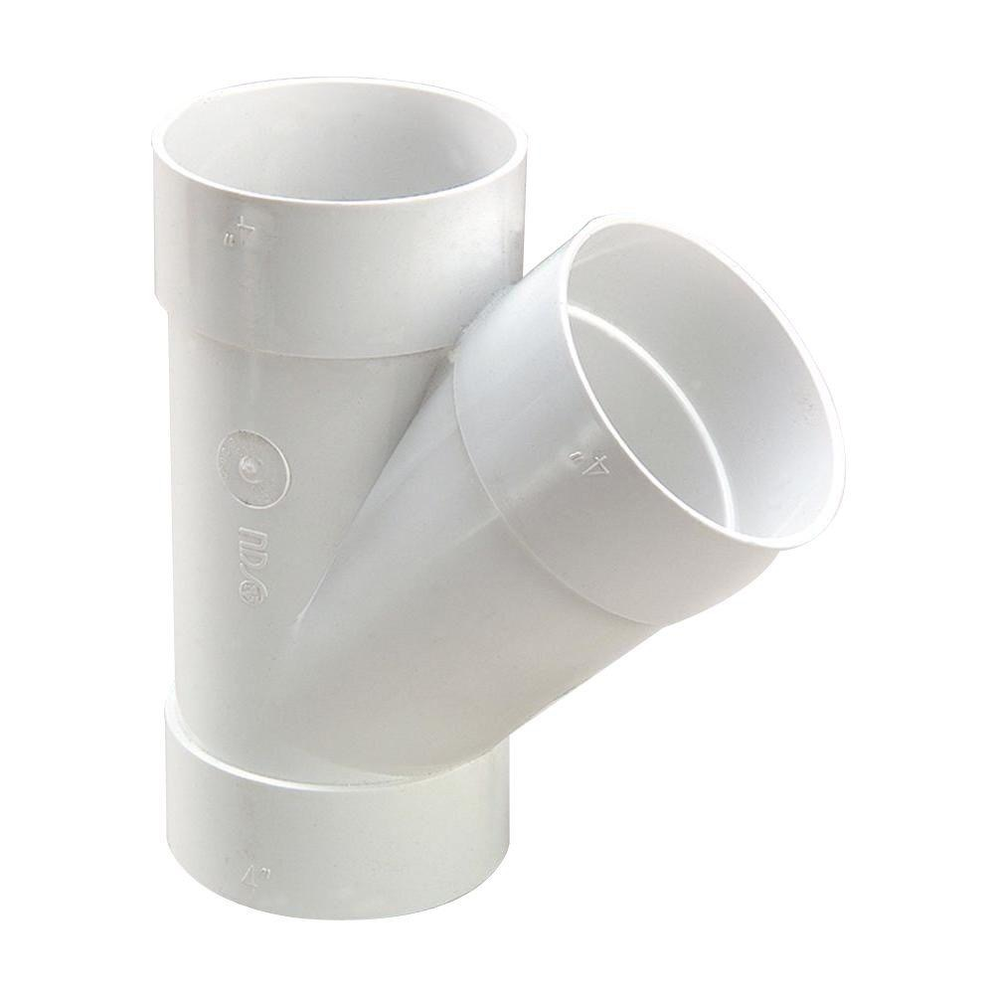
Figure 2 - PVC Wye
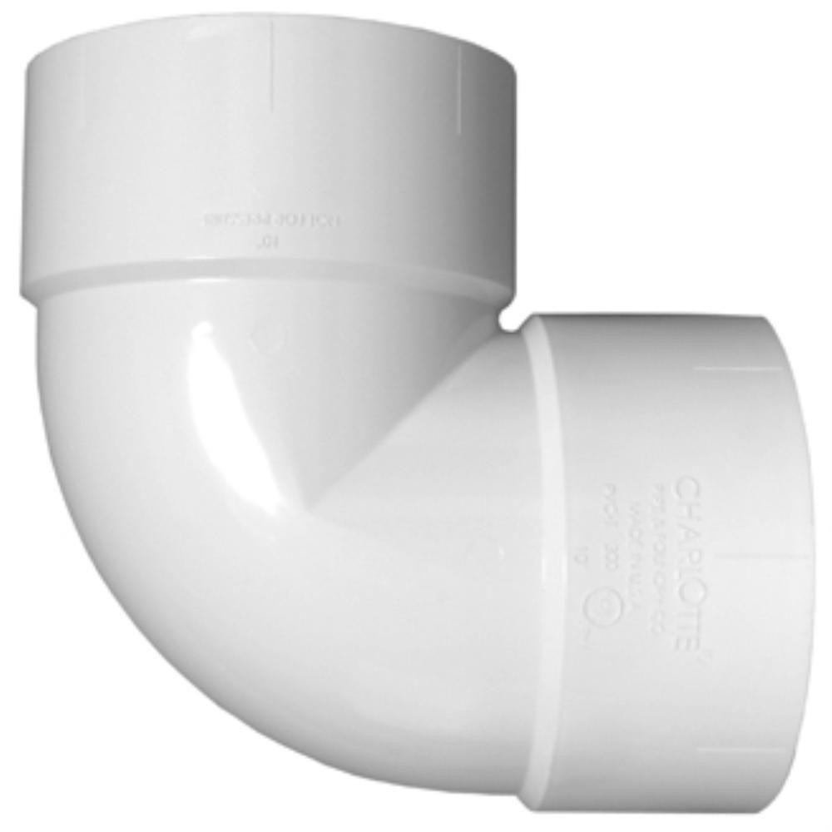
Figure 3 - PVC 90

Figure 4 - PVC 45
The robot was able to complete all of the turns shown above including the tee turn which is shown in figure 1 which we felt was the most important since this is the kind of turn that the “snake” product as mentioned earlier struggles with the most. It is important to note however that these turns were completed in situations where the robot had to travel less than 10 ft. before it reached the fitting and executed the turn. This will be explained further in results.
The robot uses an 80 ft. cable to transmit power and video feedback from the remote control box to the robot shell. We were successful in transmitting power to the motors as well as the camera and LED lights over the 80 ft. cable as well as having live video feed at a good quality.
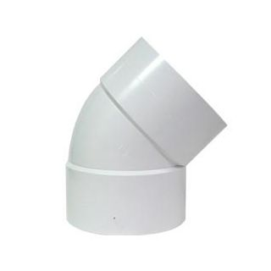
The goals that were not reached for our project were the following:
  - Robot travels and executes turns at a distance of up to 80ft.
  - Robot waterproofing
When inside the PVC sewer pipe, the robot will obviously encounter water and other liquids so it is important that the robot shell be waterproofed to protect the motors, camera, and LED light system. However, due to the time and effort that was taken into designing and 3D printing a robot shell along with the other tasks at hand, we decided after the first semester to hold off on waterproofing for our scope of work and focus on our remaining goals mentioned above. As for the robot not reaching the max travel distance, this was due to environment constraints such as space within the pipe as well as the weight of the robot itself and the weight of the wire it pulls as it travels inside the pipe.
When taking our redefined scope from the end of the spring semester we were able to reach all of our goals with the exception of the robot not able to travel the max distance of 80 ft..
Specifications
Following is a list of the specifications and constraints, along with brief highlights on important points.

Table 1: Specifications of underground, pipe inspection robot.
Operating voltage | 120V
DC motors
Gear ratio | 1000:1
Stall current at 12V | 800 mA
Stall torque at 12V | 125 oz-in
Wheels size | 40X70 mm
Camera
Resolution | 728X488
Max current at 12V | 50 mA
Travel distance | 80 ft
Pipe diameter intended for | 6”
Max number of turns | 3
Type of power | AC

Constraints
- Size: the diameter requirement places a chain of cascading constraints on the robot. For example, right from beginning, we are limited in the size of the chassis and the wheels. More importantly, it places a constraint on the size of the DC motors, which consequently places a constraint on the amount of torque and power the robot can produce. Turning and maneuvering the robot inside the pipe system was becoming increasingly more difficult with every added peripheral, to the extent that it was decided it would be best to remove the MCU from the chassis altogether and design a new chassis around that idea. The amount of electronics that we could fit inside the chassis was also constrained by the size the chassis, which limited the functionality of the robot as we were not able to fit as many peripherals as we would have liked.
- The wired connection places a constraint on how far and how many turns our robot can execute.
- PCV pipe surface irregularities and conditions place a constraint on the type and size of wheel we must use in order to overcome these conditions and not get stuck.
- The power supply being a 120 V AC input places a constraint on the user mobility, although it does provide for indefinite power.
- Financing, or the lack of it thereof, constrained us in the sense that it limited our ability to pursue means of water-proofing our robot that were well beyond our budget.

Risk Analysis and Management
Following is a list of potential risks we faced in the many different phases of this project, coupled with a plan to deal with said risk in the event it actually occurred.

- Risk: robot is immobilized by debris, rough conditions, faulty/cracked pipes, etc.
- Mitigant: robust wired connection to be able to pull the robot. A robust build as pulling will cause physical stress on the shell

- Risk: shell suffers irreparable damage
- Mitigant: design of a cost-efficient and easily replaceable shell

- Risk: failure to drag cable 80-ft deep and/or or perform a minimum of 3 turns
- Mitigant: lighter, smoother, less frictional cable insulation

Design and Methodology
Design
There were many aspects that went into the design of our robot, but before delving deeper into the specifics of each sector, below is a bird’s eye view of the system as a whole in order to better understand how every part fits together. Figure # below shows an overview diagram of our system.

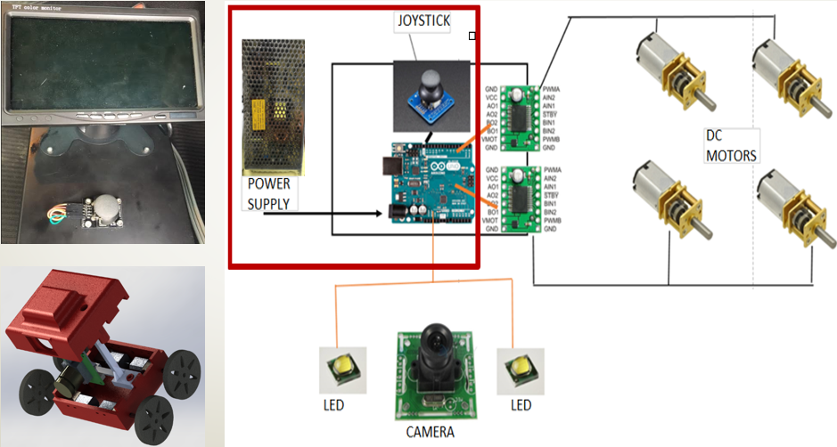
Figure 5: An overview diagram illustrating how all of the different components of our robot interact with each other to form the system as a whole.

On the left-hand side of figure # above are the two main components of the system, the control box and the chassis. The control box contains the joystick and the screen monitor where the live video feed is displayed, as is shown in the picture. Furthermore, it also encloses the power supply and the Arduino Uno microcontroller. The chassis, on the other hand, contains the DC motors and wheels for mobility, and the camera and LEDs for the live video feed. The control box is connected to an electricity outlet, using the U.S. standard of 120V AC, and from out the other end of the control box extends the 80-ft cable that connects to the robot chassis to power up the camera, LEDs, DC motors, and to provide the control signals for the motors. The power supply used has a max power output of 100 W and is adjusted to a 10.5 V DC output. The max power consumption of all components is approximately 50 W.
In choosing the DC motors, there were a few design characteristics that had to be taken into consideration. Given that the robot’s purpose is to inspect, we were not too concerned with speed, but rather, torque. Torque was important in our project, because of the sheer load the robot had to pull as the travel distance increased. With that in mind, we selected DC motors with a 1000:1 gear ratio, sacrificing speed for torque. Also, we chose wheels with the smallest diameter possible that were still feasible and able to navigate through the pipes. The reason why lies in that a smaller wheel radius translates to higher torque for the overall system. With the motors, wheels, camera and LEDs for camera lighting picked out, we then had to build and design a shell around these peripherals.

In the design of the shell, many variables had to be considered, such as shape, size, clearance fitting compared to the pipe, and how to embed components inside of the shell. Through initial calculations and basic simulation, the robot was narrowed down to two types of designs. One of the designs was a cylindrical shape while the other was a more rectangular in size. After some consideration, the team deduced that a cylindrical shape would require much more mechanical engineering knowledge than was available from the team members to finish the project on timely manner. The team hypothesized that if this type of design was selected it would require specially designed appendages such as independent suspension and wheel drive for each wheel on the robot, plus the additional gear box and direction of motion transfer would require custom fabricated miniature gear boxes.
The winning design would have to fit inside of the 6” pipe, while carrying the components required for video feedback and powering the motors. Our initial design included the microcontroller and motors attached to the case, which can be seen in Figure 6.
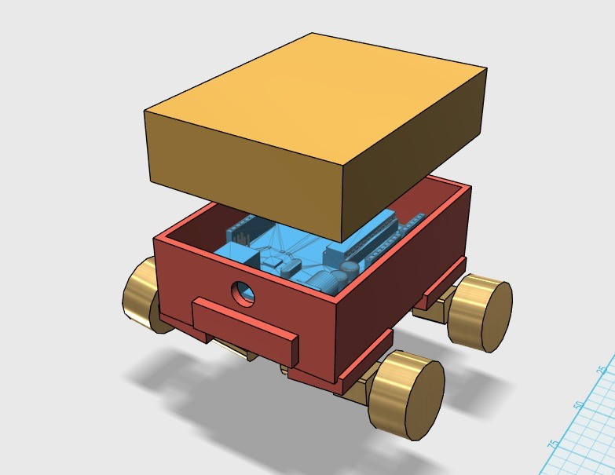
Figure 6 - The first prototype of our robot.
The robot shell was 3D printed using PLA plastic. When assembled, the robot with this particular configuration proved to be very clumsy and had poor turning capabilities while traversing through the pipe fittings and because of lack of 3D printing configuration and experience from the team in designing the models, proved to be flimsy.
Further research and development yielded a few different sub prototypes which led to the creation of prototype 2 displayed in Figure 7 below while sporting a different payload and configuration.
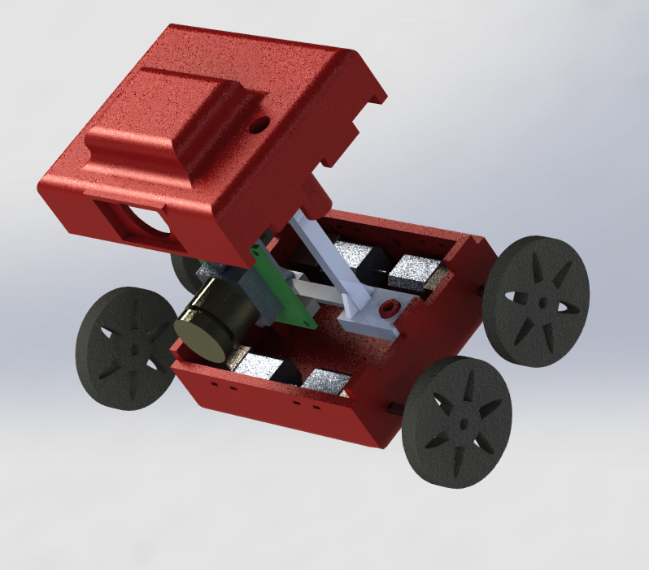
Figure 7 - Prototype 2 render with the micro-controller removed and the addition of the camera.
The new prototype proved to be much nimbler while traversing the test tracks of the pipe. The new shell has the following properties:
- Printed in PLA with thicker walls for durability.
- Convenient and clever matching top and bottom parts to fit together easily.
- Dimensions of assembled shell (viewed from the front) L x W x H of 63mm x 75mm x 52mm.
- Total dimensions of the robot with the wheels assembled (L x W x H) of 85.72mm x 89.4mm x 59.5mm

Methodology
For testing of the robot, two kinds of tests were developed. The first kinds of tests were meant to test the capability to execute the fitting turns as mentioned earlier and seen in figures 1 through 4. Each individual fitting was attached to a piece of 6” PVC pipe approximately 6 ft. in length. The robot then proceeded to travel through the pipe until it reached the fitting. If the robot was able to maneuver through the turn of the fitting, it was considered a success. If the robot at anytime turned over, got stuck, had to be retrieved by pulling it out manually, or lost video feed capability for whatever reason, the trial was considered a failure. Each fitting was tested in that manner a total of 8 times. The data was recorded for each trial.
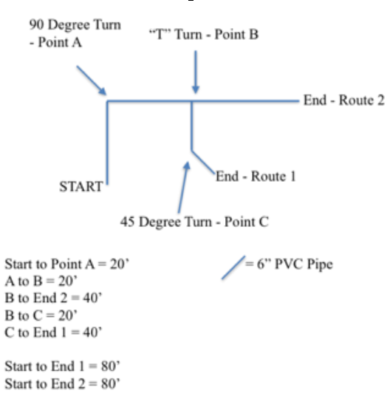
In the process of testing, we saw that behavior of the robots motion was greatly effected by the weight of the wire. As the robot progressed through the pipe, the weight of the wire would cause the robot to be heavier towards the back and cause the front wheels to lose traction. We decided to try and add weight to the robot to see if its capability to move was enhanced. The robot had small metal rods attached to the top of the shell. The total weight added to the top was approximately 130 g . The robot was then put through the same tests for each individual fitting and the data was recorded for each trial.

Figure 8 - Test Course Layout
Figure 8 shown above shows the larger test course that was developed that is designed to simulate an actual PVC sewer system. The course had 2 routes that could be taken with each route being a distance of 80 ft. long. Route 1 has a total of 3 turns, which is the goal we were aiming for. The course also has each kind of turn we have mentioned before which are the 90, 45, wye, and tee turn. Route 2 contains only one turn and was designed to test the speed of the robot when encountered with straight shots and a minimal amount of turns. The robot was tested on each route three times and was considered a success if it made it through the course without becoming stuck, overturning, or being pulled out manually for any reason as well as not losing video feedback.

Results
The table below shows the success rate of the turns using the eight trials on each fitting detailed in the first part of the methodology. As mentioned earlier, we also tested the robot with weight added. The results show that although the robot was successful in completing turns with its current design, the robot was significantly more successful when made heavier. The robot also made the turns faster with weight.

Table 2 - Results
Velocity: |  | 17 ft/minute at highest speed setting
Turn Type: | T- Turn | 45 Degree Turn | 90 Degree Turn | Wye- Turn
Without Weight: | 75% | 75% | 62.50% | 87.50%
AVG Turn Time in Seconds | 65 | 15 | 15 | 40
With Weight | 66.60% | 100% | 100% | 100%
AVG Turn Time in Seconds | 28 | 11 | 11 | 32

As for the large test course, we were not able to get much data due to the fact that the robot was not able to complete any of the routes. The robot would have trouble at point A in the test course shown in figure 6. Although the turn is one that the robot executed easily at a shorter distance, the robot had trouble maneuvering due to the weight of the wire at the distance of 20 feet. The robot had a max travel distance of 35 feet which was well short of our goal of 80 feet. Fortunately, the robot never lost power, video feed capability or became disconnected from the wire at any time. We also recorded its fastest speed being 17ft/minute. The run time for the robot is indefinite however it is recommended that the robot not be turned on continuously for more than 2 hours to prevent any overheating.
Conclusions
In conclusion, the robot was able to reach the majority of it’s goals with one exception. The robot is able to be controlled by the user via remote control joystick to maneuver through the 90, 45, wye, and tee turn. It was fairly easy to navigate as we learned to easily maneuver the robot after about 30 minutes of practice. The robot successfully provides live video feedback to the user for pipe inspection and has potential to give users an enhanced ability to inspect sewer systems pipes over the current snake method. The only goal that was not reached but that was in our scope of work this semester was the max travel distance of 80 feet which we feel is feasible if taken up by a team in the future.
Recommendations
After testing, the team has recommendations for any future teams to improve upon our work. The main focus should be the 80 ft. travel distance. The recommendations are below:
- Increase shell weight with heavier material
- Decrease wire weight by eliminating wire or wire insulation
- Change tires to larger ones
We make recommendation 1 due to the fact that we saw how much added weight improved the ability of the robot to make turns. The added weight helped the tires gain better traction which was a constant problem without the weight. Due to budget constraints, we printed the shell using the cheaper more readily available plastic material found in the UH labs but we feel that a sturdier and heavier material would not only help with the weight problem but with water proofing as well.
There are many possible ways to implement recommendation 2. Besides using different type of wire, possibly one with less thicker insulation, one could also eliminate a majority of the wire if wireless motors were used. The majority of the 80 foot cable is for sending control signals to the motors, however if the motors were wireless this would eliminate much of the weight. The reason we did not pursue this from the beginning was concern about what kind of range would these motors have and would there be signal issues with the robot being underground and encountering a variety of materials that could include, dirt, rock, concrete and others. If research could be done by a future team to see how feasible this is, this may be the best solution.
Recommendation 3 is made because we saw that when the robot struggled at turns over long distance, it was when it encountered the grooves of the fittings. We feel that a larger and thicker wheel would be better suited to go over the grooves inside of the fittings.

Financial Summary
The project went slightly over budget but it was not severe. The main cause of this being miscellaneous items such as switches and adapters to make connections. The rest of the project went according to plan and we were greatly helped by being able to 3D print at the UH labs for free however we did not have access to those labs until the fall semester so we still did get a cost for printing the shell as our initial prototypes were paid for. The pipe and fittings used for testing was also free. Figure 9 below shows the breakdown. The over budget total is $62.00.

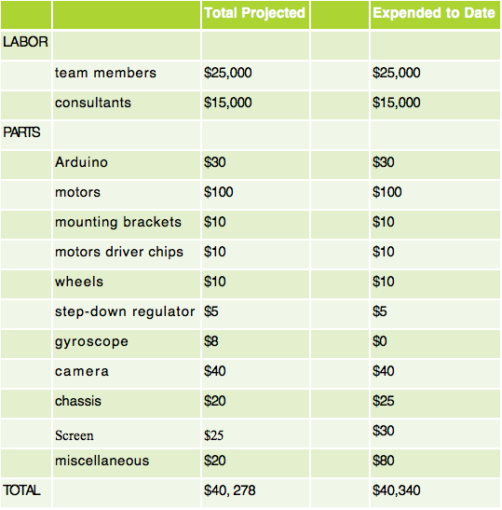
Table 3: Financial Summary

