December 4, 2016
Dr. Steven Pei
Project Manager
University of Houston
N 308 Engineering Building 1 Houston, Texas 77204-4005
Dr. Pei:
Enclosed is the final report for our team’s Air Quality Monitoring System. The significance of using a fully automated air quality system that can monitor the quality of air has increased the need of sophisticated technologies and developments to achieve higher performance and cost efficiency equipment. The purpose of this project is to improve the performance and accessibility of air quality monitoring equipment to aid research in air quality.
The air quality system consists of three main parts: a probe for detecting pollutants, Wi-Fi module for transmitting collected data, and an internet based real-time data processing platform. This report will cover further details regarding the goals, specifications and constraints of the project. It will also uncover the progress the team has achieved since the beginning.
As of December 4, 2016 the team has completed all the milestones which were initially defined. As of now all the routines for gas sensors, Wi-Fi library, and online platform completed, and have been tested for reliability purposes. We would like to inform you that the project was successfully launched and our fully functioning probe is ready to use.
It would be a pleasure for us to provide any additional information. On behalf of Air Quality Monitoring System team, I would like to thank you for the leadership and support throughout the project.
Sincerely, Air Quality Monitoring Group

TEAM 9: EPA AIR MONITORING
KAMERON BILLINGSLEY
ELI WALKER
PARTH PATEL
HAMID FAIZI
FINAL REPORT: 12-4-2016

PROJECT MANAGER: DR. STEVEN PEI

Abstract:
Houston has continually ranked among the worst cities in the nation for air quality for the past 20 years, ranking 6th in 2014 on a list of the worst areas for Ozone [1]. With a population of over 2 million, this is a very serious health risk. In the U.S., the government agency responsible for monitoring and reporting the data regarding air quality and pollution is the Environmental Protection Agency, or EPA. While the EPA has several probe locations throughout the greater Houston area, they self-report their findings without allowing any outside access to their raw data. In order to better understand the issue of air pollution and what solutions may be of use, it is important to allow independent researchers access to this information. To that end, we have teamed up with the EPA to produce a complete probe that will be low cost, easily deployable, and reliable. Our probe will be inexpensive, around $200 compared to the $1,000 models that are currently on the market, and will require no special training to operate. The probe will measure the most common pollutants, Ozone, Carbon Monoxide, and Particulate Matter 2.5 and 10 micrometers. This information will be stored locally via an onboard SD card while also being wirelessly transmitted to a remote sever using a Wi-Fi module. The probe will also be solar powered coupled with a Lithium-ion battery in order to allow the probe to be placed anywhere without worry of a nearby wall outlet. All of these features give our probe enhanced flexibility that is absent from probes currently on the market; our probe will have the ability to measure pollution levels in remote areas with no internet access as well as in urban areas, it can be deployed for just a few hours taking samples at frequent intervals, or for serval weeks with a sample rate of 30 minutes to an hour. We therefore believe that our probe will be a valuable tool in increasing the rate of air pollution research.

Introduction | 1
Statement of Goals | 3
Specifications | 4
Constraints | 5
Engineering Standards | 5
Design and Methodology | 5
Results | 7
Conclusions | 12
Recommendations | 13
Financial Summary | 14
Bibliography | 15
Appendix | 16
Outside Resource Appendix | 18

Figure 1: PM2.5 module responding to the smoke from the match | 8
Figure 2: smoke being waved from burning match into particle sensor | 9
Figure 3: ThingSpeak posts from free run tests | 10
Figure 4: Twitter posts from free run tests | 11
Figure 5: configuration window with various settings being adjusted | 12
Table 1: probe measurements vs. EPA measurements | 10
Table 2: our financial summary | 14

Intro/background:

This document is the final report of our project. It will outline the purpose of our project, a description of our deliverable, our goals, our financial summary, our design methodology, a conclusion, an assessment of our results, and some recommendations for any future students who take up this project.
Our project is an air quality monitoring probe built to be accessible and deployable by the EPA and other researchers. Current air quality assessment tools are large, bulky, and expensive; our aim was to build a device that is as inexpensive as it is user-friendly. Our target audience is professional researchers and hobbyists with some programming experience.
Air quality is measured differently between countries. In the United States, the standard metrics of air quality as well as their acceptable ranges are set by the EPA. The EPA is mainly interested in ozone, carbon monoxide, and small particle concentrations. The module will need to monitor all of these pollutants and log their concentrations at regular intervals set by the user.
The gaseous pollutants are detected by chemical sensors which translate the concentration of their respective gasses to voltages on the output terminals of each sensor. Each sensor comes with a datasheet which explains the concentration-voltage behavior of the sensor; from these data, we can design circuits which enclose the values useful to our application in the 0-3.3[V] range readable by the microcontroller. Particle pollutants (PM2.5 and PM10) require a slightly more advanced detection method. For these, a fan will blow air through a darkened detection chamber and an infrared laser will shine on the sample. The level of scattering read by the detector translates to the pollutant concentration. The particle sensor is an enclosed module packaged as one piece and communicated with via serial; we will not be designing/building this component ourselves.
The module communicates with the internet, so it also has a WiFi module. For this, we have chosen the ESP8266 for its low cost and ease of use. The ESP8266 communicates via serial using AT commands, which we have written a library to do automatically from a function call.
We have chosen ThingSpeak^{tm} as our online data-management client. The brains of the operation will be a Teensy-family microcontroller. The microcontroller will store and run the routines for each sensor, taking in the concentration values and sending them to the internet via the WiFi module. All embedded programming will be done in Arduino, since Arduino has a strong online community and plenty of support. ThingSpeak^{tm} is a free online data-logging website, built specifically for internet-of-things projects where communication to or over the world-wide web is needed. It features Twitter connectivity and can pass “.mat” files to MATLAB for easy analysis.
The probe will require power so a voltage-stabilized power source is currently underway for implementation. For probes deployed in places with easy access to power, a simple step-down and rectifier circuit can be used for power, we used a phone charger in our case. As the probe may be deployed in areas with little access to power, it will be outfitted with a solar cell and battery system.
The probe will run the gamut of substances (CO, particulate matter, O3) detecting the concentration of each at intervals set by the user. Data will be sent to Twitter, ThingSpeak^{tm} or the on-board SD card by order of the user.

Goals:
Our goals may be summarized as follows: the probe is small and robust, cost-effective, measures pollutants in a relevant range and resolution, is responsive to user inputs, and can log data reliably both on and offline. All of the goals will now be expanded on, each with its own paragraph in the order listed above.
The size of the probe was our first sticking point. We wanted a probe that could be easily transported and installed in any location indoors or out. To accomplish this, we used an outdoor electronic controller box. The box is weather-proofed with a rubber seal on the lid and a port holes with rubber stoppers removable by the user. It is rated to withstand typical environmental conditions of wind, rain, and harsh temperatures. Two of the stoppers were removed and replaced with a plastic screen, one with a fan attached. This enables the exchange of air and excludes the possibility of wildlife getting in.
The probe had to be cost-effective. All told, the probe cost less than 200$ in parts, which is remarkably less than the thousands of dollars spent to manufacture a single EPA probe. For a more detailed breakdown of the costs, see the financial summary.
Of course, the probe must monitor the concentrations of each pollutant accurately and in a relevant range to be useful to the EPA. Our probe uses the MQ-7 and MQ-131 carbon monoxide and ozone sensors respectively. The resolution for the ozone sensor changes with concentration because the sensor has a non-linear concentration/output voltage response, however it has a linear response in the “good” air quality concentration range and there resolves at, 5% of the “good quality” threshold for ozone. The carbon monoxide sensor, unfortunately, does not measure accurately below 20[ppm], which means that it is better used to detect exceedingly poor air quality and send out an advisory. The particle detector is an SKU: SEN0177 dust sensor. It can measure PM10 and PM2.5 at a range of 0-999[ug/m^3] with a 1 [ug/m^3] resolution and 98% accuracy. For PM10 that resolution 1.85% of the “good” air quality threshold, and for PM2.5, it is 8.3% [1].
The user inputs specifications as to which pollutants are to be measured, how often, and where the data is to be sent through a serial window. These specifications are stored in the non-volatile memory and interpreted by the back-end of the operating system outside of the configuration mode.
The online and offline data storage was handled by ThingSpeak and an on-board memory card data logger respectively. To transmit the data to the internet, we used an ESP8266 WiFi card, which takes in AT commands through serial communications and executes them accordingly.

Specifications:
Probe is 7x6x3” and accurately measures O3, PM2.5 and PM10 within 10% of their good-quality range. The probe measures carbon monoxide at high concentrations and can be used to issue advisories, but is only accurate between 20-2000[ppm]. The probe can post data to ThingSpeak, Twitter, or to the on-board 8Gb memory at an interval of no less than 5 minutes, as set by the user. The probe can withstand rain and other harsh weather conditions as specified by the manufacturer of the controller box. User inputs are handled through a text user interface from which the user may adjust the timing interval for each pollutant detection cycle, where that information is sent, and information about the WiFi network name and password.

Constraints:
Cost was both specification and constraint for our project. Because of the recent downturn in the price of oil, it was not possible to secure any partners or funding for this project; the department was also only able to offer limited funding and so our project was self-funded by the team members. Time was our second greatest constraint; we are allowed less than a full calendar year to complete this project and many of our team members had engagements outside of school, so scheduling was difficult for this project.

Engineering Standards:
There were a number of engineering standards implemented in the project. The microcontroller runs Arduino code, which is derived from ANSI C++. The WiFi card communicates through its own set of AT commands to the microcontroller, and communicates wirelessly through standard WiFi protocols at 2.4[GHz]. The standard PHP “GET” method was used to communicate to the ThingSpeak and Twitter servers. The SD card communicates using the SPI bus protocol, and the particle detector communicates using universal serial communication at 9600 baud.

Design and Methodology:
For this section, each design point will be grouped in its own paragraph with a description of the methods used to test and achieve that design point.
The WiFi module was the first element of this project subjected to extensive testing. Preliminary tests were conducted to determine if the module could communicate to the web at all. This was performed by manually entering AT commands with test strings sent to Twitter. Later, a rough test sketch was made which logged on to a requested WiFi network using a given password prompting the user for inputs through a serial window along the way. The module was later free-run tested to repeatedly send random numbers to ThingSpeak at a consistent interval. This test sketch could run only for a few hours before the WiFi module could no longer send data. An updated sketch was produced which reset the WiFi module whenever it detected a WiFi fault. This sketch was run for four days and showed no signs of failure; this result was interpreted as success and the version of the WiFi driver with time-out compensation made it to the final release of the probe software.
The ozone sensor was first tested to confirm that it was responding to the environment by exposing the sensor to ozone produced by an ozone generator. The generator consisted of a high-frequency ultraviolet light tube powered by a blocking-oscillator based flyback transformer. This ozone was collected in a sealed bottle and the bottle was placed over the ozone sensor and the output values of the sensor were recorded. Later, our team learned that an EPA official probe would be taking a sample close to our location. To confirm the plausibility of our ozone readings, we took a measurement close to their probe and compared it to our own. We also tried to get into contact with the chemistry department on campus, but were not able to secure an opportunity to test our sensors in a controlled environment. We were, therefor, not able to perform a proper scientific test on our sensor accuracy and defer to the datasheet for our specifications.
Similarly, we were unable to secure a proper facility to test the credibility of our particle sensor measurements. Dr. Pei had a brief correspondence with the diesel testing lab at the Energy Research Park at UH, but they were unwilling to allow us to test there. We did perform a test to see that the detector was in fact responding to the environment by blowing smoke into the vent and checking the particle matter levels. As with the ozone, we defer to the manufacturer data sheet to make our final specifications.
The on-board memory was tested using a test sketch which sent strings to text files in the memory card. The card was opened on a PC and the files containing the strings were opened and checked for the strings left by the test sketch.

Results:
The probe had to be small and robust against the environment. This specification was met by using an IP65 rated waterproof/weatherproof junction enclosure with dimensions 7x6x3” and opening two of the plugs on the bottom of the box to allow air exchange. The open vents were covered with a screen mesh and the electronics were populated mostly in the top of the box to disable any water from getting to the exposed junctions. To ensure the enclosure did not contaminate the measurements (i.e. collect certain lighter-than-air gasses inside and not allow them to escape from the sealed top of the box) a fan was added to one of the vents to force air exchange before each sample.
The probe can measure ozone and particle matter accurately and within a relevant range to the EPA specifications on air quality. The carbon monoxide sensor can measure concentrations of carbon monoxide within the “good air quality” range, however the manufacturer advises that the sensor is not accurate below 20[ppm], which is dangerously poor air quality, leaving the carbon monoxide sensor best used for issuing warnings and advisories against poor air quality. Due to our being unable to secure a legitimate facility to test our sensors, we are forced to rely on the manufacturer specifications for each sensor to assess the overall accuracy of our probe. We do, however, have sufficient evidence demonstrate that the sensors are, in fact, responding to the environment and not just generating noise. The following two figures show the particle sensor’s response to PM2.5 coming from a burning match stick. 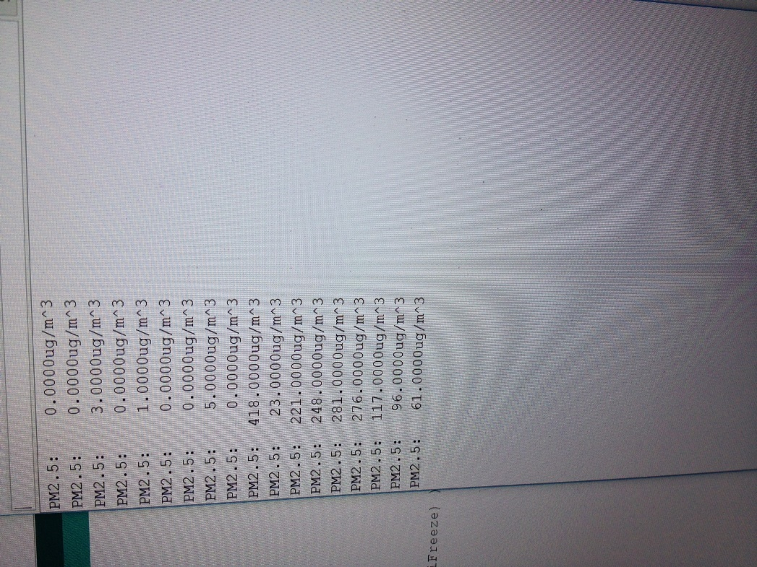
Figure 1: PM2.5 module responding to the smoke from the match

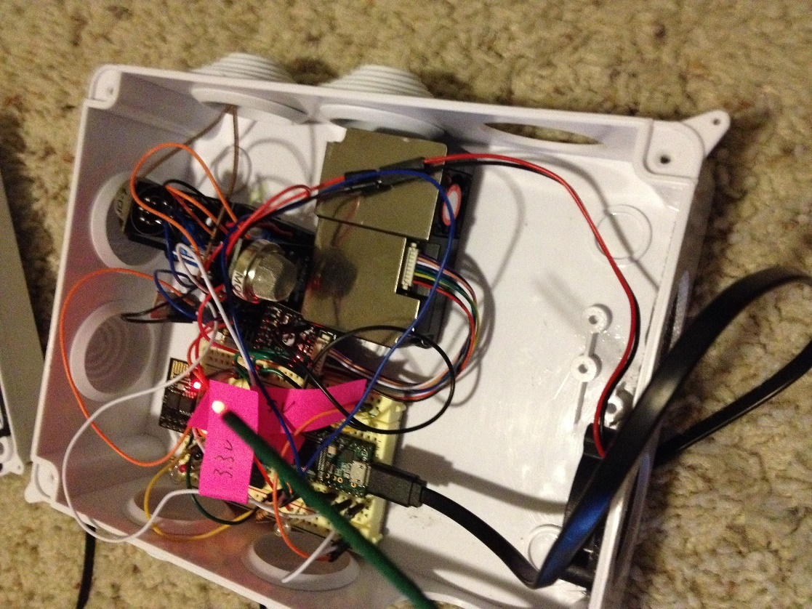
Figure 2: smoke being waved from burning match into particle sensor
We ran a similar test with the ozone sensor using an ozone generator, but we have even stronger evidence for the veracity of the ozone measurements by comparing the ozone concentration the EPA found for a location to the value our sensor found for the same location only a few yards away. Our measurement and theirs are shown in the table below

Table 1: probe measurements vs. EPA measurements
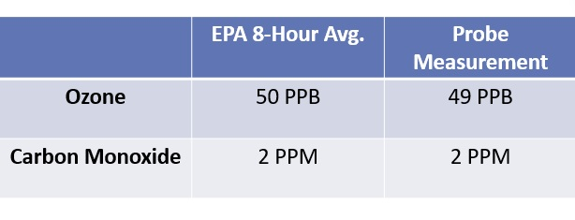
The probe is able to send data to the web via an online data management client called ThingSpeak. Several free-run tests were performed demonstrating the ability of the probe to send data continuously to ThingSpeak and Twitter, however continuously posting to Twitter at a regular, exact interval will cause Twitter to reject additional Tweets. We believe this to be a result of Twitter’s efforts to block spam robots. The following two figures show posts uploaded automatically to both our Twitter feed and ThingSpeak account
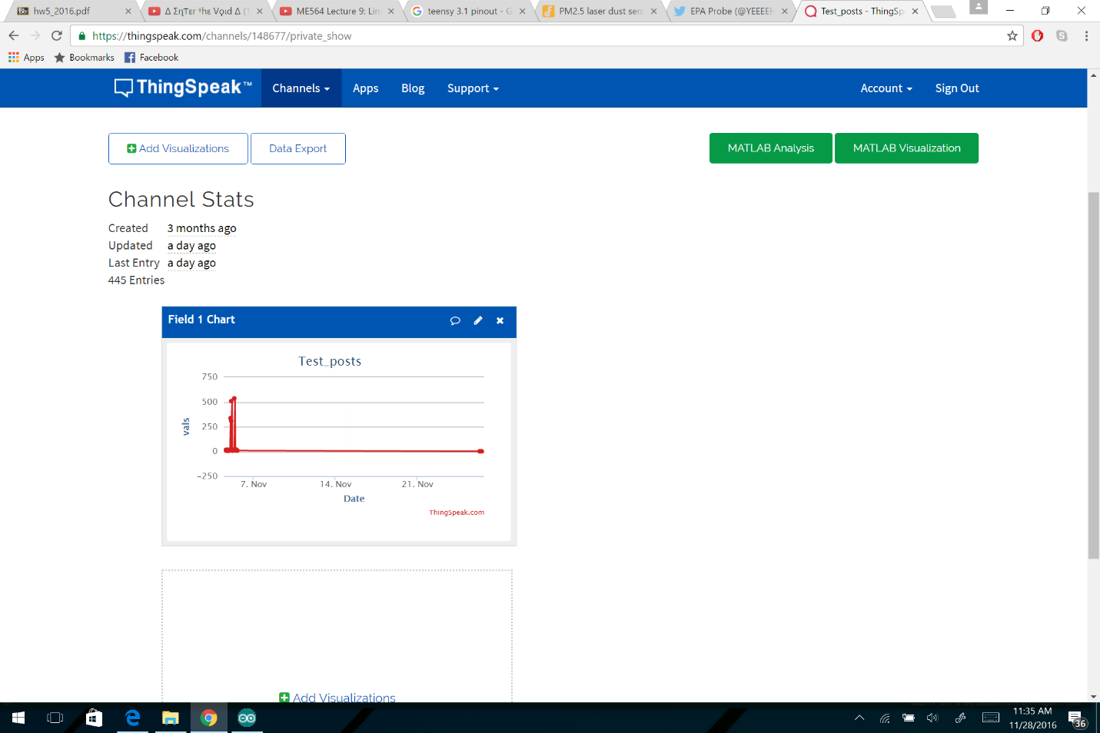
Figure 3: ThingSpeak posts from free run tests

Figure 4: Twitter posts from free run tests
The user interface is able to accept and interpret directions from the user about which pollutants are to be measured, how frequently, and where that information is to be sent. Information is passed to the probe through a serial window after starting the probe in “CONFIGURATION MODE” by holding down the black button next to the WiFi module inside the box while powering up. In addition to information about each sensor, the microcontroller also remembers information about the network and password to be used for any wireless communication, also passed through the configuration window below.
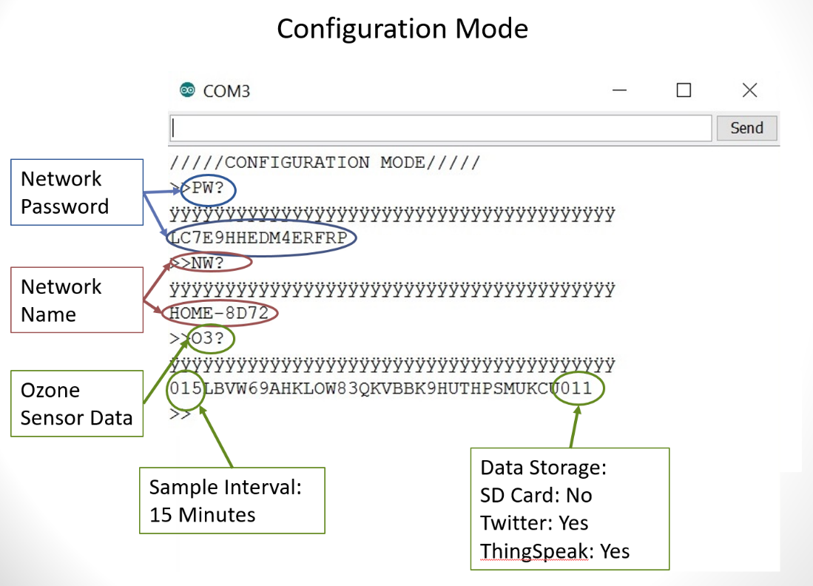
Figure 5: configuration window with various settings being adjusted along with explanations

Conclusions:
Our project aimed to create a device which could measure air pollutants commonly under EPA inspection that was inexpensive, easy to use, and communicated the information wirelessly to an online data client. To accomplish this goal, we built a wireless, weather-proof probe that gathers information about carbon monoxide, ozone, and small particles and communicates those data to an online data management client or to an SD card by order of the user. Through both individual and systematic testing, we were able to verify the functionality of our probe using the best instruments/tests available to us. Our probe is able to accept settings from the user, collect data about the environment based on those settings, and send those data to the appropriate receptacle (Twitter, ThingSpeak, or the on-board memory). There are limitations to our design; the probe cannot post continuously to Twitter because, we speculate, Twitter’s algorithm blocks robots from posting spam at repeated intervals. The probe also has a limited ability to detect carbon monoxide and should only be used to issue warnings of high concentrations of carbon monoxide. Limitations aside, the probe meets most of the original specifications and could easily be expanded on pending, for example, a better carbon monoxide sensor being invented or cheaper detectors for other EPA pollutants such as lead or nitrous oxide.
Recommendations:
As for our methods, more rigorous and complete testing could have been employed. This is especially true for our chemical and particle sensors. A statistical analysis comparing the true concentration of some reagent in the air vs the concentration detected by the sensor would have provided the clearest evidence that our sensors measured accurately. We were not able to secure any assistance from the chemistry or diesel testing labs at UH or permission to use their facilities, so in our case we deferred to the datasheets. A future team might be more aggressive in pursuing the appropriate test facilities.
We would also recommend a more robust power system. Our power system worked by solar off-grid and mains power while on-grid, but it did not feature a continuous power system for unexpected power losses. It also did not mitigate unexpected power loss with a safe shut-down procedure, and so information may possibly be corrupted or lost if the probe shuts down within a write cycle of the SD card.
More could have been done for the user interface. Our user interface is a simple command prompt style text-user-interface that while familiar to engineers and natural scientists may confuse and offend the uninitiated. For this, we recommend using a raspberri pi mini-computer and running android to create an easier to use graphic user interface. Maybe couple this with a touch screen on the inside of the probe to make the probe familiar and easy enough for anyone to use. We resisted the use of these technologies because of their immense power consumption that would drain the battery while operating off grid, but future engineers may find a solution to this problem.
Looking forward, the next team may want to add sensors not related to the pollutants monitored by the EPA. A few suggestions include: temperature, humidity, ultraviolet radiation, wind speed, atmospheric pressure, and countless others. Dr. Pei even speculated that a network of these probes could be used to create topographical maps showing the movement of, for example, particles emitting ionizing radiation or poison gas moving through a city or port. Such information could be used to re-direct traffic signals to minimize evacuation times away from the harmful cloud and trace the cloud to its source.
Financial Summary:
The table below outlines our expenditures this semester. It is identical to the table offered at the beginning of the semester. There were no unexpected costs or additional consultation needed this semester to complete the probe.
Table 2: our financial summary
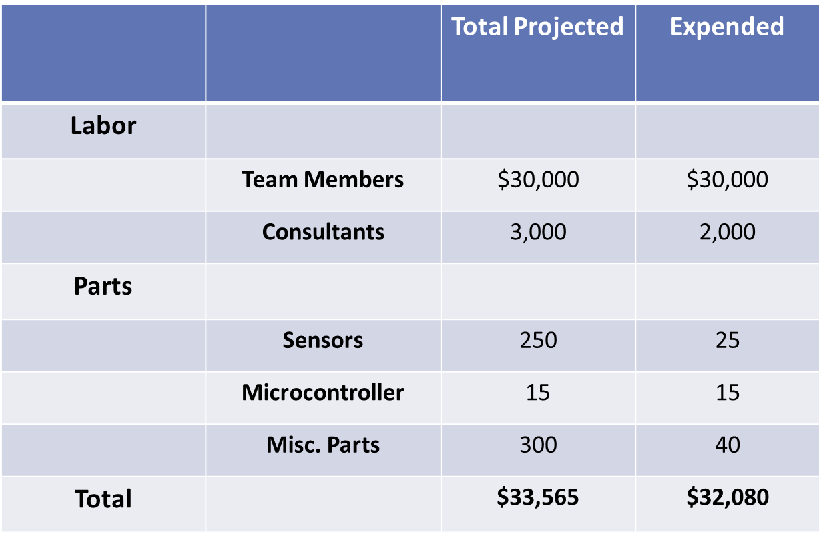
Bibliography:
[1]Unlisted Author. (2016, March 29). [online calculator]. Available: https://www.airnow.gov/index.cfm?action=airnow.calculator

Appendix:
The microcontroller used for the project, the Teensy 3.1, has since been discontinued by the manufacturer and so the connection diagram associated with it will be excluded from this appendix. Any reproductions of this project may be done by connecting the WiFi module and particle sensor to any serial ports, the SD card to any SPI bus and the gas sensors to any analog input port.
The following figure has two circuit diagrams used in the project. The top circuit is the power circuit or the fan and gas sensors. This circuit helps the probe conserve power when running on battery by withholding power from the power-hungry sensors and fan when they are not in use. The bottom circuit is the voltage divider circuit used to normalize the 5[V] analog sensor readings down to the 3.3[V] read by the Teensy microcontroller. The effects of the potentiometer resistance were mitigated in the software using constants derived from circuit analysis and information from the datasheets of each sensor, as well as some empirical testing.
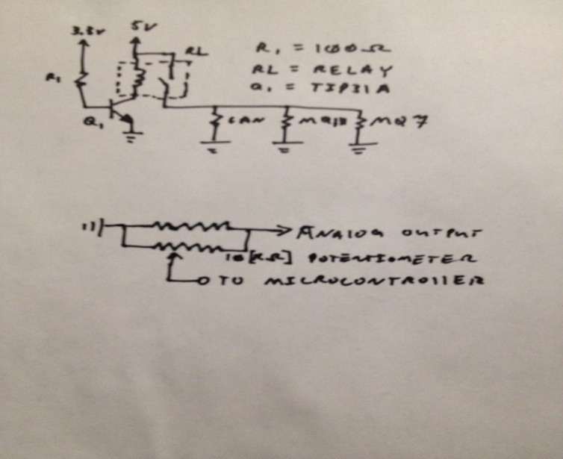
The following diagram is our off-grid power system designed and tested to power the probe where grid power is not available
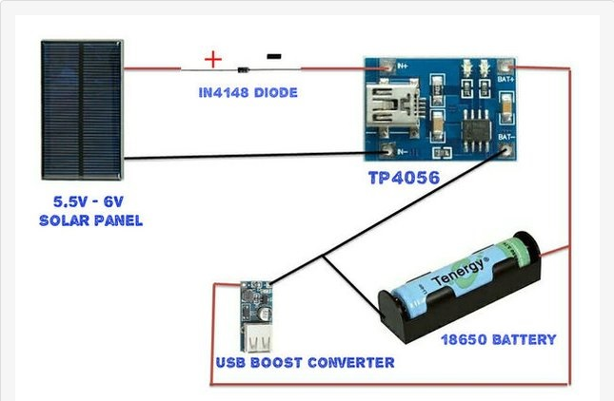
The remainder of the work associated with this project created originally by our team is in the software. The full software will not be posted here, as per the guidelines. The software has basically two spheres, the “front-end” and the “back-end.” The front-end handles information coming in from the user. It prompts the user to enter information about each pollutant and details of the WiFi network and password to be used. The “back-end” runs a routine based on the requests given by the user in the front end. The front end communicates to the back-end through the non-volatile memory, where the front end stores information and the back end later finds it. To help organize the code, a class of objects called “probe” was declared. The members of this class are information about each pollutant: detection interval, measurement routine, current value, human-readable print strings, API keys for posting to the web, and the next clock time the measurement is to be taken. An object of this class is made for each pollutant to be measured and the methods associated with the class are called in the context of each object: gather data at a certain interval, send it to the web or onboard memory.
Outside Resources:
Of course, we did not know everything we needed to know going into this project, and we needed to consult a few resources to gather the necessary knowledge. The first resource we consulted was one Kevin Darrah, a YouTuber with a comprehensive tutorial on how to connect, set up, and communicate to the ESP8266 WiFi module. He also gives basic lessons on PHP and how to use that to send data to online clients like ThingSpeak. His video may be found at the following URL: https://www.youtube.com/watch?v=qU76yWHeQuw
We also consulted several datasheets listed below each followed by a brief explanation:
TECHNICAL DATA MQ-131 GAS SENSOR

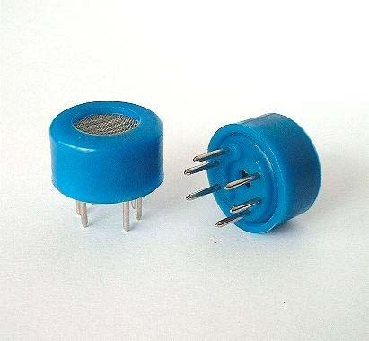
FEATURES
Fast response and High sensitivity
Stable and long life
Simple drive circuit
Wide detecting range

APPLICATION
They are used in air quality control equipments for buildings/offices, are suitable for detecting Of O₃ .

SPECIFICATIONS
- Standard work condition
Symbol | Parameter name | Technical condition | Remarks
Vc | Circuit voltage | 5V±0.1 | AC or DC
V_{H} | Heating voltage | 6V±0.1 | AC or DC
R_{L} | Load resistance | Variable
R_{H} | Heater resistance | 31Ω±5% | Room Tem
P_{H} | Heating consumption | Less than 1100mw
- Environment condition
Symbol | Parameter name | Technical condition | Remarks
Tao | Using Tem | -10 -50
Tas | Storage Tem | -20 -70
R_{H} | Related humidity | Less than 95%RH
- Sensitivity characteristic
Symbol | Parameter name | Technical parameter | Remark 2
Rs | Sensing  Resistance | 100KΩ-200KΩ  (50ppb O₃ ) | Detecting concentration scope  10ppb-2ppm O₃
α O₃  (100ppb/50ppb) | Concentration Slope rate | ≤0.65
Standard  Detecting  Condition | Temp: 20±2 Vc:5V±0.1  Humidity: 65%±5% Vh: 6V±0.1
Preheat time | Over 24 hour
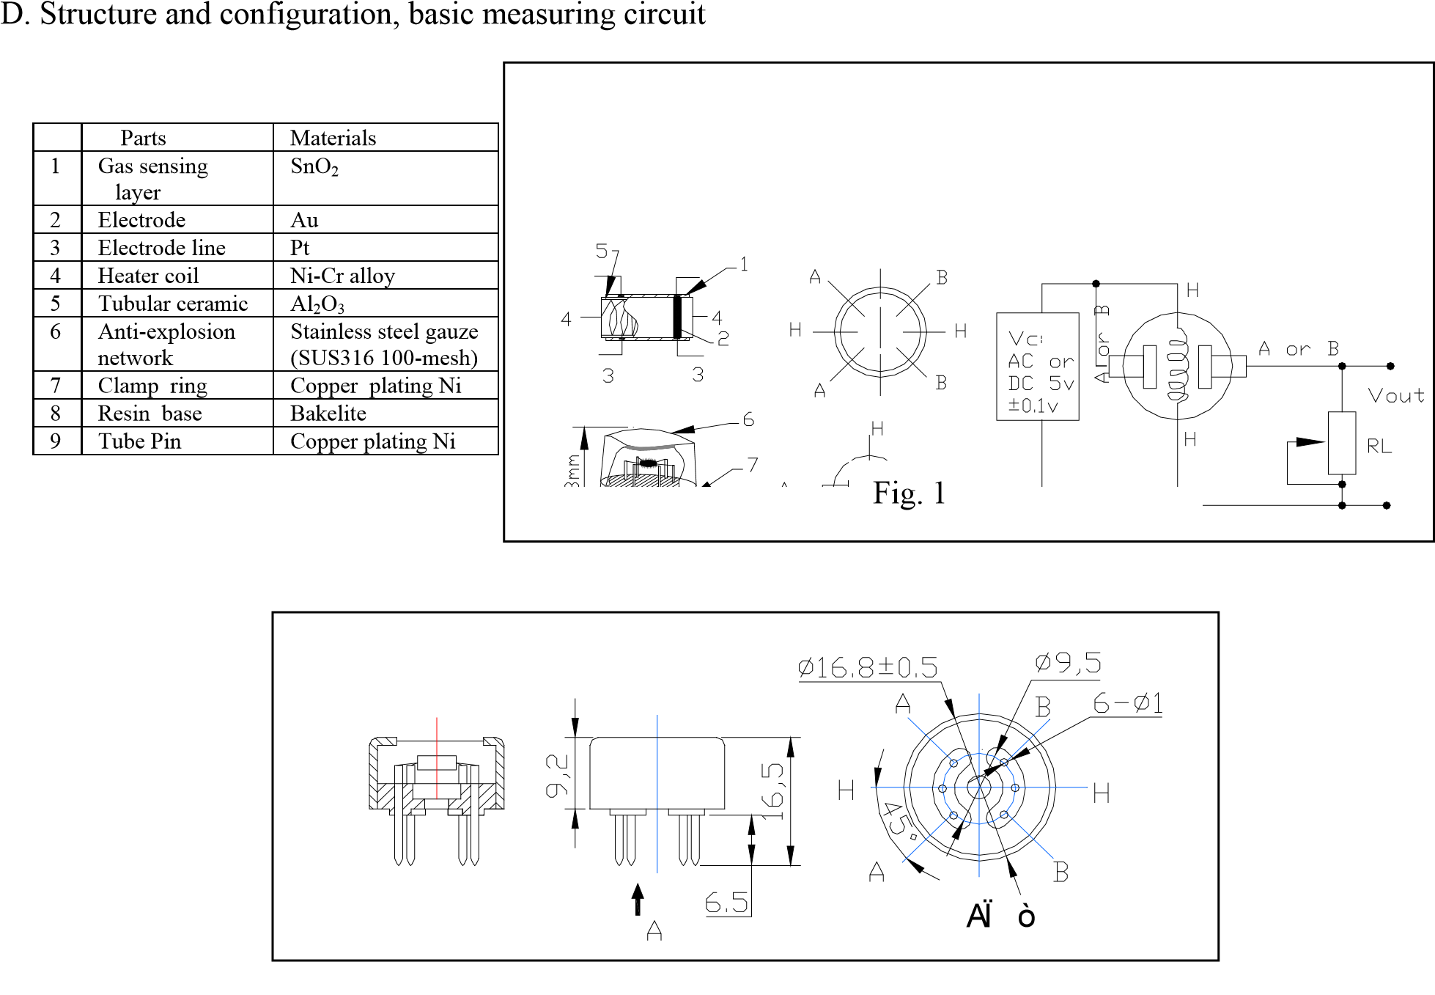
Structure and configuration of MQ-131 gas sensor is shown as Fig.1, sensor composed by micro AL2O3 ceramic tube, Metal-oxide semiconductor sensitive layer, measuring electrode and heater are fixed into a crust made by nylon and stainless steel net. The heater provides necessary work conditions for work of sensitive components. The enveloped MQ-131 have 6 pin ,4 of them are used to fetch signals, and other 2 are used for providing heating current.
Electric parameter measurement circuit is shown as above Fig.1.

E. Sensitivity characteristic curve
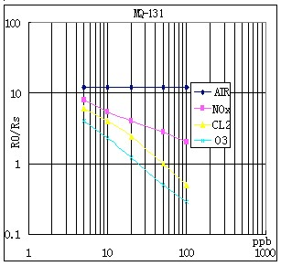
Fig.3 is shows the typical sensitivity characteristics of the MQ-131 for several gases.
in their: Temp: 20 Humidity: 65%
O₂ concentration 21%
RL=20kΩ
Ro: sensor resistance in the clean air.
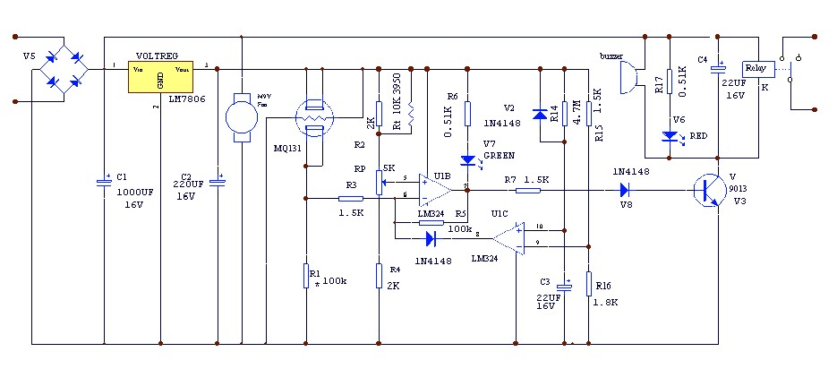
Rs: sensor resistance at various concentrations of gases.
Fig.3 sensitivity characteristics of the MQ-131

APPLICATION
Resistance value of MQ-131 is difference to various kinds and various
Concentration gases. When using this components, sensitivity adjustment is very necessary. we recommend that you calibrate the detector for 50ppb O₃ in air and use value of Load resistance that( R_{L}) about 100 KΩ(50KΩ to 200 KΩ). When accurately measuring, the proper alarm point for the gas detector should be determined after considering the temperature and humidity influence.
Noting: there are a round hole in the up and down side of the sensors, this design enable the sensor inner gas to exchange better with outside air, and the sensor shall has higher sensitivity, quicker response and resume time with a fan .
This datasheet is for the MQ131, the ozone sensor we used.
TECHNICAL DATA MQ-7 GAS SENSOR

FEATURES
- High sensitivity to carbon monoxide
- Stable and long life

APPLICATION
They are used in gas detecting equipment for carbon monoxide(CO) in family and industry or car.

SPECIFICATIONS
A. Standard work condition
Symbol | Parameter name | Technical condition | Remark
Vc | circuit voltage | 5V±0.1 | Ac or Dc
VH (H) | Heating voltage (high) | 5V±0.1 | Ac or Dc
VH (L) | Heating voltage (low) | 1.4V±0.1 | Ac or Dc
RL | Load resistance | Can adjust
RH | Heating resistance | 33Ω±5% | Room temperature
TH (H) | Heating time (high) | 60±1 seconds
TH (L) | Heating time (low) | 90±1 seconds
PH | Heating consumption | About 350mW
- Environment conditions

Symbol | Parameters | Technical conditions | Remark
Tao | Using temperature | -20℃-50℃
Tas | Storage temperature | -20℃-50℃ | Advice using scope
RH | Relative humidity | Less than 95%RH
O2 | Oxygen concentration | 21%(stand condition) the oxygen concentration can  affect the sensitivity characteristic | Minimum value is over 2%
- Sensitivity characteristic

symbol | Parameters | Technical parameters | Remark
Rs | Surface resistance Of sensitive body | 2-20k | In 100ppm  Carbon Monoxide
а(300/100ppm) | Concentration slope rate | Less than 0.5 | Rs (300ppm)/Rs(100ppm)
Standard working condition | Temperature -20℃±2℃ relative humidity 65%±5% RL:10KΩ±5%
 | Vc:5V±0.1V VH:5V±0.1V VH:1.4V±0.1V
Preheat time | No less than 48 hours | Detecting range:  20ppm-2000ppm carbon monoxide

- Structure and configuration, basic measuring circuit
Structure and configuration of MQ-7 gas sensor is shown as Fig. 1 (Configuration A or B), sensor composed by micro AL2O3 ceramic tube, Tin Dioxide (SnO2) sensitive layer, measuring electrode and heater are fixed into a crust made by plastic and stainless steel net. The heater provides necessary work conditions for work of sensitive components. The enveloped MQ-7 have 6 pin ,4 of them are used to fetch signals, and other 2 are used for providing heating current.
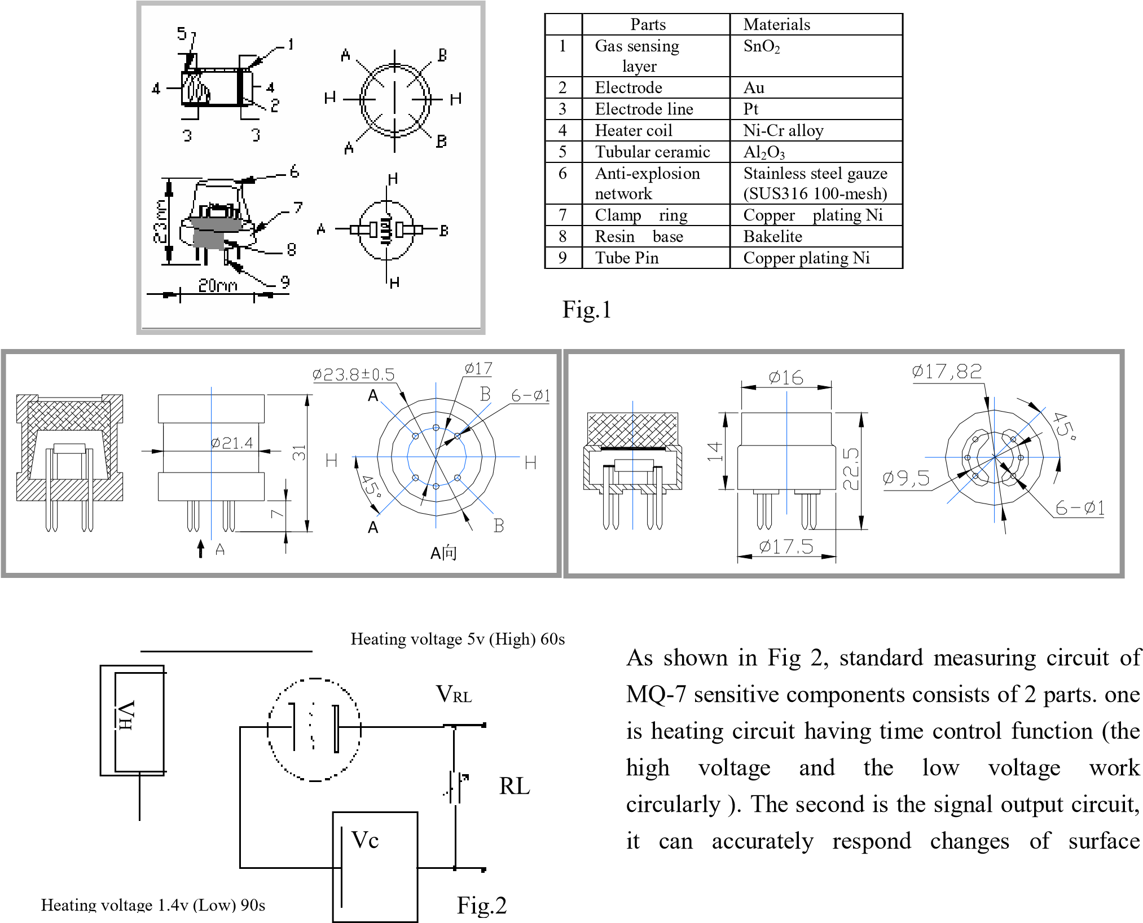
Standard circuit:
resistance of the sensor.

Electric parameter measurement circuit is shown as Fig.2
- Sensitivity characteristic curve
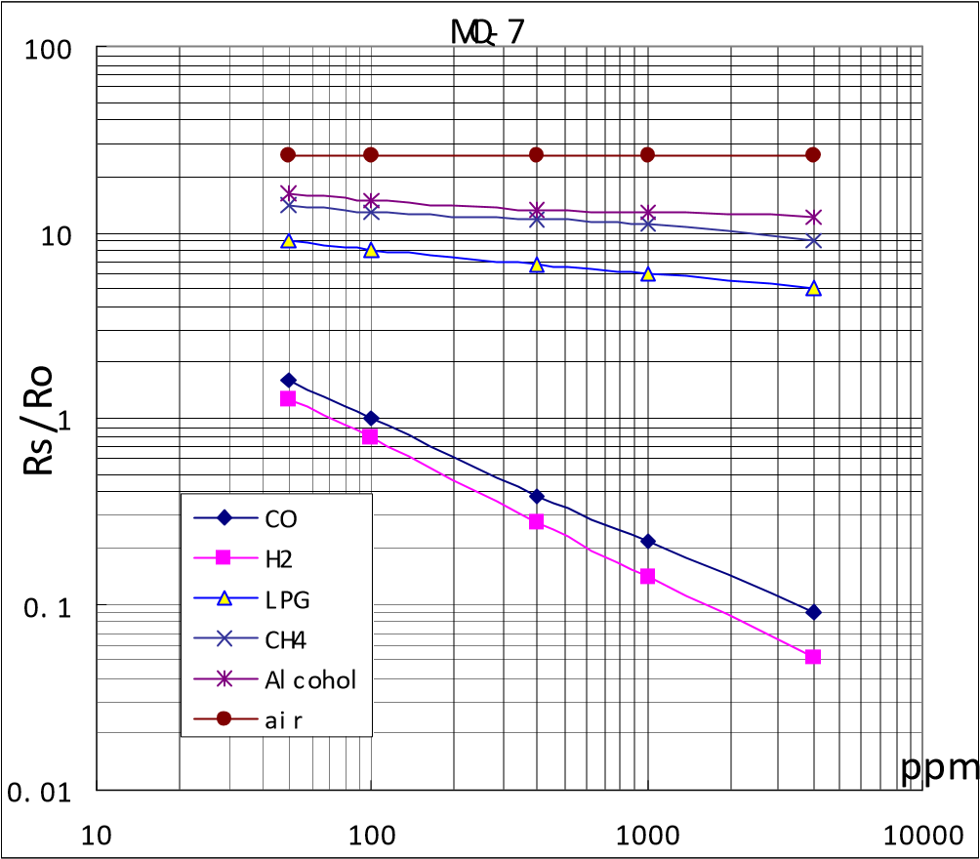
Fig.3 is shows the typical sensitivity characteristics of the MQ-7 for several gases. in their: Temp: 20℃、
Humidity: 65%、
O₂ concentration 21%
RL=10kΩ
Ro: sensor resistance at 100ppm CO in the clean air. Rs: sensor resistance at various concentrations of gases.
Fig.3 sensitivity characteristics of the MQ-7
Fig.4 is shows the typical
dependence of the MQ-7 on
temperature and humidity.
Ro: sensor resistance at 100ppm CO

in
air at 33%RH and 20degree.
Rs: sensor resistance at 100ppm CO at
different temperatures and humidities.

MQ-7
0. 5
0. 6
0. 7
0. 8
0. 9
1
1. 1
1. 2
1. 3
1. 4
1. 5
- 10
0
10
20
30
40
50
Temp
R
s
/
R
o
%RH
33
85
%RH
Fig.4

OPERATION PRINCIPLE
. The surface resistance of the sensor Rs is obtained through effected voltage signal output of the load resistance RL which series-wound. The relationship between them is described:
Rs\RL = (Vc-VRL) / VRL
Fig. 5 shows alterable situation of RL signal output measured by using Fig. 2 circuit output

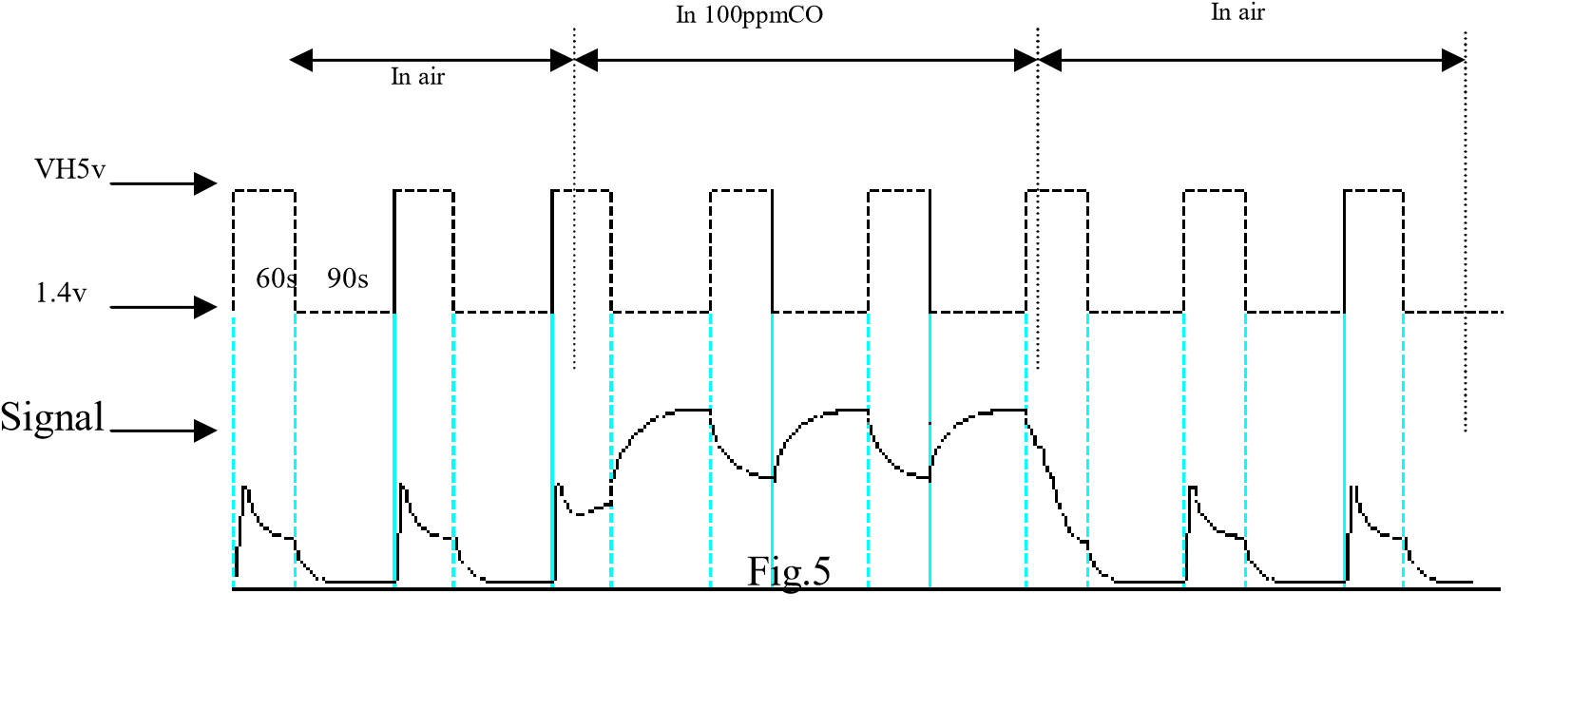
signal when the sensor is shifted from clean air to carbon monoxide (CO) , output signal measurement is made within one or two complete heating period (2.5 minute from high voltage to low voltage ).
Sensitive layer of MQ-7 gas sensitive components is made of SnO2 with stability, So, it has excellent long term stability. Its service life can reach 5 years under using condition.

SENSITVITY ADJUSTMENT
Resistance value of MQ-7 is difference to various kinds and various concentration gases. So, When using this components, sensitivity adjustment is very necessary. we recommend that you calibrate the detector for 200ppm CO in air and use value of Load resistance that( R_{L}) about 10 KΩ(5KΩ to 47 KΩ). When accurately measuring, the proper alarm point for the gas detector should be determined after considering the temperature and humidity influence. The sensitivity adjusting program:
- Connect the sensor to the application circuit.
- Turn on the power, keep preheating through electricity over 48 hours.
- Adjust the load resistance RL until you get a signal value which is respond to a certain carbon monoxide concentration at the end point of 90 seconds.
- Adjust the another load resistance RL until you get a signal value which is respond to a CO concentration at the end point of 60 seconds .
Supplying special IC solutions, More detailed technical information, please contact us.

This datasheet is for the MQ7, the carbon monoxide sensor we used.

HK-A5 Laser PM2.5/10 Sensor

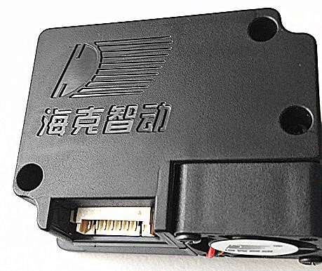
Main characteristics
- The data is accurate
- The quick response
- The standard serial digital
output
- The two-stage multipoint
calibration curve
- The smallest particle size of 0.3 microns

Overview
HK-A5 is a universal digital particle density sensor, can be used to obtain in unit volume of air in 0.3 ~ 10 microns suspended particulate matter number, i.e., particle concentration and output in the form of digital interface and output of each of the particles in the quality of data. The sensor can be embedded in a variety of airborne particulate matter concentration related instruments or air purifier equipment, to provide timely and accurate concentration of data.
Working principle：
The sensor adopts the principle of laser scattering. Even if the laser irradiation in air suspended particles produce scattering, also in a certain angle to collect light scattering, the scattering intensity with time change curve. Microprocessor data collection, through the Fourier transform get the relationship between time domain and frequency domain, followed by a series of complicated algorithms that particles of equivalent grain size and per unit volume of different particle size of particle number. The functional block diagram of the sensor is shown in the following figure:
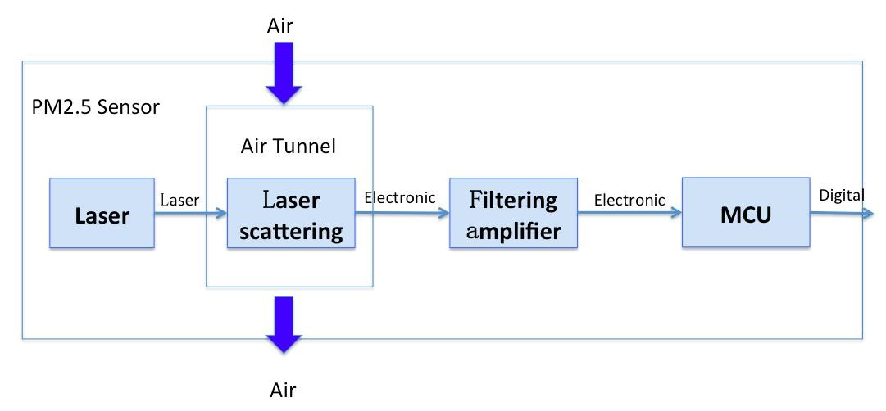

Technical specifications
Sensor Technical specifications
Parameter | Index | Unit
measuring range | 0.3～10 | Micron (um)
range | 0～999 | ug/m3
Count accuracy | 50%@0.3um、98%@≥0.5 um | %
Quasi volume | 0.1 | L (L)
$esponse time | ≤10 | Second (s)
DC power voltage | 5.0 | Volts (V)
Maximum operating  current | 120 | mA (mA)
Standby current | ≤200 | uA (uA)
Operating temperature range | -20～+50 | Degrees Celsius (c)
Working humidity  range | 0～80% | RH
Mean time to failure | ≥5 | Year (Y)
Maximum size | 46×35×20 | mm (mm)

Output result
The main output is the number of particles in the unit volume, the unit volume is 0.1 litres. Interface description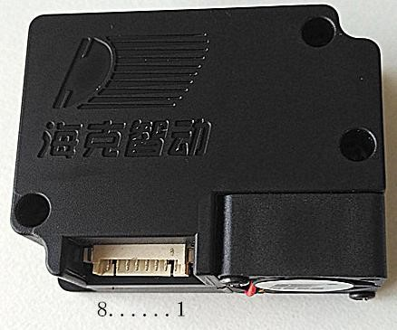
Digital interface pin definition
Pin serial  number  electrical  name function description | Pin serial number electrical name function description | Pin serial number electrical name function description
VCC PIN1 power supply (5V, voltage more stable data is more  stable) | VCC PIN1 power supply (5V, voltage more stable data is more stable) | VCC PIN1 power supply (5V, voltage more stable data is more stable)
GND PIN2  power supply | GND PIN2  power supply | GND PIN2 power supply
SET PIN3 sleep set pin  (3.3V level) | SET PIN3 sleep set pin (3.3V  level) | SET PIN3 sleep set pin (3.3V level)
RXD PIN4 serial port receiving pin (3.3V level) | RXD PIN4 serial port receiving pin (3.3V level) | RXD PIN4 serial port receiving pin (3.3V level)
TXD PIN5 serial port to send pin (3.3V  level) | TXD PIN5 serial port to send pin  (3.3V level) | TXD PIN5 serial port to send pin (3.3V level)
RESET PIN6 module reset signal (low reset, no use when hanging or pulled  high) | RESET PIN6 module reset signal (low reset, no use when hanging or pulled high) | RESET PIN6 module reset signal (low reset, no use when hanging or pulled high)
NC PIN7\8  hanging | NC PIN7\8  hanging | NC PIN7\8 hanging
Note: SET=1 module works in the continuous sampling mode, the module at the end of each sample after the initiative to upload the sample data, the sampling response time is 1S.
SET=0 module to enter low power standby mode.
RESET module reset signal, this pin users can not have to operate.
Dimension unit: mm (mm)
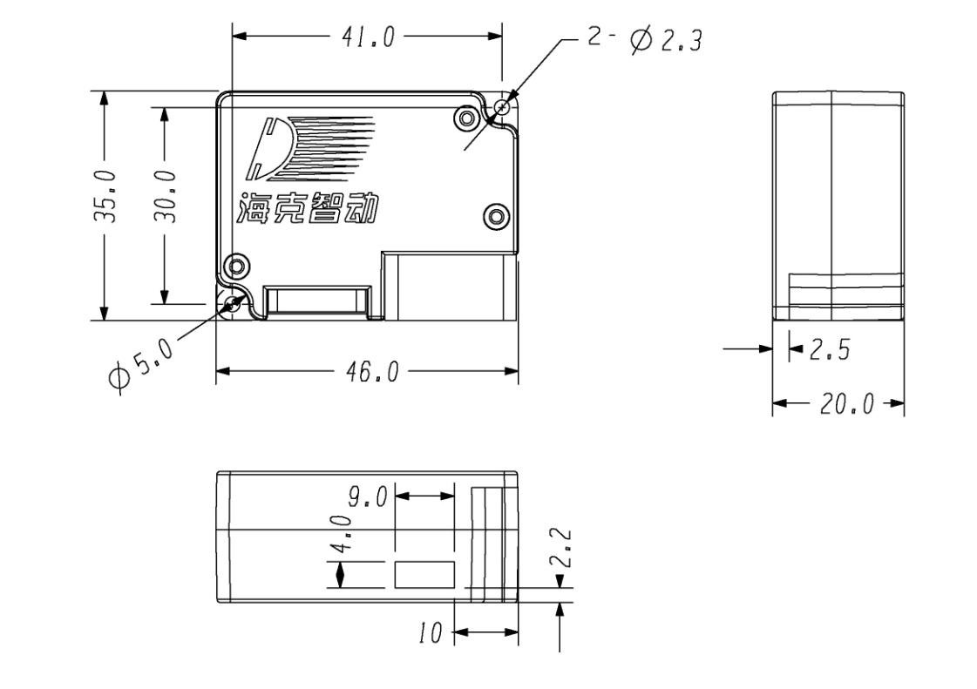

Communication protocol
Serial baud rate: 9600; parity: none; stop: 1; fixed packet length is 32 bytes.
Start symbol 1 |  | 0x42 | (fixed)
Start symbol 2 |  | 0x4d | (fixed)
Frame length  eight | high | …… |  | The frame length =2x13+2 (data and parity)
Frame length  eight bit | low | ……
Data 1 high eight |  | …… |  | The data of the 1 said the concentration of PM1.0, ug/m3
Data 1 low eight |  | ……
Data 2 high eight |  | …… |  | The data of the 2 said the concentration of PM2.5, ug/m3
Data 2 low eight |  | ……
Data 3 high eight |  | …… |  | The data of the 3 said the concentration of PM10, ug/m3
Data 3 low eight |  | ……
Data 4 high eight |  | …… |  | Internal test data 1, user retention.
Data 4 low eight |  | ……
Data 5 high eight |  | …… |  | Internal test data 2, user retention.
Data 5 low eight |  | ……
Data 6 high eight |  | ……. |  | Internal test data 3, user retention.
Data 6 low eight |  | ……
Data 7 high eight |  | …… |  | Data 7 indicates that the number of particles in the air of 0.1 litres is more than 0.3um
Data 7 low eight |  | ……
Data 8 high eight |  | …… |  | Data 8 indicates that the number of particles in the air of 0.1 litres is more than 0.5um
Data 8 low eight |  | ……
Data 9 high eight |  | ……. |  | Data 9 indicates that the number of particles in the air of 0.1 litres is more than 1.0um
Data 9 low eight |  | ……
Data 10 high eight |  | …… |  | Data 10 indicates that the number of particles in the air of 0.1 litres is more than 2.5um
Data 10 low eight |  | ……
Data 11 high eight |  | …… |  | The data of the 11 said 0.1 litres of air in more than 5.0um in diameter of particle number
Data 11 low eight |  | ……
Data 12 high eight |  | …… |  | The data of the 12 said 0.1 litres of air in more than 10um in diameter of particle number
Data 12 low eight |  | ……
Data 13 high eight |  | …… |  | The internal test data 4, user retention.
Data 13 low eight |  | ……
Data and calibration high eight |  | …… |  | Check code = (start symbol 2+ start symbol 1+...... 13 low eight)
Data and check low  eight bit |  | ……
Power quality requirements
1, the ripple is less than 100mV.
2, power supply voltage stability: 4.95 ~ 5.05V.
3, power supply: greater than 1W (current greater than 200mA).
4, upper and lower voltage power supply voltage of the system is less than the impact of 50%.

This is the datasheet for the SKU: SEN0177, the particle sensor we used.

